**EVEREST ENGINEERING COLLEGE**

*(affiliated to Pokhara University)*

**Sanepa-2, Lalitpur**



**A MINOR PROJECT FINAL REPORT ON**

**“BLOOD BANK AND DONOR MANAGEMENT SYSTEM”**

**SUBMITTED BY**

**DIPESH MAGAR [19120054]**

**JHAK PRASAD PUN [19120056]**

**MANISH RAI [19120060]**

**MILAN BHATTARAI [19120063]**

**SUBMITTED TO**

**Department of Computer and IT Engineering**

**Everest Engineering College**

**Sanepa, Lalitpur**

**NOVEMBER 4, 2022**

**ABSTRACT**

The Blood Bank and Donor Management System (BBDMS) is an application that stores, processes, retrieves, and analyzes data about blood bank administration. Our project mainly provides the communication platform between blood donor and receiver.

The major goal of the blood bank and donor management system is to keep track of blood, donors, blood groups, blood banks, and stock information. It keeps records of all information concerning blood, blood group, stocks, and blood. Because the project is all done at the administrative level, only the administrator can see it.

**Key Words:**

Blood Bank, Blood Management System, Blood Donor Management System

**TABLE OF CONTENTS**

LIST OF FIGURES v

LIST OF TABLES vi

LIST OF ABBREVIATION vii

CHAPTER 1: INTRODUCTION 1

1.1 Background 1

1.2 Problem Statement 1

1.3 Objectives 1

1.4 Applications 1

1.5 Project Features 1

1.6 System Requirement 1

1.6.1 Software Requirement 1

1.6.2 Hardware Requirement 1

CHAPTER 2: LITERATURE REVIEW 2

CHAPTER 3: METHODOLOGY 3

3.1 Introduction 3

3.2 Project Block Diagram 3

3.3 System Analysis and Design 3

3.4 Working principle 3

3.5 Implementation 3

CHAPTER 4: RESULT AND ANALYSIS 4

CHAPTER 5: CONCLUSION 5

REFERENCES 6

APPENDICES 7

LIST OF FIGURES

**FIGURE PAGE**

Figure 1.1: -------------------------------------------------------------------------- 2

Figure 1.2: --------------------------------------------------------------------------- 3

Figure 2.1: --------------------------------------------------------------------------- 7

….

# LIST OF TABLES

**TABLE PAGE**

Table 1.1: ---------------------------------------------------------------------------- 2

Table 1.2: ---------------------------------------------------------------------------- 3

Table 2.1: ---------------------------------------------------------------------------- 7

# INTRODUCTION

## Background

Searching of blood donor is become very difficult task for many people who needs blood very urgently. Now days, almost everyone has the access of internet. So, to make work of searching blood easy to needy people through the access of internet we started doing this project. Rather than traditional system of searching bloods through a phone call and different physical activity we can be shifted it into more digital approach.

## Problem Statement

The percentage of people donating blood is increasing day by day due to awareness to donate blood for those needed. The blood received have to be managed thoroughly so that there will be no negative effect to the blood receiver once they received blood.

Our web application manages all these increasing number of blood donor and keeps the records of blood donate by the donor. And, it’s provides blood to the receiver through the website in very easy and safe manner.

One of the factor of the public afraid to donate their blood is they believe in myths. The myths that they always believe are, if they donate their blood they will become fat and if they donate their blood, their blood will become less in total of amount. This BBDMS provide more information in order to educate the public so that they know blood donation will not give bad effects.

## Objectives

To develop the online platform that make easy to blood donor to donate the blood and make easy to receiver to search and get the blood.

## Applications

The application of these project is to provide the online platform that massive number of people can donate blood and keeps the clear records of these bloods. And, to make easy to receiver to get the blood.

## Project Features

Provides a beautiful UI through which user can navigate easily. Donor can register with their name ,mobile number, email id, age, gender blood group and donate the blood. Our web application tell why should you have to become donor. Receiver can search the blood through search blood option and contact to the admin and they can get the required blood.

## System Requirement

In the overview of project of BLOOD DONOR AND MANAGEMENT SYSTEM, there are some system requirements for the project to be done by the members. Software and hardware requirements are must to do the project.

### Software Requirement

1. Operating System: Windows family
2. Technology: Html,Css,Bootstrap5,JavaScript,Jquery,php,mysql
3. IDE: Vs code

### Hardware Requirement

Processor: At least i5 Processor

Ram: Min 4GB

Hard Disk: 128GB

# LITERATURE REVIEW

There are two systems that have been selected as benchmark for the development of BBMS. They are the Blood Bank India (BBI) at http://www.bloodbankindia.net, Lions Blood Bank & Research Foundation (LBBRF) from http://www.lionsbloodbank.net/.

The website for Blood Bank India is a website that provides the facility for the donor to register by him or herself as a blood donor. All citizen in India can register to the system. But, in our application citizen from any certain limited area of Nepal can register the system. Due to this we can collect information of small area effectively

LBBRF is a private organization that functions as a place to donate blood. They give a charge to the person or patient that is in needs of blood. However, the money that they collected is not for the profit for them but for recover the expenses incurred in recruiting and educating donors. In Lions Bank & Research Foundation, They will make sure the availability of blood stock in their blood bank. They also published the current status of blood stock in their website homepage. However, this blood bank does not provide the location of the available blood. Without having this function in the system, the donor cannot monitor the available blood. Our web application provide the location of the available blood on the basis of the location name.

Nepal Red Cross Society shall remain an efficient, self-sustainable, and independent humanitarian organization committed to provide immediate relief to human suffering and reduce vulnerability, under the Fundamental Principles of the Red Cross, through its network of Red Cross workers throughout the country working closely with communities and governmental and non-governmental organizations in a democratic, transparent and participatory way. Likewise, our project is inspired from the work done by Nepal Red Cross Society for a small particular location.

# METHODOLOGY

## Introduction

This chapter starts on the discussion about the project research, design and methodology. The second part presents the development of the system. The third part tells the operation process and testing. The last part, discuss the evaluation procedure.

In our project testing and verification take place in the early stage during the development stage. So we use V-Shaped model which is also the expansion of classic waterfall model and it’s based on associated test stage for the every development stage.

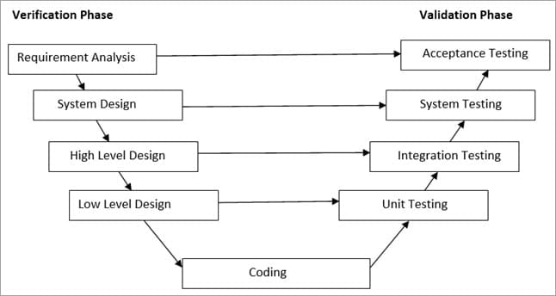

Fig:V-shaped Model

## Project Block Diagram

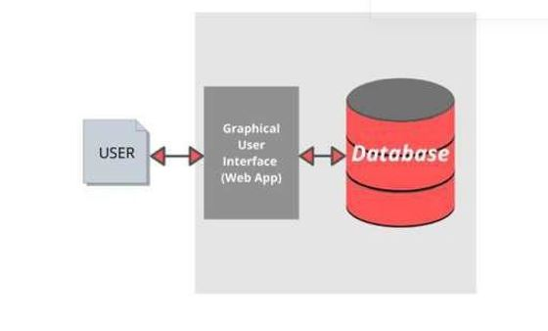

Fig: Block Diagram

## System Analysis and Design

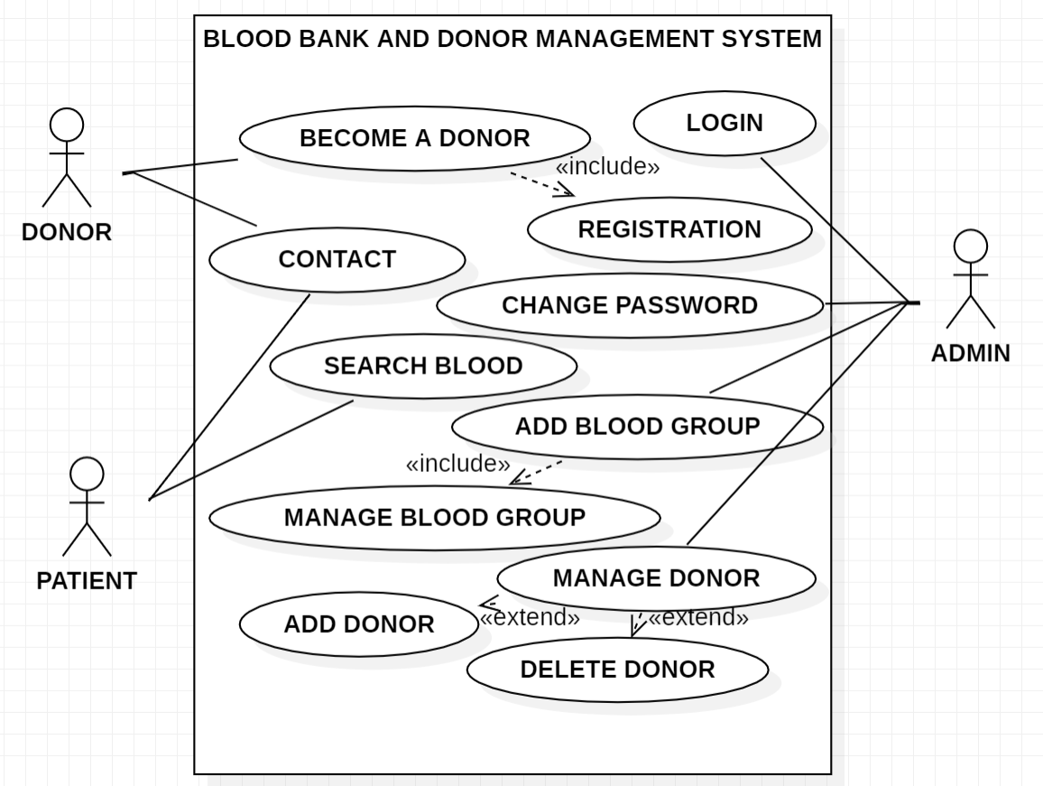 Fig: Usecase Diagram

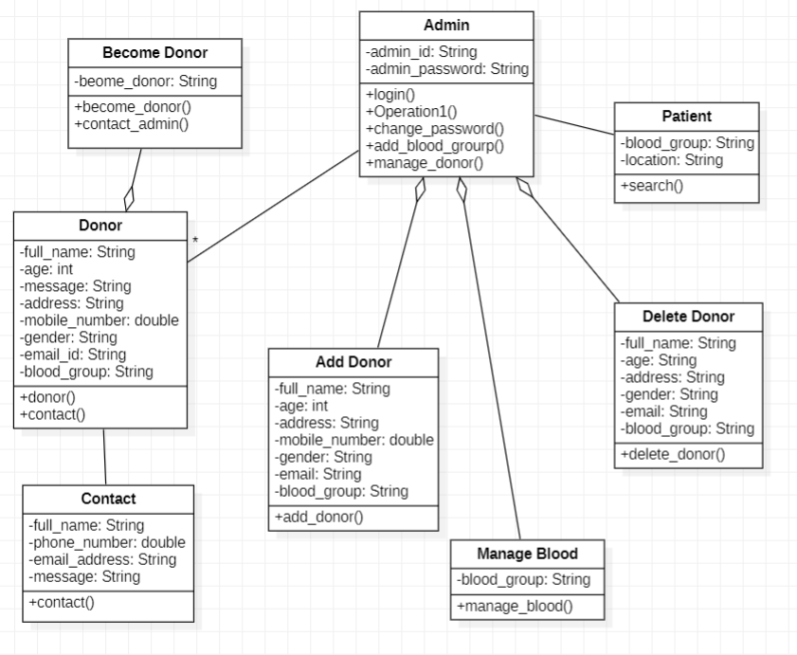

Fig:Class Diagram

## Working principle

Firstly, the main thing which played vital role in the manufacturing of the software is indeed sublime text 3 compiler. Sublime text 3 complier is the software that we used for making our “BLOOD DONAR AND MANAGEMENT SYSTEM” software.

We followed the incremental model for the development of our project. As we only knew about the initial requirements of our project so we followed this method.

Incremental development is done in steps from analysis design, implementation,   
testing/verification, maintenance. Each iteration passes through the requirements,   
design, coding and testing phases. And each subsequent release of the system adds   
function to the previous release until all designed functionality has been   
implemented.

Therefore, we followed incremental model as we didn’t need to know the crystal clear requirements for the development of the project. We could add the extra features if we want during the development .The first increment is often a core product where the basic requirements are addressed, and supplementary features are added in the next increments.

**Algorithm**

Step1: Start.

Step2: Goto Home.

Step3: Search Blood.

Step3.1: If become a donor.

Ste.p3.1.1: Register your details.

Step3.2: If blood not available.

Step3.2.1: Contact us.

Step4: End.

**FLOWCHART**

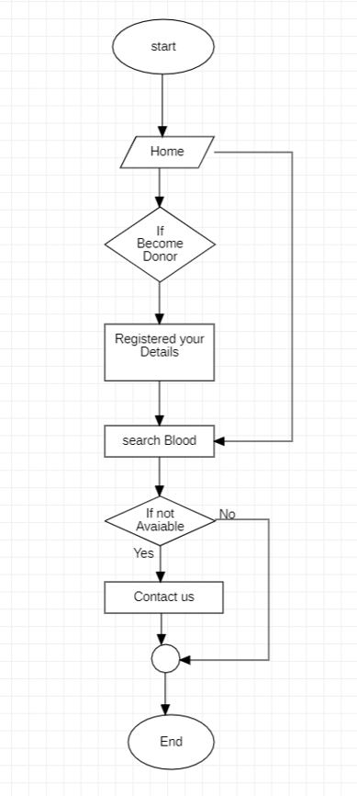

Fig: Flowchart

# RESULT AND ANALYSIS

Fig 4.1 shows the main page of the BBDMS. This interface can be accessed by all of the users of this system. This interface is accessible not only for the registered user of the system but also can be access by the public.

Fig 4.2 is a interface for donor side to become a donor. From this interface user can become donor by fill up the form available there.

Fig 4.3 is a interface for patient side. Patient can search their required blood by entering the blood group name and location.

Fig 4.4 shows the interface of dashboard where listed blood group, registrated blood group and total quries are displayed.

Fig 4.5 is a interface for Admin login from where Admin panel can login with there username and password.

Fig 4.6, Fig4.7 and Fig 4.8 show the interface of add donor ,donor list and manage contact us queries respectively.

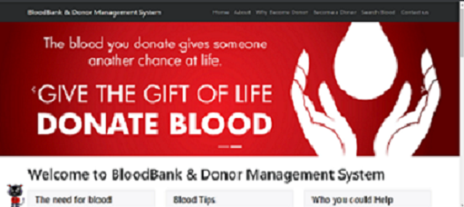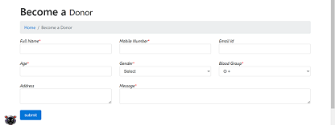

**Fig 4.1 Fig 4.2**

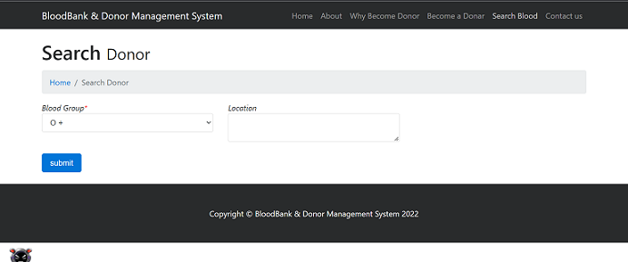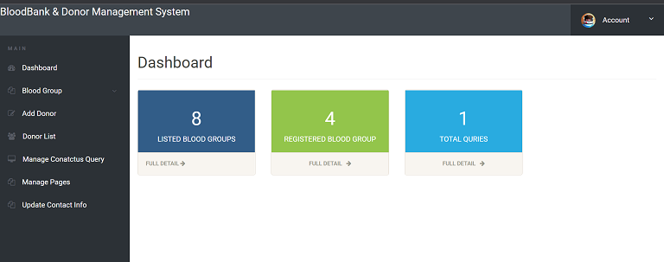

**Fig 4.3 Fig 4.4**

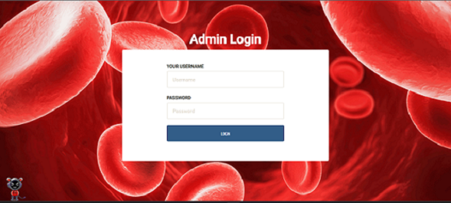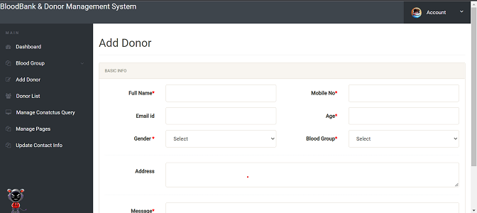

**Fig 4.5 Fig 4.6**

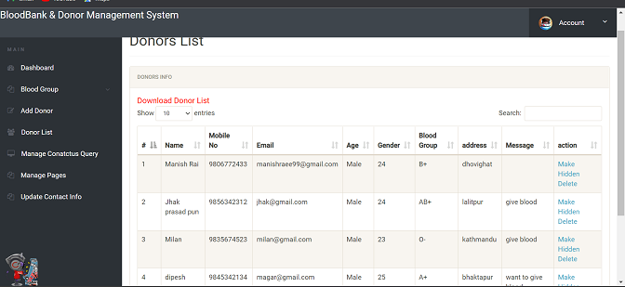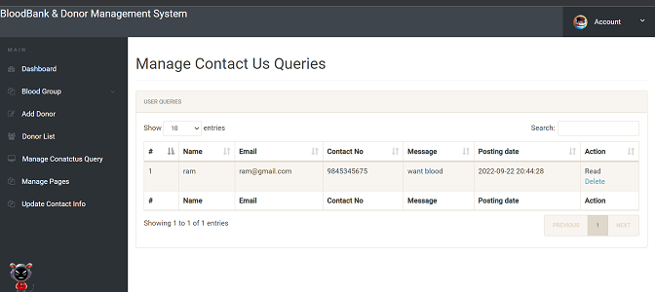

**Fig 4.7 Fig 4.8**

# CONCLUSION

* Simply our project theme is to bring connections between donor and victim (Patients).
* To provide information about the blood group and blood donors information.

# References

[1].*e-RaktaKosh*. (2022, 10 02). Retrieved from e-Raktakosh: https://www.eraktkosh.in/BLDAHIMS/bloodbank/transactions/bbpublicindex.html

*[2].Lions Blood Bank*. (2014, 8 9). Retrieved from Lions Blood Bank: https://www.lionsbloodbank.net/

*[3].Nepal Red Cross Society*. (1963). Retrieved from Nepal Redcross Society: https://nrcs.org/

# APPENDICES

