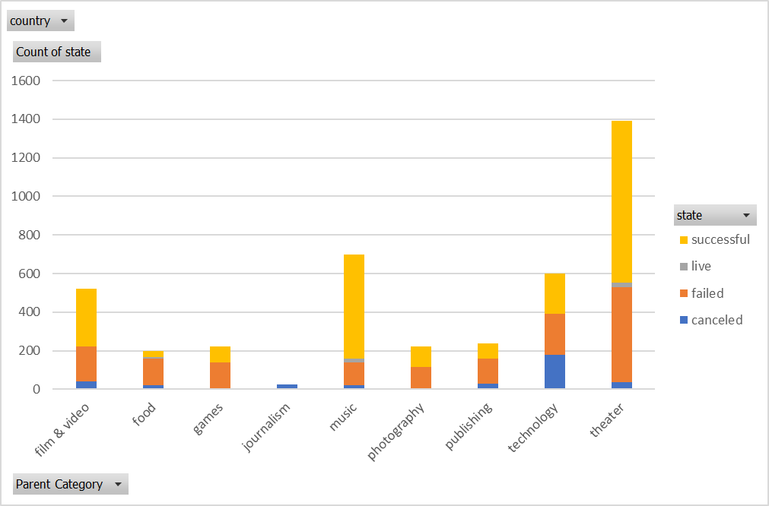

1. What are three conclusions we can make about Kickstarter campaigns given the provided data?

* In all the parent categories, Theatre has the highest successful number.
* In all the sub-categories, Play has the highest successful number.
* May is the peak month for successful campaign while December is the lowest month.

1. What are some of the limitations of this dataset?

* The goals of these campaign are very different (From 1 to 100M) which make it unfair to compare them within one group

1. What are some other possible tables/graphs that we could create?

* We should take the length of the time (from date created to date ended) into account.
* The data of target group
* The methods used in conducting the cross funding campaign