 | Core Java  Practical #2
Name | Milan Gite. | Roll Number | 24302A0003
Subject/Course: | Core Java/ BSc IT
Practical 2 | Conditional Statement
A school wants to build a small student evaluation module in Java to help teachers quickly identify the top score among three subjects and determine student grades. As a junior Java developer, you are asked to implement the following features:
- Find the Biggest Number (if-else)
Teachers want to identify the highest score among three marks entered by the user. You are required to write a Java program using if-else statements to find the biggest number.
- Find the Biggest Number (Ternary Operator)
For a shorter version, create a program that finds the highest score among three numbers using the ternary operator.
- Check Student Grade (Switch Case)
After calculating the average marks, classify the student’s grade as follows:
  - 90–100 → O
  - 80–89 → A
  - 70–79 → B
  - 60–69 → C
  - 59 - 40 → D
  - Below 40 → F

Q B) Find the Biggest Number (Ternary Operator)

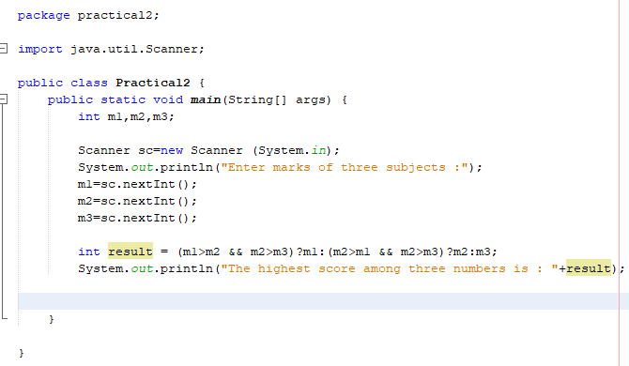

Package practical2;
Import java.util.Scanner;
Public class Practical2 {
Public static void main(String[] args) {
Int ml,m2,m3;
Scanner sc=new Scanner (System.in);
System.out.println(“Enter marks of three subjects:");
Ml=sc.nextInt();
M2=sc.nextInt();
M3=sc.nextInt();
Int result = (ml>m2 && m2>m3)?ml :(m2>ml && m2>m3)?m2:m3;
System.out.println(“The highest score among three numbers is: "+result);
}
}

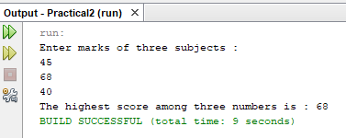

Q A) Find the Biggest Number (if-else)
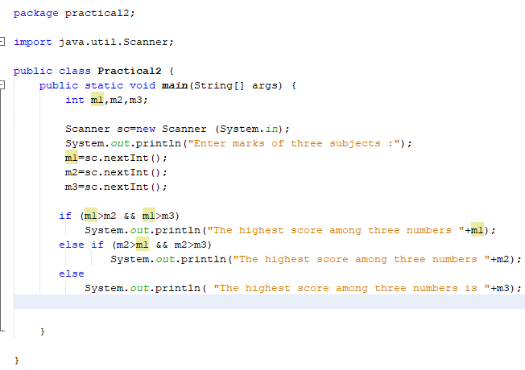

Package practical2;

Import java.util.Scanner;

Public class Practical2 {
Public static void main(String[] args) {
Int m1,m2,m3;
Scanner sc=new Scanner (System.in)”
System.out.println(“Enter marks of three subjects:");
M1=sc.nextInt();
M2=sc.nextInt();
M3=sc.nextInt();

If (m1>m2 && m1>m3)
System.out.println(“The highest score among three numbers "’m1);
Else if (m2>m1 && m2>m3)
System.out.println(“The highest score among three numbers "+m2);
Else
System.out.println(“The highest score among three numbers is "+m3);
}
}

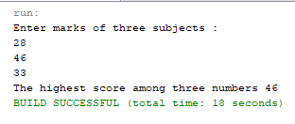

Q 3)

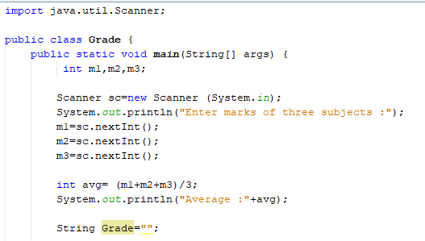

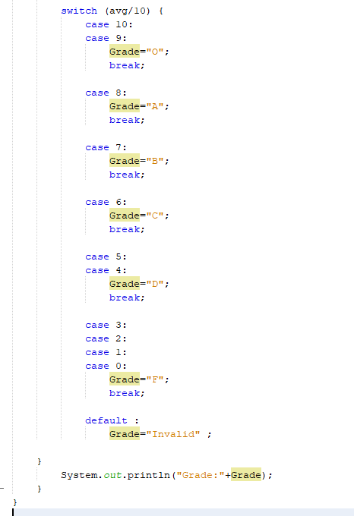

import java.util.Scanner;
public class Grade {
public static void main(String[] args) {
int m1, m2, m3;
Scanner sc = new Scanner(System.in);
System.out.println("Enter marks of three subjects:");
m1 = sc.nextInt();
m2 = sc.nextInt();
m3 = sc.nextInt();
int avg = (m1 + m2 + m3) / 3;
System.out.println("Average: " + avg);
String Grade = "";
switch (avg / 10) {
case 10:
case 9:
Grade = "O";
break;
case 8:
Grade = "A";
break;
case 7:
Grade = "B";
break;
case 6:
Grade = "C";
break;
case 5:
case 4:
Grade = "D";
break;
case 3:
case 2:
case 1:
case 0:
Grade = "F";
break;
default:
Grade = "Invalid";
}
System.out.println("Grade: " + Grade);
}
}

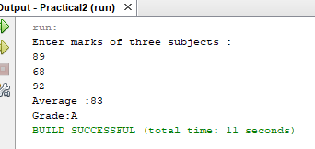

Take Home Task:
A coaching center wants to create a small Java-based progress tracking system to help instructors assess student performance during weekly practice sessions. As the assistant Java programmer, you need to implement the following modules:
a. Determine the Highest Practice Score (Using if-else)
Each student attempts three practice tests every week. Write a Java program that accepts three test scores from the user and identifies the highest score using if-else conditions.
b. Determine the Highest Practice Score (Using Ternary Operator)
Create another version of the program that also finds the highest score among the three practice tests, but this time use a ternary operator to simplify the logic.
c. Assign Performance Level (Using Switch Case)
Based on the student’s average score, classify their performance level using the following rules:
- 90–100 → Level S (Superior)
- 80–89 → Level A
- 70–79 → Level B
- 60–69 → Level C
- 50–59 → Level D
- Below 50 → Level E (Needs Improvement)
Write a Java program using a switch-case structure (using average/10) to display the appropriate performance level.

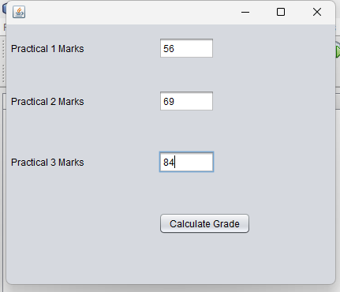

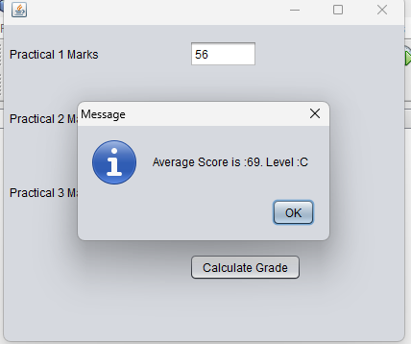

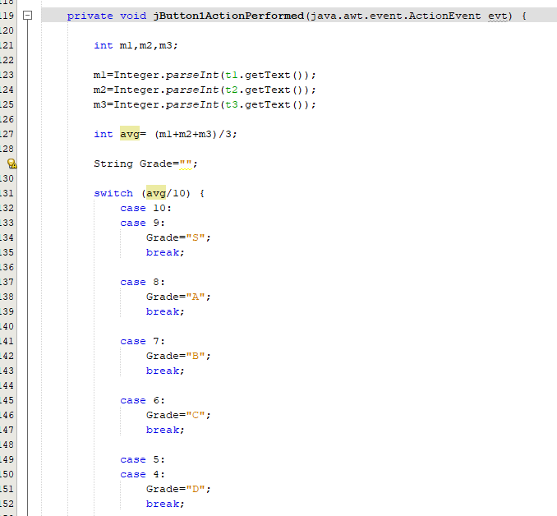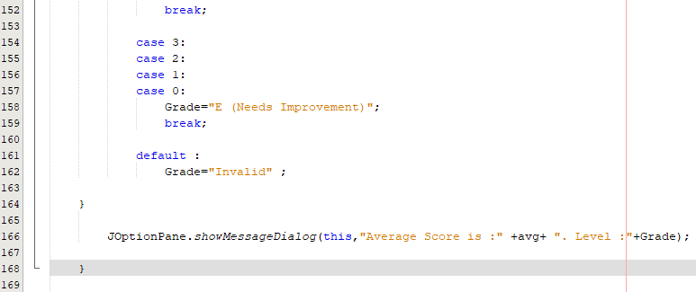

Private void jButton1ActionPerformed (java.awt.event.ActionEvent evt) {
Int m1, m2,m3;
M1=Integer.parseInt(t1.getText());
M2=Integer.parseInt(t2.getText());
M3=Integer.parseInt(t3.getText());
Int avg = (m1+m2+m3)/3;
String Grade=””;
Switch (avg/10) {
Case 10:
Case 9:
Grade =”S”;
Break;
Case 8:
Grade =”A”;
Break;
Case 7:
Grade =”B”;
Break;
Case 6:
Grade =”C”;
Break;
Case 5:
Case 4:
Grade =”D”;
Break;
Case 3:
Case 2:
Case 1:
Case 0:
Grade =”E (Needs Improvement)”;
Break;
Default:
Grade =”Invalid”;
}
JOptionPane.showMessageDialog(this, “Average Score is:” +avg+”. Level: “+Grade);
}

