CJ Lab Worksheet – Session 1
Roll No: 24302A0003.
Division: A
Batch: 1
Topic: Loops, datatypes and operators
Case Study: Classroom Management System (Command-Line Interface)
A software company is developing a small utility module for a classroom management system. The module needs to perform simple logical checks, repeated notifications, and arithmetic calculations based on teacher inputs.
As a junior Java developer, you are asked to implement the following features:

Task 1 – Boolean Check
The system must verify whether a student has completed the assignment. You are required to create a Java program that demonstrates the use of a Boolean variable and prints its value.

CODE:
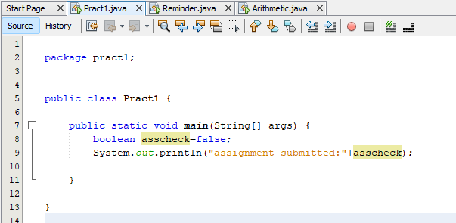

Package pract1;

Public class Pract1 {
Public static void main(String[] args) {
Boolean asscheck=false;
System.out.println(“assignment submitted: “+asscheck);
}
}

OUTPUT:
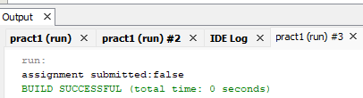

Task 2 – Repeated Notification
The system must display a reminder message 10 times using a for loop so that students do not forget to submit their work.

CODE:
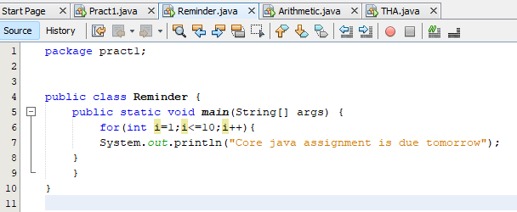

Package pract1;

Public class Reminder {
Public static void main(String[] args) {
For(int i=1;i<=10;i++){
System.out.println(“Core java assignment is due tomorrow”);
}
}
}

OUTPUT:
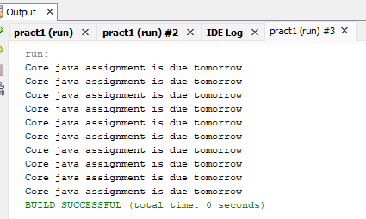

Task 3 – Arithmetic Expression Evaluation
Teachers will input three integers a, b, and c, and the system must evaluate the arithmetic expression:
a + b * c % d
and display the result.

CODE:
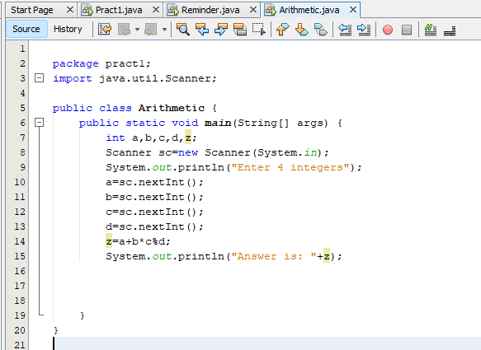

Package pract1;
Import java.util.Scanner;

Public class Arithmetic {

Public static void main(String[] args) {
Int a,b,c,d, z;
Scanner sc=new Scanner(System.in);
System.out.println(“Enter 4 integers”);
A=sc.nextInt();
B=sc.nextInt();
C=sc.nextInt();
D=sc.nextInt();
Z=a+b*c%d;
System.out.println(“Answer is: “+z);
}
}

OUTPUT:
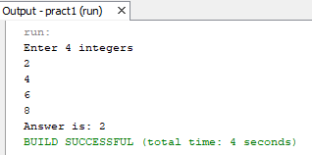

Take Home Task:
- A school wants to build a tiny calculator that helps students check their marks. The system should take the student’s name, two subject marks, and then calculate the total and average.
- As a Java developer, create a program that:
- Uses different data types (String, int, double)
- Takes input from the user
- Performs evaluation (total + average)
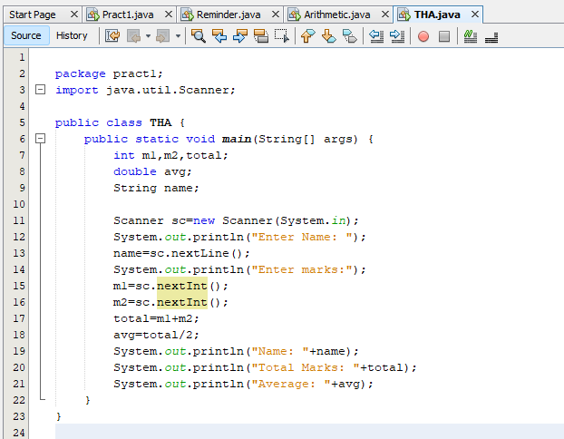

Package practl;

Import java.util.Scanner;

Public class THA {

Public static void main(String[] args) {

Int m1,m2, total;
Double avg;
String name;
Scanner sc=new Scanner(System.in);
System.out.println(“Enter Name: “);
Name=sc.nextLine();
System.out.println(“Enter marks:”);
M1=sc.nextInt();
M2=sc.nextInt();
Total=m1+m2;
Avg=total/2;
System.out.println(“Name: “+name);
System.out.println(“Total Marks: “+total);
System.out.println(“Average: “+avg);
}
}

