Milan Patel

Volatility Analysis of the S&P 500 and Financial Sectors

**Background/Theory:**

Introduction:

It is no secret that macroeconomic events have a large impact on overall market performance of financial investments. Specifically, unprecedented and unpredictable macroeconomic events can “shock” the market at the time periods Xt at which they are introduced. Indexes such as the S&P 500 and the Dow Jones can be used to obtain an idea of overall market performance at specific points in time. By analyzing the volatility of the S&P 500 index over the past sixteen years, we were able to notice the highest volatility dates, and researched the events that took place on those dates and as a result saw how much of an impact they had on the market. We were able to discover that major terrorist events that took place in America such as the Boston Bombings and the Attack on The World Trade Center shocked the market. Events such as instability in foreign politics, and instability in foreign economics, heavily impacted the indexes as well. Finally, heavy economic downturns, and oil price changes increased the volatility in the indexes.

Many analysts believe that the market is driven by fear. Historically over the last twenty years, investors have consistently proven to react fearfully when impactful and dramatic changes to macroeconomic events occur.

During these events, many investors get extremely worried about their current positions because of the bleak global market outlook at the given time. More times than not, the market rebounds and evens off eventually. But how will an investor be able to accurately predict that the markets will go back up? How will they know if they should sell their respective securities versus holding their portfolios?

The purpose of this analysis is to provide investors a tool to accurately predict the level of impact an unexpected or major market altering event occurs. This model should give more insight and answer any fears or doubts investors might have during such times. Specifically, if they should stay hold or sell their securities and assets. Although this model will not tell investors when global market altering events will occur (acts of nature, various types of political instability, and war), it should give them confidence with decision making. The goal of this model is for investors to react to drastic market changes with informed and fact based decisions, not out of fear.

ARIMA/GARCH Foundations:

Any serially correlated time series can be broken down into two additive components as such:

$y_{t}=g(y_{t-1,}y_{t-2},y_{t-3},…,e_{t-1},e_{t-2},e_{t-3},…$)+ $e_{t}$

Basically, the time series is a combination of a function g that can be predicted based on the past and et which is assumed to be white noise. The white noise is the innovation or shock that cannot be predicted on past history. Despite most economic time series not being white noise, any series is capable of being broken down into predictable and unpredictable components as shown in the above equation. The function g is considered the predictable component while et is considered the unpredictable white noise process of the series.

$g(y_{t-1,}y_{t-2},y_{t-3},…,e_{t-1},e_{t-2},e_{t-3},…$) can be written as a linear stochastic model as such:

$g(y_{t-1,}y_{t-2},y_{t-3},…,e_{t-1},e_{t-2},e_{t-3},…$)= $φ_{0}+φ_{1}y_{t-1}+…+φ_{p}y_{t-p}+e_{t}+θ_{1}e_{t-1}+…+θ_{q}e_{t-q}$

Here we see the addition of p lagged autoregressive terms, q lagged moving-average terms, and a constant. We refer to this model as an Autoregressive Moving-Average Model. If there were differencing, the model would be an ARIMA Model (“I” standing for Integrated). These types of models work ideally on stationary data. Stationarity consists of having no trend, seasonality, stable variance, and constant mean. White noise has mean=0 and variance=1, with every subsequent value in the time series having no relation with the previous. Essentially, autocorrelation must be insignificant in order to obtain adequate ARIMA models. Residual testing can be done via specific tests, one being the Box-Ljung Test. The test has the following hypothesis testing:

$$H_{0}: There is no significant autocorrelation between the residuals$$

$$H_{a}:There is significant autocorrelation between the residuals$$

The test can be used to assess the stationarity of time series data as well as determine the goodness of fit of an applied ARIMA model (For both, the null hypothesis must be failed to be rejected).

The original equation discussed considered a serially correlated time series being broken into a predictable function g and an unpredictable component $e_{t}$. While ARIMA models work well for modeling function g, it does not account for unpredictable volatility clustering. Volatility clustering refers to the phenomenon of having “clusters” of variance of different magnitudes (small, large, small, large….) at certain periods in a time series. Hence this variance is considered “volatile”, or unpredictable in a certain sense. Volatility clustering in a time series is referred to as an “ARCH effect” and can be tested for by performing a Box-Ljung Test on the squared residuals of a fitted ARIMA model. If there is significant autocorrelation between the squared residuals, there exists and ARCH effect and the next step is to model this volatility.

ARCH stands for Autoregressive conditional heteroskedasticity, which basically means that the variance of a currently observed period of time is a function of the actual sizes of the previous time periods variance. An ARCH(m) process has variance, at time t, that is conditional upon observations at previous m times such that the following is true:

$$y_{t}=r_{t}=φ_{0}+φ_{1}r_{t-1}+…+φ_{p}r_{t-p}+a_{t}+θ_{1}a_{t-1}+…+θ_{q}a_{t-q}$$

$$a_{t}=σ_{t}e_{t}$$

$$Var\left(r_{t} | r_{t-1},…,r_{t-m}\right)=σ_{t}^{2}=α_{0}+α_{1}a_{t-1}^{2}…+α_{m}a_{t-m}^{2}$$

GARCH Models are Generalized ARCH models, where a GARCH(m, n) process has variance, at time t, that is conditional upon observations at previous m times plus past variances at previous n times such that:

$$Var\left(r_{t} | r_{t-1},…,r_{t-m}\right)=σ_{t}^{2}=α_{0}+α_{1}a_{t-1}^{2}…+α_{m}a_{t-m }^{2}+β_{1}σ_{t-1}^{2}+…+β_{n}σ_{t-n}^{2}$$

The overall goal of the following analysis is to see how the overall financial market, and individual sectors within the market, respond to significant macroeconomic events. To do so, volatility will be the main quantity of interest and the GARCH models provide excellent versatility in modeling the amount of response that cannot be directly observed in time series data.

**Data Analysis:**

Step 1: Data Selection

The data used in this analysis consists of S&P 500 closing values (adjusted) from January 1st, 2000 to November 27th, 2016. There are various financial sectors that make up the S&P 500, which include Consumer Discretionary, Consumer Staples, Energy, Financials, Health Care, Industrials, Materials, Real Estate, Technology, and Utilities. For this analysis, the selected sectors are Energy, Health Care, Financials, and Technology. Extracting data for the S&P 500 adjusted data is simple enough, however extracting individual sector adjusted data is a bit more complex. To accomplish the task, the use of the Exchange traded funds (ETFs) called Standard & Poor’s Depository Receipts (SPDRs) were employed. SPDRs, informally known as “spiders”, are basically baskets of securities made up of stocks from the S&P 500 index. Each SPDR contains 1/10 of the S&P 500 index portfolio, explaining why the cost to buy one unit of the asset is nearly 1/10 of the S&P 500 index level. SPDRs provide significant insight into individual sector performance, albeit scaled by 1/10, and this is precisely the reason they were chosen as a data source for the analysis.

Step 2: Data Plotting

Financial data such as this must immediately be inspected for stationarity conditions. It is unlikely that data, especially financial data such as the type used in this analysis, will be stationary without any manipulation. Significant warnings to look for include trend and seasonality. The following plots were obtained for the S&P 500, Energy Sector, Technology Sector, Health Care Sector, and Financials Sector:

1)S&P 500

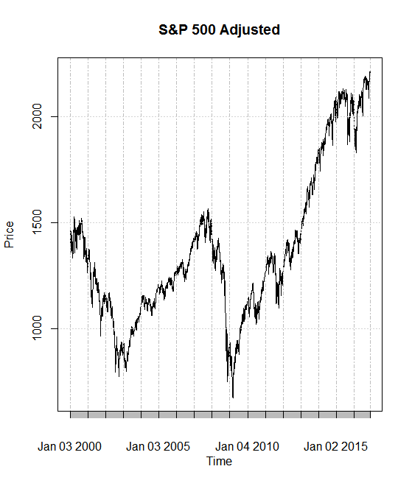

2)Energy Sector

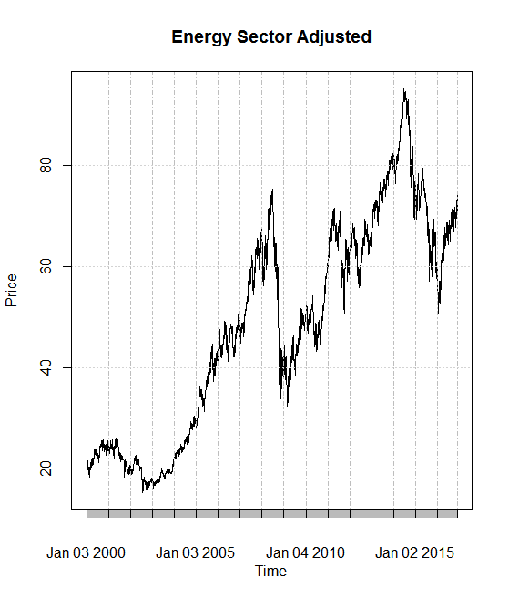

3)Technology Sector

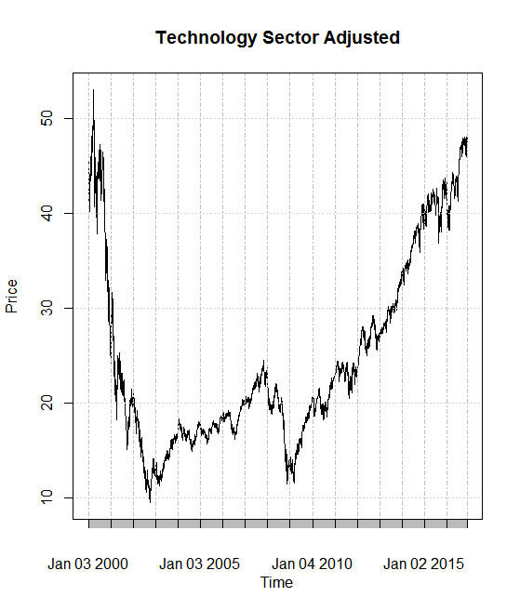

4)Health Care Sector

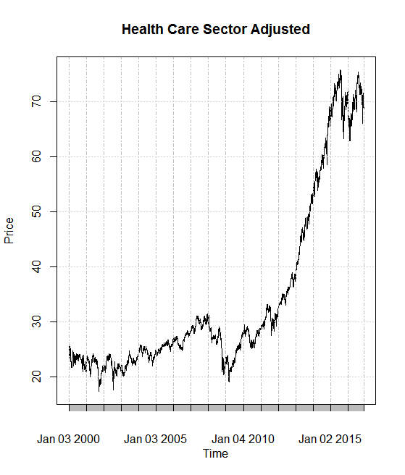

5)Financials Sector

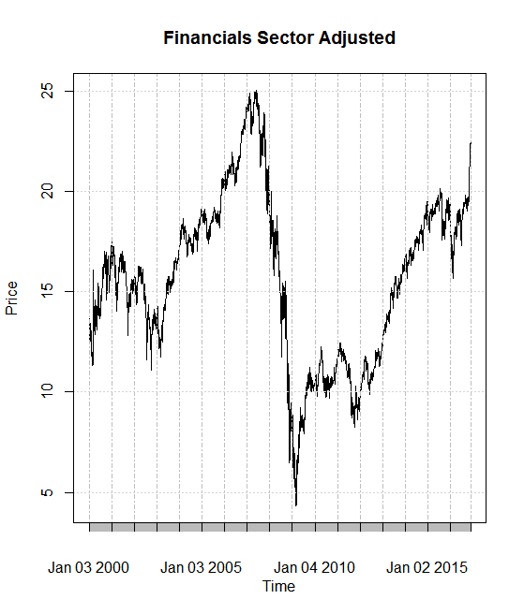

Clearly, each plot above violates stationarity conditions as they contain some kind of trend/seasonality.

Step 3: Data Transformation/Replot

The data above is plotted yearly, which explains the lack of stationarity. One step to make sure the data is stationary is transforming the data to daily return. This introduces a notion of informal “differencing” as the data will now show day to day changes that are extremely less likely to have trend/seasonality. One way to counteract the non-variance is taking the log of the daily returns. After taking the daily log returns of each data set, the new plots become:

1)S&P 500

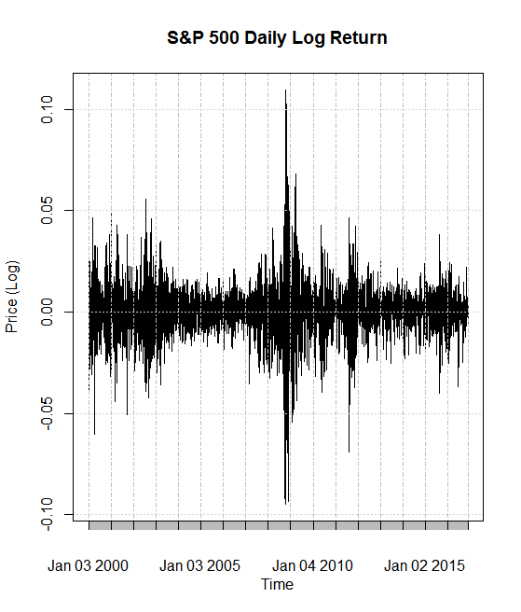

2)Energy Sector

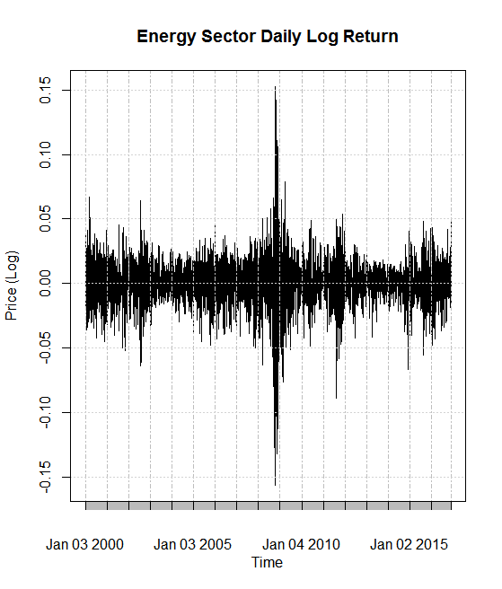

3)Technology Sector

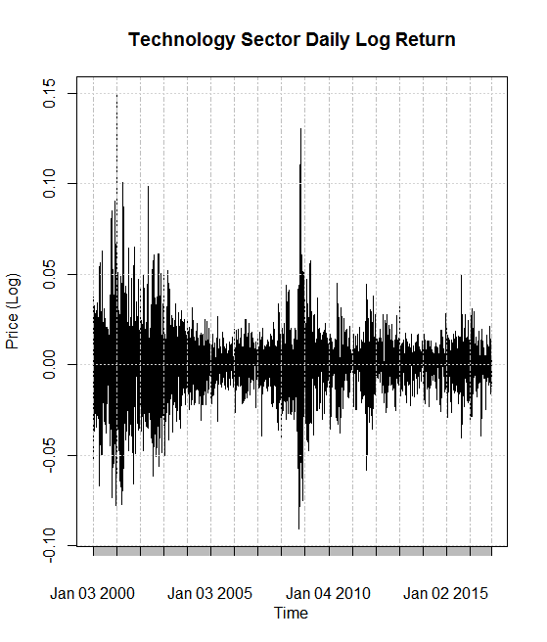

4)Health Care Sector

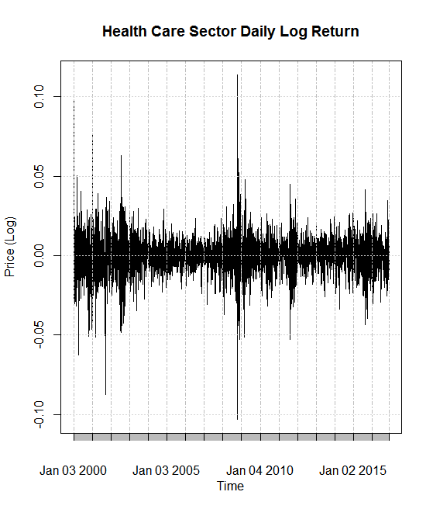

5)Financials Sector

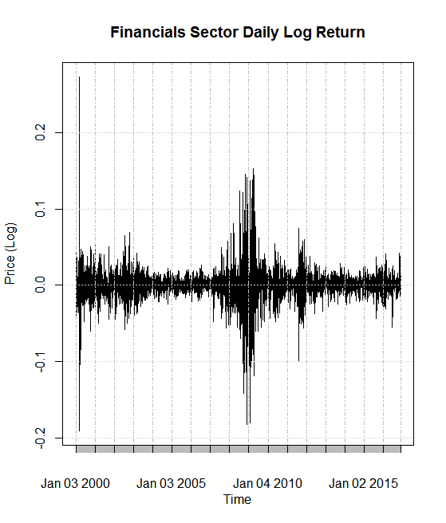

Step 4: Residual Analysis

The new plots show an indication of stationarity, but the condition still has to be confirmed with residual analysis. Performing Box-Tests on each daily log return yields the following outputs:

1)S&P 500

**Box-Ljung test**

**data: sp500.Daily**

**X-squared = 54.942, df = 10, p-value = 3.238e-08**

2)Energy Sector

**Box-Ljung test**

**data: Energy.500.Daily**

**X-squared = 53.818, df = 10, p-value = 5.247e-08**

3)Technology Sector

**Box-Ljung test**

**data: IT.500.Daily**

**X-squared = 25.37, df = 10, p-value = 0.004686**

4)Health Care Sector

**Box-Ljung test**

**data: HealthCare.500.Daily**

**X-squared = 41.236, df = 10, p-value = 1.025e-05**

5)Financials Sector

**Box-Ljung test**

**data: Financials.500.Daily**

**X-squared = 86.199, df = 10, p-value = 3.031e-14**

All hypothesis testing in this analysis will be carried out at the 95% significance level. Clearly each residual analysis above shows a p-value that is less than .05. This allows for a rejection of the Box-test null hypothesis which indicates there may exist significant autocorrelation in each time series.

**ARIMA/GARCH Modeling:**

Given there exists significant autocorrelation in each time series, the next steps for each data set are as follows:

1)Create linear stochastic model

2)Repeat residual analysis, this time using the residuals of the fitted ARIMA model

3)Perform residual analysis of the squared residuals of the fitted ARIMA model to test for ARCH effect

4)Fit appropriate GARCH model

*Note that values of p, d, q for ARIMA(p, d, q) and m, n for GARCH(m,n) were chosen by comparing AIC values (models with lowest AICs were chosen). Coefficients were also dropped if they were found to be insignificant. Every combination of p,d,q,m, n are not shown in the analysis as the process was mainly trial and error until adequate models were selected.

The four model creation steps are now carried out for each data set:

1)S&P 500

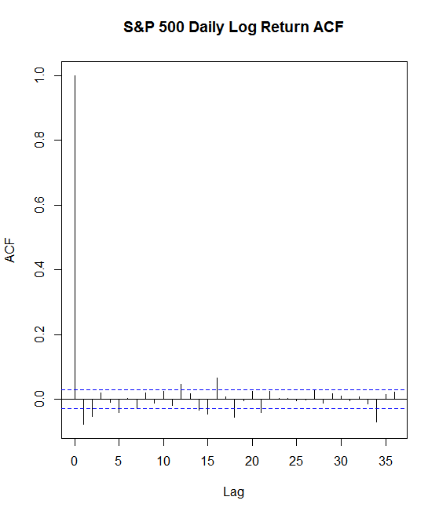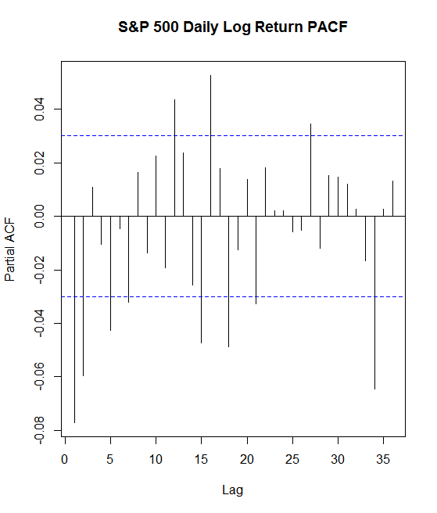

The PACF shows a lag cut off at 2 so an ARMA (2,0,0) is fitted to the S&P 500 data. The corresponding model is:

$$y_{t}=.0001-.0817y_{t-1}-.0597y_{t-2}+e_{t}$$

Box-Test for Residuals:

**Box-Ljung test**

**data: sp500.fit$residuals**

**X-squared = 17.74, df = 10, p-value = 0.05952**

P-Value>.05, the null hypothesis is not rejected.

Box-Test is performed on squared residuals in order to test for ARCH effect:

**Box-Ljung test**

**data: sp500.fit$residuals^2**

**X-squared = 3617.3, df = 10, p-value < 2.2e-16**

P-Value<.05 therefore the null hypothesis is rejected and there is still an ARCH effect.

An ARIMA (1,0,0) + GARCH (1,1) is fitted because the second AR term is found insignificant in the combined model. The corresponding model is:

$r_{t}=-.058r_{t-1}+.00049+a_{t}$**, $a_{t}=σ_{t}e_{t}$, $σ_{t}^{2}=.000002+.1α_{t-1}^{2}+.88β_{t-1}^{2}$**

2)Energy Sector

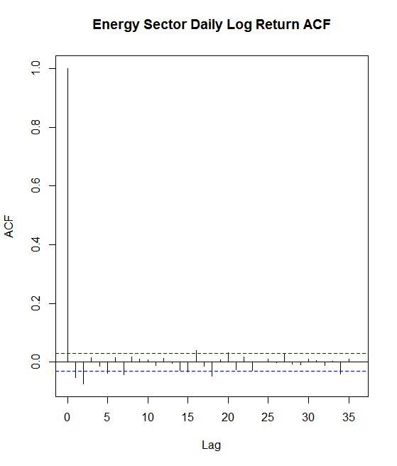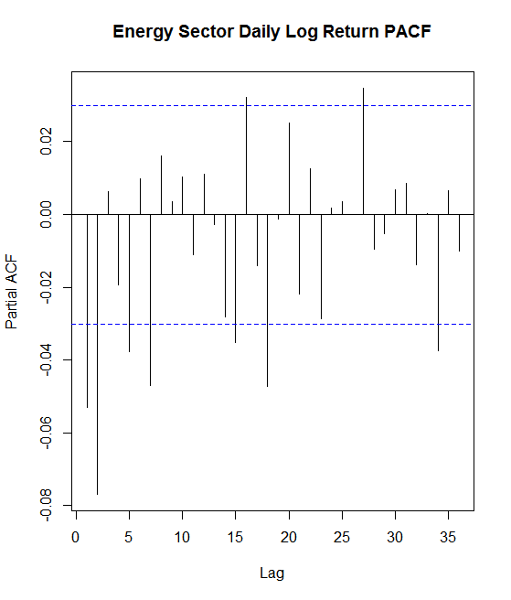

The ACF/PACF do not give a clear indication of what model to fit, so trial and error led to an ARIMA (4,0,1) fit for this data:

$$y_{t}=.0003+.66y_{t-1}-.0378y_{t-2}+.06y_{t-3}-.031y_{t-4}+e_{t}-.72e_{t-1}$$

Box-Test for Residuals:

**Box-Ljung test**

**data: Energy.fit$residuals**

**X-squared = 13.248, df = 10, p-value = 0.2101**

P-Value>.05, the null hypothesis is not rejected

Box-Test for Squared Residuals:

**Box-Ljung test**

**data: Energy.fit$residuals^2**

**X-squared = 3473.9, df = 10, p-value < 2.2e-16**

P-value<.05, there is an ARCH effect

An ARIMA (1,0,1) + GARCH (1,1) model is fitted after all insignificant AR terms are dropped.

The corresponding model is:

$r_{t}=.78r_{t-1}+.00015+a_{t}-.81a_{t-1}$**, $a_{t}=σ_{t}e_{t}$, $σ_{t}^{2}=.0000023+.072α_{t-1}^{2}+.92β_{t-1}^{2}$**

3)Technology Sector

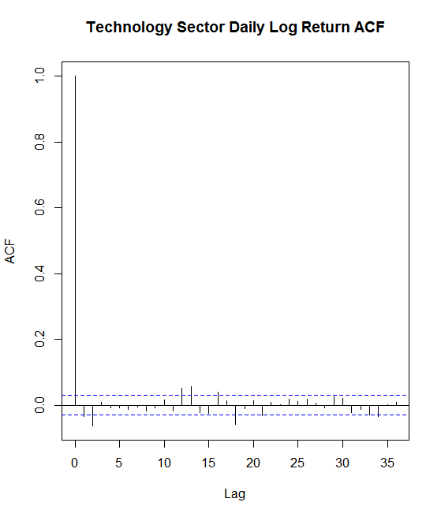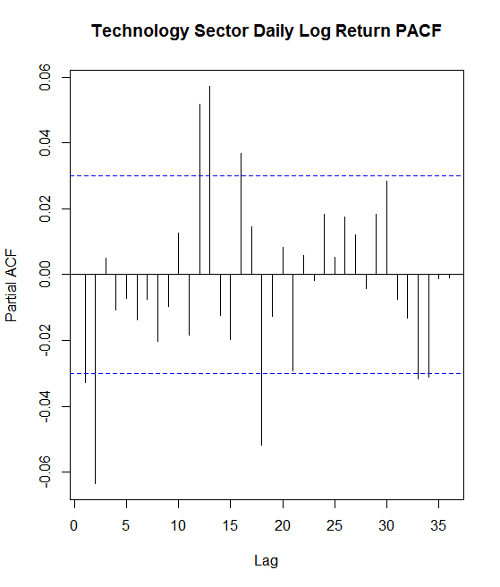

There is cutoff at lag 2 of the PACF so an ARIMA (2,0,0) is fitted for this data:

$$y_{t}=-.0350y_{t-1}-.0636y_{t-2}+e_{t}$$

Box-Test for Residuals:

**Box-Ljung test**

**data: IT.fit$residuals**

**X-squared = 5.1483, df = 10, p-value = 0.8811**

P-value>.05, the null hypothesis is not rejected

Box-Test for Squared Residuals:

**Box-Ljung test**

**data: IT.fit$residuals^2**

**X-squared = 2181.1, df = 10, p-value < 2.2e-16**

P-value<.05, there is an ARCH effect

A GARCH(1,1) model is fitted for this data after both AR terms are found to be insignificant.

$r_{t}=.000097+a_{t}$**, $a_{t}=σ_{t}e_{t}$, $σ_{t}^{2}=.0000017+.083α_{t-1}^{2}+.91β_{t-1}^{2}$**

4)Health Care Sector

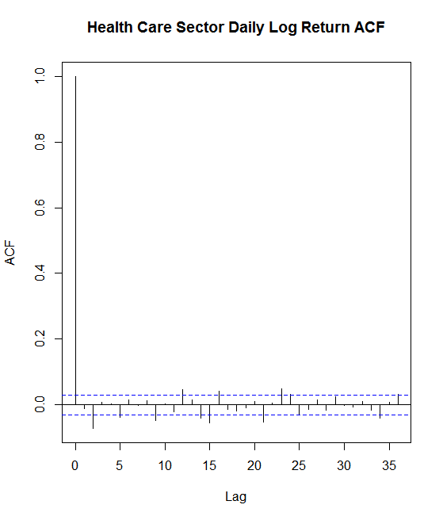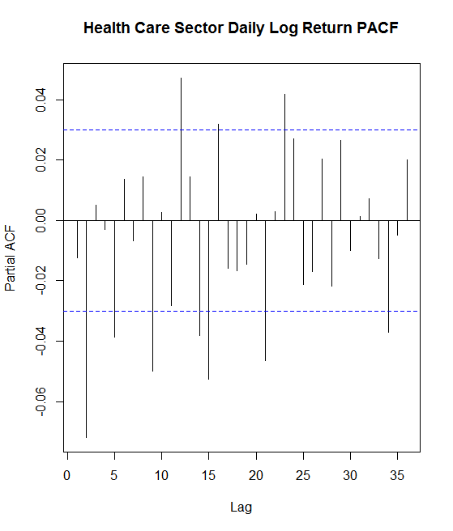

There is an ACF cutoff at lag 5, so an ARIMA(0,0,5) model is fitted to the data. The corresponding model is:

$$y_{t}=e_{t}-.012e_{t-1}-.072e_{t-2}+.005e_{t-3}-.005e_{t-4}-.04e_{5}+.002$$

Box-test for Residuals:

**Box-Ljung test**

**data: HealthCare.fit$residuals**

**X-squared = 13.773, df = 10, p-value = 0.1836**

P-value>.05, the null hypothesis is not rejected

Box-test for Squared Residuals:

**Box-Ljung test**

**data: HealthCare.fit$residuals^2**

**X-squared = 1507.2, df = 10, p-value < 2.2e-16**

P-value<.05, there is an ARCH effect

An ARIMA (0,0,4) + GARCH (1,1) if fitted after the fifth MA term is found insignificant and the corresponding model is:

$r_{t}=.0005+a_{t}-.03a_{t-1}-.05a_{t-2}-.0010a_{t-3}-.006a_{t-4}$**, $a_{t}=σ_{t}e_{t}$,**

$σ_{t}^{2}=.0000022+.088α_{t-1}^{2}+.89β_{t-1}^{2}$

5)Financials Sector

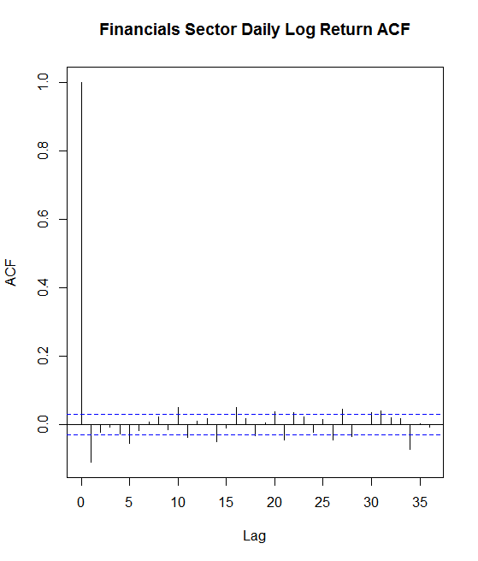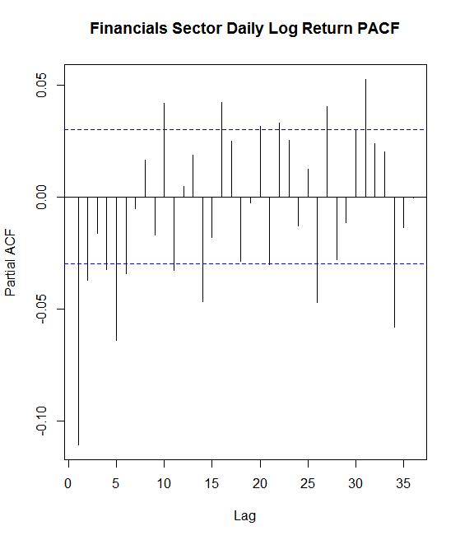

Again it is not easy to determine order from the ACF/PACF, by trial and error an ARIMA(2,0,4) model was fitted for this data:

$$y_{t}={1.12y}_{t-1}-.63y_{t-2}+e_{t}-.012e_{t-1}-.072e_{t-2}+.005e_{t-3}-.005e_{t-4}+.0001$$

Box-test for Residuals:

**Box-Ljung test**

**data: Financials.fit$residuals**

**X-squared = 9.8779, df = 10, p-value = 0.4513**

P-Value>.05, the null hypothesis is not rejected

Box-test for Squared Residuals:

**Box-Ljung test**

**data: Financials.fit$residuals^2**

**X-squared = 1449.6, df = 10, p-value < 2.2e-16**

P-Value<.05, there is an ARCH effect

An ARIMA (2,0,2) + GARCH (1,1) is fitted after insignificant AR and MA terms are dropped and the corresponding model is:

$r_{t}=.0009+.21r_{t-1}-.75r_{t-2}+a_{t}-.26a_{t-1}+.77a_{t-2}$**, $a_{t}=σ_{t}e_{t}$,**

$σ_{t}^{2}=.0000028+.14α_{t-1}^{2}+.86β_{t-1}^{2}$

**Model Adequacy**

The next step is checking if the GARCH models created are adequate. This involves plotting the residuals and the ACF/PACF of both the residuals and squared residuals for each model. It will be assumed that one or two large lags, besides the first, can be considered insignificant.

1)S&P 500

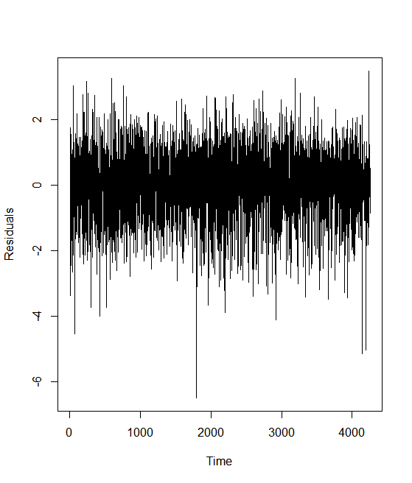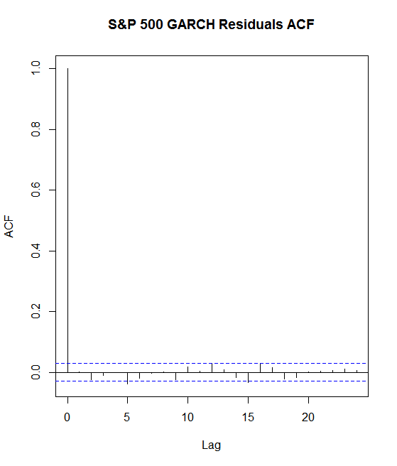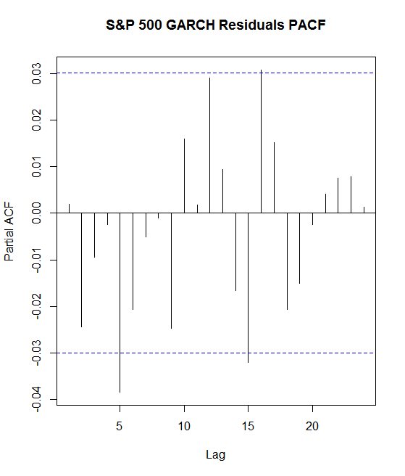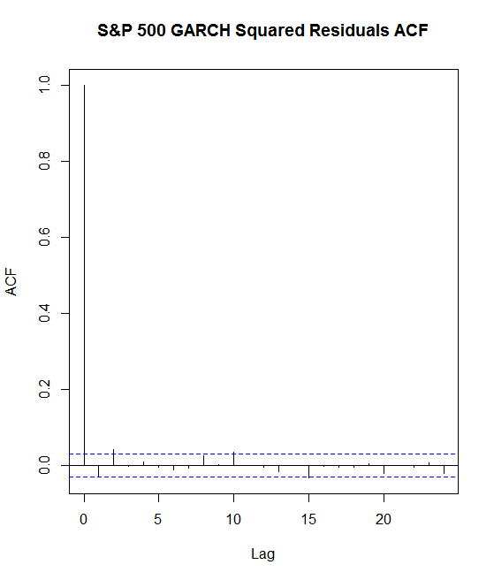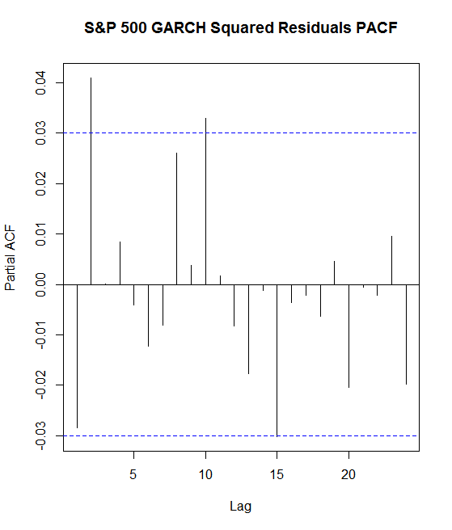

Clearly, all significant autocorrelation has been dealt with and the model is adequate.

2)Energy Sector

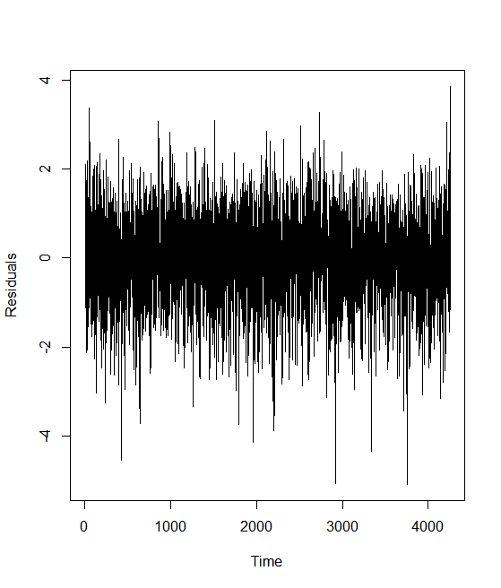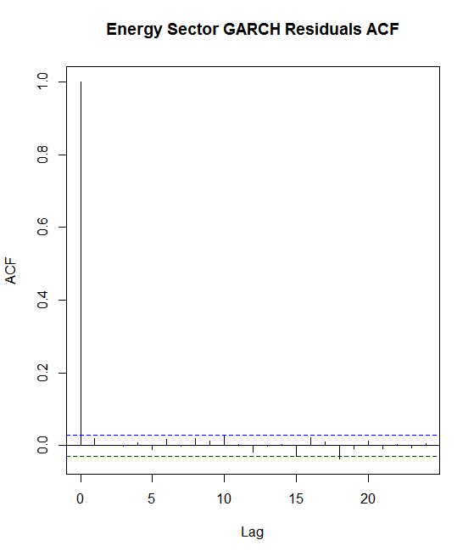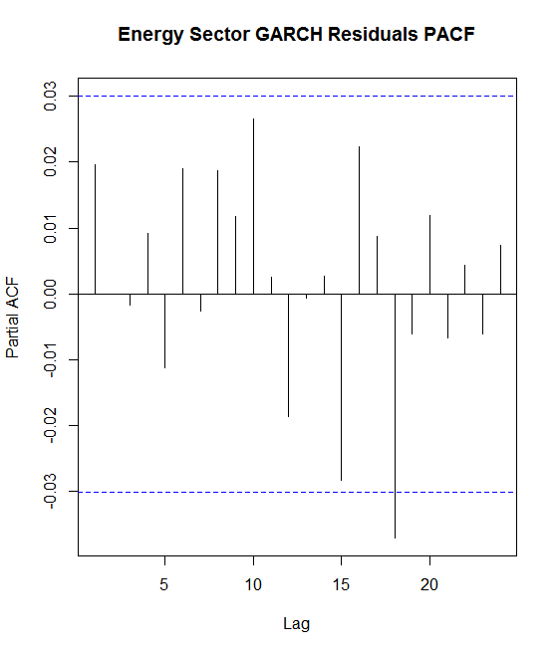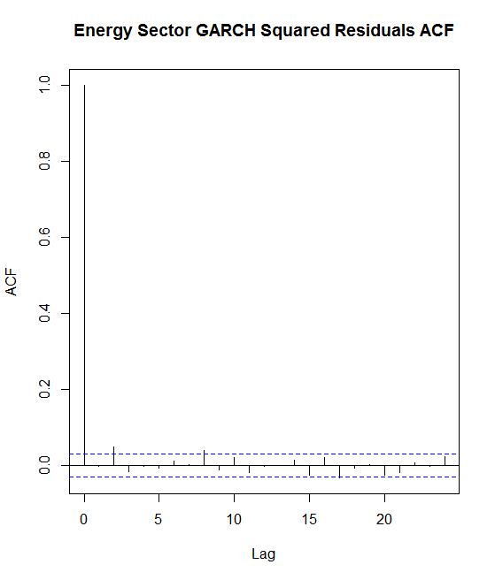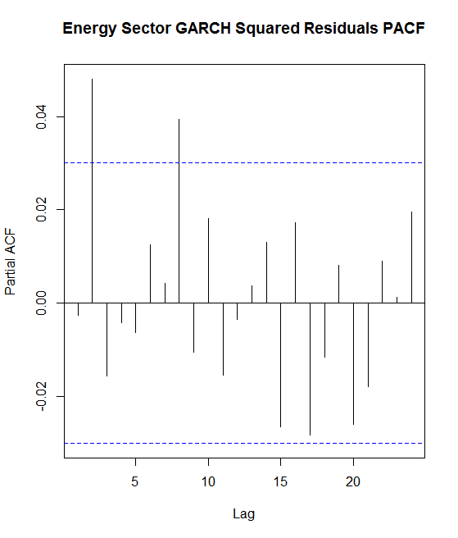

Clearly, all significant autocorrelation has been dealt with and the model is adequate.

3) Technology Sector

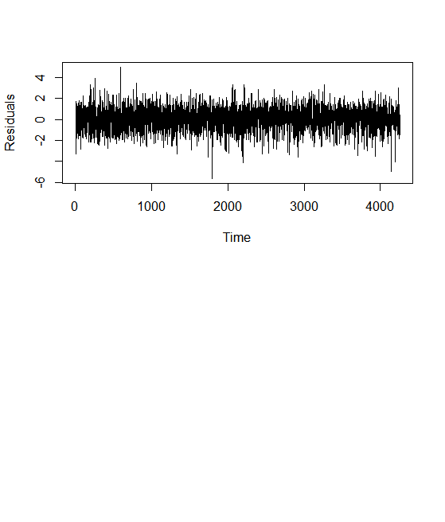

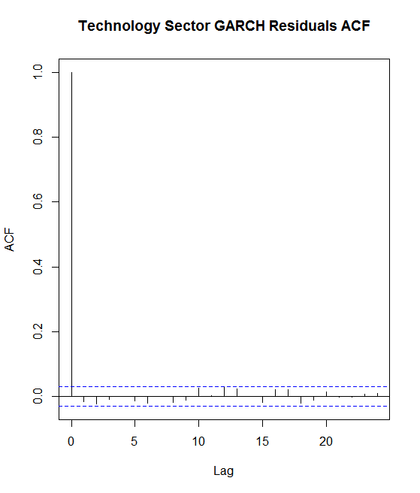

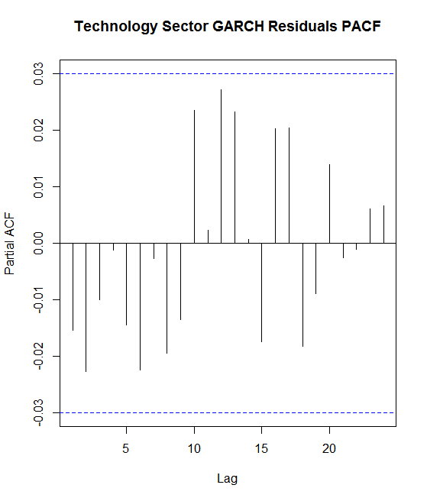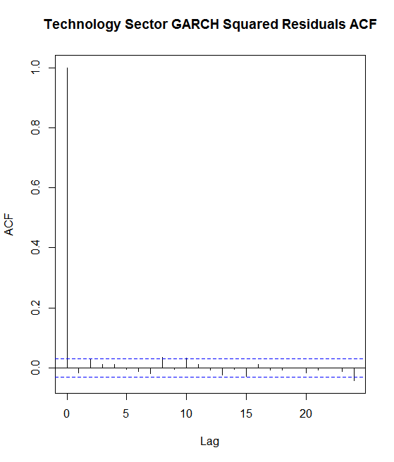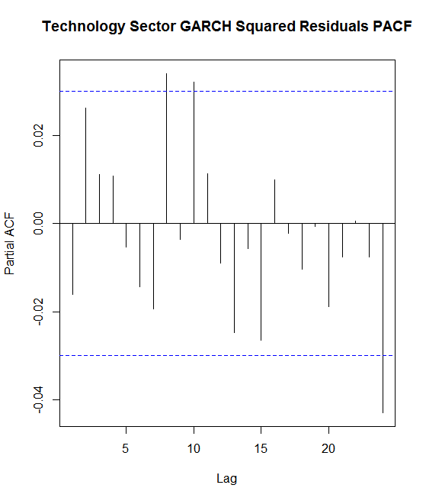

Clearly, all significant autocorrelation has been dealt with and the model is adequate.

4)Health Care Sector

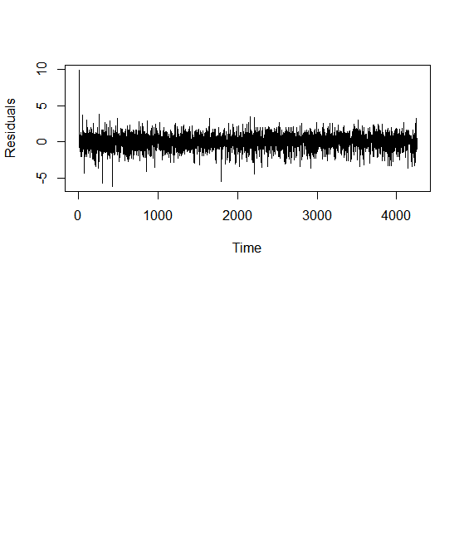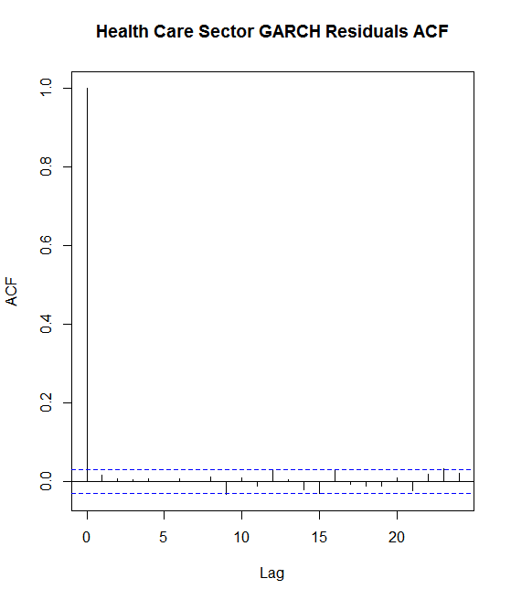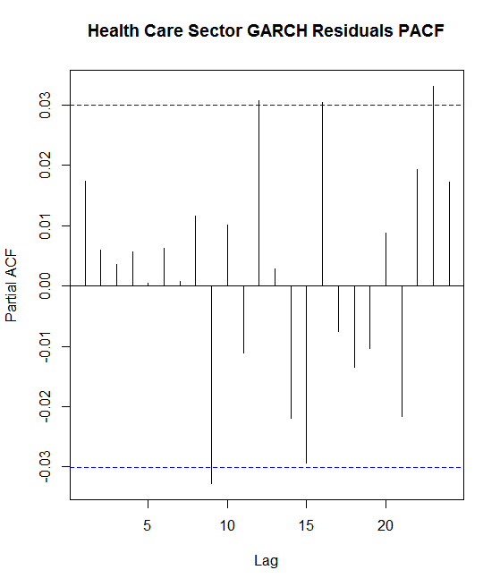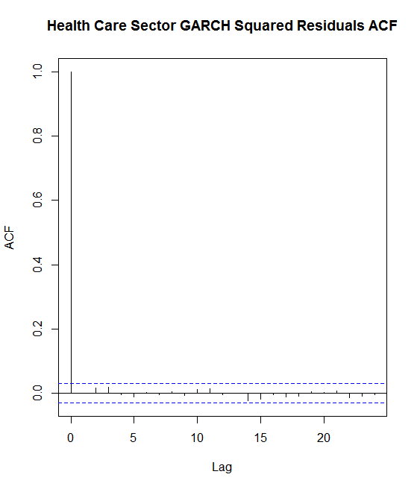

Clearly, almost all significant autocorrelation has been dealt with and the model is adequate.

5)Financial Sector

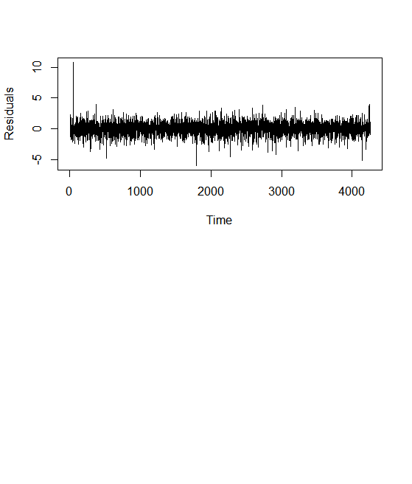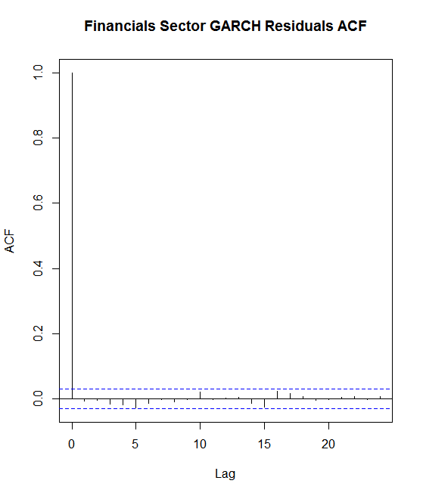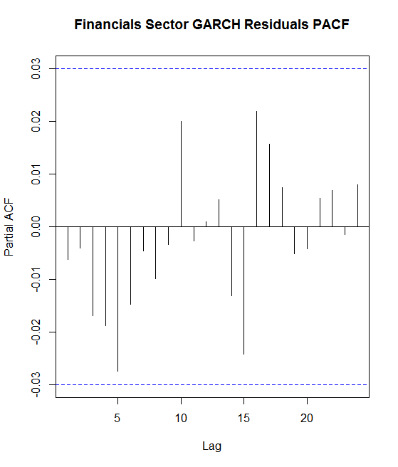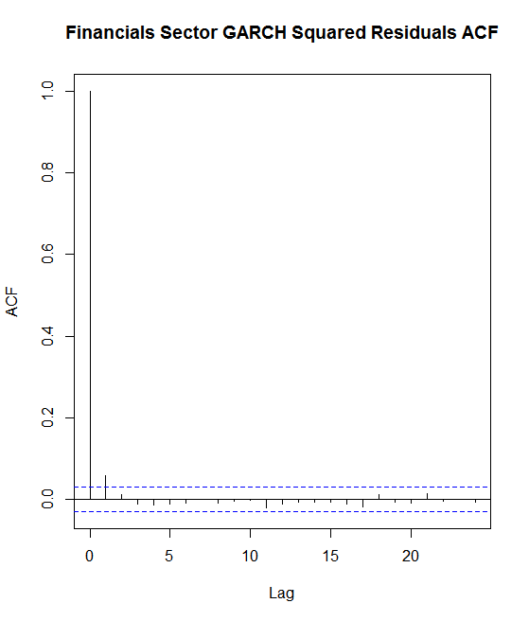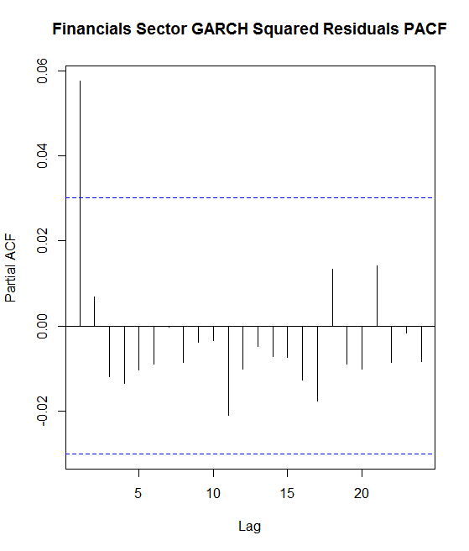

Clearly, almost all significant autocorrelation has been dealt with and the model is adequate.

**Volatility Analysis**

With fitted GARCH models for each data set, volatility analysis can be performed. Each volatility analysis follows essentially the same steps. First a plot of the volatility for the model is produced. By inspection, areas of the plot with large amounts of volatility are analyzed further. Ranges are taken at these highly volatile regions that can span from a couple of days to a couple of months around the peak volatility points. The last step is analyzing the dates these points range from and finding an explanation for the high volatility from significant macroeconomic events around the same time.

1)S&P 500

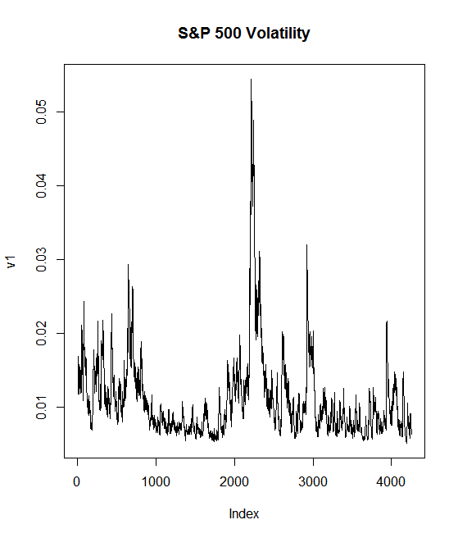

Spike 1: 424-480, Corresponding Dates: September 17, 2001-November 2, 2001

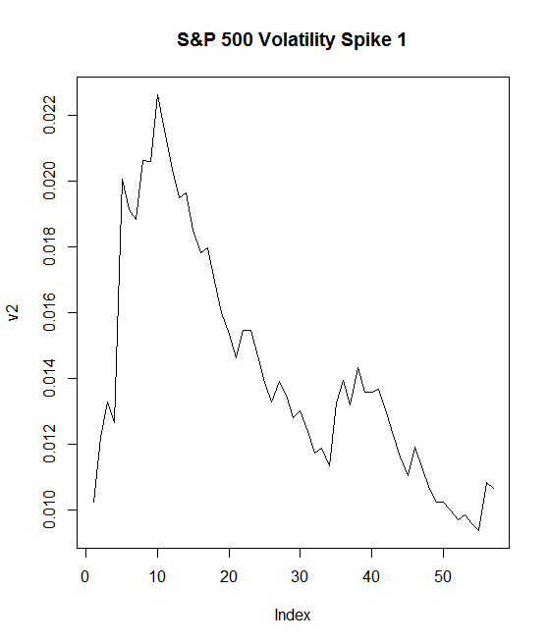

Big event(s): Aftermath of 9/11 terrorist attacks

Spike 2: 2215-2226, Corresponding Dates: September 29, 2008-October 22, 2008

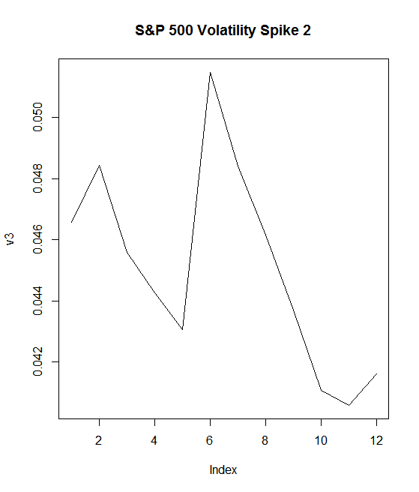

Big Event(s): Lehman Brothers Bankruptcy coupled with the House rejecting a $7 billion bailout plan. On top of this, oil prices were slumping and earnings were weak due to fear of a recession.

Spike 3: 2592-2610, Corresponding Dates: April 27, 2010-May 20, 2010

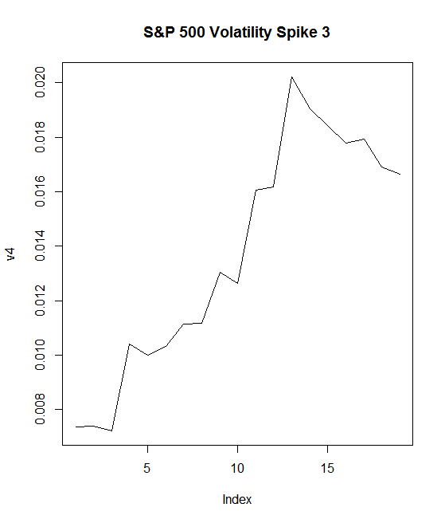

Big Event(s): The Flash Crash, where the stock market crashed for approximately 36 minutes. Also, the European Debt Crisis occurred. The slump in the Euro caused the debt rating of Greece and Portugal to drop significantly.

Spike 4: 2915-2926, Corresponding Dates: August 4, 2011-August 18, 2011

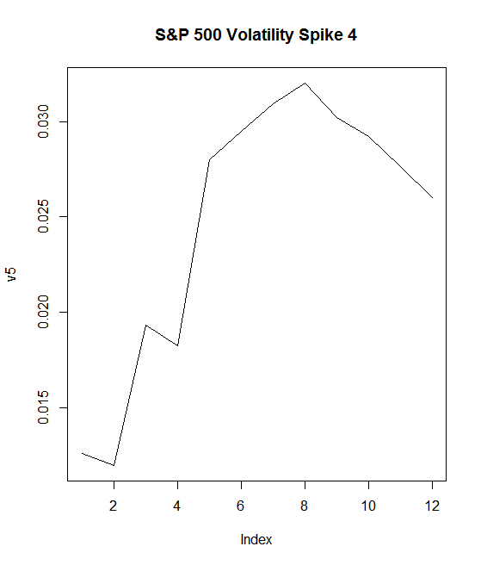

Big Event(s): In August, there was a stock market fall due to fears of contagion of the European Sovereign debt crisis to Spain and Italy, as well as concerns over the slow economic growth in the US. August 8th was known as Black Monday because of this stock market crash. Ties were also cut with the Syrian government on August 18th.

Spike 5: 2974-3005, Corresponding Dates: October 27th, 2011-December 9th, 2011

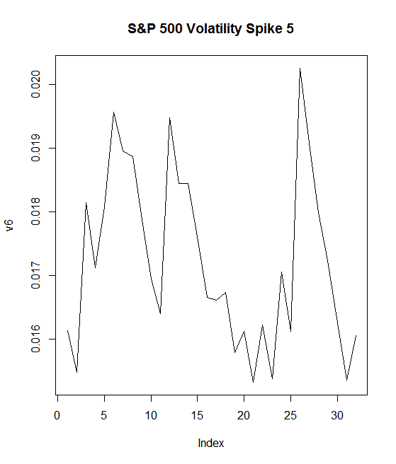

Big Event(s): On November 9th, the Penn State football coach was fired over a sexual abuse scandal. US economy growth was still significantly slow.

Spike 6: 3339-3351, Corresponding Dates: April 12, 2013-April 30, 2013

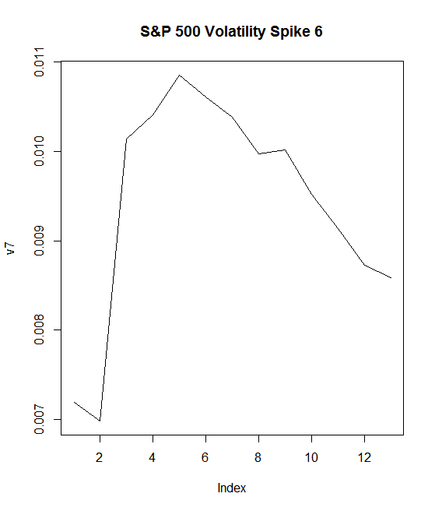

Big Event(s): On April 15th, the Boston Marathon bombings occurred in Massachusetts.

2) Energy Sector

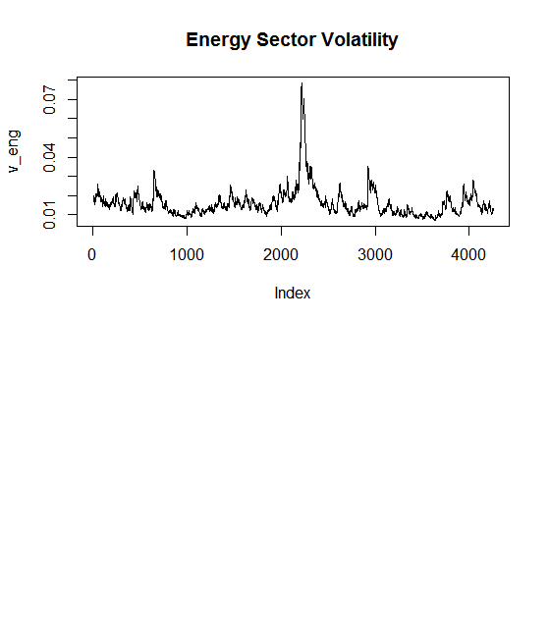

The same periods of time/big event(s) were observed for the Energy Sector that were observed for the overall S&P 500 Index. The volatility plots are given below:

Spike 1:

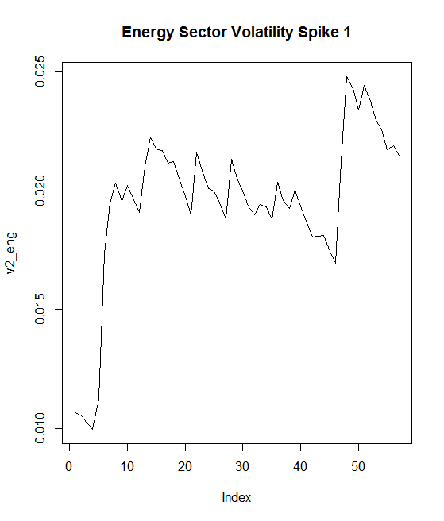

Spike 2:

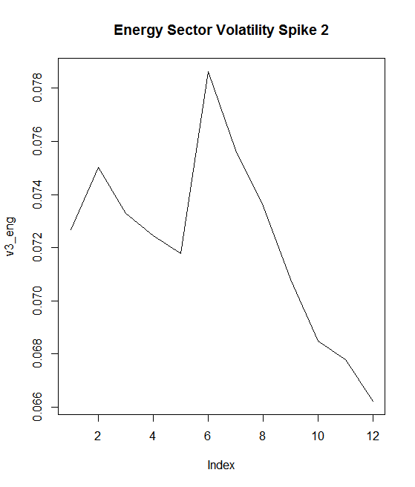

Spike 3:

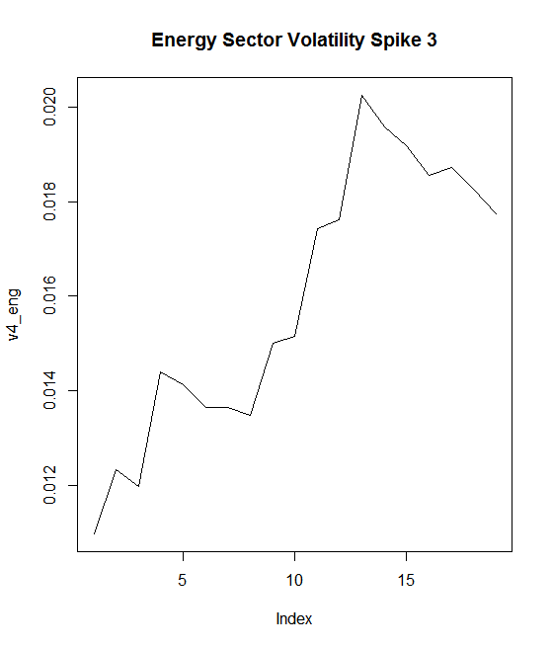

Spike 4:

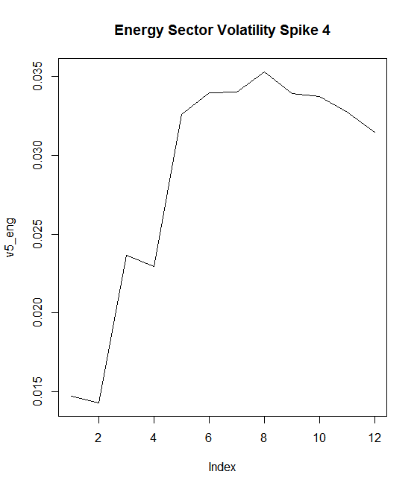

Spike 5:

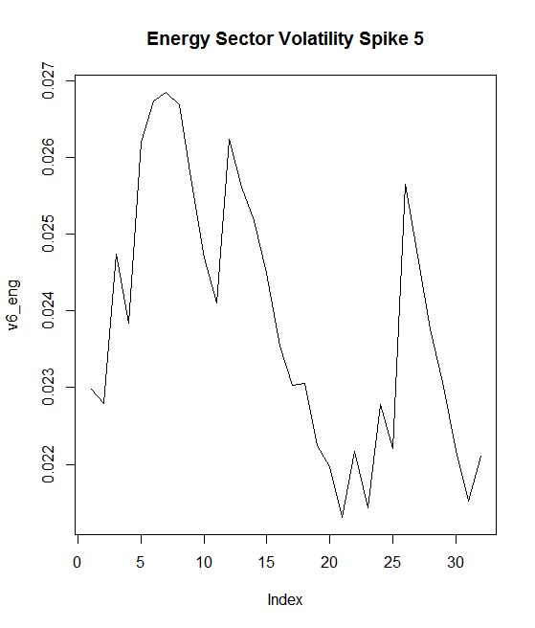

Spike 6:

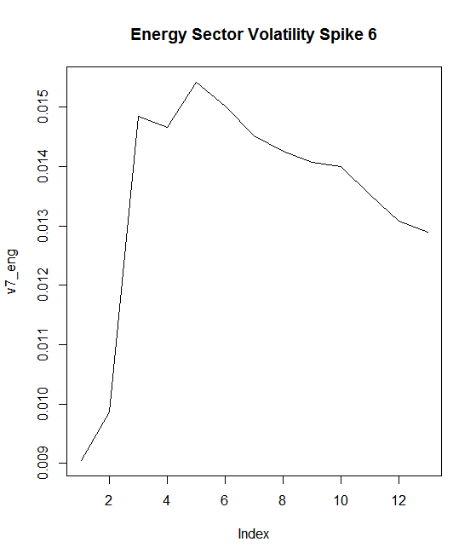

3)Technology Sector

There is one new spike in the Technology Sector, and it is found at data points 59-71. The dates for these points correspond to March 27, 2000-April 12, 2000. The climax of the dot com bubble, where stocks saw massive over valuation as a result of the success of the technology sector. The climax of the bubble was on March 10th, so this spike can be explained by the aftermath of the crash. The plot is given below:

Spike 1:

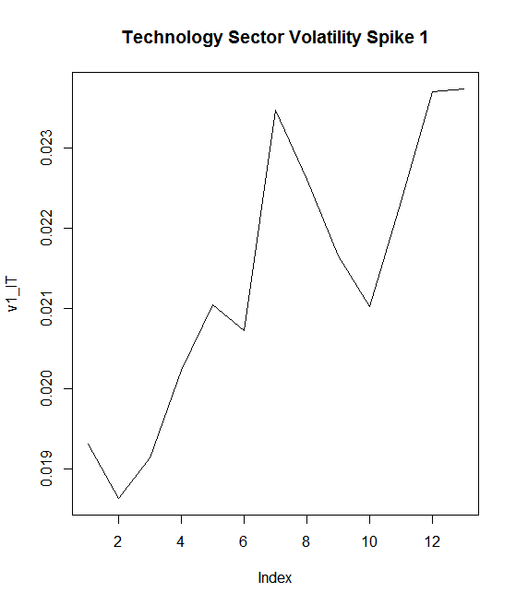

Spikes 2-7 correspond to the same events as Spikes 1-6 of the S&P 500/Energy Sector. The plots are given below:

Spike 2:

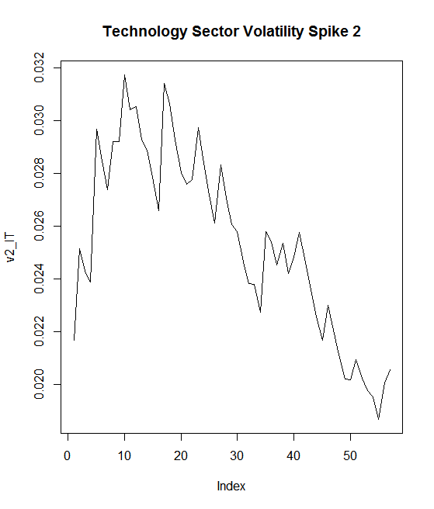

Spike 3:

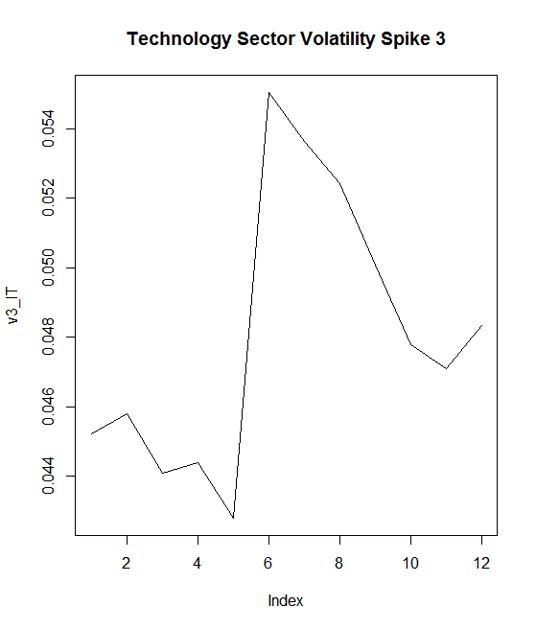

Spike 4:

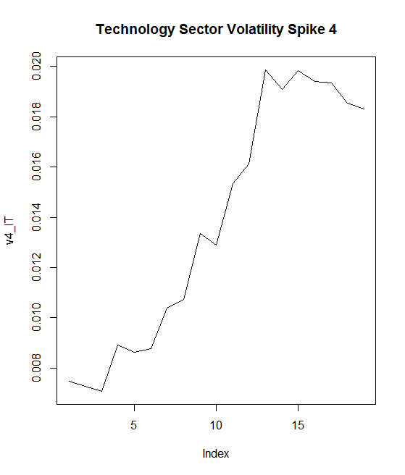

Spike 5:

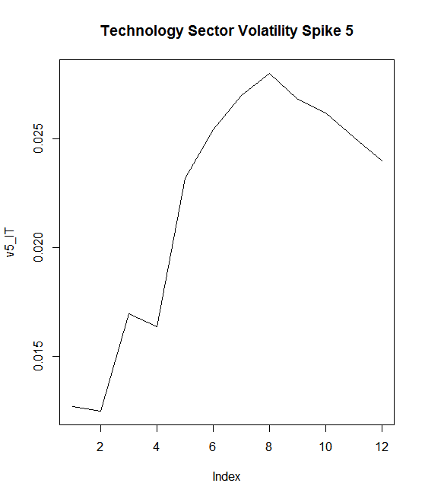

Spike 6:

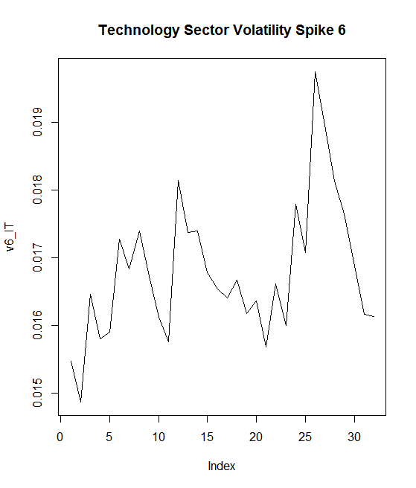

Spike 7:

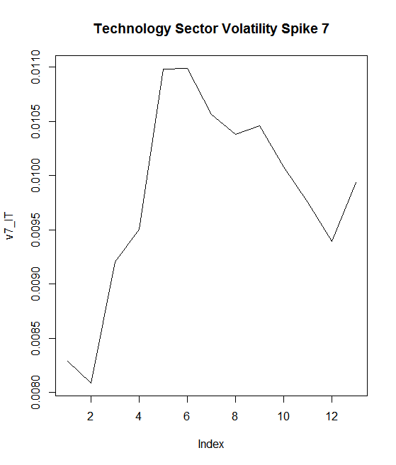

4)Health Care Sector

Spikes 1-6 have events that are the same for the Health Care Sector as they were for the S&P 500. However, Spike 7 deviates. The first six plots are given below followed by the new Spike 7.

Spike 1:

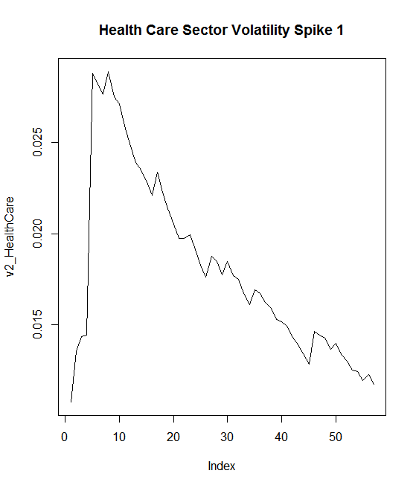

Spike 2:

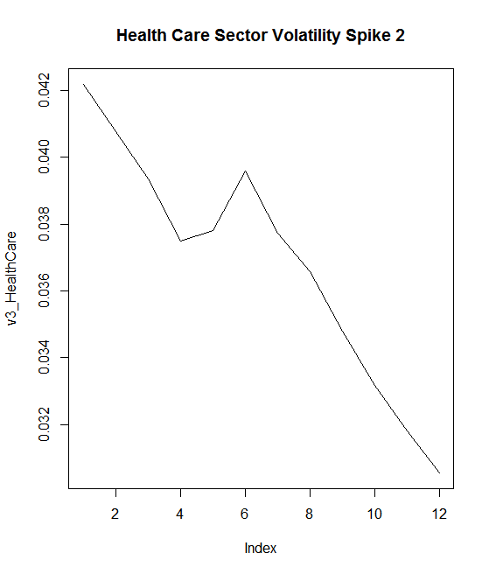

Spike 3:

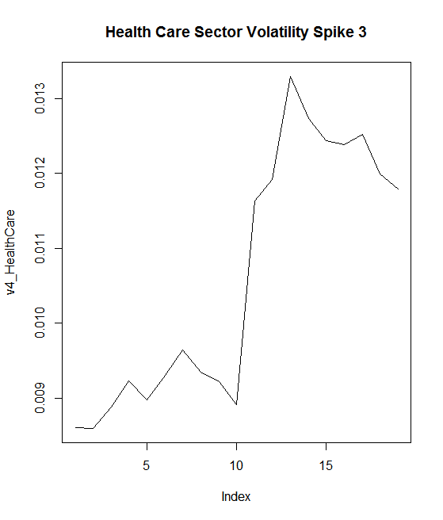

Spike 4:

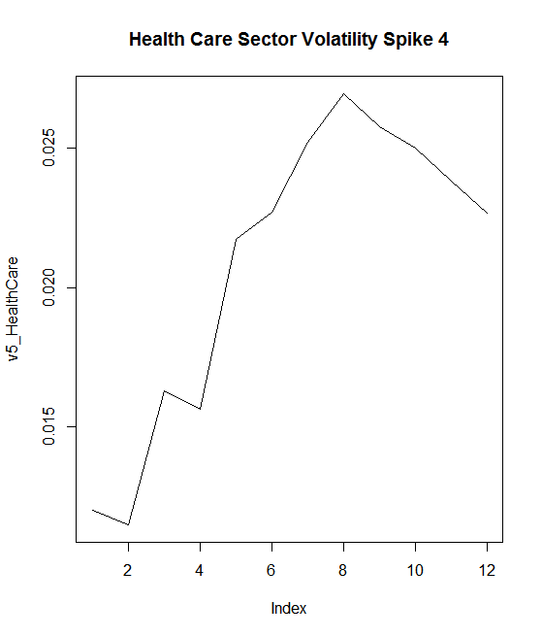

Spike 5:

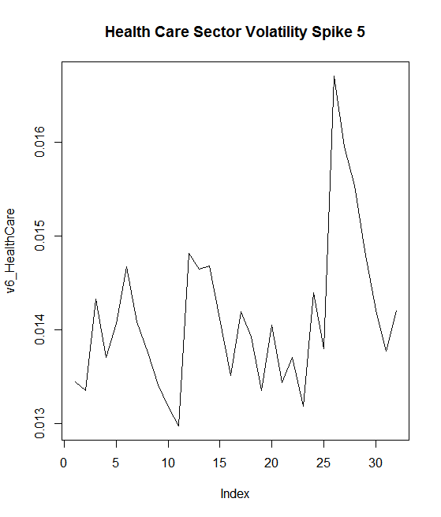

Spike 6:

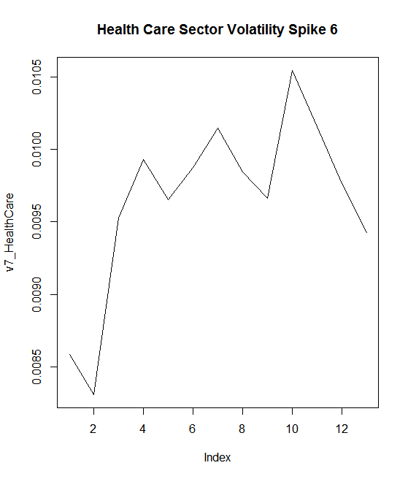

Spike 7: 3784-3796, Corresponding Dates: January 20, 2015-February 5, 2015

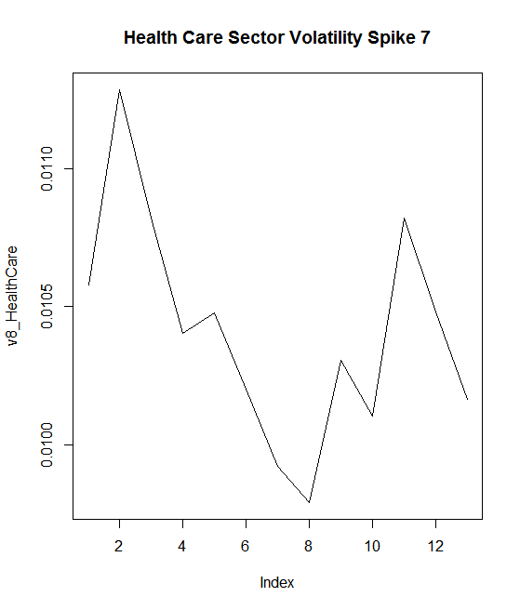

Big Event(s): Obamacare, designed to provide affordable healthcare to all American citizens, was implemented in this time period.

5)Financials Sector:

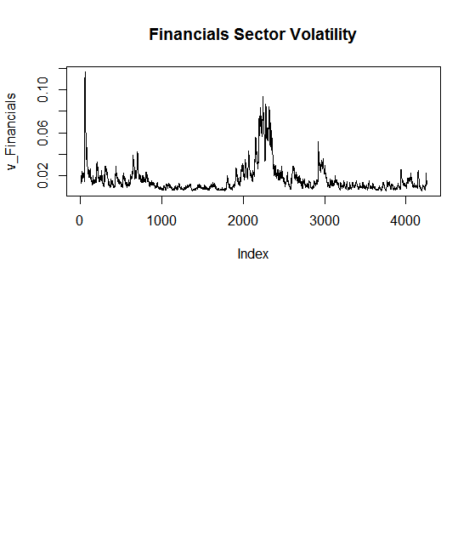

The events for the Financial Sector are the same as they were for the Technology Sector. The plots for all 7 spikes are given below:

Spike 1:

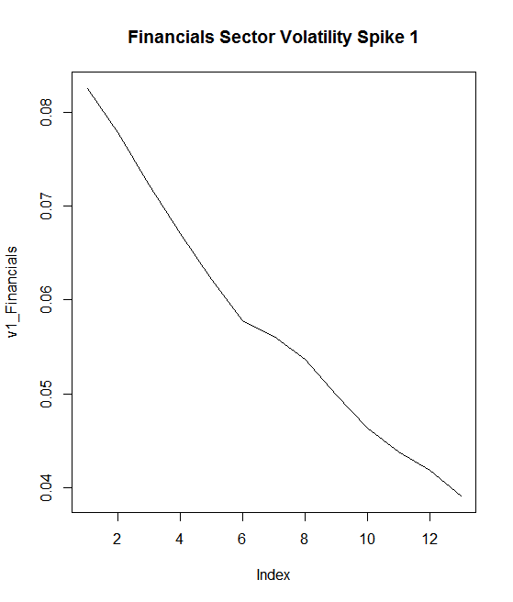

Spike 2:

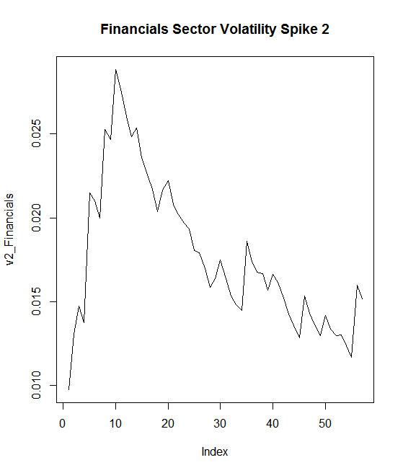

Spike 3:

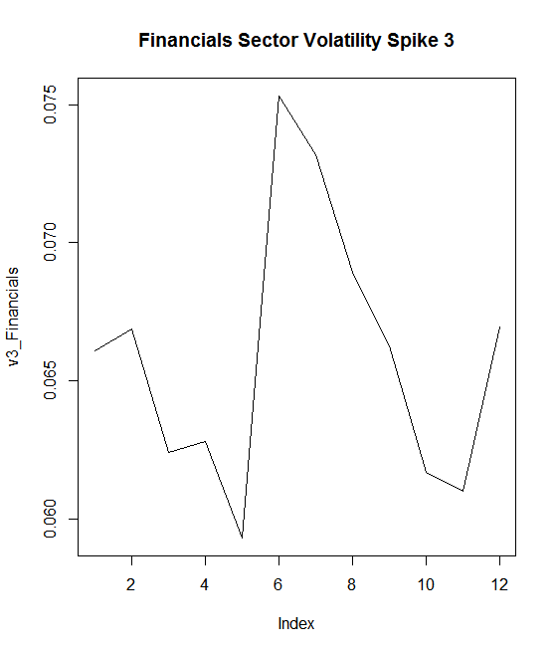

Spike 4:

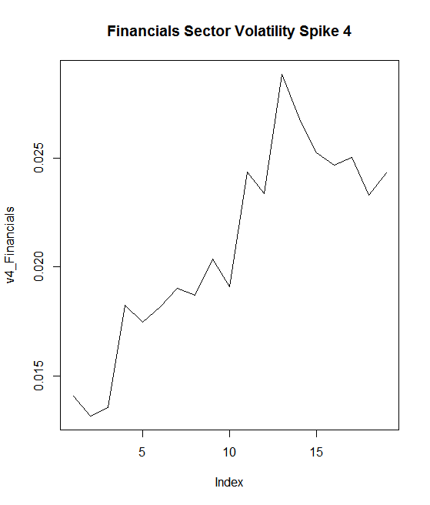

Spike 5:

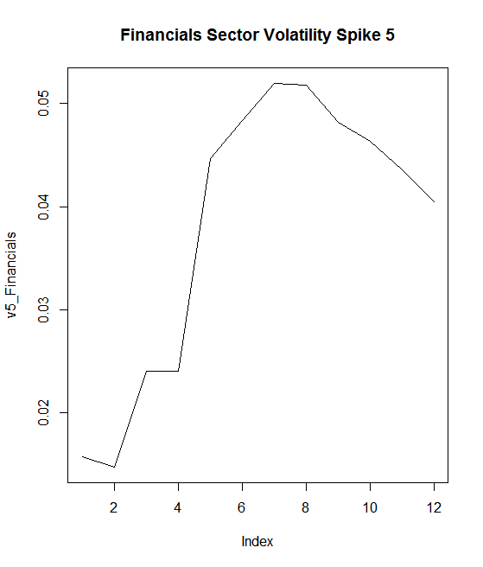

Spike 6:

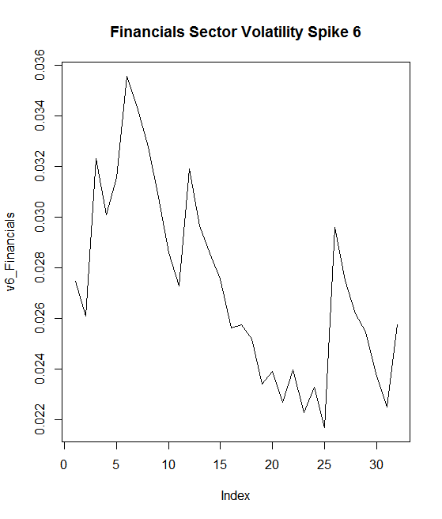

Spike 7:

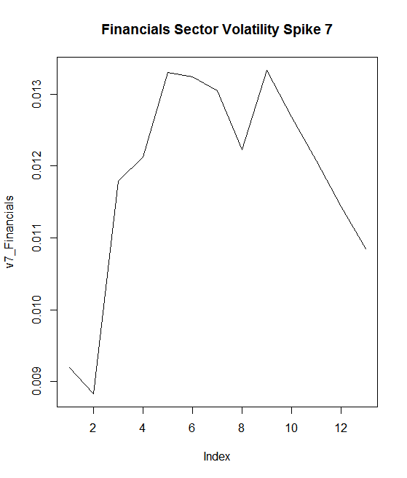

**Conclusion:**

Overall, the volatility analysis brought to light a few key takeaways. One is that market direction, in general, is typically consistent with sector direction. Close observation of the spikes from the same ranges in time shows almost identical volatility patterns between the S&P 500 and the four individual market sectors. With the exception of Technology and HealthCare having extra spikes, the events for all data sets were seen to be the same. To go back to the beginning of this report, it was stated that:

$y_{t}=g(y_{t-1,}y_{t-2},y_{t-3},…,e_{t-1},e_{t-2},e_{t-3},…$)+ $e_{t}$

Our analysis, for the most part, dealt with trying to fit ARIMA models to various data sets from the S&P 500 index as these models are part of the predictable $g(y_{t-1,}y_{t-2},y_{t-3},…,e_{t-1},e_{t-2},e_{t-3},…$) component of the equation. Furthermore, the GARCH models were fitted to the unknown, unpredictable $e_{t}$ component of the equation. Finding events that overlapped with highly volatile regions of the different GARCH models was an attempt to try to explain some of the unpredictability that was seen in the market. This kind of analysis can help investors in the long run react to market changes with knowledge rather than fear, as they will know to some degree what going on around the world is having an impact on market volatility, and for how long to expect the volatility to remain high before returning to a standard level.

**References:**

Theory:

<http://www.reed.edu/economics/parker/312/tschapters/S13_Ch_1.pdf>

<http://www.investopedia.com/>

R Code Data:

<https://finance.yahoo.com/>

General Knowledge:

<https://www.wikipedia.org/>