QUANTITATIVE RISK METHODOLOGY · RESEARCH MODEL
The Systemic & TAM Risk Model
A complete methodology with full mathematical specification and an independent engine audit — how the model reads the macro economy first, then prices and recovers each market on its own terms.
A probabilistic framework that reads the macro economy first — the envelope every market lives inside — and then asks, name by name, two separate questions: how deep can it fall, and whether, and how fast, it climbs back. The pages that follow describe the entire model: why the macro economy is checked before anything else, how a systemic collapse presses and freezes all markets at once, why the model rejects a single market-wide valuation line, and why a large, growing addressable market earns a real premium that the model respects rather than punishes.
Universe AI-semiconductor & tech equities + sector ETFs | Engine regime-switching Monte Carlo, ~150k paths × 7yr
Output drawdown × recovery probability matrix | Validation 102/102 invariant tests · 7/7 crash backtest · audited 2026-06-10

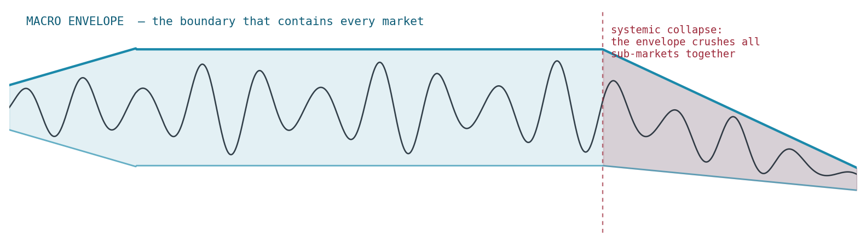
The macro economy is the envelope that contains every market. Sub-markets oscillate within it; when the envelope collapses, it crushes them together.

Contents

THE ORGANIZING IDEA

01 Why we read the macro economy first — the envelope
Every market lives inside an envelope drawn by the macro economy. Think of it the way an engineer thinks of a signal: individual stocks oscillate, rise, and fall on their own news, but the envelope — growth, rates, liquidity, credit, leverage — sets the ceiling and the floor that contain all of that motion. Sub-markets are the signal; the macro economy is the boundary curve. You cannot know where the signal can go without first knowing the shape of the envelope it is trapped inside.
That is why the model computes the macro state before it looks at a single company. The macro reading sets the regime probabilities for everything downstream — how often the market enters a crisis, how hard correlations spike, whether a collapse freezes recovery for years. No amount of individual quality protects a name when the envelope itself collapses: when the macro economy deteriorates enough to take down the S&P and the broad market, that collapse presses down on all markets at once. So the first question is never "is this stock good?" It is "what is the envelope doing, and how much room does it leave?"
The macro stress index splits its inputs into two families, because they behave differently in time. Structural signals are slow-burn fragility — stretched valuations, high real rates, leverage build-up, debt loads — the conditions that make a fall deeper and a recovery slower if something tips. Acute signals are the trigger — credit spreads, volatility, a liquidity drain — the things that fire when the system is actually seizing. A market can slide into a long de-rating from structural fragility while the acute triggers stay fast asleep; that decoupling was the lesson of 2022, and the model encodes it by driving the slow grind regime from structural stress and the sharp crisis regime from acute stress.
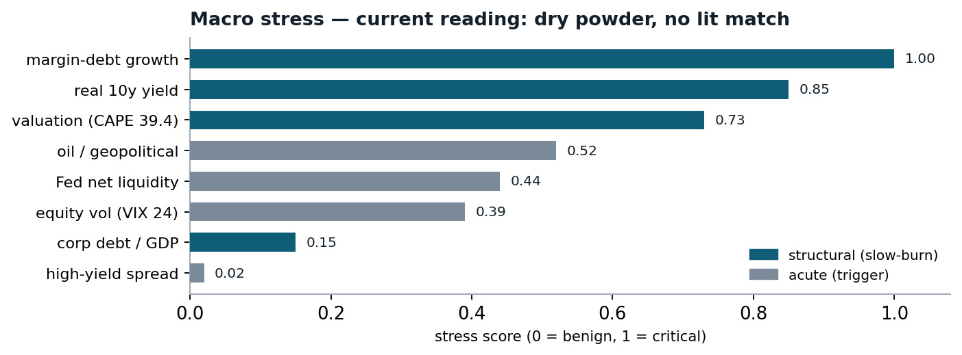
FIG 1 — Today the structural channel (valuation, real rates, leverage) is elevated while the acute channel (credit, volatility) is calm. The powder is dry; no match is lit.

MACRO STRESS — CURRENT READING
Composite stress score | 0.482
Structural (slow-burn fragility) | 0.583 · elevated
Acute (seizure trigger) | 0.246 · dormant
Margin-debt growth (leverage) | +45% YoY · score 1.00
Valuation — Shiller CAPE | 39.4 · score 0.73
Real 10-year yield | 2.25% · score 0.85
High-yield credit spread | 312 bps · score 0.02
Equity volatility (VIX) | 24 · score 0.39
Reading: the powder is dry (high valuations, leverage, real rates) but no match is lit (credit and volatility calm). The structural channel widens the tail; the acute channel decides whether it fires.
This is the reason the whole model is ordered the way it is. The macro envelope is computed first because it is the constraint within which every other calculation happens. Everything that follows — depth, recovery, the growth premium, the systemic freeze — is downstream of the envelope.

The mathematics of the stress index
Each macro input xᵢ is scored against documented benign-to-critical bands [bᵢ, cᵢ], so every contribution is auditable: a reading at or below its benign level scores 0, at or beyond its critical level scores 1, linear in between. The scores aggregate to weighted group means, and the composite deliberately includes a max term — a fragile system OR a live acute shock lifts the index even when the other channel is quiet:
component score → group means → composite. Today: S_struct = 0.583, S_acute = 0.246 → S = 0.50(0.583)+0.30(0.246)+0.20(0.583) = 0.482, matching the reported 48/100.
The composite does not act on prices directly. It acts on the probability of entering the bad regimes, through a bounded multiplier relative to the calibration baseline S₀:
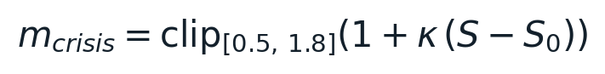
today S ≈ S₀, so m_crisis ≈ 0.99 — the crisis odds are essentially at their calibrated base rate. The clamp [0.5, 1.8] keeps any single macro reading from dominating the simulation.
Two design choices matter here. First, the bands are falsifiable: anyone can dispute "margin debt +45% YoY scores 1.00" by pointing at the documented band, and the index recomputes. Second, the index is bounded and slow-moving by construction — it tilts the regime odds rather than forcing an outcome, which is what keeps the model a probability engine rather than a market-timing switch.
TRANSMISSION

02 How the envelope presses sub-markets
The macro state does not stay abstract — it flows into every name through four mechanisms, each modeling a different way the envelope reaches down and squeezes.

Regime-switching
The market occupies one of four moods at any moment — calm, stress, crisis, or a slow de-rating grind. Macro stress raises the probability of entering the bad regimes: acute stress feeds crisis-entry, structural stress feeds grind-entry. The worse the envelope, the more time the market spends in regimes that fall hard and heal slowly.

Correlation spike
In calm times, names move on their own stories and diversification works. In a macro crisis, cross-correlations jump toward 0.9 — everything falls together because the shock is to the envelope itself, not to any one company. This is the envelope pressing every signal down at once, and it is why "I am diversified across ten tech names" offers far less protection in a true macro event than in a normal pullback.

The systemic freeze
At the extreme — a total collapse — the envelope does not just push prices down, it freezes the recovery of the entire market for a period, because the financial plumbing seizes. This is the dominant tail risk and it gets its own section below.

The liquidity gate
Whether a collapse becomes a multi-year freeze or a months-long scare depends on the macro authorities. Draining liquidity (2008) lets the freeze run; a central-bank flood (2020) breaks it. The same panic produces a very different recovery depending on the backstop.

The regime mathematics — from base rates to a live tail
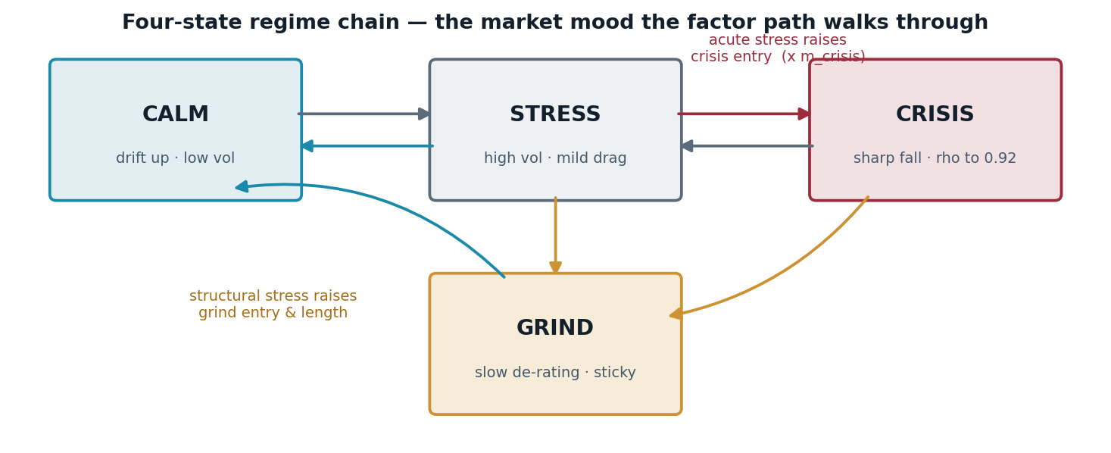
FIG 2 — The factor path walks through four regimes. Acute stress raises crisis entry; structural stress raises grind entry and length. Correlations rise toward ρmax = 0.92 inside crisis (and halfway there in grind).
The systemic tail is not hand-set — it is derived from history through a constant-hazard survival transform, then tilted by the live stress reading. Five systemic episodes in 97 years pins the 5-year base rate p₅; the implied annual hazard λ converts it to any horizon; a catalyst premium π and the stress multiplier do the rest:
every step from "5 episodes in 97 years" to the 3 / 6 / 9% systemic tail at 6 / 12 / 18 months is visible and adjustable — no magic constant.
Regime · P(occupied) at horizon | 6 months | 12 months | 18 months
Benign | 48% | 38% | 31%
Correction | 38% | 40% | 40%
Bear | 11% | 16% | 20%
Systemic | 3% | 6% | 9%
Current regime probabilities (each column sums to 100%; verified). The systemic row is the derived tail above — small at short horizons, accumulating with time, scaled today by m_crisis ≈ 0.99.
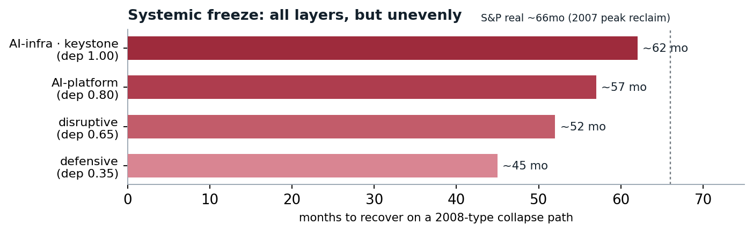
FIG 3 — Recovery time after a 2008-type collapse scales with each layer’s dependence on the keystone. The plumbing (AI-infra) stays frozen longest; the defensive layer thaws first. "All layers, but unevenly."
THE KEYSTONE & THE FREEZE

03 Systemic failure is the dominant risk
Most recovery logic in the model assumes no total collapse — each name heals at its own fundamental speed once the dust settles. But that assumption breaks in the one case that matters most. When the macro envelope causes a true systemic collapse — the broad market down past roughly 55% — the financial system itself freezes. Credit stops rolling, intermediation breaks, and even healthy companies cannot reclaim their value, not because anything is wrong with them, but because the market they trade in is broken. This is the 2008 case: frozen for years, across all layers.
The model represents this explicitly as a systemic-freeze layer. On the paths where the broad market collapses past the threshold, recovery is suspended market-wide — the recovery clock is paused while the plumbing is seized, then resumes. Three properties make it faithful to how systemic failures actually behave.

It propagates by dependency on the keystone
A systemic collapse does not freeze every sector equally. It freezes hardest the markets most dependent on the broken core. In this universe the keystone is the compute, data-center, and AI-infrastructure layer — the plumbing that the platform and application layers run on. So the freeze length scales by dependence: AI-infra at full weight, the platform layer somewhat less, disruptive names less again, and defensive names least. This is the literal meaning of "a financial collapse affects all layers" — but it affects them unevenly, in proportion to how much each one leans on the frozen core.

The liquidity gate decides 2008 from 2020
Panic alone does not freeze a system — the response does. In 2008 liquidity was draining as the crisis hit, so the freeze ran for years. In 2020 the same magnitude of panic was met by a massive central-bank flood, and the freeze was averted — months, not years. The model computes freeze severity as panic multiplied by a liquidity-backstop gate, so a deep collapse with draining liquidity produces a long freeze, while the same collapse with a flood produces a short one.

It is causal
A freeze can only delay a recovery that is still in progress when the freeze starts. A collapse in year five cannot reach back and delay a recovery that already completed in year one — there is no look-ahead. The delay is precisely the part of the freeze that overlaps the recovery window.

The freeze, quantified
Severity is panic times a liquidity gate. Panic is scored from funding-freeze signals (high-yield and investment-grade spreads, rate volatility, equity volatility) against documented benign-to-freeze bands; the gate falls toward a floor as 3-month Fed net liquidity ΔL₃ₘ floods, because a backstop breaks a freeze. Duration is then a bounded affine function of severity — even a mild confirmed freeze costs at least 40% of the base delay — scaled by each layer’s keystone dependency:
arithmetic check against history: 2008 sev 0.714 → 30×(0.40+0.60×0.714) ≈ 24.9 months at full dependency; 2020 sev 0.121 → ≈ 14.2 months, averted by the flood; today sev 0.022 — dormant.
Causality is enforced per path, with the "still in progress" test taken after the cyclical demand floor — a memory name whose price bounced by day 90 but is held to day 315 by its demand cycle is still underwater when a day-200 freeze hits, so the freeze must delay it. On gated paths the recovery becomes the longest of: the pre-freeze (cyclical-floored) recovery, the natural climb plus the post-trough freeze overlap, and "cannot finish before the freeze clears":
t_br = breach day, τ_tr = trough, t_end = freeze end. The gate condition (rightmost) is the no-look-ahead rule: a path that already healed before the breach is untouched.

SYSTEMIC-FREEZE — THE LIQUIDITY GATE
2008 seizure — liquidity draining | severity 0.71 → ~25 mo freeze
2020 crash — central-bank flood | severity 0.12 → ~14 mo, averted
Today — calm, no credit stress | severity 0.02 → dormant
Collapse trigger (broad-market drawdown) | ≥ 55%
Keystone → defensive dependency | 1.00 → 0.35
Reading: on a 2008-state path the keystone takes ~62 months to recover, against the S&P’s real ~66 months to reclaim its 2007 peak. The layer is dormant today and only shapes the deep tail.
WHY THIS IS THE DOMINANT RISK
Individual fundamentals govern the ordinary case. But a systemic collapse overrides them — it presses every market down together and freezes them all from healing. That is why the model checks the macro envelope first and treats systemic failure as the risk that, when it fires, matters more than anything specific to any one name.

THE AGGREGATE FALLACY

04 Why we reject the Warren Buffett indicator
The Buffett indicator — total stock-market capitalization divided by GDP — is the best-known "is the market overvalued" gauge. It draws one line across the whole market and says: when the ratio is high, stocks are expensive and must revert. The model does not use it as a signal, and the reason is the same reason the model exists: treating the entire market as one undifferentiated asset measured against one fixed fair line throws away everything that actually determines risk.

What the indicator ignores
- Composition. Today’s index is dominated by high-margin, capital-light, high-growth businesses — software, platforms, AI infrastructure. They legitimately earn higher multiples than the asset-heavy industrial economy the ratio was calibrated on. Comparing 2026 to the 1970s compares different organisms.
- Interest rates. Valuation is rate-dependent. At low real rates a higher multiple is justified; at high real rates, less. The ratio has no rates term at all.
- Globalization. US large-caps earn a large share of revenue abroad. Dividing global earnings (the numerator) by domestic output (GDP) is a mismatch that widens every year.
- Its own track record. It has read "overvalued" for over a decade while the market compounded. A signal that has been wrong for ten years is not a timing tool.

What we do instead
- We never ask whether the aggregate sits above a fixed line. We decompose each name’s valuation into a base (what an average business is worth, set by a rates-aware fair multiple), a justified premium (earned by growth, margins, TAM, dominance), and an unsupported premium (the floating, speculative part).
- Only the unsupported float is treated as fragility. The justified premium is not a sin to be punished — it is value the business has earned.
- The fair multiple itself moves with real rates, so the baseline is honest about the macro environment rather than frozen in a single historical average.

The fair multiple, derived
The baseline is an earnings-yield model anchored where a 1.5% real 10-year yield maps to an 18× fair multiple (E/P = 5.56%). Each percentage point of real rates moves the fair earnings yield one-for-one, and the clamp keeps the multiple inside an economically sane band:
r_real = 2.25% today → E/P = 6.31% → PE_base = 15.8× (verified against the live model to 0.05). At r_real = 0 the same formula gives 24.6× — the 2020 environment — with no recalibration.

THE RATES-AWARE FAIR MULTIPLE, VS. A FIXED LINE
Fair base multiple today (real rate 2.25%) | 15.8×
Fair base multiple at a 1.5% real-rate anchor | 18.0×
Fair base multiple in 2020 (near-zero real rates) | ~24.6×
Market CAPE today (the "expensive" headline) | 39.4
Reading: a single fixed line would call the market uniformly expensive. The model instead moves its own baseline with rates and then asks, per name, how much of the premium above that baseline is earned versus floating.
WHY YOU CAN’T PRICE EVERYTHING THE SAME

05 The growth premium is real
Some assets deserve a premium, and pretending they do not is the mistake the aggregate view makes. The clearest analogy is real estate. A home with an ocean view, or one in a scarce prime district, sells for far more than the median price per square foot — and that premium is real, not overvaluation. It reflects a scarce, durable, desirable attribute that buyers compete for. No one prices every house at the city average and calls the waterfront homes "overpriced" for trading above it.
Equities work the same way. A company with a large and growing total addressable market (TAM), strong execution, high margins, and durable demand deserves a higher multiple than the average company. It is supply and demand applied to growth itself: high-quality compounding is scarce, so the market bids it up. In a good economy that premium expands — risk appetite is high and growth is scarce, so the scarce thing commands more. In a crisis the floating part of it deflates. But the earned core of the premium is not fragility; it is the equity-market equivalent of the ocean view.
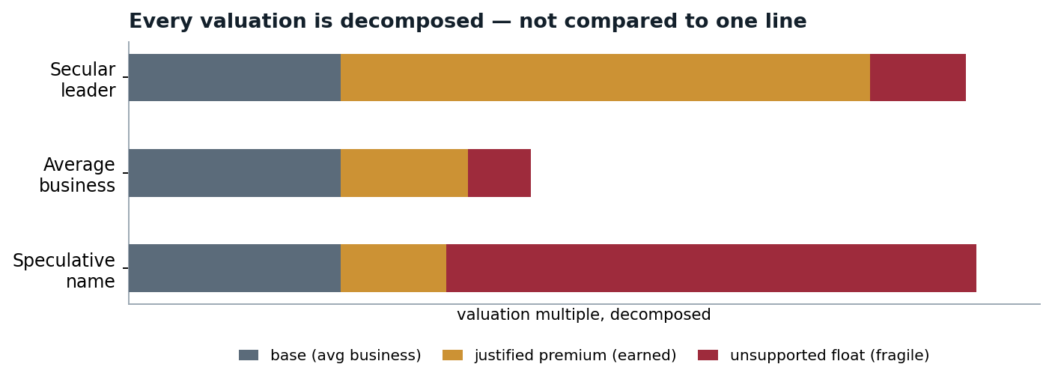
FIG 4 — The secular leader carries a large earned premium and only a thin float; the speculative name is mostly float. Same headline "expensive," opposite fragility. This is why they cannot be modeled the same way.
The TAM does double duty. It justifies the premium on the way up, and it powers the recovery on the way back: a company with a large serviceable runway recovers because demand keeps growing into it, while a name whose story has outrun its market does not. This is the bridge between the valuation side of the model and the recovery side — the same quality that earns the premium is the quality that brings the price back.
the decomposition behind FIG 4: the base is rates-aware, the justified slice is earned by TAM, growth, margins, and dominance — and only the unsupported float is treated as fragility.

The earn-back clock — growing into the multiple
The premium is testable through time. A name trading above its fair multiple must grow into it; the earn-back clock measures how long that takes at the growth rate the company actually keeps through a crash — secular businesses keep compounding (×1.05), cyclicals lose a quarter of it during the down-cycle (×0.78), broken theses lose half (×0.50):
T_earn → 0 means the multiple is already supported at crash growth; T_earn → ∞ means the name cannot grow into its price on its surviving growth — the quantitative content of "broken."
Name (2026-06-05) | Archetype | Growth | Crash growth | Earn-back | P(rec ≤18m)
NVIDIA | secular | 45% | ×1.05 → 47% | 0.0 y | 43%
Micron | cyclical | 50% | ×0.78 → 39% | 0.4 y | 40%
Astera Labs | secular | 70% | ×1.05 → 74% | 1.3 y | 46%
Palantir | secular | 55% | ×1.05 → 58% | 2.1 y | 38%
Lumentum | cyclical | 55% | ×0.78 → 43% | 3.3 y | 36%
ARKK | broken | 42% | ×0.50 → 21% | 7.9 y | 28%
CoreWeave | cyclical | 60% | ×0.78 → 47% | ∞ | 27%
IonQ | broken | 80% | ×0.50 → 40% | ∞ | 24%
The earn-back clock in action. NVIDIA’s multiple is supported at crash growth (0.0y); IonQ carries the highest growth number in the universe yet earns back never — its price cannot be grown into on the growth that survives a crash. The clock is what turns "premium" from an opinion into a measurable claim.
THE PRINCIPLE
You cannot model every name on one multiple any more than you can price every house at the city average. The model respects the earned premium, isolates the speculative float, and lets the size and durability of the TAM drive both the premium and the recovery.

THE SPINE

06 Depth and recovery are different questions
The single principle that holds the whole model together is that how deep a name falls and whether it recovers are governed by different forces, and must never be crossed.
Depth is market-driven. How far a name falls in a shock is set by its beta to the market and by how correlations spike in a crisis — it is a property of the envelope and the name’s sensitivity to it. A high-beta name falls hard in a crisis whether it is the best company in the world or the worst.
Recovery is fundamental. Whether the name climbs back, and how fast, is set by its TAM, growth, demand cycle, balance sheet, and — in the extreme — whether a systemic freeze has the whole market locked. Two names can fall exactly as far and have completely different futures: one reclaims its peak in a year, the other never does.
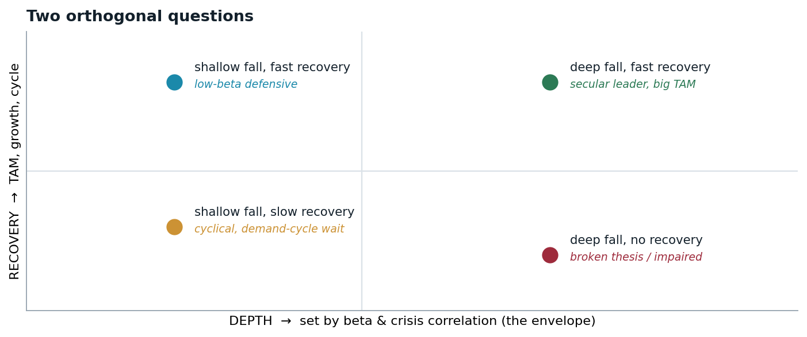
FIG 5 — Beta places a name left-to-right; fundamentals place it top-to-bottom. The two are independent, so a deep fall says nothing on its own about whether the name comes back.
THE ENGINE

07 Regime-switching Monte Carlo
The model does not produce a forecast — it produces a distribution. It rolls the market forward roughly 150,000 times, each a distinct seven-year future, and counts what happens. A "probability" in this model is a frequency over those futures, the way a rain forecast is a frequency over similar weather days — not a guess about one outcome.
Each simulated future is built in layers. First the market mood walks through the four regimes, with transition odds set by the macro stress reading. Then each name reacts: its price moves with the market factor scaled by its beta, plus its own idiosyncratic noise, with fat tails so extreme moves are not understated and a crisis correlation spike so names move together when the envelope is hit. From each path the model measures the deepest drawdown inside each horizon — 6, 12, and 18 months — and then searches forward for the day the name reclaims its prior peak. Aggregated over all paths, that becomes a probability of falling and, conditional on falling, a probability of having recovered by each later horizon.

The stochastic specification
Daily returns load on the shared factor through beta, plus an idiosyncratic Student-t shock with four degrees of freedom — heavy enough that variance stays finite but crashes are not understated. Correlation is state-dependent: it rises toward ρmax inside the crisis state c_t and halfway there in the grind state g_t, with the blend constructed so each name’s standalone volatility is preserved (√ρ² + √(1−ρ)² = 1) — only the joint tail fattens:
depth comes from β and ρ; nothing about a company’s quality appears in this equation — by design. Quality enters only on the recovery side.
Measurement is then mechanical and identical for every name. The drawdown at horizon h is the worst peak-to-trough inside it; the recovery time is the first day the prior peak is reclaimed, counted from the trough (21 trading days per month):
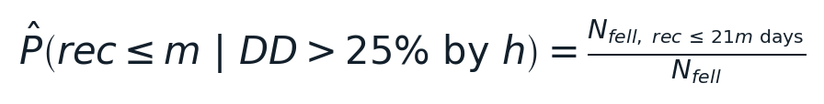
the headline matrix is nothing more than counting: of the paths that fell >25% within h, what share reclaimed the peak within m months of the trough.

THE FOUR REGIMES
Calm | drift up, low volatility — the default
Stress | elevated volatility, mild negative drift
Crisis | sharp drawdown, correlations → 0.9 (acute-driven)
Grind | slow de-rating, sticky negative drift (structural-driven)
Reading: the grind regime is what stops a crisis from always V-shaping; the crisis regime is what makes the deep falls. Both entry rates rise with macro stress.

Sampling precision and determinism
At 150,000 paths the binomial sampling error on any headline probability is at most about an eighth of a percentage point — far below the decimals anyone should read from a risk model anyway:
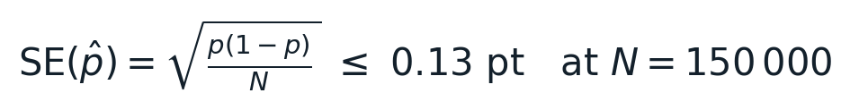
conditional probabilities (recovery given a fall) have a smaller effective sample — the fallen paths — so their error is ~0.2–0.3 pt. Either way, the simulation noise is an order of magnitude below the judgment uncertainty in the inputs.
The engine is fully deterministic: a fixed master seed drives the factor path, and each name’s idiosyncratic stream is seeded by the master seed XOR a CRC-32 of the name — so results are bit-for-bit reproducible and order-invariant (adding or removing a name never changes any other name’s numbers). Both properties were verified in this audit: two identical runs hash identically, and re-running under a different seed moved no headline metric beyond what sampling noise predicts.
THE DIFFERENTIATED LAYERS

08 Recovery dynamics
Once a name has fallen, the model does not let it heal on a single generic curve. Recovery is shaped by what kind of business it is — the same differentiation that runs through the valuation side.
Crash-conditional growth. A secular business (durable, growing TAM) keeps compounding through a selloff and recovers smoothly. A cyclical business sees its actual demand fall during the down-cycle, so it recovers later and along a different shape. A broken business — whose demand thesis is invalidated — steps down and may not recover at all.
Per-theme cyclical demand troughs. Cyclical recovery is not merely slower — it is back-loaded, because demand keeps falling for a period after the price rolls over and the price cannot reclaim its peak until the cycle clears. The wait is calibrated per theme: memory is the deepest and longest cycle, optical and broad-semis are shorter. The result is a recovery curve that is flat early and steep late, which is the demand-rebound picture rather than a constant slowdown.
Solvency and dilution. The growth-premium logic also runs on the downside. A company with weak financials survives a deep crash if its revenue stays durable, but becomes a permanent impairment if revenue craters at the same time — and a cash-poor, levered name forced to raise equity at the lows takes a permanent per-share haircut. Durable-revenue businesses are spared; the fragile ones are not. This is why a levered name with sticky enterprise revenue is treated very differently from a levered name with cyclical revenue.

The recovery channel, quantified
The fundamentals enter the Monte Carlo as a bounded shift on each name’s recovery propensity: recovery quality (TAM durability, dominance, margins) pushes it up, fragility pushes it down, and a capital-intensity penalty docks recovery quality when capex runs above 15% of revenue — heavy spenders heal slower out of a trough:
RQ = recovery quality ∈ [0,1], FR = fragility, CI = capex intensity. The same crash-growth archetype that sets the earn-back clock (×1.05 / ×0.78 / ×0.50) also shifts the simulated recovery — valuation and recovery are deliberately driven by one set of judgments, not two.
Cyclical back-loading is calibrated per theme from each cycle’s own history — demand keeps falling for a period after the price rolls over, stabilizes, and only then can the price reclaim its peak. A second-leg term adds the residual demand drop during stabilization:
Theme | Demand-down | Stabilization | Second leg | Character
Memory (DRAM/NAND) | 9 mo | 6 mo | 15% | deepest, longest cycle
Optical / photonics | 6 mo | 3 mo | 8% | shorter, milder
Broad / analog semis | 4 mo | 4 mo | 6% | mild and short
This is why Micron’s conditional recovery reads 0% at 6 and 12 months in the matrix — not slowness, but an explicit demand floor: the cycle has not cleared, so the peak cannot be reclaimed yet. The curve then catches up steeply, which is the demand-rebound shape.
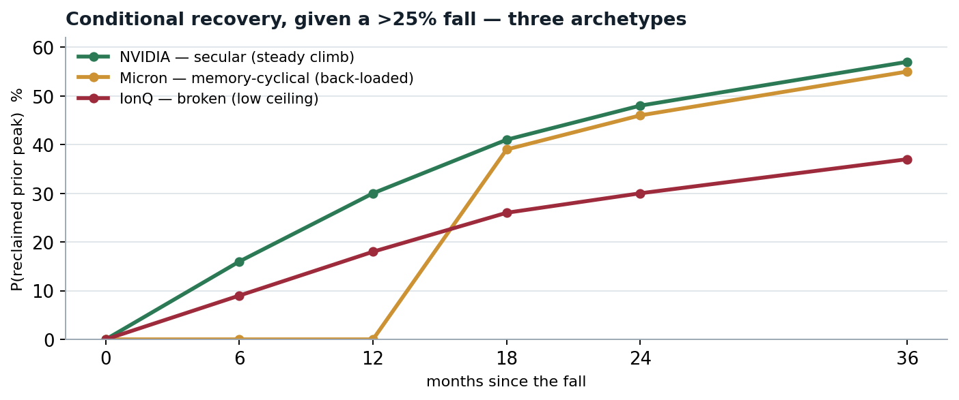
FIG 6 — Three names that fall to similar depths, three different recoveries. The secular leader climbs steadily toward a ~57% reclaim by three years; the memory-cyclical name is flat for over a year while demand bottoms, then catches up; the broken name’s ceiling stays low — most paths never reclaim the peak. Same depth, opposite futures — the spine of the model.
THE HEADLINE OUTPUT

09 The drawdown × recovery matrix
The model’s primary output, per name, is a matrix that answers exactly the two questions in the order they matter. For each drawdown horizon — 6, 12, 18 months — it gives the probability of a fall, and then, conditional on that fall, the probability that the name has reclaimed its prior peak within 6, 12, 18, 24, or 36 months, plus the residual that is still underwater past three years (the slow, cyclical-wait, impaired, or permanent tail). These are probabilities; the model makes no claim about exact timing.
NVIDIA — secular · if >25% fall within | P(fall) | ≤6m | ≤12m | ≤18m | ≤24m | ≤36m | down >36m
6 months | 15% | 16% | 30% | 41% | 48% | 57% | 43%
12 months | 37% | 17% | 32% | 42% | 50% | 59% | 41%
18 months | 55% | 16% | 33% | 43% | 50% | 59% | 41%

The contrast across archetypes is sharpest at a single horizon. Taking the case where each name falls more than 25% within twelve months — the same depth trigger, three different futures:
If >25% fall within 12 months | P(fall) | recover ≤12m | ≤24m | ≤36m | still down >36m
NVIDIA — secular | 37% | 32% | 50% | 59% | 41%
Micron — cyclical | 45% | 0% | 46% | 55% | 45%
IonQ — broken | 58% | 19% | 30% | 36% | 64%

Notice the shapes. The secular name recovers from the first month; the cyclical name shows near-zero early recovery — the explicit demand trough — then catches up once the cycle clears; the broken name has a low ceiling that barely rises, with most paths still underwater past three years.
The names are then ranked, and the ranking is deliberately not a single number — it carries the kind of recovery with it, because a high expected return that depends on a cyclical rebound is a different proposition from one backed by secular compounding.
Rank label | Meaning | Examples
HIGH | secular growth, clean recovery — earns the premium and climbs back smoothly | NVIDIA, Astera Labs
HIGH* | high growth but rebound-dependent — recovery waits on a demand cycle | Micron, AMD, Marvell
AVOID | broken thesis — does not rank high regardless of how cheap it looks | speculative pre-revenue names

The asterisk is doing real work: a cyclical name can screen as cheap precisely because its earnings are at a cyclical peak, right before they roll over. The model prices it on through-cycle earnings and flags the recovery as conditional, rather than waving it through as a clean value name.
READING THE BUCKETS

10 Ranking within each archetype
"Best" means something different inside each archetype, because what makes a name best depends on how it recovers. So the model uses a different sort key in each bucket — and a name that looks strong on one is demoted on another. (Numbers below are the 2026-06-05 snapshot; the full table is in Appendix A.)
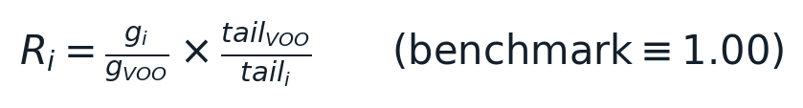
the reward-to-risk metric: growth per unit of long-drawdown risk, normalized so the S&P itself scores exactly 1.00. Verified in this audit to reproduce exactly, all names, from its inputs. The tail here is the report’s definition — fell >25% and still underwater at ~3.5 years.

Secular — rank by reward-to-risk
These earn their premium and climb back, so they are ranked straight by how much growth you get per unit of recoverable drawdown risk — the reward-vs-S&P number. Best at the top:
Astera Labs (5.15) · NVIDIA (4.54) · Palantir (4.15) · Broadcom (3.64) · CHAT (3.36) · SMH (3.15) · SOXX (2.94) · AIQ (2.65) … then Meta (1.91), ARM (1.71), IGV (1.52), Microsoft (1.43), QQQ (1.43), Oracle (1.42), VGT (1.35) … down to the low-growth defensives VOO (1.00), SCHD (0.96), Cisco (0.70), IBM (0.53), Apple (0.50).
Two caveats. The 3× leveraged ETFs (SOXL / TECL / TQQQ) screen high here but are excluded from the real ranking — they decay on any choppy path, with roughly 100% odds of a >25% fall. And the bottom of the list is not "bad": VOO and SCHD simply deliver less growth per unit of risk. They are the safest, lowest-reward end of the same good bucket.

Cyclical — all rebound-dependent; rank on two axes
Every name here needs the demand cycle to turn, so reward alone is not enough — you also have to ask whether it survives the trough to enjoy the rebound. That second axis is the >3y permanent tail. Best = high reward AND a low-to-moderate tail.
Group | Names (reward-vs-S&P, >3y tail) | Why
Top | DRAM (3.72, 20%) · Micron (3.82, 22%) · Marvell (2.80, 21%) · AMD (3.54, 21%) | high reward, moderate tail, solvent — clean rebound bets
Mid | Lumentum (3.30, 28%) · Appl. Opto (2.81, 32%) · Vertiv (1.87, 25%) · AppLovin (1.92, 26%) · Coherent (1.45, 29%) | strong reward but a fatter tail — rebound if they survive
Watch | CoreWeave (2.18, 45%) | highest reward, worst survivability — closest to slipping into "broken"
Low-reward | Texas Instruments (1.00, 23%) · Qualcomm (0.76, 17%) · Tesla (0.83, 34%) · Kioxia (0.34, 25%) | safe-ish or fragile, but little growth to rebound into
The key cyclical insight: a high reward number with a high permanent tail (CoreWeave) is more dangerous than a slightly lower reward with a survivable tail (DRAM, Micron) — because a cyclical that cannot fund itself through the down-cycle never reaches the rebound at all. A fat tail is treated as a demotion toward "broken."

Broken — all "avoid"; ordering is only "least-bad"
There is no real top-to-best here — the whole point of the gate is that none of these belong in the buy list. If forced to order by least permanent damage (highest chance of eventual recovery): QTUM (least bad) → ARKK → IonQ (worst). Note that IonQ carries the highest growth number in the entire universe (80%) yet sits at the bottom — the model refusing to reward an unproven thesis. The ordering only says which is closest to salvageable if its thesis turns, not a list to buy from.
THE ONE-LINE RULE
Within secular, rank by reward-to-risk and take the top. Within cyclical, take high reward with a survivable tail — and treat a fat tail as a demotion toward broken. Within broken, do not rank — avoid, with the worst being the names most likely to never come back.

BASKETS

11 ETFs diversify execution, not the envelope
An ETF is treated as a holdings-weighted basket, and the key insight is about which risks a basket removes and which it cannot. A basket diversifies away idiosyncratic execution and survival risk — the "did I pick the one company that mismanaged the cycle or got disrupted" risk. Owning all the memory makers instead of one means you no longer carry the bet on which of them executes best; their individual stumbles are largely independent and wash out.
But a basket does not diversify two things. It cannot diversify the macro envelope — when the broad market collapses, the whole basket falls with it, because that risk is common to every holding. And it cannot diversify a cyclical theme’s demand cycle — a pure memory ETF is exposed to the memory cycle no matter how many memory names it holds, because the down-cycle hits all of them at once. So a thematic ETF is more predictable on the recovery side (execution noise averages out) while still carrying the full envelope and the full theme cycle. The model damps each basket’s idiosyncratic risk in proportion to how concentrated it is — a three-name basket gets far less diversification credit than a thirty-name one — and classifies baskets by predictability from broad index down to narrow or leveraged.
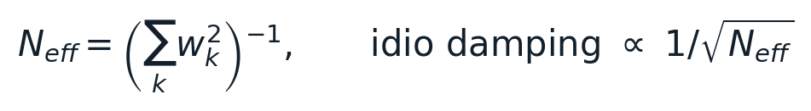
concentration is measured by the effective number of independent holdings — the inverse Herfindahl of the weights. A 3-name memory ETF has N_eff ≈ 3.0; a 40-name AI basket ≈ 9.3; idiosyncratic damping scales with √N_eff, so the narrow basket keeps most of its single-name risk while the broad one averages it away.
HONESTY

12 Verification, validation, and reliability
A model earns trust two ways: by proving its engine computes what it claims (verification), and by showing its claims behave sensibly against history (validation). Both were done — including an independent audit on 2026-06-10 that re-derived the formulas and re-ran the engine from outside its own test suite. This section reports the results, and is equally honest about what they do not prove.

Independent engine audit (2026-06-10)
Check | Method | Result
Output invariants | machine-checked, all 47 names: bounds, monotonicity, complements | 0 violations across 132 matrix rows
Ranking formula | recomputed reward-vs-S&P from raw inputs, unrounded | exact to machine precision; VOO ≡ 1.00
Macro formulas | re-derived composite, fair multiple, freeze severity & duration | all reproduce: 0.482 · 15.8× · 0.71/0.12/0.02
Determinism | two identical runs, full output hashed | bit-identical
Seed-robustness | re-ran engine under a different seed, 9 headline metrics | max |z| = 2.27 — pure sampling noise
Test suite | full invariant suite on fresh artifacts | 102 / 102 pass
Depth backtest | seven historical crises, macro dial set to each eve | 7 / 7 realized falls inside the simulated band

What the invariant suite guards
The 102 tests are not one big assertion — they pin each mechanism separately, so a regression in any layer fails loudly: balance-sheet and dilution logic (17 tests), macro and regime wiring (14), ETF and leverage handling (14), recovery and matrix construction (13), the systemic freeze including its causality rules (9), cyclical demand troughs (7), valuation and the earn-back clock (7), schema and determinism (2), and cross-module consistency invariants (19). Any drift in a calibration constant, a formula, or an output schema breaks a named test.

The historical depth backtest
Setting the macro inputs to the documented eve of each of seven crises — without touching anything else — the simulated drawdown distribution brackets the realized fall in all seven, across regimes as different as a valuation bubble, a funding seizure, a pandemic, and a rate shock:
Episode | Stress | Fair PE | Sim median | Sim p90 | Realized | Verdict
2000 dot-com peak | 59 | 12.1× | −43% | −70% | −49% | captured
2007 GFC eve | 41 | 15.5× | −38% | −64% | −57% | captured
2011 EU debt / downgrade | 45 | 23.5× | −38% | −65% | −19% | captured
2015–16 China / oil | 40 | 22.9× | −36% | −63% | −14% | captured
2018 Q4 tightening | 40 | 19.4× | −38% | −64% | −20% | captured
2020 COVID shock | 39 | 24.6× | −36% | −63% | −34% | captured
2022 rate shock | 50 | 18.0× | −40% | −67% | −25% | captured
Two honest readings. First, this validates the stress-to-depth mechanism, not recovery timing — the macro inputs are documented historical approximations used to test the machinery, not predictions made in advance. Second, the deepest realized fall (2008, −57%) sits inside the band but toward its edge — which is exactly where a genuine tail event should sit, and is the case the systemic-freeze layer exists to handle on the recovery side.
The recovery side is where the systemic-freeze layer earns its place. The reason 2008 is interesting is not depth — it is that a systemic collapse takes years to heal, and a model that lets every name bounce independently would understate that. The freeze layer represents the long, frozen, all-layers recovery explicitly, calibrated so a 2008-type keystone collapse reads as roughly the S&P’s real five-and-a-half-year heal (model ~62 months vs ~66 realized). The depth backtest simply does not score that channel; the calibration check above does.

Findings and limits — stated plainly
Two tail definitions coexist in the codebase. The published tables define the >3y tail as "fell >25% and still underwater ~3.5 years after the trough"; an internal ranking module uses the stricter "fell and never recovered within the 7-year simulation." Each is applied exactly and consistently within its own artifact (verified), and orderings agree — but the columns should be unified under one definition. This document uses the published definition throughout.
Fast-refresh mode is for smoke tests only. The light pipeline runs ~800 paths (sampling error ±1.6 pt) for speed; quoted numbers must always come from full-resolution runs, where sampling error is ≤0.13 pt.
The judgment inputs are the real uncertainty. Expected growth, TAM durability, permanence, and the archetype labels are documented opinions the simulation sweeps — the model makes them explicit and testable, not objective. Crisis correlation (~0.9) is surfaced as a portfolio warning rather than hidden in per-name cells; the reward scaling is growth-tilted and under-penalizes leveraged ETFs, whose ~100% fall odds should be read directly; dividends, fees, and taxes are out of scope.
Solvency channel, validated on outcomes. The impairment logic is checked against real 2021–2024 cases: it separates the names that became permanent impairments from those that recovered, keyed on revenue durability through the trough — the same durable-vs-fragile distinction that drives the dilution haircut.
WHAT THIS MODEL IS — AND ISN’T
It is a probability engine: it tells you how likely a fall is over a horizon, and how likely a recovery is given a fall, with the macro envelope read first and each name’s growth premium and recovery treated on its own terms. It is not a price target, not a market-timing signal, and not a promise. It is a disciplined way to reason about depth, recovery, and the one collapse that overrides everything.

CURRENT SNAPSHOT

Appendix A — The current ranking (2026-06-05)
The full-universe output as of the 2026-06-05 model run. Read tiers and ranges, not decimals — the specific numbers are a dated snapshot and shift slightly as the model is recalibrated; the ordering and the verdicts are what carry. Growth sets the tier; the >3y tail is the chance a >25% fall is still underwater at about 3.5 years; vs-S&P is growth per unit of long-drawdown risk, with the S&P benchmark fixed at 1.00.

MACRO & SYSTEMIC STRESS — 2026-06-05
Composite index | 48 / 100 · moderate (watch-zone)
Structural fragility / acute trigger | 58 / 25
CAPE · real 10y · VIX | 39.4 · 2.25% · 24
Brent · HY spread · margin-debt YoY | $96 · 312 bps · +45%
Reading: scales the crisis odds about ×0.99 — elevated structural fragility, calm acute triggers.

Master ranking — by reward-to-risk (vs S&P, high to low)
The Recovery column is the crash-growth-aware verdict and overrides a flattering vs-S&P number: a "broken — avoid" or "cyclical — rebound-dependent" tag means read the verdict, not the rank.
Name | Type | Tier | Recovery (verdict) | Growth | >3y tail | vs S&P
Astera Labs | stock | High | PEG-fast / MC-uncertain | 70% | 22% | 5.15
NVIDIA | stock | High | PEG-fast / MC-uncertain | 45% | 16% | 4.54
Palantir | stock | High | watch | 55% | 22% | 4.15
Micron | stock | High | cyclical — rebound-dep | 50% | 22% | 3.82
DRAM (Roundhill Memory) | ETF | High | cyclical — rebound-dep | 45% | 20% | 3.72
Broadcom | stock | Mod | diversified / safe | 38% | 17% | 3.64
AMD | stock | High | cyclical — rebound-dep | 45% | 21% | 3.54
CHAT (Roundhill GenAI) | ETF | Mod | diversified / safe | 32% | 16% | 3.36
Lumentum | stock | High | cyclical — rebound-dep | 55% | 28% | 3.30
IonQ | stock | High | broken — avoid | 80% | 42% | 3.16
SMH (VanEck Semis) | ETF | Mod | diversified / safe | 30% | 16% | 3.15
SOXX (iShares Semis) | ETF | Mod | diversified / safe | 28% | 16% | 2.94
Applied Optoelectronics | stock | High | cyclical — rebound-dep | 55% | 32% | 2.81
Marvell | stock | Mod | cyclical — rebound-dep | 35% | 21% | 2.80
AIQ (Global X AI) | ETF | Mod | diversified / safe | 25% | 16% | 2.65
CoreWeave | stock | High | cyclical — rebound-dep | 60% | 45% | 2.18
ARKK (ARK Innovation) | ETF | High | broken — avoid | 42% | 35% | 1.99
AppLovin | stock | Mod | cyclical — rebound-dep | 30% | 26% | 1.92
Meta | stock | Mod | diversified / safe | 18% | 16% | 1.91
Vertiv | stock | Mod | cyclical — rebound-dep | 28% | 25% | 1.87
QTUM (Defiance Quantum) | ETF | Mod | broken — avoid | 22% | 20% | 1.82
ARM | stock | Mod | diversified / safe | 25% | 24% | 1.71
NUKE (Nuclear/Uranium) | ETF | Mod | diversified / safe | 22% | 22% | 1.69
GRID (Smart Grid) | ETF | Mod | diversified / safe | 18% | 18% | 1.61
IGV (Software) | ETF | Mod | diversified / safe | 20% | 22% | 1.52
Coherent | stock | Mod | cyclical — rebound-dep | 25% | 29% | 1.45
Microsoft | stock | Safe | diversified / safe | 14% | 16% | 1.43
QQQ (Nasdaq-100) | ETF | Mod | diversified / safe | 16% | 19% | 1.43
Oracle | stock | Mod | diversified / safe | 16% | 19% | 1.42
VGT (Info Tech) | ETF | Mod | diversified / safe | 15% | 18% | 1.35
DTCR (Data Ctr Infra) | ETF | Safe | diversified / safe | 14% | 18% | 1.29
Alphabet | stock | Safe | diversified / safe | 12% | 19% | 1.04
Amazon | stock | Safe | diversified / safe | 13% | 21% | 1.01
Texas Instruments | stock | Safe | cyclical — rebound-dep | 14% | 23% | 1.00
VOO (S&P 500) | ETF | Safe | diversified / safe | 9% | 15% | 1.00
SCHD (Dividend) | ETF | Safe | diversified / safe | 6% | 10% | 0.96
Tesla | stock | Mod | cyclical — rebound-dep | 17% | 34% | 0.83
Qualcomm | stock | Safe | cyclical — rebound-dep | 8% | 17% | 0.76
Cisco | stock | Safe | diversified / safe | 6% | 14% | 0.70
IBM | stock | Safe | diversified / safe | 5% | 16% | 0.53
Apple | stock | Safe | diversified / safe | 7% | 23% | 0.50
Kioxia | stock | Safe | cyclical — rebound-dep | 5% | 25% | 0.34

Excluded from the ranking — 3× leveraged trading vehicles (path-dependent decay): SOXL, TECL, and TQQQ each carry roughly a 100% chance of a >25% fall and a ~29–30% >3y tail. Read those odds directly; they are not growth holdings.

REFERENCE

Appendix B — Symbols, constants, and definitions
Every constant below is set in one auditable calibration file; changing any of them and re-running reproduces the whole report. Values as of the 2026-06-05 calibration.
Object | Definition | Value / form
S, S_struct, S_acute | composite stress and its two group-weighted sub-indices | 0.482 · 0.583 · 0.246
s_i bands [b_i, c_i] | benign→critical scoring band per macro input | documented per input
m_crisis | crisis-entry multiplier, clip[0.5, 1.8](1+κ(S−S₀)) | ≈ 0.99 today
p₅, λ, π_h | 5-yr systemic base rate → hazard → horizon tail × premium | 5 episodes / 97 yrs
E/P anchor | fair earnings yield at 1.5% real 10y | 5.56% (PE 18×)
PE_base clamp | fair-multiple band from E/P clip [4%, 12%] | [8.3×, 25.0×]; 15.8× today
β_i, σ_i, ν | factor loading, idio vol, Student-t degrees of freedom | per name; ν = 4
ρ_max | crisis correlation ceiling (grind reaches halfway) | 0.92
Horizons | drawdown 6/12/18 m; recovery 6–36 m post-trough; 21 d/mo | 7-yr paths (1,764 d)
N, chunk, seed | Monte Carlo scale and reproducibility | 150,000 · 25,000 · fixed; per-name CRC-32
κ_crash | crash-conditional growth multiplier by archetype | 1.05 / 0.78 / 0.50
Cyclical troughs | demand-down + stabilization, second leg, per theme | 9+6 m 15% · 6+3 m 8% · 4+4 m 6%
Δq_rec | recovery shift: 0.30·RQ − 0.25·FR | bounded; capex docks RQ above 15% CI
Freeze trigger | broad-market drawdown that seizes the plumbing | ≥ 55%
Freeze duration | 30 mo × (0.40 + 0.60·sev) × dependency | 2008 → ~25 mo · 2020 → ~14 mo
Liquidity gate | clip[0.15, 1]((2 − ΔL₃ₘ)/14) | flood → floor; drain → 1
Dependency dep(g) | keystone → platform → disruptive → defensive | 1.00 / 0.80 / 0.65 / 0.35
>3y tail (report) | fell >25% and not recovered within 36 m of trough | published definition
Tail (internal alt.) | fell >25% and never recovered within the 7-yr sim | flagged for unification
R_i (vs S&P) | (g_i / g_VOO) × (tail_VOO / tail_i) | benchmark ≡ 1.00
N_eff | inverse Herfindahl of basket weights, 1/Σw² | DRAM ≈ 3.0 · CHAT ≈ 9.3
SE(p̂) | binomial sampling error √(p(1−p)/N) | ≤ 0.13 pt at N = 150k

RESEARCH MODEL — NOT INVESTMENT ADVICE.
All figures are outputs of a simulation built on documented assumptions and are illustrative of method, not recommendations. Probabilities are frequencies over simulated futures and carry model and calibration uncertainty. Nothing here is a solicitation to buy or sell any security.

