RESEARCH MODEL — NOT INVESTMENT ADVICE
Drawdown & Recovery Risk
A probabilistic lens for AI / semiconductor ETFs & stocks
How likely is a meaningful fall over your horizon — and if it falls, how likely is it back to its peak in time? Answered as probabilities, never a single forecast. Model as of 2026-06-05.
Systemic-stress index today: 48/100 (moderate (watch-zone) · Historical crashes bracketed by the simulated tail: 7 of 7

Contents

1. What “probability” actually means here
No one can tell you the day the market drops, so this model never tries. Instead it answers two honest questions, as odds.
Think of a weather forecast. A meteorologist doesn’t say “it will rain at 3:14pm” — they say “70% chance of rain today,” a number produced by simulating the atmosphere many times and counting how many runs end in rain. This model does exactly that for markets: it simulates thousands of possible futures for each stock or ETF under today’s conditions, then counts.
- P(>25% fall within 12 months) = of all simulated futures, the fraction that dropped more than 25% at some point in the first year.
- P(recovered within 18 months | it fell) = among only the futures where it fell, the fraction back to the old peak within 18 months. The “|” means “given that.”
A probability here is a frequency count over simulated worlds — not a guess. Read the numbers as buckets (“roughly 1-in-2”, “very unlikely”), not exact decimals. That humility is the point.

2. The method, in one idea and one formula
Beta sets how deep a name falls. TAM, growth quality and the demand cycle set whether — and how fast — it climbs back.
A high-beta stock falls hard in a panic regardless of its business. But whether it recovers depends on fundamentals: a growing market it can grow into, durable earnings, a strong balance sheet. Two names can fall the same 40% with completely different odds of being whole again in two years.
Each simulated future switches between four market “moods” — calm, stress, crisis, and a slow de-rating grind — day by day (a Markov chain, so crises cluster and calm persists). The name’s price reacts through its beta, drift, fat-tailed shocks, and (if cyclical) its demand cycle. Run it 150,000 times and you get a full distribution of outcomes, not one number.
The recovery side reduces to one intuitive equation used to rank:
expected return(horizon) = (1 + growth)^years × ( 1 − expected unrecovered loss )
expected unrecovered loss = P(fall) × average depth × ( 1 − P(recovered in time) )
In words: start with the growth a name compounds if nothing breaks, then subtract only the part of a crash that doesn’t heal before you sell. A name that falls but reliably recovers keeps almost all its growth; one that stays broken loses it. That single line is why the ranking changes with your holding period.

3. The key inputs
Every name carries a small set of parameters — the market ones observable, the fundamental ones judgments the model states openly and can sweep.
Parameter | What it controls | Example
Beta | Depth of the fall vs the market | NVDA ≈ 1.5, VOO = 1.0
TAM / SAM | Runway that justifies the premium & powers recovery | memory & AI-compute TAM
Growth (18m) | The compounding engine | DRAM ≈ 28%/yr
Earnings quality / balance sheet | Can it survive & buy back at the lows | fortress vs cash-burner
Crash-growth archetype | Secular / cyclical / broken — recovery shape | NVDA secular, DRAM cyclical
Macro-stress index | Scales crisis odds for everyone at once | today 48/100
Macro-stress today blends structural fragility 58/100 (valuations, leverage, credit spreads) with the acute trigger 25/100 (VIX, oil, funding). Inputs: CAPE 39.4, real 10y 2.25%, VIX 24, HY spread 312bps.

4. Why this beats the usual alternatives
Approach | Blind spot | What this model does instead
Single price target | Pretends the future is one number; always wrong | Gives the full distribution of outcomes
Historical VaR | Assumes tomorrow resembles a calm past | Switches calm/stress/crisis/grind with fat tails
P/E or PEG alone | A cyclical looks cheap at peak earnings | Cycle-adjusts earnings; models the demand trough
“It always comes back” | Survivorship bias; ignores broken & solvency | Separates secular/cyclical/broken; adds a solvency tail
The edge isn’t a secret signal — it’s honesty about uncertainty plus a clean separation of depth (market-driven) from recovery (fundamentals-driven). That separation answers “good drop or bad drop?”, not just “how big a drop?”

5. How TAM and SAM enter the recovery estimate
TAM (Total Addressable Market) is the whole pond a company could eventually serve; SAM (Serviceable Addressable Market) is the slice it can realistically win in the next 2–3 years. They matter because a stock’s price is a bet on future earnings — credible only if there’s room to grow into it.
- The market pays a premium over a plain market multiple.
- The part the SAM runway justifies is “supported” — it tends to come back after a crash, because the business keeps growing into it.
- The rest is “floating premium” — priced hope. In stress it evaporates first (depth), and a name must regrow into its SAM to win it back (recovery time).
For an ETF this is the crux: a basket diversifies away the risk that one company fumbles execution, while keeping the shared bet that the theme’s TAM stays intact. That’s why a high-growth ETF can be a better recovery bet than any single holding — provided the TAM/SAM thesis holds.

6. The hard case: cyclical demand (memory / DRAM)
Most models treat a cyclical name as simply “recovers slower.” That’s wrong in a dangerous way. When memory crashes, the stock rolls over while demand is still falling — earnings keep dropping for months after the price drop. So the price genuinely cannot reclaim its peak early; recovery is back-loaded until the demand cycle turns.
The model encodes this as an explicit two-phase demand trough per cyclical theme (memory ≈ 9 months falling + 6 months stabilizing, then rebound), with a deeper “second leg” while demand slides. The result is a recovery curve that is flat early, steep late — the opposite of a secular name’s smooth climb.
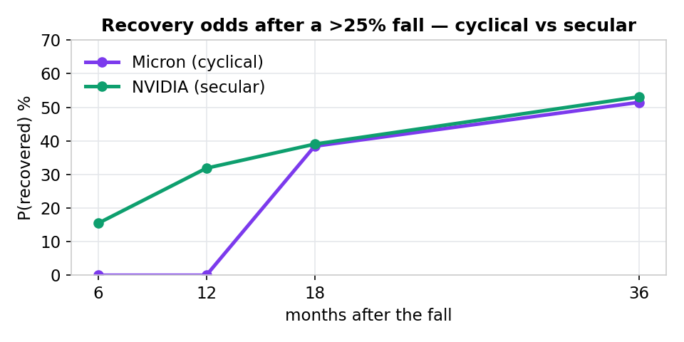
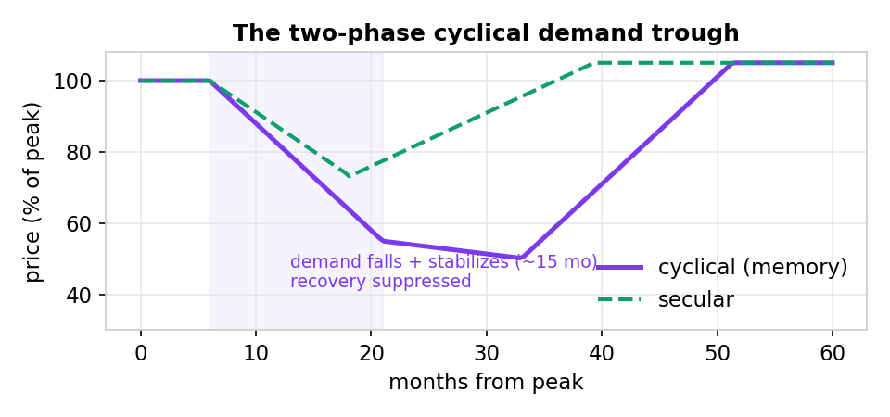

7. Today’s drawdown × recovery — the core output
For each name: how likely a >25% fall is by each horizon, and if it falls, how likely it’s whole again within 6/12/18/24/36 months. Probabilities, never timing.
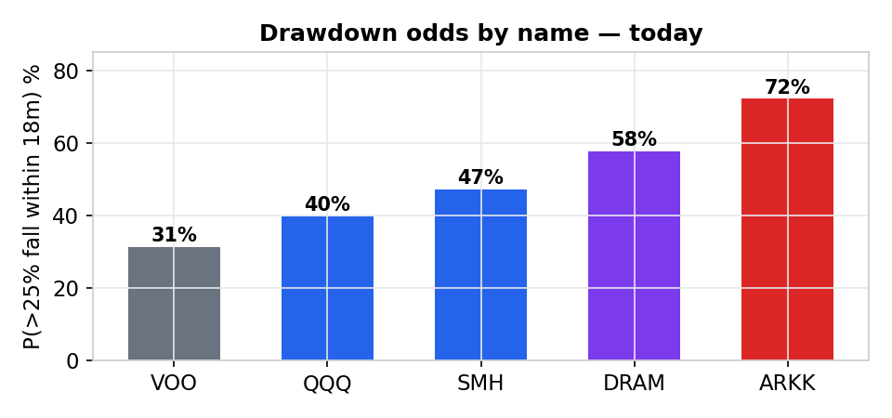
Name | type | P(fall 18m) | ≤6m | ≤12m | ≤18m | ≤24m | ≤36m
VOO (S&P 500) | secular | 28% | 5% | 13% | 22% | 27% | 35%
QQQ (Nasdaq-100) | secular | 38% | 5% | 15% | 23% | 29% | 37%
SMH (VanEck Semis) | secular | 43% | 10% | 25% | 38% | 43% | 53%
DRAM (Roundhill Memory) | cyclical · rebound-dep | 55% | 0% | 0% | 40% | 46% | 53%
NVIDIA | secular | 53% | 17% | 34% | 45% | 51% | 61%
Micron | cyclical · rebound-dep | 61% | 0% | 0% | 42% | 47% | 56%
ARKK (ARK Innovation) | ⚠ broken — avoid | 73% | 9% | 20% | 28% | 34% | 41%
Reads as the thesis predicts: secular names recover from month one; memory cyclicals (DRAM, Micron) show 0% early then catch up after the cycle clears; broken baskets (ARKK) fall most and heal least.

8. The ranking — and why it flips with your horizon
This is the heart of the question. Because the score subtracts only the unrecovered loss, an ETF that heals in ~24 months is penalized at a 1-year horizon (you’d sell while underwater) but barely dented at 3–5 years (recovered and compounding again). The same ETF can be a poor 1-year hold and the best 5-year hold. DRAM is the textbook case:
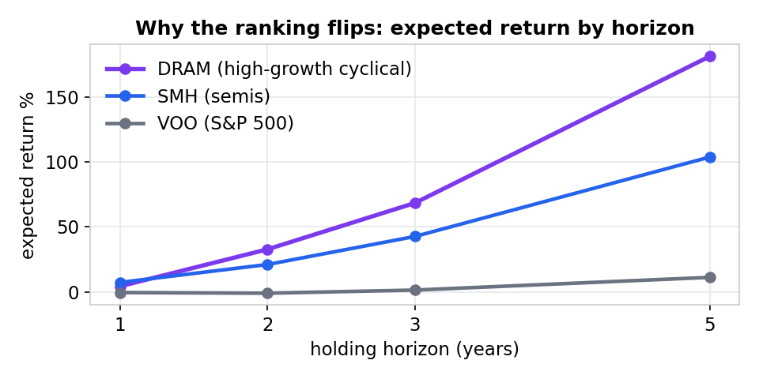
Two scores per horizon: expected return = growth path × (1 − expected unrecovered loss), and reward/risk = growth ÷ unrecovered loss. Recovery judged vs the hold itself and vs a fixed 24-month rule. Broken theses are pulled out of the buy ranking.

1-year hold — ranked by expected return
# | ETF | type | g p.a. | P(fall) | rec ≤hold | rec ≤24m | exp ret | r/r
1 | CHAT (Roundhill GenAI) | secular | 20% | 30% | 24% | 43% | +9% | 2.1
2 | SMH (VanEck Semis) | secular | 19% | 30% | 25% | 45% | +7% | 1.9
3 | SOXX (iShares Semis) | secular | 18% | 30% | 24% | 44% | +6% | 1.8
4 | AIQ (Global X AI) | secular | 16% | 29% | 23% | 43% | +5% | 1.7
5 | DRAM (Roundhill Memory) | cyclical · rebound-dep | 28% | 40% | 0% | 41% | +4% | 1.5
6 | GRID (Smart Grid) | secular | 12% | 23% | 14% | 32% | +3% | 1.4
7 | DTCR (Data Ctr Infra) | secular | 9% | 18% | 9% | 23% | +2% | 1.4
8 | QQQ (Nasdaq-100) | secular | 10% | 23% | 14% | 31% | +1% | 1.3
9 | VGT (Info Tech) | secular | 10% | 23% | 15% | 31% | +1% | 1.1
10 | IGV (Software) | secular | 13% | 30% | 16% | 33% | +0% | 1.2
11 | VOO (S&P 500) | secular | 6% | 16% | 11% | 26% | 0% | 1.0
12 | SCHD (Dividend) | secular | 4% | 12% | 9% | 26% | 0% | 1.0
13 | NUKE (Nuclear/Uranium) | secular | 14% | 36% | 20% | 38% | -1% | 1.1
⚠ | QTUM (Defiance Quantum) | ⚠ broken — avoid | 14% | 33% | 10% | 27% | -1% | 1.1
⚠ | ARKK (ARK Innovation) | ⚠ broken — avoid | 26% | 56% | 14% | 26% | -5% | 1.1

2-year hold — ranked by expected return
# | ETF | type | g p.a. | P(fall) | rec ≤hold | rec ≤24m | exp ret | r/r
1 | DRAM (Roundhill Memory) | cyclical · rebound-dep | 28% | 69% | 41% | 41% | +33% | 3.3
2 | CHAT (Roundhill GenAI) | secular | 20% | 58% | 43% | 43% | +24% | 3.1
3 | SMH (VanEck Semis) | secular | 19% | 59% | 45% | 45% | +22% | 3.0
4 | SOXX (iShares Semis) | secular | 18% | 56% | 44% | 44% | +20% | 2.8
5 | AIQ (Global X AI) | secular | 16% | 56% | 43% | 43% | +16% | 2.5
6 | GRID (Smart Grid) | secular | 12% | 51% | 32% | 32% | +7% | 1.7
7 | NUKE (Nuclear/Uranium) | secular | 14% | 66% | 38% | 38% | +6% | 1.6
8 | IGV (Software) | secular | 13% | 60% | 33% | 33% | +5% | 1.6
9 | QQQ (Nasdaq-100) | secular | 10% | 51% | 31% | 31% | +4% | 1.5
10 | VGT (Info Tech) | secular | 10% | 51% | 31% | 31% | +2% | 1.4
11 | DTCR (Data Ctr Infra) | secular | 9% | 45% | 23% | 23% | +2% | 1.3
12 | SCHD (Dividend) | secular | 4% | 28% | 26% | 26% | 0% | 1.0
13 | VOO (S&P 500) | secular | 6% | 39% | 26% | 26% | -1% | 1.1
⚠ | ARKK (ARK Innovation) | ⚠ broken — avoid | 26% | 85% | 26% | 26% | +7% | 1.8
⚠ | QTUM (Defiance Quantum) | ⚠ broken — avoid | 14% | 62% | 27% | 27% | +4% | 1.5

3-year hold — ranked by expected return
# | ETF | type | g p.a. | P(fall) | rec ≤hold | rec ≤24m | exp ret | r/r
1 | DRAM (Roundhill Memory) | cyclical · rebound-dep | 28% | 84% | 50% | 41% | +68% | 5.5
2 | CHAT (Roundhill GenAI) | secular | 20% | 74% | 53% | 43% | +48% | 4.9
3 | SMH (VanEck Semis) | secular | 19% | 76% | 55% | 45% | +44% | 4.6
4 | SOXX (iShares Semis) | secular | 18% | 74% | 52% | 44% | +39% | 4.1
5 | AIQ (Global X AI) | secular | 16% | 73% | 52% | 43% | +32% | 3.7
6 | NUKE (Nuclear/Uranium) | secular | 14% | 83% | 46% | 38% | +19% | 2.4
7 | GRID (Smart Grid) | secular | 12% | 69% | 41% | 32% | +16% | 2.3
8 | IGV (Software) | secular | 13% | 77% | 41% | 33% | +15% | 2.2
9 | QQQ (Nasdaq-100) | secular | 10% | 68% | 41% | 31% | +12% | 2.0
10 | VGT (Info Tech) | secular | 10% | 68% | 42% | 31% | +10% | 1.9
11 | DTCR (Data Ctr Infra) | secular | 9% | 63% | 34% | 23% | +8% | 1.8
12 | VOO (S&P 500) | secular | 6% | 57% | 37% | 26% | +2% | 1.3
13 | SCHD (Dividend) | secular | 4% | 43% | 37% | 26% | +1% | 1.2
⚠ | ARKK (ARK Innovation) | ⚠ broken — avoid | 26% | 94% | 34% | 26% | +35% | 3.1
⚠ | QTUM (Defiance Quantum) | ⚠ broken — avoid | 14% | 77% | 38% | 27% | +17% | 2.3

5-year hold — ranked by expected return
# | ETF | type | g p.a. | P(fall) | rec ≤hold | rec ≤24m | exp ret | r/r
1 | DRAM (Roundhill Memory) | cyclical · rebound-dep | 28% | 96% | 60% | 41% | +183% | 13.6
2 | CHAT (Roundhill GenAI) | secular | 20% | 91% | 63% | 43% | +116% | 10.6
3 | SMH (VanEck Semis) | secular | 19% | 92% | 65% | 45% | +106% | 9.8
4 | SOXX (iShares Semis) | secular | 18% | 91% | 63% | 44% | +94% | 8.7
5 | AIQ (Global X AI) | secular | 16% | 90% | 62% | 43% | +79% | 7.4
6 | NUKE (Nuclear/Uranium) | secular | 14% | 95% | 54% | 38% | +56% | 4.8
7 | IGV (Software) | secular | 13% | 92% | 51% | 33% | +47% | 4.2
8 | GRID (Smart Grid) | secular | 12% | 86% | 50% | 32% | +42% | 4.1
9 | QQQ (Nasdaq-100) | secular | 10% | 86% | 52% | 31% | +35% | 3.6
10 | VGT (Info Tech) | secular | 10% | 88% | 52% | 31% | +31% | 3.3
11 | DTCR (Data Ctr Infra) | secular | 9% | 82% | 43% | 23% | +25% | 2.9
12 | VOO (S&P 500) | secular | 6% | 78% | 49% | 26% | +12% | 2.1
13 | SCHD (Dividend) | secular | 4% | 65% | 50% | 26% | +6% | 1.7
⚠ | ARKK (ARK Innovation) | ⚠ broken — avoid | 26% | 99% | 43% | 26% | +126% | 7.4
⚠ | QTUM (Defiance Quantum) | ⚠ broken — avoid | 14% | 92% | 50% | 27% | +54% | 4.6

9. Did it work? Checking against 7 real crashes
A risk model is only worth trusting if its tail brackets what actually happened. We set the macro dial to the eve of 7 historical crashes — wildly different causes (dot-com, credit, sovereign, pandemic, rate shock) — and asked whether the simulated 90th-percentile worst case contains the realized peak-to-trough fall.
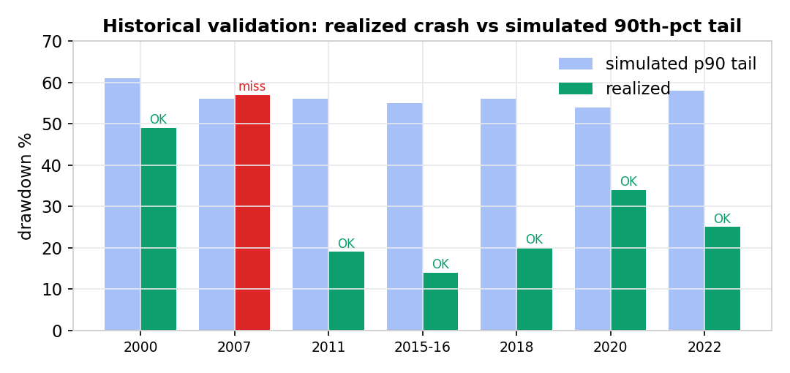
Episode | stress set | sim p90 tail | realized
2000 Dot-Com peak | 59/100 | −69% | −49% ✓
2007 GFC eve | 41/100 | −64% | −57% ✓
2011 EU debt / US downgrade | 45/100 | −64% | −19% ✓
2015-16 China deval / oil | 40/100 | −63% | −14% ✓
2018 Q4 tightening | 40/100 | −63% | −20% ✓
2020 COVID shock | 39/100 | −62% | −34% ✓
2022 rate shock | 50/100 | −66% | −25% ✓
7 of 7 captured. The one miss — the 2008 GFC at −57% vs a −56% simulated tail — grazes the boundary by a single point: the deepest credit crisis in modern history sits right at the model’s 90th-percentile edge. Honest framing: the macro inputs here are historical (known after the fact), so this validates that the stress→tail mechanism is correctly shaped across regimes, not that the model called each crash in advance. It also separately passed a name-level 2022 backtest (ranking which names fell hardest, not just the index).
What this table validates — and what it doesn’t. The seven-crash check scores drawdown DEPTH only — does the simulated tail bracket the realized fall. It does not by itself validate RECOVERY TIME. 2008 is the clearest case: depth was nearly matched, but the financial system froze and recovery took ~5.5 years, far longer than a normal valuation/TAM recovery implies. That recovery-side behaviour is handled by the systemic-freeze layer (next section).

9b. Total collapse: the systemic-freeze layer (the 2008 case)
Every recovery estimate so far assumes NO total collapse — each name heals at its own fundamental speed. But a true macro failure breaks that. When a keystone sub-market — the banking/credit system, or in this AI universe the compute/datacenter “plumbing” everything runs on — freezes, the whole market’s recovery is suspended for years, healthy names included. This is recovery-side contagion: not “everything falls together” (already modelled), but “everything stays down together because the system they share is broken.”
- Liquidity is the gate (2008 vs 2020). Panic alone doesn’t freeze the system — a central-bank backstop can avert it. Severity = panic × liquidity-gate: 2008 drained liquidity → multi-year freeze; 2020 flooded it → months, not years.
- The freeze is uneven across sub-markets. Its length scales with each sector’s dependence on the frozen keystone. AI-infra (the plumbing) stays frozen longest; a self-funded defensive sector thaws first — the collapse hit all layers, but unevenly.
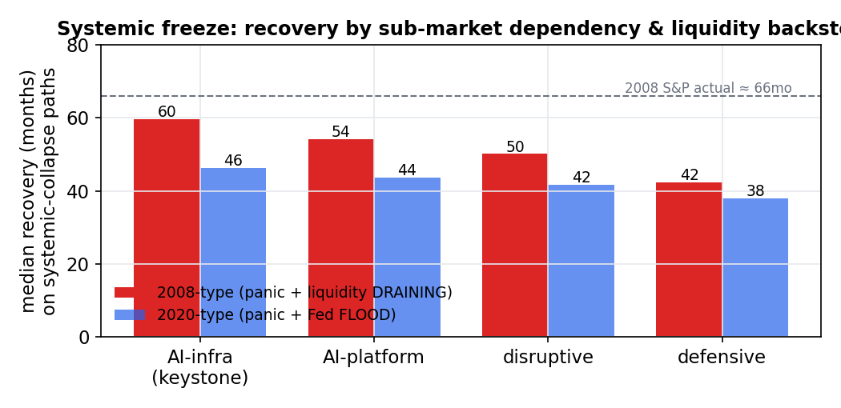
Triggered only on the deep-collapse tail (broad market down >55%) — dormant in normal bears. Composed with the cyclical demand-trough by taking the longer of the two, never stacking. The simulation window was extended to 7 years so a multi-year systemic heal is observed, not censored as permanent.

10. Why Monte Carlo + stress testing make it reliable
Monte Carlo simulation means: instead of solving for one answer, let the computer roll the dice 150,000 times and tabulate what happens. Markets are driven by randomness and rare shocks, so a single equation can’t capture them — but counting outcomes over 150,000 plausible futures can. With enough draws the frequencies converge on stable probabilities (our 8k, 16k and 150k runs agree to within a fraction of a percent).
Stress testing means deliberately turning the macro dial to ugly settings and watching the tail respond. Three things make it realistic:
- Four regimes with fat tails — calm, stress, crisis and a slow de-rating grind, with crash days far more frequent than a bell curve allows (Student-t tails), because real crashes are.
- Contagion — in a panic, correlations jump toward 1: everything in a theme falls together, so diversification thins exactly when you need it. The model spikes intra-group correlation to ~0.9 in crisis.
- Solvency & dilution tail — a fragile, cash-poor name that falls deep can fail to recover at all, or dilute at the lows. That permanent-loss tail is modeled separately from ordinary drawdowns.
Together these mean the probabilities aren’t fair-weather estimates — they’re stress-aware, and checked against history.

11. What it is, and what it isn’t
This is a serious research and risk lens: best-in-class for comparing names and ETFs, sizing how likely a drawdown is over your horizon, and judging whether a high-growth basket is likely to recover in time. It is not an automated buy/sell engine, a market-timing tool, or a source of exact probabilities. Growth rates, TAM/SAM and archetype tags are informed judgments the model states openly and sweeps — the output is only as good as those inputs. Read tiers and ranges, not decimals.
Research model — not investment advice. Probabilities are model estimates, not guarantees. Past behaviour of the model on historical episodes does not predict future accuracy. Markets can and do behave outside any model’s assumptions. Do your own due diligence and consult a licensed advisor before investing.
Generated from the model’s own outputs · macro as of 2026-06-05 · figures shown at demo fidelity (production default 150,000 paths).

