1.0 Overview of the Company
  - History
BrainyBeam Technologies Pvt Ltd is established in 2009-10. We believe to work with less but highly qualified and experienced developers. We have small team of 80+ developers. We follow standard software development process. We are well known for on time delivery of high quality and secure products.
Company follows standard software development process. We are well known for on time delivery of high quality and secure products. We implement standard security protocols for software development.
BrainyBeam is an innovative web and mobile app development company in India and USA that has specialization and expertise in developing Web and Mobile application for organization in various verticals such as Retail, Travel, Construction, Entertainment, Lifestyle, Social Networking and Education.


Experienced Team
Developers love what they do and the people they work with. The team is half-split between developers, designers, quality analysts and project managers. All of them who work at BrainyBeam share the vision and values of development community. Developers are driven by the idea that the best work is born when diligence mixes with fun and creativity mixes with professionalism, which makes their process unique.
 | Certified Developers  Company has highly skilled certified developers in different technologies.  - Java Certified developers  - Microsoft (MCSD)  - Amazon Web Services (AWS Certified Developer - Associate Level)  - Cloudera (CCDH)  - Oracle (APEX)  - Red Hat  - Salesforce Developers  - Scrum.org Professional Scrum Developer I (PSD I)

BrainyBeam understand importance of punctuality in software industry and they believe to deliver high quality and secure products on time.
BrainyBeam have good record to prepare project timeline and deliver work on defined timeline. Team has a good track record in last 5 years. Developers haven’t delayed a single app/web project in past 5 years. BrainyBeam have good combination of technical department and management to make sure that developers are punctual for delivery and client meetings.
 | Management Team  Company has highly experienced management team responsible for project management, sales, delivery and client meetings. There are several causes for project delay from management side. Our team works smart to avoid delays. We have policies for management team to avoid delay in client meetings and project delivery.

  - Different product / scope of work
On the following Technologies company is providing the solution of the clients
 | Android Development  Convert your ideas with Android app! We have highly qualified and experienced team of Android apps development. We have worked on wide range of customized and user friendly

 | iOS Development  Convert your ideas with iOS app! We have elegant team to develop iPhone, iPad, iWatch applications. Our team is capable to work with wide range of customized and user-friendly apps.
 |  | IoT Development  We have elegant team for IoT Development including apps and hardware. We are working on IOT since 2014. Device to device connectivity (Internet of Things) is currently revolutionizing the world.

 | Windows Development  We have experienced small team for Windows development. We deal with Windows desktop, tablet and phone application development. We are working with latest technologies like XAML and AWT.

 | Web Development  We have highly skilled team of web and eCommerce developers. We work with latest technologies like Core PHP, WordPress, Drupal, Joomla, Magento, AngularJS, ROR, Html 5, .NET and Java.

 | Enterprise Solutions  Our team has good understanding of marketplace and enterprise. We never miss our deadline and our team never compromise on our standards to achieve best quality of work

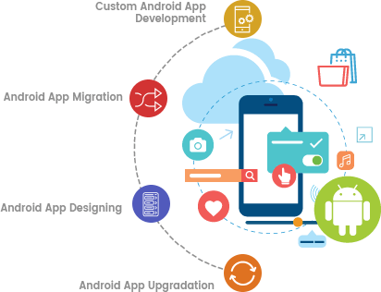 | We offer website development services in affordable price accordingly to the client's expectations completely. Our website development services are the most successful services in providing cost effective solutions for website development solutions. Our web development services are highly reliable, secure and scalable web development application solutions in affordable price accordingly to the expectations of clients completely. Our web development services are highly superior and professional services to reach the global identity for successful business for web development services. We have a team of experienced web developers for PHP, ASP .Net, and Open sources like Joomla, WordPress and Magento and PHP web development software solutions to the clients completely.

Creative design for your website  We gained the experience of working with leading MNCs to build internet-based software application and in turn to increase their efficiency.  As the modern programmers, we are familiar with all the latest techniques of PHP programming with creation of database in My SQL. We make use of the technologies of AJAX application as it can reduce the interaction time online by introducing AJAX Engine as a mediator between the user and the server. The ultimate goal of a successful online endorsement is to have a user-friendly site which is listed top in the search engine results while providing a rich user experience to its visitors. Our qualified team of developers and graphical user interface design experts can blend your portal creation and search engine marketing goals into one organized approach. | 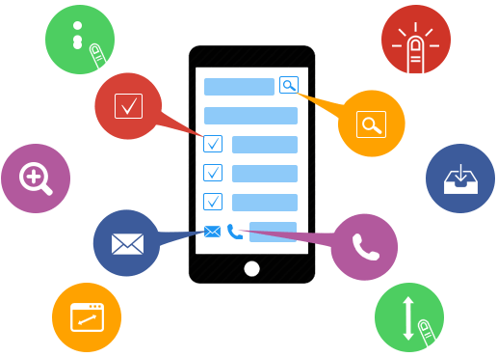
- Gaming Solution  - E-commerce solutions  - Real Estate solutions  - Social networking | - Corporate solutions  - Event solutions  - Health solutions

Website development at BrainyBeam Pvt Ltd.
As a web development company, we provide professional website designing and website development services, ecommerce website development, web application development, web design, offshore website design and development (PhP, Asp.net, MySQL, MS SQL server, java Script, Oracle, HTML/XML, visual basic), Flash design and Development, Flash custom animation, Tutorials, Corporate Presentations, CBTs, Logo Designing Graphics and Print Design Solutions etc. Effectiveness, high motivation, and high level of professional expertise are three major keys, which help [Company's] experienced web application and software developers open the doors to a successful completion of all their projects, from simple to intricate

- Able understand both back-end and front-end development  - Do not specialize in only one back-end technology  - Must follow best exercises  - Apply source control  - Understanding of advertising schemes encompassing the projects | - Invests time in explore and development  - Pliable to change  - Has an exhaustive testing process, including automated tests

  - Organization chart

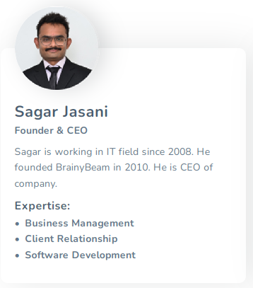 | 

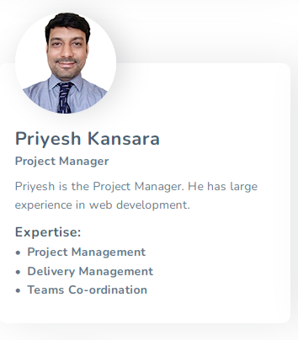 | 

 | 

 | 

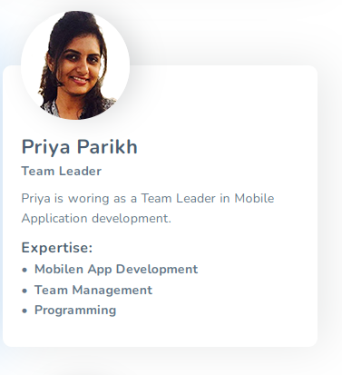 | 

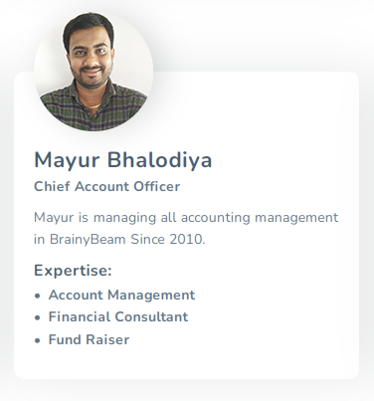 | 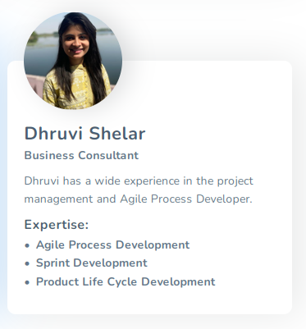

  - Capacity of plant

Process
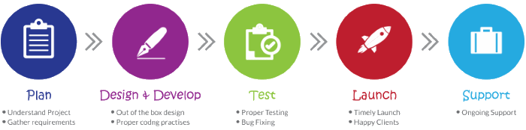

Planning is crucial to ensure expected output and our team of strategists, developers, designers, marketers and administrators hatch out a detailed plan for the entire development process for every single app. WE understand Deeply below points before we start project:
- Understand Concept of Project
- Conceptualizing the Idea
- In-depth Research and Planning
- Requirement And Estimation Approval

Design and Develop
To us, design is much more than just the aesthetics. It's about the functionality. We want your users to have the best experience with your digital business, so we focus on making user experience intriguing, addictive, intuitive and friendly. And With error free, clean coded and highly customizable development being high in demand, we follow agile application development process to address errors and issues with concurrent testing and proactive fixes at every step.
- Study Demographics and Use Cases
- Emotional design with colors
- UX Personalization
- Release Plan
- Coding with stipulated timeframe
- Full stack backend development

Testing
Now starts the real excitement, when you can see your website or app being brought to life! We put the whole developed plan into action by creating a beta version of your product. Each module of the project is scrupulously tested and goes through multiple testing phases under various environments and conditions to ensure the best result.
- Unit Testing
- Desktop/Mobile App Testing
- Web Application Testing
- Prototype Testing
- Test Automation
- Performance Testing
- Functionality and Usability Testing
- Integrated Systems Testing
- Device Compatibility
- Cross-browser Testing
- Cloud-based Testing
- Security Testing

Launch
Get ready to see your finished masterpiece! After all of the testing has been completed and after incremental quality assurance, our experts deploy the end product on respective app stores and web browsers, assuring the passing of the fickle approval process and the standards of the online stores.
- Release to live environment
- Ensure integrity
- Post-deployment maintenance and support

Support
We boast of a highly experienced support team to help our customers achieve business objectives through the app. We ensure guiding your app to success with continuous post development support.
- Lifetime support
- Dedicated team for maintanence
- Dedicated team for bug resolving
- Dedicated developers for future changes

