DOKUMENTACIJA
ServiseRSjson
Web programiranje 2

Milan Stojković 122/23

UVOD
- Sajt je napravljen koristeći: HTML, CSS, Bootstrap, XML, JavaScript.
- Korišćen je templejt sajta sa predmeta Praktikum iz Web programiranj 2.

- Opis funkcionalnosti:

  - Dinamički ispisan navigacioni meni.
  - Dinamički određuje trenutno aktivan link.
  - Dinamički ispis brzih linkova u footeru.
  - Dinamički ispisuje vrste usluga.
  - Tajmer koji ispisuje vreme do kraja popusta.
  - Dinamički ispisuje brendove.
  - Dinamički ispis kartice komponenata(računa cenu sa popustom).
  - Pamti ubačene komponente u korpu.
  - Dinamicki pretražuje komponente, sortira I po potrebi pravi paginaciju.
  - Dinamički kreira radio buttona.
  - Pamti sve informacije za sve korisnike koji su se prijavili prema imejlu.
  - Ispisuje poslednjeg prijavljenog korisnika.
  - Validacija forme:
    - Regular Expression za ime, prezime, email adresu i broj telefona.
    - Proverava da li je izabrana jedna vrsta računara.
    - Dugme potvrdi proverava da li us podaci uneti ispravno i ukoliko nisu ispisuje grešku.
ORGANIZACIJA SAJTA
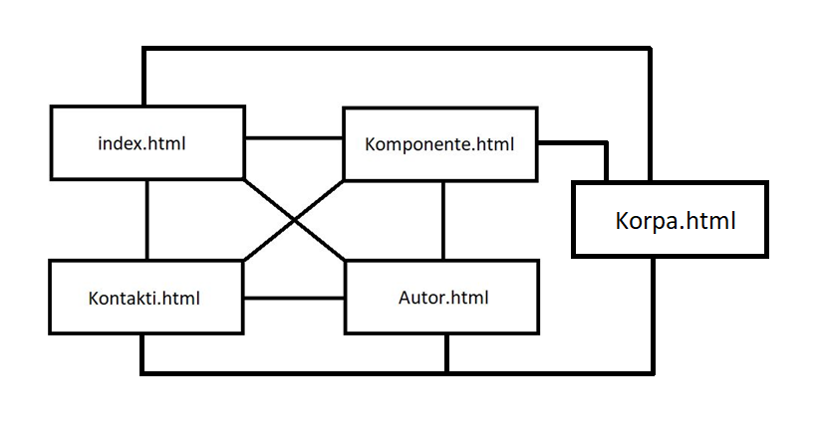

SAJT MAPA
<?xml version="1.0" encoding="UTF-8"?>
<urlset xmlns="http://www.sitemaps.org/schemas/sitemap/0.9">
<url>
<loc>https://milanstojkovic12223.github.io/ServiseRSjson/index.html</loc>
<lastmod>2026-3-24</lastmod>
<changefreq>weekly</changefreq>
<priority>0.80</priority>
</url>
<url>
<loc>https://milanstojkovic12223.github.io/ServiseRSjson/Komponente.html</loc>
<lastmod>2026-3-24</lastmod>
<changefreq>monthly</changefreq>
<priority>0.70</priority>
</url>
<url>
<loc>https://milanstojkovic12223.github.io/ServiseRSjson/Kontakti.html</loc>
<lastmod>2026-3-24</lastmod>
<changefreq>yearly</changefreq>
<priority>0.50</priority>
</url>
<url>
<loc>https://milanstojkovic12223.github.io/ServiseRSjson/Korpa.html</loc>
<lastmod>2026-3-24</lastmod>
<changefreq>yearly</changefreq>
<priority>0.40</priority>
</url>
<url>
<loc>https://milanstojkovic12223.github.io/ServiseRSjson/Autor.html</loc>
<lastmod>2026-3-24</lastmod>
<changefreq>yearly</changefreq>
<priority>0.40</priority>
</url>
</urlset>

SLIKE STRANICA I OPIS FUNKCIONALNOSTI

Dinamički ispisuje linkove u meniju. Belom bojom označava trenutnu stranicu.

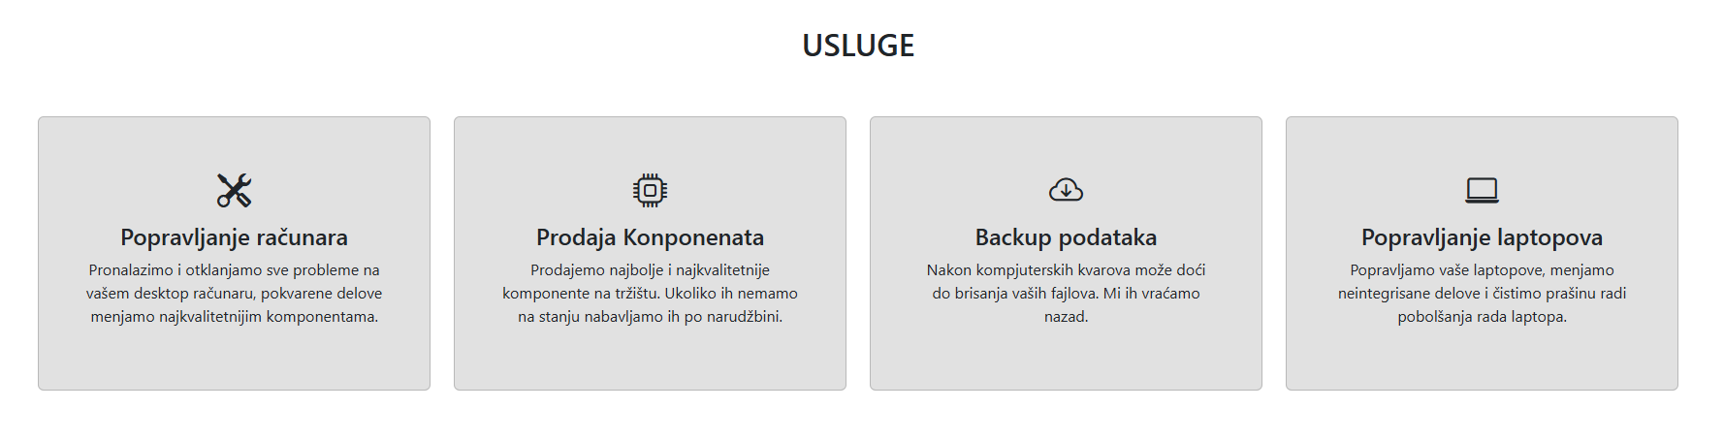
Dinamički ispisuje vrste usluga.

Ispisuje tajmer koji odbrojava vreme do kraja popusta.

Dinamički ispisuje brendove sa kojima sarađujemo.
Dinamički ispisuje brze linkove.

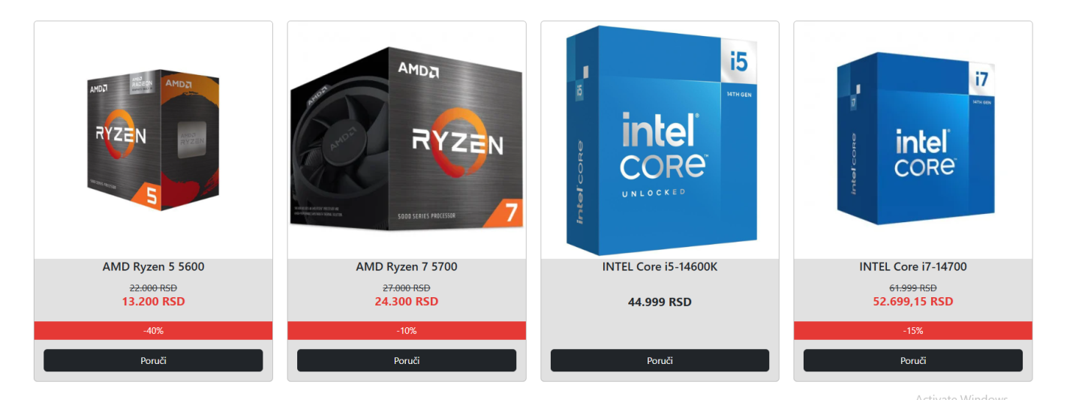
Dinamički kreira i ispisuje kartice sa komponentama.
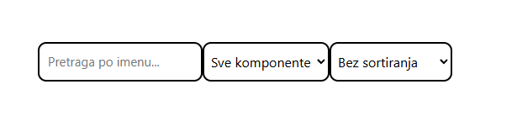
Omogućava pretragu po imenu, kategoriji i sortiranje.
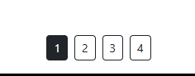
Kreira paginaciju po potrebi.

Link ka korpi, i ispisuje količinu proizvoda u korpi.
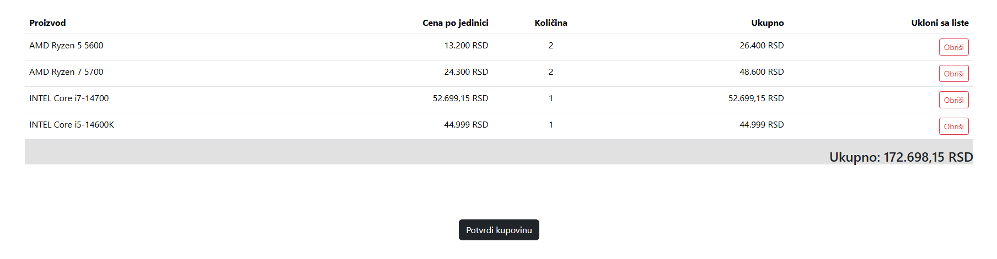
Pamti upisane komponente u korpu, računa ukupnu cenu i omogućava brisanje iz korpe.
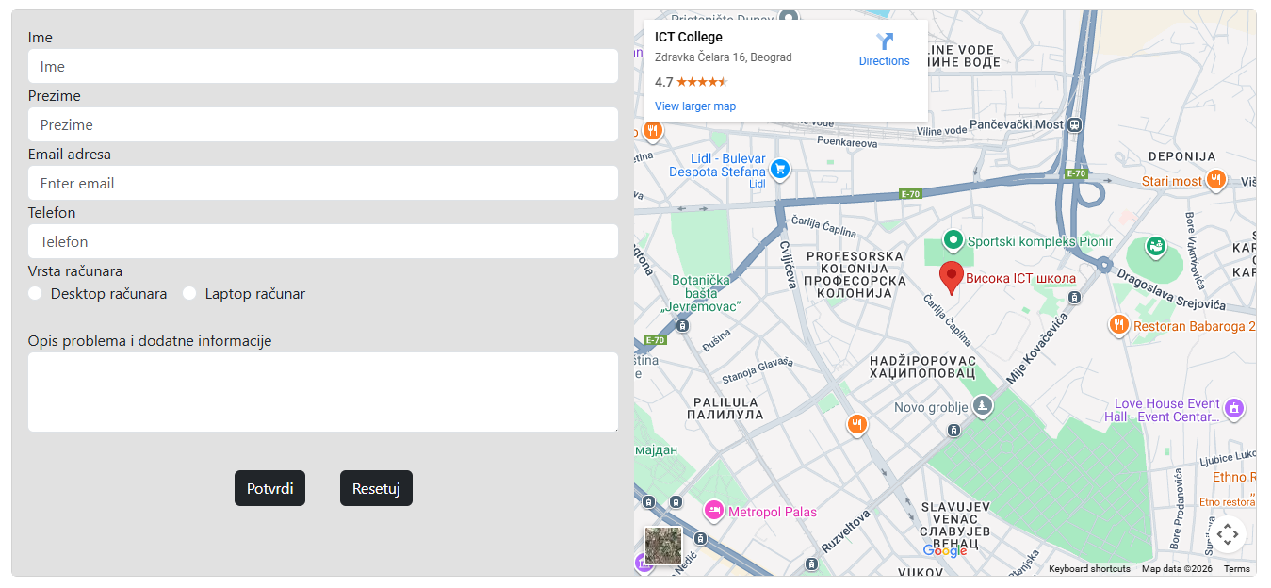
Dinamicki kreira radio button za Vrste računara.
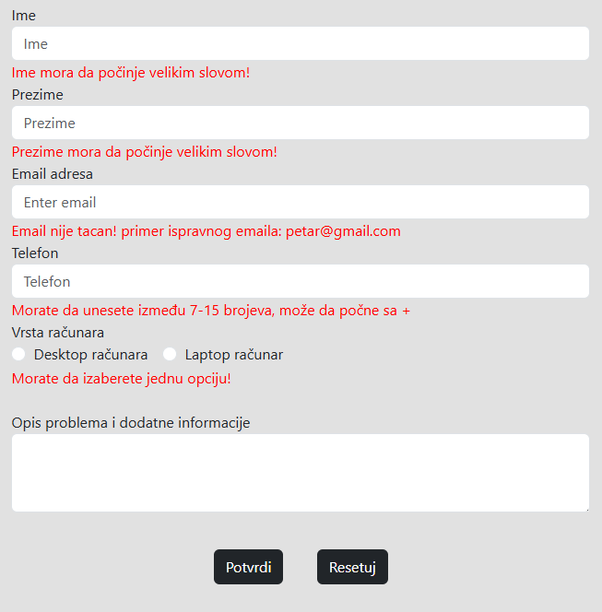
Klikom na dugme Potvrdi proverava ispravnost unetih podataka. Ukoliko je podatak neispravno unešen vraća grešku.
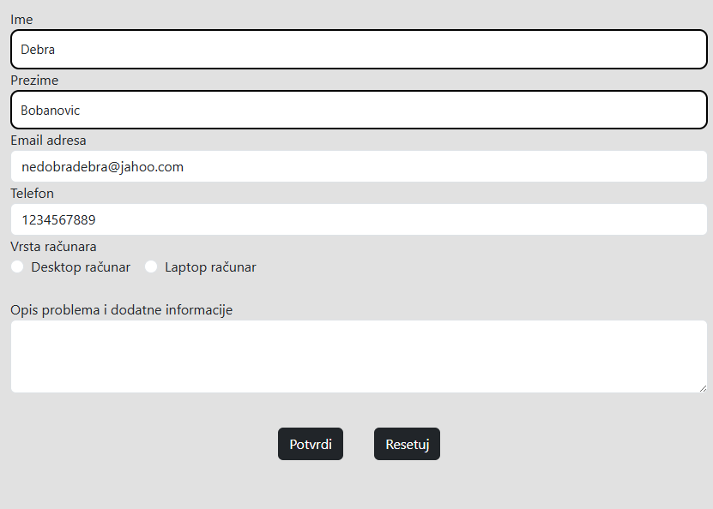
Pamti sve informacije za sve korisnike koji su se prijavili prema imejlu i upisuje podatke poslednjeg prijavljenog gorisnika.

KODOVI
index.html
<!DOCTYPE html>
<html lang="sr">
<head>
<meta charset="UTF-8">
<meta name="viewport" content="width=device-width, initial-scale=1.0">
<meta name="keywords" content="kompjuter, laptop, servis">
<meta name="description" content="Najbolji serviser računara u Srbiji">
<meta name="copyright" content="Milan Stojkoivć @ 2026">
<meta name="language" content="Serbian">

<link rel="icon" type="image/x-icon" href="assets/img/fav.JPG">

<link rel="stylesheet" href="https://cdn.jsdelivr.net/npm/bootstrap-icons@1.10.5/font/bootstrap-icons.css"/>

<link rel="stylesheet" href="assets/css/style.css">
<link rel="stylesheet" href="assets/css/responsive.css">

<link href="https://cdn.jsdelivr.net/npm/bootstrap@5.3.3/dist/css/bootstrap.min.css" rel="stylesheet" integrity="sha384-QWTKZyjpPEjISv5WaRU9OFeRpok6YctnYmDr5pNlyT2bRjXh0JMhjY6hW+ALEwIH" crossorigin="anonymous">
<script src="https://kit.fontawesome.com/646dd2caa7.js" crossorigin="anonymous"></script>

<title>ServiseRS</title>
</head>
<body>

<header>
<nav class="navbar navbar-expand-md navbar-dark bg-dark fixed-top">
<div class="container-fluid">
<a class="navbar-brand" href="index.html">
<img src="assets/img/lg2.JPG" class="d-inline-block align-top mc-logo" alt="logo">
ServiseRS
</a>
<button class="navbar-toggler" type="button" data-bs-toggle="collapse" data-bs-target="#navbarNav" aria-controls="navbarNav" aria-expanded="false" aria-label="Toggle navigation">
<span class="navbar-toggler-icon"></span>
</button>
<div class="collapse navbar-collapse justify-content-end" id="navbarNav">

</div>
</div>
</nav>
</header>

<div id="carouselExampleIndicators" class="carousel slide mc-car-marg-t" data-bs-ride="carousel">
<div class="carousel-indicators">
<button type="button" data-bs-target="#carouselExampleIndicators" data-bs-slide-to="0" class="active" aria-current="true" aria-label="Slide 1"></button>
<button type="button" data-bs-target="#carouselExampleIndicators" data-bs-slide-to="1" aria-label="Slide 2"></button>
<button type="button" data-bs-target="#carouselExampleIndicators" data-bs-slide-to="2" aria-label="Slide 3"></button>
</div>
<div class="carousel-inner">
<div class="carousel-item active" data-bs-interval="3000">
<img src="assets/img/computer-repair.jpg" class="d-block w-100" alt="computer-repair">
<div class="carousel-caption d-none d-md-block ">
<h2>Popravljanje računara</h2>
<p>ServiseRS vrši kompletan servis desktop i laptop računara.</p>
</div>
</div>
<div class="carousel-item" data-bs-interval="3000">
<img src="assets/img/ram.jpg" class="d-block w-100" alt="RAM">
<div class="carousel-caption d-none d-md-block">
<h2>Backup podataka</h2>
<p>Spašavanje izgubljenih podataka sa pokvarenih računara.</p>
</div>
</div>
<div class="carousel-item" data-bs-interval="3000">
<img src="assets/img/asus.jpg" class="d-block w-100" alt="ASUS">
<div class="carousel-caption d-none d-md-block">
<h2>Prodaja Konponenata</h2>
<p>Sve što vam treba na jednom mestu.</p>
</div>
</div>
</div>
<button class="carousel-control-prev" type="button" data-bs-target="#carouselExampleIndicators" data-bs-slide="prev">
<span class="carousel-control-prev-icon" aria-hidden="true"></span>
<span class="visually-hidden">Previous</span>
</button>
<button class="carousel-control-next" type="button" data-bs-target="#carouselExampleIndicators" data-bs-slide="next">
<span class="carousel-control-next-icon" aria-hidden="true"></span>
<span class="visually-hidden">Next</span>
</button>
</div>

<section id="usluge">
<div class="mc-w-90 mx-auto py-5">
<div class="row">
<div class="col-6 mx-auto text-center">
<h2>USLUGE</h2>
</div>
</div>
<div class="row mt-5" id="serviceType">

</div>
</section>

<!--popust-->
<div class="container-fluid">
<div class="mc-w-90 card mb-5 mx-auto">
<div class="row g-0 mc-bg-gray1">

<div class="col-xl-6 col-lg-12 text-center">
<div class="card-body mc-usteda">
<h1 class="card-title">UŠTEDITE DO 40% !</h1>
<h2 class="card-text">PRAZNIČNI POPUST JE STIGAO</h2>
<div id="timerId" class="mc-tajm"></div>
<a href="Komponente.html"><button class="btn btn-md bg-dark text-white" type="button">POGLEDAJ</button></a>
</div>
</div>
<div class="col-xl-6 col-lg-12">
<img src="assets/img/discount1.jpg" class="img-fluid " alt="Popravljanje">
</div>
</div>
</div>
</div>

<div class="container-fluid">
<div class="mc-w-90 card mb-5 mx-auto">
<div class="row g-0 mc-bg-gray1">
<div class="col-xl-6 col-lg-12">
<img src="assets/img/lpt.jpg" class="img-fluid " alt="Popravljanje">
</div>
<div class="col-xl-6 col-lg-12">
<div class="card-body">
<h1 class="card-title mc-ind-ctt">Imate problema sa računarem?</h1>
<p class="card-text">Ako je odgovor na to pitanje da oda je ServiseRS rešenje vaših problema.</br></br> Od nas možete da očekujete da brzo i jeftino rešimo sve vaše probleme. Samo donesite vaš desktop ili laptop računara i u roku da 3 dana će vaš računar raditi ako nov.</p>
<a href="Kontakti.html"><button class="btn btn-md bg-dark text-white" type="button">KONKTAKTI</button></a>
</div>
</div>
</div>
</div>
</div>

<section id="brendovi">
<div class="mc-w-90 mx-auto py-5">
<div class="row">
<div class="col-6 mx-auto text-center">
<h2>BRENDOVI SA KOJIMA SARAĐUJEMO</h2>
</div>
</div>

<div class="row mt-5" id="brandsId">

</section>

<footer class="bg-body-tertiary mt-5 text-center text-lg-start">
<div class="text-center p-1 mc-bg-black text-white">
<p class="mt-3 mx-icon-x" id="footerID"></p>
<p >© 2026 Milan Stojkoivć</p>
</div>
</footer>

<script src="https://cdn.jsdelivr.net/npm/@popperjs/core@2.11.8/dist/umd/popper.min.js" integrity="sha384-I7E8VVD/ismYTF4hNIPjVp/Zjvgyol6VFvRkX/vR+Vc4jQkC+hVqc2pM8ODewa9r" crossorigin="anonymous"></script>
<script src="https://cdn.jsdelivr.net/npm/bootstrap@5.3.3/dist/js/bootstrap.min.js" integrity="sha384-0pUGZvbkm6XF6gxjEnlmuGrJXVbNuzT9qBBavbLwCsOGabYfZo0T0to5eqruptLy" crossorigin="anonymous"></script>
<script src="https://code.jquery.com/jquery-3.7.1.min.js"></script>
<script src="assets/js/main.js"></script>
</body>
</html>

Komponente.html
<!DOCTYPE html>
<html lang="sr">
<head>
<meta charset="UTF-8">
<meta name="viewport" content="width=device-width, initial-scale=1.0">
<meta name="keywords" content="kompjuter, laptop, servis">
<meta name="description" content="Najbolji serviser računara u Srbiji">
<meta name="copyright" content="Milan Stojkoivć @ 2026">
<meta name="language" content="Serbian">

<link rel="icon" type="image/x-icon" href="assets/img/fav.JPG">

<link rel="stylesheet" href="https://cdn.jsdelivr.net/npm/bootstrap-icons@1.10.5/font/bootstrap-icons.css"/>

<link rel="stylesheet" href="assets/css/style.css">
<link rel="stylesheet" href="assets/css/responsive.css">

<link href="https://cdn.jsdelivr.net/npm/bootstrap@5.3.3/dist/css/bootstrap.min.css" rel="stylesheet" integrity="sha384-QWTKZyjpPEjISv5WaRU9OFeRpok6YctnYmDr5pNlyT2bRjXh0JMhjY6hW+ALEwIH" crossorigin="anonymous">
<script src="https://kit.fontawesome.com/646dd2caa7.js" crossorigin="anonymous"></script>

<title>Komponente</title>
</head>
<body class="d-flex flex-column min-vh-100">

<header>
<nav class="navbar navbar-expand-md navbar-dark bg-dark fixed-top">
<div class="container-fluid">
<a class="navbar-brand" href="index.html">
<img src="assets/img/lg2.JPG" class="d-inline-block align-top mc-logo" alt="logo">
ServiseRS
</a>
<button class="navbar-toggler" type="button" data-bs-toggle="collapse" data-bs-target="#navbarNav" aria-controls="navbarNav" aria-expanded="false" aria-label="Toggle navigation">
<span class="navbar-toggler-icon"></span>
</button>
<div class="collapse navbar-collapse justify-content-end" id="navbarNav">
<ul class="navbar-nav">

</div>
</div>
</nav>
</header>

<main class="flex-grow-1">
<h1 class="text-center mc-mt">NAJBOLJI DELOVI NA JEDNOM MESTU</h1>

<div class="cart-div">
<a class="cart-link" href="Korpa.html">
<i class="fa-solid fa-cart-shopping"></i>
<span id="cartCounter" class="badge bg-danger">0</span>
</a>
</div>
<div class="container">
<div class="row justify-content-center g-2">
<input type="text" id="searchInput" class="col-7 col-md-auto" placeholder="Pretraga po imenu..." />

<select id="componentsFilter" class="col-7 col-md-auto">
<option value="all">Sve komponente</option>
</select>

<select id="selectSort" class="col-7 col-md-auto">
<option value="default">Bez sortiranja</option>
<option value="title-asc">Naziv A-Z</option>
<option value="price-asc">Cena rastuce</option>
<option value="price-desc">Cena opadajuce</option>
<option value="discount-desc">Po popustu</option>
</select>
</div>
</main>
<div id="products" class="row mt-5 mc-w-90 mx-auto"></div>
<p id="noResults" class="hidden">Nema komponenata za zadate kriterijume.</p>

<div id="pagination" class="text-center mt-4"></div>

</main>

<footer class="bg-body-tertiary text-center text-lg-start">
<div class="text-center p-1 mc-bg-black text-white">
<p class="mt-3 mx-icon-x" id="footerID"></p>
<p >© 2026 Milan Stojkoivć</p>
</div>
</footer>

<script src="https://cdn.jsdelivr.net/npm/@popperjs/core@2.11.8/dist/umd/popper.min.js" integrity="sha384-I7E8VVD/ismYTF4hNIPjVp/Zjvgyol6VFvRkX/vR+Vc4jQkC+hVqc2pM8ODewa9r" crossorigin="anonymous"></script>
<script src="https://cdn.jsdelivr.net/npm/bootstrap@5.3.3/dist/js/bootstrap.min.js" integrity="sha384-0pUGZvbkm6XF6gxjEnlmuGrJXVbNuzT9qBBavbLwCsOGabYfZo0T0to5eqruptLy" crossorigin="anonymous"></script>
<script src="https://code.jquery.com/jquery-3.7.1.min.js"></script>
<script src="assets/js/main.js"></script>
</body>
</html>

Kontakti.html
<!DOCTYPE html>
<html lang="sr">
<head>
<meta charset="UTF-8">
<meta name="viewport" content="width=device-width, initial-scale=1.0">
<meta name="keywords" content="kompjuter, laptop, servis">
<meta name="description" content="Najbolji serviser računara u Srbiji">
<meta name="copyright" content="Milan Stojkoivć @ 2026">
<meta name="language" content="Serbian">

<link rel="icon" type="image/x-icon" href="assets/img/fav.JPG">

<link rel="stylesheet" href="https://cdn.jsdelivr.net/npm/bootstrap-icons@1.10.5/font/bootstrap-icons.css"/>

<link rel="stylesheet" href="assets/css/style.css">
<link rel="stylesheet" href="assets/css/responsive.css">

<link href="https://cdn.jsdelivr.net/npm/bootstrap@5.3.3/dist/css/bootstrap.min.css" rel="stylesheet" integrity="sha384-QWTKZyjpPEjISv5WaRU9OFeRpok6YctnYmDr5pNlyT2bRjXh0JMhjY6hW+ALEwIH" crossorigin="anonymous">
<script src="https://kit.fontawesome.com/646dd2caa7.js" crossorigin="anonymous"></script>

<title>Kontakti</title>
</head>
<body>

<header>
<nav class="navbar navbar-expand-md navbar-dark bg-dark fixed-top">
<div class="container-fluid">
<a class="navbar-brand" href="index.html">
<img src="assets/img/lg2.JPG" class="d-inline-block align-top mc-logo" alt="logo">
ServiseRS
</a>
<button class="navbar-toggler" type="button" data-bs-toggle="collapse" data-bs-target="#navbarNav" aria-controls="navbarNav" aria-expanded="false" aria-label="Toggle navigation">
<span class="navbar-toggler-icon"></span>
</button>
<div class="collapse navbar-collapse justify-content-end" id="navbarNav">

</div>
</div>
</nav>
</header>

<div class="container-fluid mc-margin">
<div class="mc-w-90 card mb-5 mx-auto">
<div class="row g-0 mc-bg-gray1">
<div class="col-xl-6 col-lg-12">
<div class="card-body">
<form target="_blank" action="index.php" method="get">
<div class="form-group">
<label for="name">Ime</label>
<input type="text" class="form-control" id="name" placeholder="Ime">
<div id="nameErrMsg"></div>
</div>
<div class="form-group">
<label for="surname">Prezime</label>
<input type="text" class="form-control" id="surname" placeholder="Prezime">
<div id="surnameErrMsg"></div>
</div>
<div class="form-group">
<label for="email">Email adresa</label>
<input type="email" class="form-control" id="email" placeholder="Enter email">
<div id="emailErrMsg"></div>
</div>
<div class="form-group ">
<label for="phone">Telefon</label>
<input type="tel" class="form-control" id="phone" placeholder="Telefon">
<div id="phoneErrMsg"></div>
</div>

<label for="computerType">Vrsta računara</label><br>
<div id="computerType">

</div>
<div id="computerTypeErrMsg"></div>
<div class="form-group">
<br>
<label for="exampleFormControlTextarea1">Opis problema i dodatne informacije</label>
<textarea class="form-control" id="exampleFormControlTextarea1" rows="3"></textarea>
</div>
<br>
<div class="text-center">
<button type="submit" class="btn btn-md mx-3 my-3 bg-dark text-white" id="SubmitBut">Potvrdi</button>
<button type="reset" class="btn btn-md mx-3 bg-dark text-white" id="ResetBut">Resetuj</button>
</div>
</form>
</div>
</div>
<div class="col-xl-6 col-lg-12 mc-pom">
<iframe src="https://www.google.com/maps/embed?pb=!1m14!1m8!1m3!1d11321.435429847032!2d20.4844148!3d44.8142534!3m2!1i1024!2i768!4f13.1!3m3!1m2!1s0x475a7a9609031735%3A0xc17ed71f59ac4725!2sICT%20College!5e0!3m2!1sen!2srs!4v1700570699381!5m2!1sen!2srs" width="100%" height="100%" frameborder="0" style="border:0"></iframe>
</div>
</div>
</div>
</div>

<footer class="bg-body-tertiary text-center text-lg-start" >
<div class="text-center p-1 mc-bg-black text-white">
<p class="mt-3 mx-icon-x" id="footerID"></p>
<p >© 2026 Milan Stojkoivć</p>
</div>
</footer>

<script src="https://cdn.jsdelivr.net/npm/@popperjs/core@2.11.8/dist/umd/popper.min.js" integrity="sha384-I7E8VVD/ismYTF4hNIPjVp/Zjvgyol6VFvRkX/vR+Vc4jQkC+hVqc2pM8ODewa9r" crossorigin="anonymous"></script>
<script src="https://cdn.jsdelivr.net/npm/bootstrap@5.3.3/dist/js/bootstrap.min.js" integrity="sha384-0pUGZvbkm6XF6gxjEnlmuGrJXVbNuzT9qBBavbLwCsOGabYfZo0T0to5eqruptLy" crossorigin="anonymous"></script>
<script src="https://code.jquery.com/jquery-3.7.1.min.js"></script>
<script src="assets/js/main.js"></script>
</body>
</html>

Autoru.html
<!DOCTYPE html>
<html lang="sr">
<head>
<meta charset="UTF-8">
<meta name="viewport" content="width=device-width, initial-scale=1.0">
<meta name="keywords" content="kompjuter, laptop, servis">
<meta name="description" content="Najbolji serviser računara u Srbiji">
<meta name="copyright" content="Milan Stojkoivć @ 2026">
<meta name="language" content="Serbian">

<link rel="icon" type="image/x-icon" href="assets/img/fav.JPG">

<link rel="stylesheet" href="https://cdn.jsdelivr.net/npm/bootstrap-icons@1.10.5/font/bootstrap-icons.css"/>

<link rel="stylesheet" href="assets/css/style.css">
<link rel="stylesheet" href="assets/css/responsive.css">

<link href="https://cdn.jsdelivr.net/npm/bootstrap@5.3.3/dist/css/bootstrap.min.css" rel="stylesheet" integrity="sha384-QWTKZyjpPEjISv5WaRU9OFeRpok6YctnYmDr5pNlyT2bRjXh0JMhjY6hW+ALEwIH" crossorigin="anonymous">
<script src="https://kit.fontawesome.com/646dd2caa7.js" crossorigin="anonymous"></script>

<title>O autoru</title>
</head>
<body>

<header>
<nav class="navbar navbar-expand-md navbar-dark bg-dark fixed-top">
<div class="container-fluid">
<a class="navbar-brand" href="index.html">
<img src="assets/img/lg2.JPG" class="d-inline-block align-top mc-logo" alt="logo">
ServiseRS
</a>
<button class="navbar-toggler" type="button" data-bs-toggle="collapse" data-bs-target="#navbarNav" aria-controls="navbarNav" aria-expanded="false" aria-label="Toggle navigation">
<span class="navbar-toggler-icon"></span>
</button>
<div class="collapse navbar-collapse justify-content-end" id="navbarNav">

</div>
</div>
</nav>
</header>

<div class="container-fluid mc-margin">
<div class="mc-w-60 card mb-5 mx-auto">
<div class="row g-0 mc-bg-gray1">
<div class="col-xxl-6 col-auto-12">
<img src="assets/img/Autor.JPG" class="img-fluid mc-img" alt="...">
</div>
<div class="col-xxl-6 col-auto-10">
<div class="card-body">
<h1 class="card-title mc-ctt">Milan Stojković</h1>
<p class="card-text mc-ctxt"><br><br>Student Akademije Tehničko Umetničkih Strukovnih Studija u Beogradu, Odsek Visoka škola za informacione i komunikacione tehnologije.</br>Broj indeksa:122/23</p>

</div>
</div>
</div>
</div>
</div>

<footer class="bg-body-tertiary text-center text-lg-start">
<div class="text-center p-1 mc-bg-black text-white">
<p class="mt-3 mx-icon-x" id="footerID"></p>
<p >© 2026 Milan Stojkoivć</p>
</div>
</footer>

<script src="https://cdn.jsdelivr.net/npm/@popperjs/core@2.11.8/dist/umd/popper.min.js" integrity="sha384-I7E8VVD/ismYTF4hNIPjVp/Zjvgyol6VFvRkX/vR+Vc4jQkC+hVqc2pM8ODewa9r" crossorigin="anonymous"></script>
<script src="https://cdn.jsdelivr.net/npm/bootstrap@5.3.3/dist/js/bootstrap.min.js" integrity="sha384-0pUGZvbkm6XF6gxjEnlmuGrJXVbNuzT9qBBavbLwCsOGabYfZo0T0to5eqruptLy" crossorigin="anonymous"></script>
<script src="https://code.jquery.com/jquery-3.7.1.min.js"></script>
<script src="assets/js/main.js"></script>
</body>
</html>

Korpa.html
<!DOCTYPE html>
<html lang="sr">
<head>
<meta charset="UTF-8">
<meta name="viewport" content="width=device-width, initial-scale=1.0">
<meta name="keywords" content="kompjuter, laptop, servis">
<meta name="description" content="Najbolji serviser računara u Srbiji">
<meta name="copyright" content="Milan Stojkoivć @ 2026">
<meta name="language" content="Serbian">

<link rel="icon" type="image/x-icon" href="assets/img/fav.JPG">

<link rel="stylesheet" href="https://cdn.jsdelivr.net/npm/bootstrap-icons@1.10.5/font/bootstrap-icons.css"/>

<link rel="stylesheet" href="assets/css/style.css">
<link rel="stylesheet" href="assets/css/responsive.css">

<link href="https://cdn.jsdelivr.net/npm/bootstrap@5.3.3/dist/css/bootstrap.min.css" rel="stylesheet" integrity="sha384-QWTKZyjpPEjISv5WaRU9OFeRpok6YctnYmDr5pNlyT2bRjXh0JMhjY6hW+ALEwIH" crossorigin="anonymous">
<script src="https://kit.fontawesome.com/646dd2caa7.js" crossorigin="anonymous"></script>

<title>Korpa</title>
</head>
<body class="d-flex flex-column min-vh-100">

<header>
<nav class="navbar navbar-expand-md navbar-dark bg-dark fixed-top">
<div class="container-fluid">
<a class="navbar-brand" href="index.html">
<img src="assets/img/lg2.JPG" class="d-inline-block align-top mc-logo" alt="logo">
ServiseRS
</a>
<button class="navbar-toggler" type="button" data-bs-toggle="collapse" data-bs-target="#navbarNav" aria-controls="navbarNav" aria-expanded="false" aria-label="Toggle navigation">
<span class="navbar-toggler-icon"></span>
</button>
<div class="collapse navbar-collapse justify-content-end" id="navbarNav">
<ul class="navbar-nav">

</div>
</div>
</nav>
</header>

<main class="flex-grow-1">
<div id="cartDiv" class="shop-div">
</div>
<button type="submit" class="btn btn-md d-block mx-auto my-3 bg-dark text-white mt-auto" data-bs-toggle="modal">Potvrdi kupovinu</button>
</main>

<footer class="bg-body-tertiary text-center text-lg-start">
<div class="text-center p-1 mc-bg-black text-white">
<p class="mt-3 mx-icon-x" id="footerID"></p>
<p >© 2026 Milan Stojkoivć</p>
</div>
</footer>

<script src="https://cdn.jsdelivr.net/npm/@popperjs/core@2.11.8/dist/umd/popper.min.js" integrity="sha384-I7E8VVD/ismYTF4hNIPjVp/Zjvgyol6VFvRkX/vR+Vc4jQkC+hVqc2pM8ODewa9r" crossorigin="anonymous"></script>
<script src="https://cdn.jsdelivr.net/npm/bootstrap@5.3.3/dist/js/bootstrap.min.js" integrity="sha384-0pUGZvbkm6XF6gxjEnlmuGrJXVbNuzT9qBBavbLwCsOGabYfZo0T0to5eqruptLy" crossorigin="anonymous"></script>
<script src="https://code.jquery.com/jquery-3.7.1.min.js"></script>
<script src="assets/js/main.js"></script>
</body>
</html>

style.css
/*index*/
.mc-logo{
width:40px;
}

.mc-usteda{
margin-top: 10%;
}

.mc-w-90{
width: 90%;
}

.mc-tajm{
font-size: 60px;
color: #E53935;
}

.mc-bg-gray1{
background-color: #E1E1E1 !important;
}

.mc-icon-size {
width: 60px;
height: 60px;
}

.mc-icon-size i{
font-size: 35px;
}

.mc-bg-black{
background-color: black;

}

.mx-icon-x{
font-size: 25px;
}

.mc-w-60{
width: 60%;
}
.mc-margin{
margin-top: 8%;
}
.mc-img{
width: 100%;
}
/*Autor*/
.mc-ctt{
margin-top: 50px;
}

.mc-ctxt{
font-size: 25px;
}

/*kontakti*/
.mc-pom{
height: 600px;
}
.mc-margin{
margin-top: 9%;
}

.mc-mt{
margin-top: 8%;
margin-bottom: 5%;
}

/*komponente*/
.discount-price{
font-weight: bold;
color: #E53935;
font-size: 20px;
}

.regular-price{
margin-top: 25px;
font-size: 20px;
font-weight: bold;
}

.discount{
display: inline-block;
background: #E53935;
color: #ffffff;
padding: 4px 8px;
font-size: 15px;
margin-top: 4px;
}

.price-old{
margin-top: 5px;
margin-bottom: -5px;
text-decoration: line-through;
}

.hidden {
display: none;
}

#noResults{
text-align: center;
font-weight: bold;
font-size: 25px;
}
.filterSort{
text-align: center ;
}
input[type="text"],select{
border-radius: 8px;
font-size: 15px;
border: 2px solid black;
border-radius: 10px;
padding: 10px;
}

/*korpa*/

/* korpa */
body {
overflow-x: hidden; /* uklanja horizontalni scroll */
}
.cart-div {
position: fixed;
top: 120px;
right: 35px;
z-index: 100;
}

.cart-div i {
font-size: 25px;
color: #6F6F6F ;
}

.cart-link {
position: relative;
display: inline-block;
}

.cart-div .badge {
position: absolute;
}

.shop-div{
margin: 100px;
background-color: #E1E1E1;
}

responsive.css
@media screen and (max-width: 1340px){
.mc-ind-ctt{
font-size: 22px;
}
.mc-mt{
margin-top: 12%;
}
.mc-usteda{
margin-top: 5%;
}
}

@media screen and (max-width: 850px){
.mc-margin{
margin-top: 15%;
}
.mc-usteda{
margin-top: 1%;
}
.cart-div i {
font-size: 20px;
}
.cart-div {
right: 26px;
}
}

@media screen and (max-width: 700px){
.mc-car-marg-t{
margin-top: 9%;
}
}
@media screen and (max-width: 550px){
.mc-car-marg-t{
margin-top: 11%;
}
.mc-mt{
font-size: 22px;
margin-top: 18%;
}
.mc-h2-v{
font-size: 20px;
}
.mc-tajm{
font-size: 45px;
}
}
@media screen and (max-width: 450px){
.mc-margin{
margin-top: 25%;
}
.mc-ctxt{
font-size: 13px;
}
.mc-ctt{
font-size: 25px;
}
.mc-car-marg-t{
margin-top: 14%;
}

.mc-mt{
font-size: 20px;
margin-top: 22%;
}
.mc-tajm{
font-size: 35px;
}
}

@media screen and (max-width: 365px){
.mc-car-marg-t{
margin-top: 18%;
}
.mc-tajm{
font-size: 28px;
}
}

@media screen and (max-width: 300px){
.mc-car-marg-t{
margin-top: 21%;
}
.mc-mt{
margin-top: 28%;
}
}

main.js
//pocetak
let productsData=[];
let categoriesData=[];
let currentPagePagination = 1;

const PRODUCTS_PER_PAGE = 4;
const BASE_URL="assets/data/";
const CART_KEY="cartKey";
const USER_KEY="userKey";
const MAX_DISCOUNT = 3;
const MAX_REGULAR = 8;

function ajaxCallBack(fileName, onSuccess){
$.ajax({
url: BASE_URL + fileName,
method: "get",
dataType: "json",
success: onSuccess,
error: function(jqXHR, exception){
let msg = "";
if(jqXHR.status === 0){
msg = "Not connect. Verify Network.";
} else if(jqXHR.status == 404){
msg = "Requested page not found. [404]";
} else if(jqXHR.status == 500){
msg = "Internal Server Error [500].";
} else if(exception === "parsererror"){
msg = "Requested JSON parse failed.";
} else if(exception === "timeout"){
msg = "Time out error.";
} else if(exception === "abort"){
msg = "Ajax request aborted.";
} else {
msg = "Uncaught Error: " + jqXHR.responseText;
}
console.log(msg);
}
});
}

window.onload =function(){
onEvent();
initializeCommonPage();
}

function initializeCommonPage(){
try{
ajaxCallBack("menu.json", function(data){
renderNavigation(data);
});

ajaxCallBack("footer.json",renderFooter);

const htmlLocation = window.location.href;

if(htmlLocation.includes("index.html") || window.location.pathname ==="/"){
ajaxCallBack("services.json",renderServices);
ajaxCallBack("associates.json",renderAssociates);
discountTimer();
}

if(htmlLocation.includes("Komponente.html")){
ajaxCallBack("categories.json",function(data){
categoriesData =data;
renderCategories();
});
ajaxCallBack("product.json",function(data){
productsData = data;
renderProduct();
updateCartIcon();
renderCart();
});
}
if(htmlLocation.includes("Kontakti.html")){
renderFormRadioButtons(arrComputerType);
loadUser();
}
if(htmlLocation.includes("Korpa.html")){
ajaxCallBack("product.json",function(data){
productsData = data;
updateCartIcon();
renderCart();
});
}
}catch(error){
console.error("Greška u initializeCommonPage:", error);
alert("Došlo je do greške prilikom učitavanja stranice.");
}

}
//navigacija
function renderNavigation(arrMenu){
let navigationHTML = `<ul class="navbar-nav">`;
for(let objMenu of arrMenu){
navigationHTML +=`<li class="nav-item">
<a ${menuPositioning(objMenu.href)} aria-current="page">${objMenu.name}</a>
</li>`;
}
navigationHTML += `</ul>`;
document.getElementById('navbarNav').innerHTML = navigationHTML;
}

function menuPositioning(menuUrl){

const currentPath = window.location.pathname;

const isActive = currentPath.includes(menuUrl) || currentPath === "/" && menuUrl === "index.html";

return `class="nav-link ${isActive ? "active" : ""}" href="${isActive ? "#" : menuUrl}"`;
}

//footer

function renderFooter(arrFooter){
let footerHtml ="";
for(let objFooter of arrFooter){
footerHtml+=`<a class="text-white" target="_blank" href="${objFooter.href}"><i class="${objFooter.icon}"></i></a>`;
}
document.getElementById("footerID").innerHTML =footerHtml;
}

//Komponente.html

//prikaz kategorija
function renderCategories(){
const start = $("#componentsFilter");
categoriesData.forEach(element =>{
start.append(`<option value="${element.name}">${element.name}</option>`);
})
}
//prikaz delova
function renderProduct(){
const container = $("#products");
const noResults = $("#noResults");

container.empty();

var filteredProducts =getFilter();
filteredProducts = getSort(filteredProducts);

if(filteredProducts.length === 0){
noResults.removeClass("hidden");
document.getElementById("pagination").innerHTML = "";
currentPagePagination = 1;
return;
}
noResults.addClass("hidden");

const startIndex = (currentPagePagination - 1) * PRODUCTS_PER_PAGE;
const endIndex = startIndex + PRODUCTS_PER_PAGE;
const productsForPage = filteredProducts.slice(startIndex, endIndex);

var productHtml ="";
productsForPage.forEach(objProduct =>{
productHtml+=`<div class="col-12 col-lg-3 col-md-6 col-sm-12 mb-4">
<div class="card d-flex flex-column h-100 mx-auto mc-bg-gray1 text-center">
<img class="card-img-top" src="${objProduct.img}" alt="${objProduct.name}">
<h5>${objProduct.name}</h5>
${getPriceHtml(objProduct.price,objProduct.discount)}
<button type="submit" class="btn btn-md mx-3 my-3 bg-dark text-white mt-auto btn-add-cart-item" data-id="${objProduct.id}">Poruči</button>
</div>
</div>`;
});
document.getElementById("products").innerHTML =productHtml;
renderPagination(filteredProducts.length);
}

function getPriceWithDiscount(price, discount){
if (discount === 0) {
return price;
}
return price - (price * discount / 100)
}

function getPriceHtml(price, discount){

if(discount===0){
return `<p class="regular-price">${price.toLocaleString('de-DE')} RSD</p>`;
}

else{
const priceWithDiscount = getPriceWithDiscount(price, discount);
return `<p class="price-old">${price.toLocaleString('de-DE')} RSD</p>
<p class="discount-price">${priceWithDiscount.toLocaleString('de-DE')} RSD</p>
<p class="discount">-${discount}%</p>`;
}
}

// filter i sort
function onEvent(){
$("#searchInput").on("input", function (){
currentPagePagination = 1;
renderProduct();
});
$("#componentsFilter").on("change", function (){
currentPagePagination = 1;
renderProduct();
});
$("#selectSort").on("change", function (){
currentPagePagination = 1;
renderProduct();
});
//regex
$("#SubmitBut").on('click', function(event) {
event.preventDefault();
validateRegex();

});
//paginacija
$(document).on("click", ".btn-page", function(){
currentPagePagination = parseInt($(this).data("page"));
renderProduct();
});

//dodavanje u korpu
$(document).on("click", ".btn-add-cart-item", function(){
adToCart(parseInt($(this).data("id")));
updateCartIcon();
renderCart();
});
//brisanje iz korpte dugme
$(document).on("click", ".btn-delete", function(){
deleteItem(parseInt($(this).data("id")));
});

}

function getFilter(){
const searchInput = $("#searchInput").val().trim().toLowerCase();
const searchComponents = $("#componentsFilter").val();

return productsData.filter(function(products){
const returnInput = products.name.toLowerCase().includes(searchInput);
const returnComponents = searchComponents === "all" || searchComponents === products.type;

return returnInput && returnComponents;
})
}

function getSort(products){
const sortType =$("#selectSort").val();
const arrNewProducts = [...products];

arrNewProducts.sort(function(a,b){

if( sortType==="title-asc"){
return a.name.localeCompare(b.name);
}
if( sortType==="price-asc"){
return getPriceWithDiscount(a.price,a.discount) - getPriceWithDiscount(b.price,b.discount);
}
if( sortType==="price-desc"){
return getPriceWithDiscount(b.price,b.discount) - getPriceWithDiscount(a.price,a.discount);
}
if( sortType==="discount-desc"){
return b.discount - a.discount;
}

return a.id -b.id;
});
return arrNewProducts;
}

//paginacija
function renderPagination(productNumber){
const totalPages = Math.ceil(productNumber / PRODUCTS_PER_PAGE);
let paginationHtml ="";
if(totalPages <=1){
document.getElementById("pagination").innerHTML ="";
return;
}
for(let i = 1; i <= totalPages; i++){
paginationHtml += `<button class="btn btn-sm mb-3 mx-1 ${i === currentPagePagination ? "btn-dark" : "btn-outline-dark"} btn-page" data-page="${i}">
${i}
</button>`;
}
document.getElementById("pagination").innerHTML = paginationHtml;
}

//ls

function saveLs(key, value){
localStorage.setItem(key, JSON.stringify(value));
}

function getLs(key){
const data = localStorage.getItem(key);
if(!data) return [];
try{
return JSON.parse(data);
}
catch(error){
console.error("Greška prilikom parsiranja Local Storage-a za ključ: " + key, error);
return [];
}
}

//korisnici
function getUsers() {
return getLs(USER_KEY) || [];
}

function saveUserData(){
const users = getUsers();
const userData ={
name: checkName.value.trim(),
surname: checkSurname.value.trim(),
email: checkEmail.value.trim(),
phone: checkPhone.value.trim()
}
const exists = users.some(user => user.email === userData.email);
if(exists){
console.log("Korisnik sa ovim emailom već postoji!");
return;
}
users.push(userData);
saveLs(USER_KEY, users);

console.log(JSON.parse(localStorage.getItem(USER_KEY)));
console.log("sacuvan user");
}

function loadUser(){
console.log(JSON.parse(localStorage.getItem(USER_KEY)));
const user = getLs(USER_KEY) || [];
if(user.length){
const userData = user[user.length - 1];
checkName.value = userData.name;
checkSurname.value = userData.surname;
checkEmail.value = userData.email;
checkPhone.value = userData.phone;
}
}

//korpa
function getCart(){
return getLs(CART_KEY) || [];
}
function saveCartData(cart){
saveLs(CART_KEY, cart);
}

function adToCart(getId){
let items = getCart();
let exists = items.find(item => item.productID === getId);
let product = productsData.find(p => p.id === getId);

if(exists){
if(product.discount > 0){
if(exists.quantity >=MAX_DISCOUNT){
alert("Maksimalna kolicina za proizvode na popustu je " + MAX_DISCOUNT);
return;
}
}
else if(product.discount === 0){
if(exists.quantity >=MAX_REGULAR){
alert("Maksimalna kolicina za ovaj proizvod je "+ MAX_REGULAR);
return;
}
}
exists.quantity+=1;
}
else{
items.push({
productID: getId,
quantity: 1
});
}
saveCartData(items);
renderCart();
}

function updateCartIcon(){
let cart = getCart();
let sum = 0;
for(let i = 0; i < cart.length; i++){
sum += cart[i].quantity;
}
let counter = document.getElementById("cartCounter");
if(counter){
counter.textContent = sum;
}
console.log(JSON.parse(localStorage.getItem(CART_KEY)));
}

//korpa.html
function renderCart(){
const cartDiv = document.getElementById("cartDiv");
if(!cartDiv){
return;
}

let cart = getCart();
if(cart.length === 0){
cartDiv.innerHTML = `<p class="alert text-center">Korpa je prazna.</p>`;
return;
}

let total = 0;
let cartHtml = `
<table class="table">
<thead>
<tr>
<th>Proizvod</th>
<th class="text-end">Cena po jedinici</th>
<th class="text-center">Količina</th>
<th class="text-end">Ukupno</th>
<th class="text-end">Ukloni sa liste</th>
</tr>
</thead>
<tbody>
`;

for(let obj of cart){
let item = productsData.find(e => e.id === obj.productID);
if(!item) continue;

let priceWithDiscount = getPriceWithDiscount(item.price, item.discount);
let totalPerItem = priceWithDiscount * obj.quantity;
total += totalPerItem;

cartHtml += `
<tr>
<td>${item.name}</td>
<td class="text-end">${priceWithDiscount.toLocaleString('de-DE')} RSD</td>
<td class="text-center">${obj.quantity}</td>
<td class="text-end">${totalPerItem.toLocaleString('de-DE')} RSD</td>
<td class="text-end">
<button class="btn btn-outline-danger btn-sm btn-delete" data-id="${item.id}">Obriši</button>
</td>
</tr>
`;
}

cartHtml += `
</tbody>
</table>
<div class="text-end">
<h4>Ukupno: ${total.toLocaleString('de-DE')} RSD</h4>

</div>
`;

cartDiv.innerHTML = cartHtml;
}

function deleteItem(id){
var items = getCart().filter(e=> e.productID !== id);
saveLs(CART_KEY, items);
renderCart();
updateCartIcon();
}

//index.html

//usluge

function renderServices(arrService){
var serviceHtml ="";
arrService.forEach(objService =>{
serviceHtml+=`<div class="col-12 col-lg-3 col-md-6 col-sm-12 mb-4">
<div class="card h-100 mx-auto mc-bg-gray1 text-center p-5">
<div class="mc-icon-size mx-auto ">
<i class="${objService.icon}"></i>
</div>
<h4>${objService.title}</h4>
<p>${objService.text}</p>
</div>
</div>`;
});
document.getElementById("serviceType").innerHTML =serviceHtml;
}

//brendovi
function renderAssociates(arrAssociates){
var associatesHtml ="";
arrAssociates.forEach(objAssociates =>{
associatesHtml+=`<div class="col-12 col-lg-3 col-md-6 col-sm-12 mb-4">
<div class="card h-100 mx-auto mc-bg-gray1 text-center">
<a href="${objAssociates.href}"><img src="${objAssociates.img}" class="w-100" alt="${objAssociates.alt}"></a>
</div>
</div>`;
});
document.getElementById("brandsId").innerHTML =associatesHtml;
}

//tajmer
function discountTimer(){
const TIMER_DATE = new Date("Apr 28, 2026 23:59:59").getTime();

setInterval(function(){
let todaysDate = new Date().getTime();
let timeBetween = TIMER_DATE - todaysDate;

let days = Math.floor(timeBetween / (1000 * 60 * 60 * 24));
let hours = Math.floor((timeBetween % (1000 * 60 * 60 * 24)) / (1000 * 60 * 60));
let minutes = Math.floor((timeBetween % (1000 * 60 * 60)) / (1000 * 60));
let seconds = Math.floor((timeBetween % (1000 * 60)) / 1000);
if(document.getElementById('timerId')){
document.getElementById('timerId').innerHTML = days + "d " + hours + "h " + minutes + "m " + seconds + "s";
}

},1000);
}

//Kontakti.html

//ispis radio button-a
let arrComputerType = ["Desktop","Laptop"];

function renderFormRadioButtons(arrComputerType){
let radioButtonHtml ="";
arrComputerType.forEach(element =>{
radioButtonHtml+=`<div class="form-check form-check-inline">
<input class="form-check-input" type="radio" name="Racunar" id="${element}" value="${element}">
<label class="form-check-label" for="${element}">${element} računar</label>
</div>`;
})
document.getElementById("computerType").innerHTML=radioButtonHtml;
}

//forma

//hvatanje potrebnih elemenata
const checkName =document.getElementById('name');
const checkSurname =document.getElementById('surname');
const checkEmail =document.getElementById('email');
const checkPhone =document.getElementById('phone');

const submitButton = document.getElementById('SubmitBut');

const nameError =document.getElementById('nameErrMsg');
const surnameError =document.getElementById('surnameErrMsg');
const emailError =document.getElementById('emailErrMsg');
const phoneError =document.getElementById('phoneErrMsg');
const computerTypeError = document.getElementById('computerTypeErrMsg');

//regex
const REGEX_PHONE = /^(\+)?[0-9]{7,15}$/;
const REGEX_EMAIL = /^[\w\d\.]+@[\w\d\.]+\.[a-zA-Z\d]{2,}$/;
const REGEX_NAME =/^[A-ZŠĆČŽĐ][a-zčćžšđ]{1,9}$/;

//provera unosa

function validateField(value, regex, errorElement, message) {
if (!regex.test(value)) {
errorElement.textContent = message;
errorElement.style.color = 'red';
return false;
} else {
errorElement.textContent = '';
return true;
}
}

function validateRegex() {
let isValid = true;

// Ime
if (!validateField(checkName.value, REGEX_NAME, nameError, 'Ime mora da počinje velikim slovom!')) {
isValid = false;
}

// Prezime
if (!validateField(checkSurname.value, REGEX_NAME, surnameError, 'Prezime mora da počinje velikim slovom!')) {
isValid = false;
}

// Email
if (!validateField(checkEmail.value, REGEX_EMAIL, emailError, 'Email nije tačan! Primer: petar@gmail.com')) {
isValid = false;
}

// Telefon
if (!validateField(checkPhone.value, REGEX_PHONE, phoneError, 'Morate da unesete 7-15 brojeva, može da počne sa +')) {
isValid = false;
}

// Vrsta računara
const selectedComputer = document.querySelector('input[name="Racunar"]:checked');
if (!selectedComputer) {
computerTypeError.textContent = 'Morate da izaberete jednu opciju!';
computerTypeError.style.color = 'red';
isValid = false;
} else {
computerTypeError.textContent = '';
}

// Ako je sve validno
if (isValid) {
saveUserData();
}
}

associates.json
[
{
"img": "assets/img/apple-lg.jpg",
"href": "https://www.apple.com/",
"alt": "apple-logo"
},
{
"img": "assets/img/asus-lg.jpg",
"href": "https://www.asus.com/",
"alt": "asus-logo"
},
{
"img": "assets/img/hp-lg.jpg",
"href": "https://www.hp.com/us-en/home.html",
"alt": "HP-logo"
},
{
"img": "assets/img/lg-lg.jpg",
"href": "https://www.lg.com/us",
"alt": "LG-logo"
}
]

categories.json
[
{
"name": "Procesori"
},
{
"name": "Matične ploče"
},
{
"name": "Grafičke karte"
},
{
"name": "Memorija"
}
]

footer.json
[
{
"href": "https://twitter.com/",
"icon": "bi mx-3 bi-twitter"
},
{
"href": "sitemap.xml",
"icon": "bi mx-3 bi-diagram-3-fill"
},
{
"href": "DOKUMENTACIJA.pdf",
"icon": "bi bi-file-earmark-fill"
},
{
"href": "Servisiranje racunara.zip",
"icon": "bi bi-file-earmark-zip-fill"
}
]

menu.json
[
{
"href": "index.html",
"name": "Početna"
},
{
"href": "Komponente.html",
"name": "Komponente"
},
{
"href": "Kontakti.html",
"name": "Kontakti"
},
{
"href": "Autor.html",
"name": "O autoru"
},
{
"href": "DOKUMENTACIJA.pdf",
"name": "Dokumentacija"
}
]

product.json
[
{
"id": 1,
"img": "assets/img/amd3.jpg",
"name": "AMD Ryzen 5 5600",
"price": 22000,
"discount": 40,
"type": "Procesori"
},

{
"id": 2,
"img": "assets/img/amd8.webp",
"name": "AMD Ryzen 7 5700",
"price": 27000,
"discount": 10,
"type": "Procesori"
},

{
"id": 3,
"img": "assets/img/i5-2.jpg",
"name": "INTEL Core i5-14600K",
"price": 44999,
"discount": 0,
"type": "Procesori"
},

{
"id": 4,
"img": "assets/img/i7.webp",
"name": "INTEL Core i7-14700",
"price": 61999,
"discount": 15,
"type": "Procesori"
},

{
"id": 5,
"img": "assets/img/mp1.webp",
"name": "MSI PRO A620M-E",
"price": 10999,
"discount": 20,
"type": "Matične ploče"
},

{
"id": 6,
"img": "assets/img/mp2.jpg",
"name": "ASROCK B650 PRO",
"price": 32999,
"discount": 40,
"type": "Matične ploče"
},

{
"id": 7,
"img": "assets/img/mp3.jpg",
"name": "GIGABYTE Z790",
"price": 34999,
"discount": 10,
"type": "Matične ploče"
},

{
"id": 8,
"img": "assets/img/mp4.jpg",
"name": "ASUS PRIME X670",
"price": 29999,
"discount": 0,
"type": "Matične ploče"
},

{
"id": 9,
"img": "assets/img/gk1.jpg",
"name": "MSI RTX4060Ti Ventus ",
"price": 64999,
"discount": 20,
"type": "Grafičke karte"
},

{
"id": 10,
"img": "assets/img/gk2.jpg",
"name": "GIGABYTE GeForce RTX4070 12GB",
"price": 99999,
"discount": 40,
"type": "Grafičke karte"
},

{
"id": 11,
"img": "assets/img/gk3.jpg",
"name": "ASUS GeForce RTX4060 DDR6",
"price": 69999,
"discount": 40,
"type": "Grafičke karte"
},

{
"id": 12,
"img": "assets/img/gk4.jpg",
"name": "GIGABYTE RTX4060 8G GV-3 DDDR6",
"price": 69999,
"discount": 0,
"type": "Grafičke karte"
},

{
"id": 13,
"img": "assets/img/mm1.jpg",
"name": "KINGSTON Fury Beast 16GB DDR5 6000MHz",
"price": 9999,
"discount": 40,
"type": "Memorija"
},

{
"id": 14,
"img": "assets/img/mm2.jpg",
"name": "KINGSTON Fury Beast 32GB DDR5 6000MHz",
"price": 16999,
"discount": 0,
"type": "Memorija"
},

{
"id": 15,
"img": "assets/img/mm3.jpg",
"name": "KINGSTON Fury Beast 16GB DDR5 6000MHz",
"price": 8999,
"discount": 20,
"type": "Memorija"
},

{
"id": 16,
"img": "assets/img/mm4.jpg",
"name": "KINGSTON Fury Beast 32GB DDR5 5200MHz",
"price": 14999,
"discount": 10,
"type": "Memorija"
}
]

services.json
[
{
"icon": "bi bi-tools",
"title": "Popravljanje računara",
"text": "Pronalazimo i otklanjamo sve probleme na vašem desktop računaru, pokvarene delove menjamo najkvalitetnijim komponentama."
},
{
"icon": "bi bi-cpu",
"title": "Prodaja Konponenata",
"text": "Prodajemo najbolje i najkvalitetnije komponente na tržištu. Ukoliko ih nemamo na stanju nabavljamo ih po narudžbini."
},
{
"icon": "bi-cloud-arrow-down",
"title": "Backup podataka",
"text": "Nakon kompjuterskih kvarova može doći do brisanja vaših fajlova. Mi ih vraćamo nazad."
},
{
"icon": "bi bi-laptop",
"title": "Popravljanje laptopova",
"text": "Popravljamo vaše laptopove, menjamo neintegrisane delove i čistimo prašinu radi pobolšanja rada laptopa."
}
]

