

**Tribhuvan University**

**Faculty of Humanities and Social Science**

**A PROJECT PROPOSAL ON**

**STUDENT RESULT MANAGEMENT SYSTEM**

**Submitted to**

**Department of Computer Application**

**Patan Multiple Campus**

**Patan Dhoka, Lalitpur**

***“In partial fulfillment of the partial requirement for the Bachelor in Computer Application”***

**Submitted by**

Rohan Thapa

Year/part: 2078/Fourth Semester

University Registration Number: 6-2-22-51-2021

Roll number:18/078

Date: 2080/09/13



**Tribhuvan University**

**Faculty of Humanities and Social Science**

**Patan Multiple Campus**

**Patan Dhoka, Lalitpur**

# LETTER OF APPROVAL

This is to certify that this project prepared by **Rohan Thapa** entitled “**Student Result Management System”** in partial fulfillment of the requirements for the degree f Bachelor in Computer Application (BCA) has been evaluated. In our opinion it is satisfactory in the scope and quality as a project for the required degree.

……………………. ………………………. ….……………………..

Mr. Bhoj Raj Joshi Mr. Roshan Tandukar Mr. Basanta Chapagain

Program Coordinator Faculty Member Faculty Member

Patan Multiple Campus Patan Multiple Campus Patan Multiple Campus

Patan Dhoka, Lalitpur Patan Dhoka, Lalitpur Patan Dhoka, Lalitpur

# Contents

LETTER OF APPROVAL i

Contents ii

List of Figures iii

Student Management System 1

1. Introduction 1

2. Problem Statement 1

3. Objectives 2

4. Methodology 2

4.1 Requirement Identification: 3

4.1.1 Study of existing system 3

4.1.2 Requirement Collection 3

4.1.2.1 Functional Requirements 3

4.1.2.2 Non-functional Requirement 4

4.2 Feasibility Study: 5

4.2.1 Technical Feasibility: 5

4.2.2 Operational Feasibility: 5

4.2.3 Economic Feasibility: 5

4.3 High level Design of System 6

4.3.1 System Analysis and Design 6

4.3.1.1 Data Modeling (ER-Diagram) 6

4.3.1.2 Process Modeling (DFD) 6

5. Gantt Chart 9

6. Expected Outcome 9

Reference 11

# List of Figures

Figure 1:Waterfall Model for Student management system 2

Figure 2:Use Case diagram for student management system 4

Figure 3: ER-Diagram of Student Management System 6

Figure 4: Level-0 DFD of Student Management System 7

Figure 5:Level 1 DFD of Student Management System 8

Figure 6:Gantt chart for Project Timeline 9

# Student Result Management System

# Introduction

The Student Result Management System is a web-based tool designed to automate the administration of students result by tracking students' grades. The system is intended to replace manual work and optimize the result preparation process, providing an easy-to-understand explanation of exam results for both administrators and students.

Student Result management systems provide capabilities for managing students results based on class and courses; documenting grading, transcripts of academic achievement and co-curricular activities, and forming student schedules. The system is divided into three modules- Student, Teacher and Administrator

The faculty member based on their class and student inserts result of student of different subject of different exam which the student can view it. A result management system helps teachers to make a customized plan for the students and helps in improving their learning. The system helps to save time in processing students’ results as the data will be accessible online which ultimately helps teachers to be more focused on teaching.

# Problem Statement

Traditional methods of providing student results often encounter issues related to inefficiency and lack of transparency. Manually calculating grades and recording data can be time-consuming and prone to errors. Paper-based records are easily lost or damaged, and students may not receive their results promptly, hindering further academic decisions.

Furthermore, traditional methods can limit accessibility and communication. Students may only have access to their results during specific times and locations, making it difficult to track their progress. Communication and feedback exchange between students, teachers, and administrators can also be hindered. Analyzing and tracking student performance data effectively becomes a challenge due to the limitations of these traditional methods.

These issues negatively impact all stakeholders. Students experience frustration and delays, teachers spend valuable time on administrative tasks rather than focusing on instruction, and administrators face limitations in data analysis and decision-making. Implementing a digital Student Result Management System can address these concerns, fostering efficiency, transparency, and accessibility for all involved.

# Objectives

The objective of Student Result Management System (SRMS) is multiple, aiming to address grading aspect of educational institute and student. The objectives are:

1. To reduce paperwork and manual effort in providing student result
2. To provide students with easy access to their results

# Methodology

In working on this project, I've opted for the waterfall model due to its clear and step-by-step approach. It suits the needs because of a well-defined understanding of the project requirements from the start, and I want to progress through each phase in a linear manner. Additionally, I've chosen structured analysis and design as it helps me visually map out the system before diving into development. This approach allows me, as a solo developer, to break down the complexity of the project into understandable components, making it easier to manage and modify as necessary. The structured methodology ensures that my system is well-organized and easy to comprehend throughout the development process.

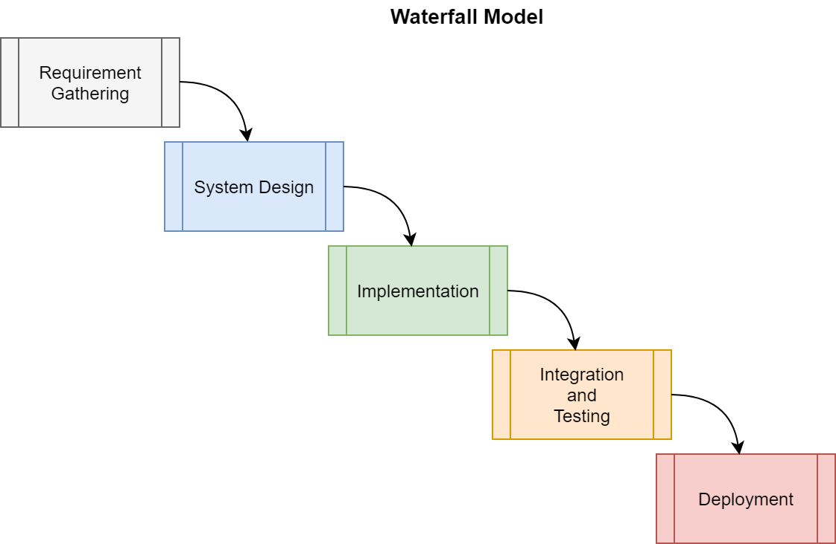

**Figure 1:Waterfall Model for Student Result management system**

## **Requirement Identification**:

### Study of existing system

The currently existing Student Result Management System (SRMS) functions as a digital tool for educational institutions, covering enrollment, academic records, and exams. It accommodates administrators, teachers, students, and parents with distinct roles. There are many systems such as Neverskip’s result management system, MyClassboard, Edufar , Fedena etc.

Neverskip’s result management system is a comprehensive solution that simplifies the process of managing exam results. The system offers several features that make it easy to customize report cards, track student progress, and generate performance analysis reports. However, it is difficult to use and require an initial training for teachers. [1]

MyClassCampus is a cloud-based school management software that offers a user-friendly result management system. It has an automated grading system and online examination system that makes the result generation process seamless for schools. But those systems are expensive and difficult.

### Requirement Collection

Student Management System (SRMS) aims to enhance the student grading process of educational institution, increasing efficiency and transparency. The requirement collection includes both functional and non-functional aspects, ensuring a comprehensive solution.

#### Functional Requirements

* **For Admin**
  1. The system should allow admin to securely log in with unique credentials.
  2. Admin should be able to add, modify or deactivate user accounts.
  3. A system should have good dashboard displaying detailed information and system status.
  4. Admin should be able to send notices to students and teacher.
* **For Teacher**
  1. Secure Login for teachers with role-based access
  2. Access to input and manage student grades.
* **For Student**
  1. Secure login for student with access to personal data.
  2. Student should be able to view and update personal information.
  3. Access to exam grades and transcripts.

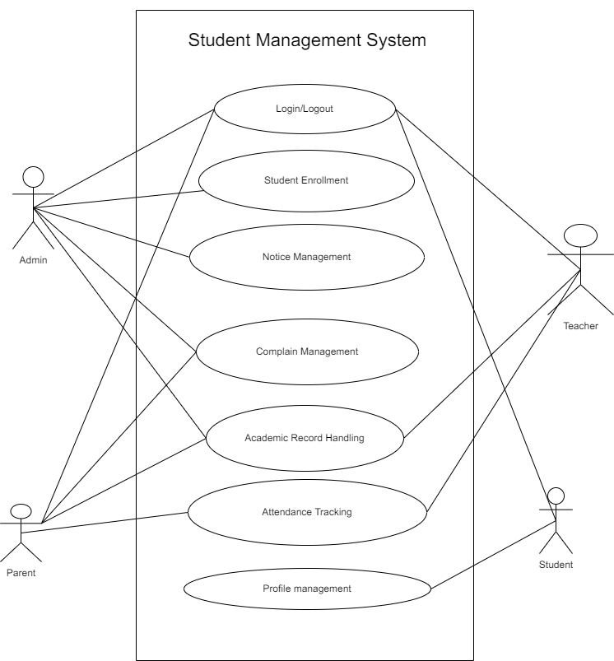

**Figure 2:Use Case diagram for student result management system**

#### Non-functional Requirement

* **Performance**

Student Management System (SMS) must have optimal performance even with heavy load in the system and handle high number of users.

* **Security**

SMS system must have robust security measure to protect student sensitive information

* **Scalability**

The system must be expandable in the coming future with data volume, number of students and data and other features with more of students’ requirement as well.

* **Reliability**

This system must be reliable with minimal downtime while maintenance with proper management of data and reliable backups.

* **Usability**

The system must have user-friendly interfaces that is easy to operate and navigate.

* **Availability**

The system must be available 24/7 with minimal down time.

In conclusion, the functional and non-functional requirements must be considered while developing a SRMS system for efficient performance.

## Feasibility Study:

A feasibility study for the proposed SRMS would access where the system is viable and practical to implement. The following factors should be considered.

### Technical Feasibility:

The technology used for building this system are pretty basic. It uses basic programming languages with suitable libraries that will be able to achieve the aimed result. All the existing open-source resources can be used for developing and maintaining system.

### Operational Feasibility:

Student Result management system should be easy to operate and user-friendly and won’t require any specific skills to operate. Even teacher or parents with some basic knowledge can easily use it.

### Economic Feasibility:

Student Result management system that will be developed is economically feasible and cost effective. All the tools and resources required are either open sources or free. After the completion of system, the organization didn’t need to make any changes to existing hardware.

## High level Design of System

### System Analysis and Design

#### Data Modeling (ER-Diagram)

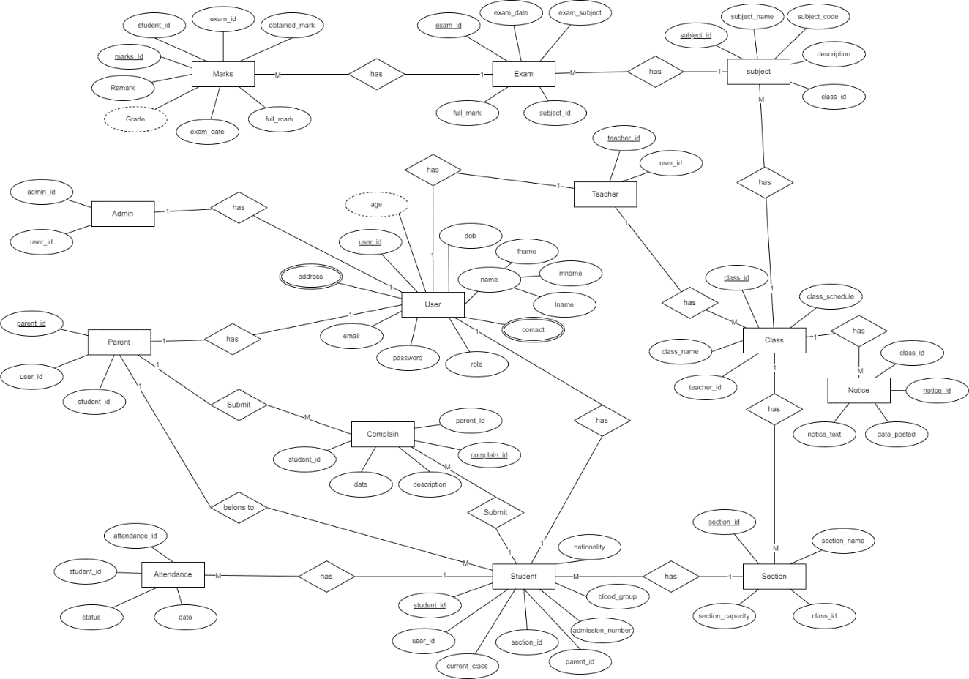In Entity-Relationship diagram there are many entities such as Student, teacher, class, section, examination and grades. Student has attributes like student_id, name, dob, class_id, address, email etc. Parents and Teacher also have their attributes of personal information. Class has class_id and no of students. Examination has examination_id, class_id, exam Date and Type.

**Figure 3: ER-Diagram of Student Result Management System**

#### Process Modeling (DFD)

Data Flow Diagram of Student Management System consists of two levels of DFD Level 0 DFD i.e. Context diagram and level one DFD.

In Level 0 diagram, login request is the input of SRMS where users request for login. Student request for profile management, admin request for viewing student grade records. The system response with the login response and academic records of students.

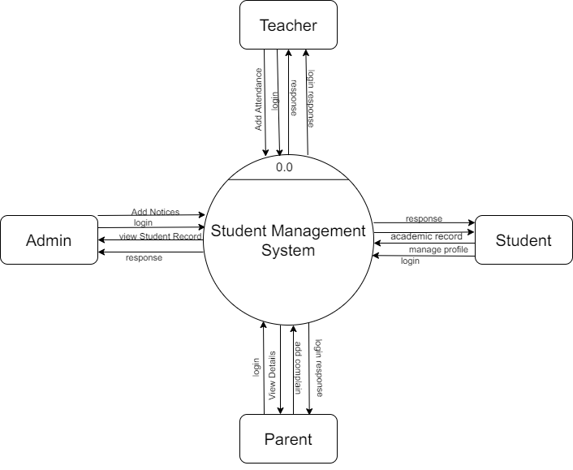

**Figure 4: Level-0 DFD of Student Management System**

In level 1 DFD, there are 5 processes where for login, register, Notice, Examination and Grading. Process 1 is responsible for login process. Process 2 is responsible for Result management of Student, Process 3 is responsible for managing notices, Process 4 is responsible for Student Register and lastly Process 5 is responsible for managing Examination.

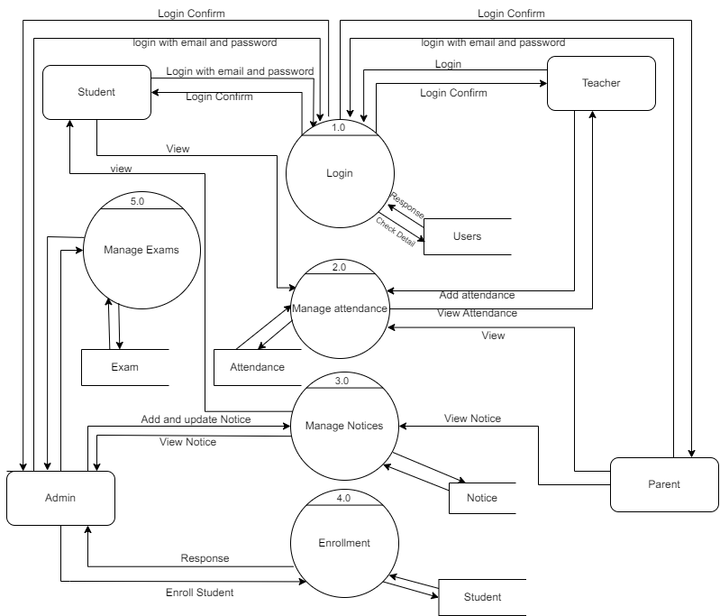

**Figure 5:Level 1 DFD of Student Result Management System**

**System Design Tools**

* **Implementation Tools**

**Front End**

1. **HTML (Hyper Text Markup Language):** Essential for structuring web content, providing a foundation for displaying information.
2. **CSS (Cascading Style Sheet):** Styles and enhances HTML elements, ensuring a visually appealing and consistent layout.
3. **React JS:** A JavaScript library for building user interfaces, facilitating a dynamic and responsive web experience.

**Backend**

1. Node JS: Empowers server-side development with a fast and scalable runtime environment for executing JavaScript code.

**Database**

1. MySQL: A robust relational database management system, offering efficient data storage and retrieval capabilities for web application.

|  |  |  |  |  |  |  |  |  |  |  |  |  |  |  |
| --- | --- | --- | --- | --- | --- | --- | --- | --- | --- | --- | --- | --- | --- | --- |
| Weeks  Task Name | Project Schedule | | | | | | | | | | | | | |
| 1 | 2 | 3 | 4 | 5 | 6 | 7 | 8 | 9 | 10 | 11 | 12 | 13 | 14 |
| 1 Getting Started |  |  |  |  |  |  |  |  |  |  |  |  |  |  |
| 1.1 Analysis |
| 1.2 Requirement Gathering |
| 2 System Design Architecture |  |  |  |  |  |  |  |  |  |  |  |  |  |  |
| 2.1 Detailed design and architecture |
| 2.2 Prepare design documentation |
| 3 Implementation |  |  |  |  |  |  |  |  |  |  |  |  |  |  |
| 3.1 Development |
| 3.2 Setting up environment |
| 3.3 Quality Testing |
| 4 Development |  |  |  |  |  |  |  |  |  |  |  |  |  |  |
| 4.1 Setup system |
| 4.2 Run beta |
| 5 Documentation |  |  |  |  |  |  |  |  |  |  |  |  |  |  |

# Gantt Chart

**Figure 6: Gantt chart for Project Timeline**

A Gantt chart is drawn below to show the time management done during the execution of the system.

# Expected Outcome

Implementing this project is expected to bring significant benefits to the educational institution and its students. It will streamline record-keeping, improve operational efficiency, and enhance the accuracy of managing student data. The system, with comprehensive profiles, promotes transparency and reliability. For parents, easy access to academic records and attendance data will boost engagement and communication. The transition to a digital system is anticipated to reduce costs by eliminating paper-based processes, demonstrating financial prudence. In summary, the project aims to strengthen operations, improve communication, and achieve cost savings, ultimately enhancing the overall educational experience.

# Reference