Table of Contents
1. Introduction 1
2. Problem Statement 1
3. Objectives 1
4. Methodology 2
a. Requirement Identification 3
i. Study of Existing System 3
ii. Literature Review 3
iii. Requirement Analysis 4
b. Feasibility Study 5
i. Technical Feasibility 5
ii. Operational Feasibility 5
iii. Economic Feasibility 6
c. High Level Design of System 6
i. System Flow Chart 6
ii. Description of Algorithms 7
5. Gantt Chart 9
6. Expected Outcome 9
7. References 10

Table of Figures
Figure Methodology: 1 Waterfall Model 2
Figure Methodology: 2 System Flow Chart 6

Table of Tables
Table Gantt chart: 1 Gantt chart 9

Introduction
PixSift is a web-based visual discovery platform that allows users to upload, explore, and search images in a curated, duplicate-free feed. The system uses perceptual hashing, Hamming distance similarity matching, and k-means color palette extraction to detect near-duplicate uploads and to enable color-based visual search, turning a raw and cluttered image collection into a clean, searchable, and visually organized discovery experience.
The amount of visual content shared online today is growing at an enormous rate. On image-centric platforms, the same picture is frequently uploaded many times in slightly different forms — resized, cropped, re-compressed, or lightly edited — which clutters the feed with near-duplicate content and degrades the browsing experience. At the same time, discovery on most platforms depends heavily on keywords and manual tags, which makes it difficult for users, especially designers and creators, to find images by how they actually look, such as by their dominant colors.
The goal of this project is to build a system that fingerprints every uploaded image, detects near-duplicates before they clutter the feed, extracts the dominant colors of each image to support color-based search, and presents the results in a responsive masonry-style discovery feed. Rather than relying only on third-party services for its core intelligence, PixSift implements the detection and search algorithms directly, so that the platform is both practical and technically grounded.

Problem Statement
On image sharing platforms, users generally upload pictures without any awareness of whether a visually identical or near-identical image already exists in the collection. The same image is often re-uploaded after being resized, cropped, or re-compressed, and because a simple exact-match file hash changes completely with even a one-pixel edit, these near-duplicates are not caught and end up cluttering the feed. As the collection grows, the proportion of redundant content increases, and the quality of discovery for every user declines.
At the same time, finding a specific kind of image is difficult. Discovery on most platforms is driven by keywords and manually assigned tags, which are inconsistent, incomplete, and unable to capture visual properties such as color. A user who wants images with a particular dominant color, for example to match a design palette, has no reliable way to search for them. There is therefore a need for a smart, accessible image platform that can automatically fingerprint each image, detect near-duplicates on upload to keep the feed clean, and allow users to discover images by their visual characteristics — all built on algorithms that the system implements itself rather than treating as an external black box.

Objectives
The main objectives of this project are
- To develop a web-based visual discovery platform that allows users to upload, explore, and manage images in a responsive, curated feed.
- To implement a perceptual hashing and Hamming distance based near-duplicate detection algorithm that identifies and flags visually similar images at the time of upload.
- To implement a k-means based dominant color extraction and color search mechanism that lets users discover images by their dominant colors.

Methodology
This project follows the Waterfall Model, a linear and sequential software development approach where each phase must be completed before moving to the next.
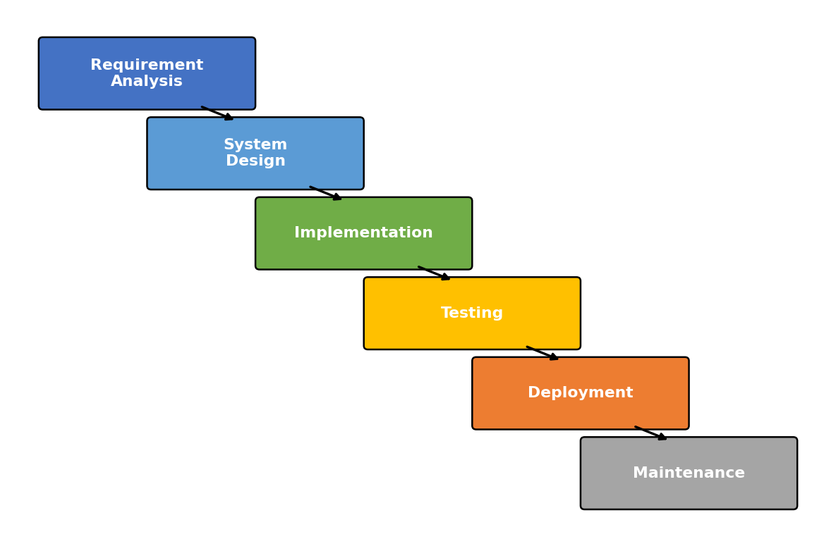
Figure Methodology: 1 Waterfall Model
- Requirement Analysis: Identify and define the overall system requirements and user needs.
- System Design: Plan the system architecture, database structure, and user interface.
- Implementation: Develop the application by building the frontend, backend, and integrating all components.
- Testing: Verify the system functionality and fix any errors or issues.
- Deployment: Launch the application in a live environment for users.
- Maintenance: Monitor, update, and improve the system after deployment.

Requirement Identification

Study of Existing System
Pinterest is a widely used visual discovery platform that lets users save and explore images organized into boards, and it recommends related images based on user activity. However, its focus is on personalized recommendation and content saving rather than on detecting near-duplicate uploads, and its underlying algorithms are proprietary and not accessible for study or academic implementation. [1]
Dribbble is a popular platform where designers publish and browse creative work, and it is known for its clean, image-first presentation. While Dribbble sets a strong example of visual browsing and includes color-based filtering of shots, it is a curated professional showcase rather than an open platform, and it does not expose how its color or similarity features are implemented. [2]
TinEye is a dedicated reverse image search engine that finds where an image appears online by matching it against a large index, using image fingerprinting techniques. It demonstrates the practical value of perceptual matching, but it is a search service over the wider web rather than a self-contained sharing platform, and it does not manage an image feed, user uploads, or color-based discovery for a community of users. [3]
Although these systems are effective within their own scope, none of them provides a single, freely accessible platform where images can be uploaded to a shared feed, automatically checked for near-duplicates, and discovered by their dominant colors, with the core algorithms implemented transparently. Because of this, there is a need for an open and intelligent visual discovery system such as PixSift.

Literature Review
Perceptual hashing is a family of techniques that produce a compact fingerprint of an image based on its visual content rather than its exact bytes, so that visually similar images produce similar hashes. A widely referenced approach computes the hash from the low-frequency coefficients of the Discrete Cosine Transform of a reduced grayscale version of the image, which captures the overall structure while discarding fine detail and making the fingerprint robust to resizing and compression. This forms the basis of the fingerprinting used in this project. [4]
The Hamming distance, introduced in coding theory, measures the number of positions at which two equal-length binary strings differ. Because a perceptual hash is a fixed-length bit string, the similarity of two images can be estimated by the Hamming distance between their hashes: a small distance indicates a likely near-duplicate. This provides a simple and efficient basis for the duplicate detection step of the system. [5]
K-means clustering is a classical unsupervised learning algorithm that partitions a set of points into k groups by iteratively assigning each point to the nearest cluster center and updating the centers to minimize the total within-cluster squared distance. Applied to the pixels of an image in a color space, k-means yields the dominant colors of the image, which can be stored as its palette and used for color-based search. [6]
Content-based image retrieval is a well-established field concerned with searching images by their visual features such as color, texture, and shape rather than by text tags. The literature establishes color as one of the most effective and inexpensive low-level features for retrieval, which supports the design decision to represent each image by an extracted color palette and to enable discovery through color similarity. [7]

Requirement Analysis
- Functional Requirements
Upload and explore images
The system should allow registered users to upload images and to browse all shared images in a responsive masonry-style discovery feed. This gives users a single place to contribute and explore visual content.
Detect near-duplicate uploads
At the time of upload, the system must compute a perceptual hash of the image and compare it against existing hashes so that near-duplicate images — including resized, cropped, or re-compressed versions — are detected and flagged. This keeps the feed clean and free of redundant content.
Extract colors and search by color
The system must extract the dominant colors of each image and allow users to search and filter images by a chosen color. This enables discovery based on how images actually look rather than only on tags.
View image details
The system should provide a detail page for each image showing the full image, the uploader, its tags, and its dominant color palette, so that users can inspect and act on any image in the feed.
Manage accounts and content
The system should support user registration and login, a profile page listing a user’s uploads, and an administrative interface to manage users and moderate reported or flagged images.
- Non-Functional Requirements
Accuracy of duplicate detection
The system must reliably identify genuine near-duplicates while avoiding false matches on merely similar but distinct images, since the credibility of the curated feed depends on this accuracy.
Fast processing speed
The system should compute fingerprints, run the duplicate check, and return search results quickly, even as the number of stored images grows, to ensure a smooth browsing experience.
Easy user interaction
The user interface should be simple, clean, and intuitive so that users can upload, browse, and search images without any technical knowledge.
Scalability
The system should be able to handle a growing number of users and images without significant degradation in performance, allowing it to grow from an academic prototype into a practically usable service.
Reliable output
The system must produce consistent and dependable results every time, so that users can trust the duplicate flags and color search results generated by the system.

Feasibility Study

Technical Feasibility
The proposed system is technically feasible because it can be built using modern, widely supported programming technologies such as JavaScript and Python, together with mature open-source frameworks for building the web interface, the server, and the database. These technologies provide sufficient capability for image upload, storage, fingerprint computation, clustering, and search. The perceptual hashing, Hamming distance comparison, and k-means color extraction are lightweight algorithms that run efficiently on ordinary hardware, and image storage can be handled through freely available cloud storage services, so the system does not require any specialized or expensive equipment.

Operational Feasibility
The system is operationally feasible because it is designed to be simple and practical for everyday users. A user only has to register, upload an image, or browse and search the feed; the fingerprinting, duplicate checking, and color extraction all happen automatically in the background. No special technical skill is needed, and the outputs — a clean feed, a duplicate warning, or a set of color-matched images — are presented in a clear and understandable way. Consequently, PixSift can be operated by ordinary users through any web browser.

Economic Feasibility
The project is economically feasible because the overall cost of development is very low. Open-source programming languages, libraries, and development tools are used throughout, so there are no software licensing fees. The system can be developed and tested on ordinary computers, and both free hosting tiers and free cloud storage tiers can be used for deployment and image storage. Publicly available and user-contributed images serve as the data source at no acquisition cost.

High Level Design of System

System Flow Chart
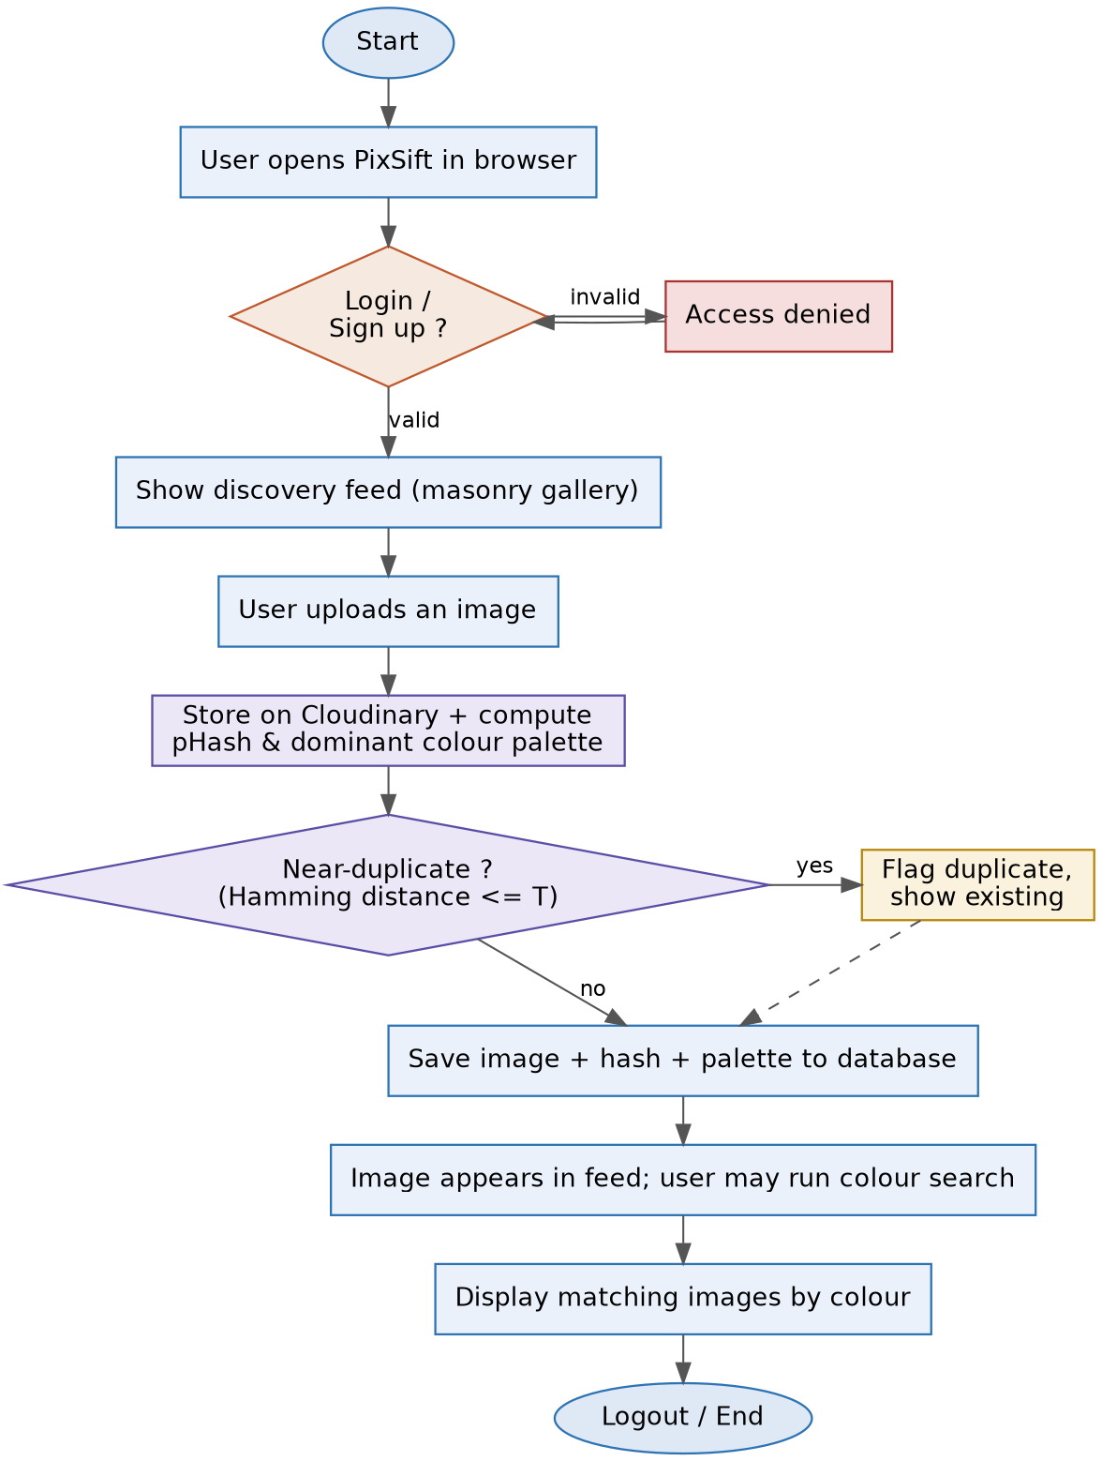
Figure Methodology: 2 System Flow Chart
The flow starts when a user opens the PixSift web application in a browser. The system first checks whether the user is logged in. If the login details are wrong, access is denied; if they are correct, the user is taken to the discovery feed. From the feed, the user may upload an image. On upload, the image is stored and the system computes its perceptual hash and dominant color palette. The system then checks the new hash against existing hashes using the Hamming distance: if a near-duplicate is found within the threshold, the image is flagged and the existing image is shown; otherwise, the image, its hash, and its palette are saved to the database. The image then appears in the feed, where the user may optionally run a color search to display images that match a chosen dominant color. All user data, images, hashes, and palettes are stored in the database to keep everything saved and updated. Finally, when the user finishes, they log out to safely end the session.

Description of Algorithms
PixSift consists of three core algorithms that handle image fingerprinting, near-duplicate detection, and dominant color extraction. The selection of these algorithms is based on techniques commonly used in perceptual image hashing, information theory, and unsupervised learning.
- Perceptual Hashing – Image Fingerprinting
Purpose:
Generates a compact fingerprint of each image that reflects its visual content, so that visually similar images — even after resizing, cropping, or compression — produce similar fingerprints.
Overview:
The perceptual hash reduces the image to a small grayscale version, applies the Discrete Cosine Transform (DCT) to capture its low-frequency structure, and converts the most significant coefficients into a fixed-length binary hash. Because it relies on overall structure rather than exact pixels, the hash is robust to common image transformations. In this project the hash of every uploaded image is stored in the database for later comparison.
Working Process:
- The uploaded image is converted to grayscale and resized to a small fixed size (for example 32×32).
- The DCT of the reduced image is computed, and the top-left block of low-frequency coefficients is retained.
- The median of these coefficients is calculated, and each coefficient is converted to a bit based on whether it exceeds the median:
hash(i) = 1 if D(i) > median(D), else 0
- The resulting sequence of bits forms the 64-bit perceptual hash of the image.
Key Idea: A perceptual hash captures what an image looks like, not its exact bytes, so near-identical images map to near-identical fingerprints.
- Hamming Distance – Near-Duplicate Detection
Purpose:
Determines how similar two images are by comparing their perceptual hashes, so that near-duplicate uploads can be detected and flagged.
Overview:
The Hamming distance counts the number of bit positions at which two equal-length binary hashes differ. Two images whose hashes differ in only a few bits are visually near-identical, while images that differ in many bits are distinct. A threshold is chosen so that pairs below it are treated as duplicates.
Working Process:
- When a new image is uploaded, its perceptual hash is computed.
- The Hamming distance between the new hash and each stored hash is calculated:
H(a, b) = Σ (aᵢ ⊕ bᵢ)
- If the smallest distance is within the threshold T, the image is flagged as a near-duplicate and the matching image is shown; otherwise it is accepted as new:
duplicate if H(a, b) ≤ T
Key Idea: Counting differing bits between two fingerprints is a fast and effective way to measure visual similarity and catch reposts and edits.
- K-Means Clustering – Dominant Color Extraction
Purpose:
Extracts the dominant colors of each image so that images can be represented by a color palette and discovered through color-based search.
Overview:
K-means clustering groups the pixels of an image into k clusters in a color space by repeatedly assigning each pixel to the nearest cluster center and recomputing the centers. The final cluster centers are the dominant colors of the image, and their sizes indicate how prominent each color is. These palettes are stored and later compared to a user’s chosen color.
Working Process:
- The pixels of the image are treated as points in a color space, and k initial cluster centers are chosen.
- Each pixel is assigned to the nearest center, and the centers are updated to the mean of their assigned pixels, minimizing the within-cluster squared distance:
argmin Σ ‖x − μ_c‖²
- The assignment and update steps repeat until the centers stabilize.
- The final centers are stored as the image’s dominant color palette and used to match against colors selected in search.
Key Idea: Clustering an image’s pixels reduces it to a few representative colors, turning color into a searchable feature.

Gantt chart
The project is planned over 16 weeks. The following table outlines the key milestones and their scheduled timeframes:
Table Gantt chart: 1 Gantt chart
Activity | W1 | W2 | W3 | W4 | W5 | W6 | W7 | W8 | W9 | W10 | W11 | W12 | W13 | W14 | W15 | W16
1. Requirement Identification & Literature Review | ■ | ■
2. Feasibility Study |  | ■ | ■
3. System Design |  |  | ■ | ■ | ■
4. Coding Feed & Upload Module |  |  |  |  | ■ | ■ | ■ | ■
5. Implement Algorithms (pHash, Hamming, K-Means) |  |  |  |  | ■ | ■ | ■ | ■ | ■
6. Testing |  |  |  |  |  |  |  |  |  | ■ | ■ | ■
7. Bug Fixes & Performance Optimization |  |  |  |  |  |  |  |  |  |  |  | ■ | ■
8. Deployment & Documentation |  |  |  |  |  |  |  |  |  |  |  |  |  | ■ | ■ | ■
9. Final Report Writing & Presentation Prep |  |  |  |  |  |  |  |  |  |  |  |  |  |  | ■ | ■

Expected Outcome
Once the system is completed, PixSift will automatically fingerprint every uploaded image and detect near-duplicates at the point of upload, keeping the discovery feed clean and free of redundant reposts, crops, and re-compressed copies. Users will be warned when they attempt to upload an image that already exists in a near-identical form, which reduces clutter and improves the overall quality of the feed.
The system will also extract the dominant colors of each image and allow users to search and filter the feed by color, so that images can be discovered by how they look rather than only by tags. Combined with a responsive, image-first browsing experience, this makes the platform genuinely useful for creators and designers looking for visual inspiration.
In addition, the system will maintain useful information about images, their fingerprints, and their palettes, which can support moderation and further analysis of the collection. As the number of images grows, effective duplicate detection and color-based discovery become increasingly valuable, representing a meaningful improvement over a plain image gallery.
Overall, this project will strengthen the developer’s understanding of fundamental concepts in software engineering, including perceptual hashing, information theory, unsupervised clustering, and content-based image retrieval, as well as the design of intelligent, data-driven web systems.

References
[1] | Pinterest, Inc., "Pinterest – Visual Discovery Engine," [Online]. Available: https://www.pinterest.com. [Accessed 21 07 2026].
[2] | Dribbble Holdings Ltd., "Dribbble – Discover the World’s Top Designers," [Online]. Available: https://dribbble.com. [Accessed 21 07 2026].
[3] | TinEye (Idée Inc.), "TinEye Reverse Image Search," [Online]. Available: https://tineye.com. [Accessed 21 07 2026].
[4] | C. Zauner, "Implementation and Benchmarking of Perceptual Image Hash Functions," M.S. thesis, Upper Austria University of Applied Sciences, Hagenberg, 2010.
[5] | R. W. Hamming, "Error Detecting and Error Correcting Codes," The Bell System Technical Journal, vol. 29, no. 2, pp. 147-160, 1950.
[6] | S. P. Lloyd, "Least Squares Quantization in PCM," IEEE Transactions on Information Theory, vol. 28, no. 2, pp. 129-137, 1982.
[7] | R. Datta, D. Joshi, J. Li and J. Z. Wang, "Image Retrieval: Ideas, Influences, and Trends of the New Age," ACM Computing Surveys, vol. 40, no. 2, pp. 1-60, 2008.

