**Introduction to GIMP**

The GIMP is a multiplatform photo manipulation tool. GIMP is an acronym for GNU Image Manipulation Program.

The GIMP is suitable for a variety of image manipulation tasks, including photo retouching, image composition, and image construction.

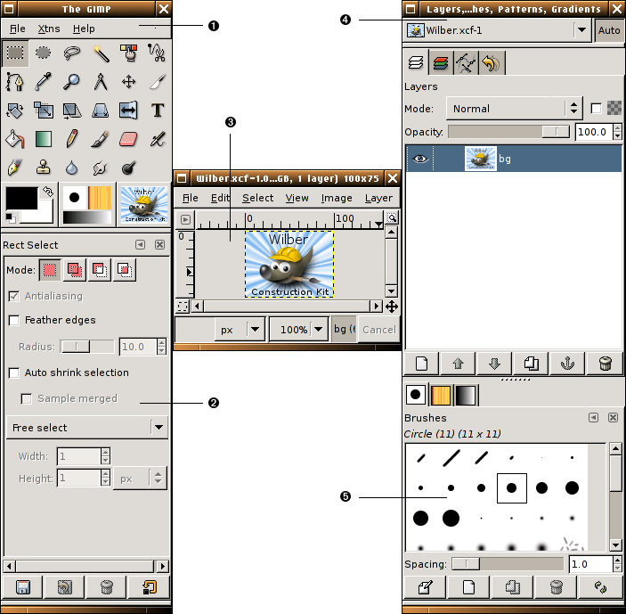

Main Window of GIMP

1. **The Main Toolbox**: This is the heart of the GIMP. It contains the highest level menu, plus a set of icon buttons that can be used to select tools, and more.
2. **Tool options**: Docked below the main Toolbox is a Tool Options dialog, showing options for the currently selected tool (in this case, the Rectangle Select tool).
3. **An image window**: Each image open in GIMP is displayed in a separate window. Many images can be open at the same time: the limit is set only by the amount of system resources. It is possible to run GIMP without having any images open, but there are not very many useful things to do then.
4. **Layers Dialog**: This dialog window shows the layer structure of the currently active image, and allows it to be manipulated in a variety of ways. It is possible to do a few very basic things without using the Layers dialog, but even moderately sophisticated GIMP users find it indispensible to have the Layers dialog available at all times.
5. **Brushs/Patterns/Gradients**: The docked dialog below the layer dialog shows the dialogs for managing brushes, patterns and gradients.

**The Main Tool Box in GIMP**

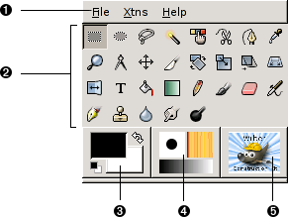

***Toolbox Menu****:* This menu is special: it contains some commands that cannot be found in the menus that are attached to images. These include commands for setting preferences, creating certain types of dialogs, etc. The contents are described systematically in the Toolbox Menu section.

***Tool icons****:* These icons are buttons which activate tools for a wide variety of purposes: selecting parts of images, painting on them, transforming them, etc.

***Foreground/Background colors****:* The color areas here show you GIMP’s current foreground and background colors, which come into play in many operations. Clicking on either one of them brings up a color selector dialog that allow you to change to a different color. Clicking on the double-headed arrow swaps the two colors, and clicking on the small symbol  
in the lower left corner resets them to black and white.

***Brush/Pattern/Gradient****:* The symbols here show you GIMP’s current selections for: the Paint brush, used by all tools that allow you to paint on the image for the Pattern,  
which is used in filling selected areas of an image; and for the Gradient, which comes into play whenever an operation requires a smoothly varying range of colors.

***Active Image****:* In GIMP, you can work with many images at once, but at any given  
moment, one of them is the ‘active image’. Here you find a small iconic representation of the active image. Clicking on it brings up a dialog with a list of all the currently open images, allowing you to make a different one active if you want to.  
(Clicking on the window where the image is displayed will accomplish the same thing, though.)

**Image window in GIMP**

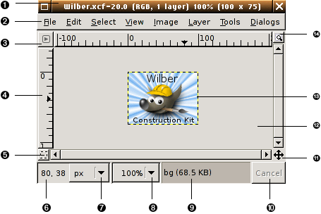

1. **Title Bar**: At the top of the image window you will probably see a emphasis bar, showing the name of the image and some basic information about it. The emphasis bar is actually provided by the windowing system, not by GIMP itself, so its appearance may vary with different operating systems, window managers, and/or themes. In the Preferences dialog you can customize the information that appears here, if you want to.
2. **Image Menu**: Directly below the emphasis bar appears the Image Menu (unless it has been suppressed). This menu gives you access to nearly every operation you can perform on an image. (There are some ‘global’ actions that can only be accessed via the Toolbox menu.) You can also get the Image Menu by right-clicking inside the image 1, or by left clicking on the little ‘arrow’ symbol in the upper left corner, if for some reason you find one of these more convenient.
3. **Menu Button**: Clicking on this little button gives you the Image Menu, except in a column instead of a row. Mnemonics users who don’t want the menu bar visible can acces to this menu by pressing the Shift-F10 key.
4. **Ruler**: In the default layout, rulers are shown above and to the left of the image, indicating coordinates within the image. You can control what type of coordinates are shown if you want to. By default, pixels are used, but you can change to other units, using the Units setting described below.
5. **QuickMask Toggle:** At the lower left corner of the image display is a small button that toggles on or off the Quick Mask, which is an alternate, and often extremely useful, way of viewing the selected area within the image.
6. **Pointer Coordinates:** In the lower left corner of the window is a rectangular area used to show the current pointer coordinates (that is, the mouse location, if you are using a mouse), whenever the pointer is within the image boundaries. The units are the same as for the rulers.
7. **Units menu:** By default, the units used for the rulers  
   and several other purposes are pixels. You can change to inches, cm, or several other possibilities using this menu. (If  
   you do, note that the setting of ‘Dot for dot’ in the View menu affects how the display is scaled: see Dot for Dot for more  
   information.
8. **Zoom button:**(This feature is new in GIMP 2.2; it does not appear in GIMP 2.0). There are a number of ways to zoom  
   the image in or out, but this menu is perhaps the simplest.
9. **Status Area:**The Status Area appears below the image display. Most of the time, by default, it shows which part of  
   the image is currently active, and the amount of system memory that the image is consuming. You can customize the  
   information that appears here, by changing your Preferences. When you perform time-consuming operations, the status  
   area changes temporarily to show what operation is being performed, and its state of progress.
10. **Cancel Button***:* At the lower right corner of the window appears the Cancel button. If you start a complex, time-consuming  
    operation (most commonly a plug-in), and then decide, while it is being computed, that you didn’t really want to do it  
    after all, this button will cancel it immediately.
11. **Navigation control**: This is a small cross-shaped button at the lower right corner of the image display. Clicking on it, and holding the left mouse button down, brings up a window showing a miniature view of the image (Navigation Preview), with the displayed area outlined. You can pan to a different part of the image by moving the mouse while keeping the button depressed. For large images of which only a small part is displayed, the navigation window is often the most convenient way of getting to the part of the image you are looking for. (See Navigation Dialog for other ways to access the Navigation Window). (If your mouse has a middle-button, click-drag with it to span across the image).
12. **Inactive Padding Area**: This padding area separate the active image display and the inactive padding area, so you’re able to distinguish between them. You cannot apply any Filters or Operations in general on the inactive area.
13. **Image Display**: The most important part of the image window is, of course, the image display or canvas. It occupies the central area of the window, surrounded by a yellow dotted line showing the image boundary, against a neutral gray background. You can change the zoom level of the image display in a variety of ways, including the Zoom setting described below.
14. **Image Window Resize Toggle**: If this button is pressed, the image itself will be resized if the image window is resized.

**Introduction to layers**

You can think of layers as a stack of slides. Using layers, you can construct an image of several conceptual parts, each of which can be manipulated without affecting any other part of the image. Layers are stacked on top of each other. The bottom layer is the background of the image, and the components in the foreground of the image come above it.

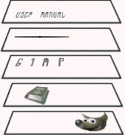 An image with layers

Layers of the image Resulting image

There is no limit, in principle, to the number of layers an image can have: only the amount of memory available on the system. It is not uncommon for advanced users to work with images containing dozens of layers. You can group layers to make your work easier.

**Layer Properties**

**Name**

Every layer has a name. This is assigned automatically when the layer is created, but you can change it. You can change the name of a layer either by double-clicking on it in the Layers dialog, or by right-clicking there and then selecting the top entry in the menu that appears, Edit Layer Attributes.

**Presence or absence of an alpha channel**

An alpha channel encodes information about how transparent a layer is at each pixel. It is visible in the Channel Dialog: white is complete opacity, black is complete transparency and grey levels are partial transparencies.

**Layer type**

The layer type is determined by the image type (see previous section) and the presence or absence of an alpha channel. These are the possible layer types:

* RGB
* RGBA
* Gray
* GrayA
* Indexed
* IndexedA

**Visibility**

It is possible to remove a layer from an image, without destroying it, by clicking on the symbol in the Layers dialog. This is called “toggling the visibility” of the layer.

**Active layer**

Usually, you activate a layer, to work on it, clicking it in the layer list.

**Linkage to other layers**

If you click between the eye icon and the layer thumbnail, you get a chain icon, which enables you to group layers for operations on multiple layers (for example with the Move tool or a transform tool).

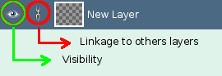

**Size and boundaries**

In the image window, the boundaries of the currently active layer are shown outlined with a black-and-yellow dashed line.

The main reason why this matters is that you cannot do anything to a layer outside of its boundaries: you can't act on what doesn't exist. If this causes you problems, you can alter the dimensions of the layer using any of several commands that you can find near the bottom of the Layer menu.

**Opacity**

The opacity of a layer determines the extent to which it lets colors from layers beneath it in the stack show through. Opacity ranges from 0 to 100, with 0 meaning complete transparency, and 100 meaning complete opacity.

**Mode**

The Mode of a layer determines how colors from the layer are combined with colors from the underlying layers to produce a visible result.

**Layer mask**

In addition to the alpha channel, there is another way to control the transparency of a layer: by adding a *layer mask*, which is an extra grayscale drawable associated with the layer.

**Layer mode**

GIMP has twenty-one layer modes. Layer modes are also sometimes called “blending modes”. Selecting a layer mode changes the appearance of the layer or image, based on the layer or layers beneath it. If there is only one layer, the layer mode has no effect. There must therefore be at least two layers in the image to be able to use layer modes.

Layer mode equation is

E = M + I

means, “ For each pixel in the upper (Mask)and lower (Image) layer, add each of the corresponding color components together to form the E resulting pixel's color. ” Pixel color components must always be between 0 and 255.

List of layer mode

1. **Normal**
2. **Dissolve**
3. **Multiply**
4. **Divide**
5. **Screen**
6. **Overlay**
7. **Dodge**
8. **Burn**
9. **Hard light**
10. **Soft light**
11. **Grain extract**
12. **Grain merge**
13. **Difference**
14. **Addition**
15. **Subtract**
16. **Darken only**
17. **Lighten only**
18. **Hue**
19. **Saturation**
20. **Color**
21. **Value**

**Selection Tool**

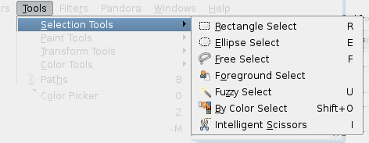

Selection tools are designed to select regions from the active layer so you can work on them without affecting the unselected areas. Each tool has its own individual properties, but the selection tools also share a number of options and features in common.

**Rectangle Selection**

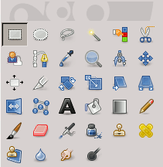

The Rectangle Selection tool is designed to select rectangular regions of the active layer: it is the most basic of the selection tools, but very commonly used.

**Ellipse Selection**

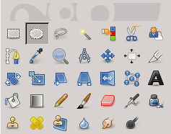

The Ellipse Selection tool is designed to select circular and elliptical regions from an image, with high-quality anti-aliasing if you want it.

**Free Selection (Lasso)**

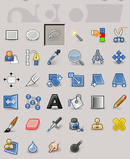

The Free Selection tool, or Lasso, lets you create a selection by drawing it with the pointer.

**Fuzzy selection (Magic wand)**

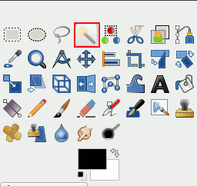

The Fuzzy Select (Magic Wand) tool is designed to select areas of the current layer or image based on color similarity.

**Select By Color**

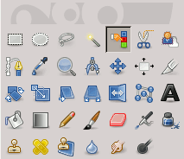

The Select by Color tool is designed to select areas of an image based on color similarity. It works a lot like the Fuzzy Select tool (“Magic Wand”). The main difference between them is that the Magic Wand selects contiguous regions, with all parts connected to the starting point by paths containing no large gaps; while the Select by Color tool selects all pixels that are sufficiently similar in color to the pixel you click on, regardless of where they are located.

**Intelligent Scissors**

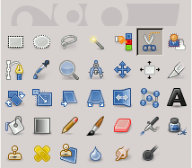

The Intelligent Scissors tool is an interesting piece of equipment: it has some features in common with the Lasso, some features in common with the Path tool, and some features all its own. It is useful when you are trying to select a region defined by strong color-changes at the edges.

**Foreground Select**

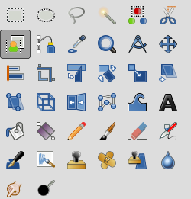

This tool lets you extract the foreground from the active layer or from a selection. With GIMP-2.10, selection refinement has been improved. After the selection is made, with its marching ants, you can copy-paste or click-and-drag it to another image used as background, and, inverting the selection, you can make changes in background.

**Paint Tools**

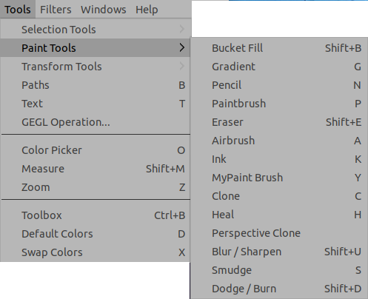

The GIMP Toolbox includes thirteen “paint tools”, all grouped together at the bottom (in the default arrangement).

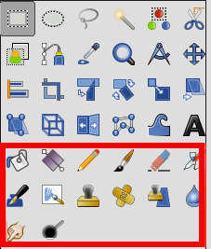

The feature they all have in common is that all of them are used by moving the pointer across the image display, creating brush-strokes. Four of them

* the [Pencil](https://docs.gimp.org/2.10/en/gimp-tool-pencil.html),
* the [Paintbrush](https://docs.gimp.org/2.10/en/gimp-tool-paintbrush.html),
* the [Airbrush](https://docs.gimp.org/2.10/en/gimp-tool-airbrush.html) and
* the [Ink tool](https://docs.gimp.org/2.10/en/gimp-tool-ink.html)

and [MyPaint brushes](https://docs.gimp.org/2.10/en/gimp-tool-mypaint-brush.html" \o "3.8. MyPaint Brush), a new feature in Gimp-2.10.6,

behave like the intuitive notion of “painting” with a brush. Pencil, Paintbrush, and Airbrush are called “basic painting tools” or [brush tools](https://docs.gimp.org/2.10/en/gimp-tools-brush.html).

The other tools use a brush to modify an image in some way rather than paint on it:

* the [Bucket Fill](https://docs.gimp.org/2.10/en/gimp-tool-bucket-fill.html) fills with color or pattern;
* the [Gradient](https://docs.gimp.org/2.10/en/gimp-tool-gradient.html) fills with gradients;
* the [Eraser](https://docs.gimp.org/2.10/en/gimp-tool-eraser.html) erases;
* the [Clone tool](https://docs.gimp.org/2.10/en/gimp-tool-clone.html) copies from a pattern, or image;
* the [Perspective Clone](https://docs.gimp.org/2.10/en/gimp-tool-perspective-clone.html) tool copies into a changed perspective;
* the [Heal tool](https://docs.gimp.org/2.10/en/gimp-tool-heal.html) corrects small defects;
* the [Convolve tool](https://docs.gimp.org/2.10/en/gimp-tool-convolve.html) blurs or sharpens;
* the [Smudge tool](https://docs.gimp.org/2.10/en/gimp-tool-smudge.html) smears;
* the [Dodge/Burn tool](https://docs.gimp.org/2.10/en/gimp-tool-dodge-burn.html) lightens or darkens.

**Brush Tools (Pencil, Paintbrush, Airbrush)**

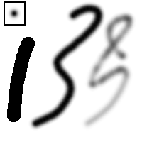

Three strokes painted with the same round fuzzy brush (outline shown in upper left), using the Pencil (left), Paintbrush (middle), and Airbrush (right).

The Pencil is the crudest of the tools in this group: it makes hard, non-anti-aliased brushstrokes. The Paintbrush is intermediate: it is probably the most commonly used of the group. The Airbrush is the most flexible and controllable. This flexibility also makes it a bit more difficult to use than the Paintbrush, however.

**Bucket Fill**

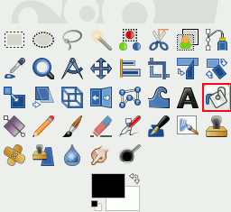

This tool fills a selection with the current foreground color. If you **Ctrl**+click and use the Bucket tool, it will use the background color instead.

**Gradient**

This tool fills the selected area with a gradient from the foreground and background colors by default, but there are many options. To make a gradient, drag the cursor in the direction you want the gradient to go and you release the mouse button when you feel you have the right position and size of your gradient. The softness of the gradient depends on how far you drag the cursor. The shorter the drag distance, the sharper it will be.

For Shape, there are 11 options: Linear, Bilinear, Radial, Square, Conical (symmetric), Conical (asymmetric), Shaped (angular), Shaped (spherical), Shaped (dimpled), Spiral (clockwise), and Spiral (counterclockwise).

**Pencil**

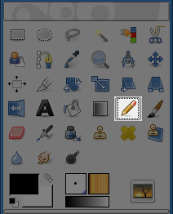

The Pencil tool is used to draw free hand lines with a hard edge. The pencil and paintbrush are similar tools. The main difference between the two tools is that although both use the same type of brush, the pencil tool will not produce fuzzy edges, even with a very fuzzy brush. It does not even do anti-aliasing.

**Paintbrush**

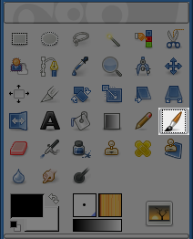

The paintbrush tool paints fuzzy brush strokes. All strokes are rendered using the current brush.

**MyPaint Brush**

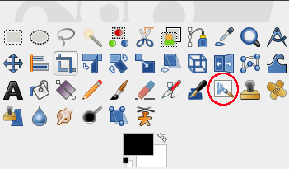

MYPAINT is a free painting program that comes with a lot of specific brushes.

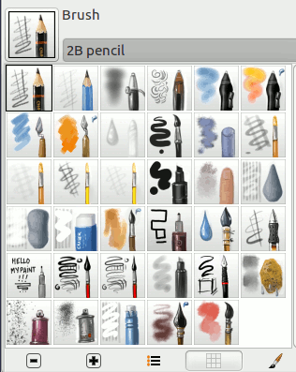

**Eraser**

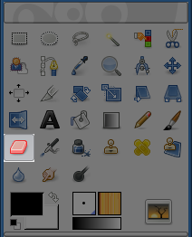

The Eraser is used to remove areas of color from the current layer or from a selection of this layer. If the Eraser is used on something that does not support transparency (a selection mask channel, a layer mask, or the Background layer if it lacks an alpha channel), then erasing will show the background color, as displayed in the Color Area of the Toolbox (in case of a mask, the selection will be modified). Otherwise, erasing will produce either partial or full transparency, depending on the settings for the tool options.

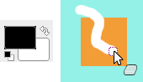 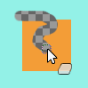

The Background Color is White. The image has no Alpha channel. The Eraser (Opacity 100%) shows the BG color.

The image has an Alpha channel. The Eraser shows transparency.

**Airbrush**

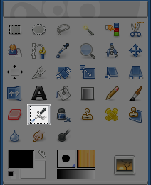

The Airbrush tool emulates a traditional airbrush. This tool is suitable for painting soft areas of color.

**Ink**

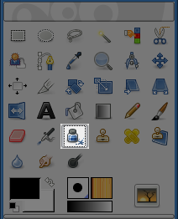

The Ink tool uses a simulation of an ink pen with a controllable nib to paint solid brush strokes with an antialiased edge. The size, shape and angle of the nib can be set to determine how the strokes will be rendered.

**Clone**

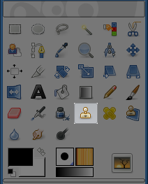

The Clone tool uses the current brush to copy from an image or pattern. It has many uses: one of the most important is to repair problem areas in digital photos, by “painting over” them with pixel data from other areas.

**Heal**

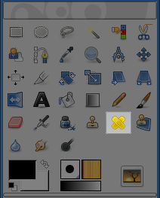

This tool was once described as “The healing brush looks like a smart clone tool on steroids”. And indeed the Healing Tool is a close relative to the Clone Tool, but it is more smart to remove small failures in images. A typical usage is the removal of wrinkles in photographs. To do so, pixels are not simply copied from source to destination, but the area around the destination is taken into account before cloning is applied.

**Perspective Clone**

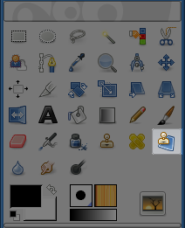

This tool allows you to clone according to the perspective you want. First, set the wanted vanishing lines in the same way as with the [Perspective](https://docs.gimp.org/2.10/en/gimp-tool-perspective.html) tool. Then copy the source area in the same way as with the [Clone](https://docs.gimp.org/2.10/en/gimp-tool-clone.html) tool.

**Blur/Sharpen**

The Blur/Sharpen tool uses the current brush to locally blur or sharpen your image. Blurring with it can be useful if some element of your image stands out too much, and you would like to soften it. In “Sharpen” mode, the tool works by increasing the contrast where the brush is applied. A little bit of this may be useful, but over-application will produce noise.

**Smudge**

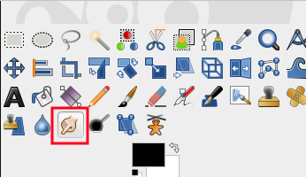

* If the Flow option is set to 0.00 (default), the Smudge tool uses the current brush to smudge colors on the active layer or a selection. It takes color in passing and uses it to mix it to the next colors it meets.
* When the Flow option is more than 0.00, the Smudge tool works as a brush using the foreground color of the toolbox and blend it with the underlying color.

**Dodge/Burn**

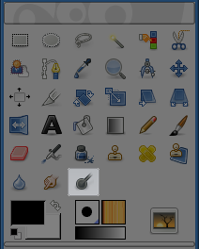

The Dodge or Burn tool uses the current brush to lighten or darken the colors in your image. The mode will determine which type of pixels are affected.

**Transform Tools**

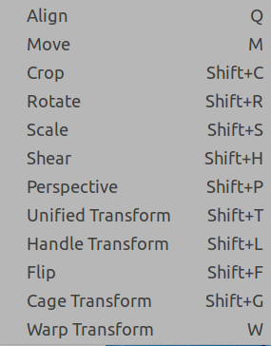

Inside the Transformation tool dialog, you will find eight tools to modify the presentation of the image or the presentation of an element of the image, selection, layer or path.

**Align**

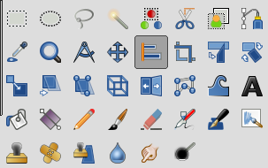

The Align tool is useful to align the image layers with various image objects. When this tool is selected, the mouse pointer turns to a small hand. By clicking on an element of a layer in the image, you choose the layer which will be moved; this focused layer has small squares in corners and is called source. Then buttons in the dialog become active: they allow you to select the target, i.e other layer, selection, path, the source will be aligned with.

**Move**

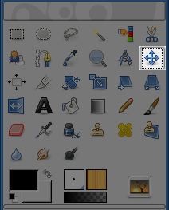

The Move Tool is used to move layers, selections, paths or guides. It works also on texts.

**Crop**

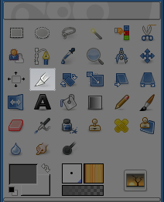

The Crop Tool is used to crop or clip an image. It works on all the layers of the image, visible and invisible. This tool is often used to remove borders, or to eliminate unwanted areas to provide you with a more focused working area. It is also useful if you need a specific image size that does not match the original dimensions of your image.

**Rotate**

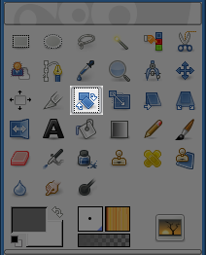

This tool is used to rotate the active layer, a selection or a path. When you click on the image or the selection with this tool a Rotation adjustment dialog is opened. There, you can set the rotation axis, marked with a point, and the rotation angle. You can do the same by dragging the mouse pointer on the image or the rotation point.

**Scale**

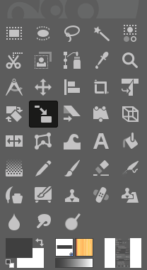

The Scale Tool is used to scale layers, selections or paths (the Object).

When you click on image with the tool the Scaling Information dialog box is opened, allowing to change separately Width and Height.

**Shear**

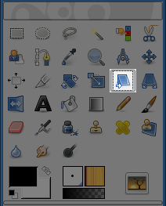

Shear tool is used to shift one part of an image, a layer, a selection or a path to a direction and the other part to the opposite direction. For instance, a horizontal shearing will shift the upper part to the right and the lower part to the left. A rectangle becomes a diamond. This is not a rotation: the image is distorted.

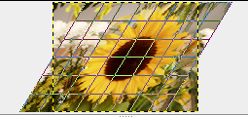

**Perspective**

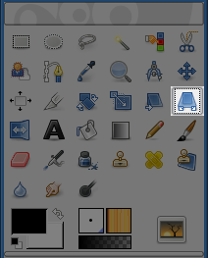

The Perspective Tool is used to change the “perspective” of the active layer content, of a selection content or of a path. When you click on the image, according to the Preview type you have selected, a rectangular frame or a grid pops up around the selection (or around the whole layer if there is no selection), with a handle on each of the four corners. By moving these handles by click-and-drag, you can modify the perspective.

**Unified Transform**

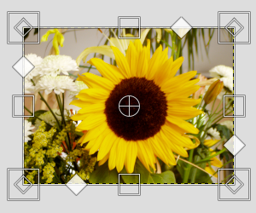

This tool combines several tools: Rotate, Scale, Shear and Perspective, performing one or several of these actions at once in one single operation.

* Several kinds of **handles**, on the edges:
  + ***https://docs.gimp.org/2.10/en/images/toolbox/shear-icon.png*** Diamonds for shearing
  + ***https://docs.gimp.org/2.10/en/images/toolbox/scale-icon.png*** Squares for scaling.
  + ***https://docs.gimp.org/2.10/en/images/toolbox/perspective-icon.png*** Small diamonds for changing perspective, in large squares for Scaling.

Click and drag a handle to perform the action of the concerned tool

* A **circle with a cross inside** at the center of the image window for the pivot. Click and drag this circle to move the pivot. It can be placed out of the image window, and even where you want on screen (but you can no longer see it, unless you enlarge the image window).

**Handle Transform**

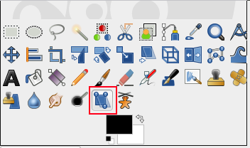

This tool allows you to apply moving, rotating, shearing, perspective and scaling corrections using handles placed on canvas.

**Flip**

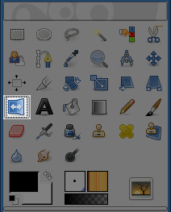

The Flip tool provides the ability to flip layers or selections either horizontally or vertically. When a selection is flipped, a new layer with a Floating Selection is created. You can use this tool to create reflections.

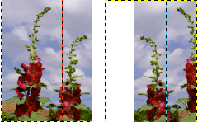

**The Cage Tool**

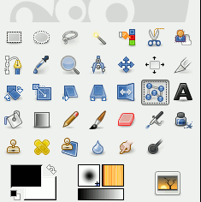

The Cage tool is a special transforming tool allowing you to select the transforming area by setting anchor points by free hand drawing similar to the way you do it with the Free Selection (Lasso) tool.

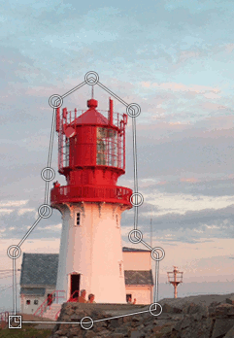 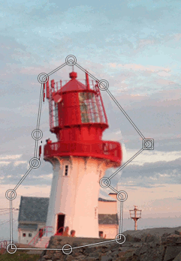

The cage area selected Transformed