PROFILE / NOT A CHRONOLOGY
I BUILD THINGS
UNTIL THEY FEEL INEVITABLE.
Independent full-stack developer / vibecoder / product-minded troublemaker. I make games, web products, mobile apps and the systems behind them.
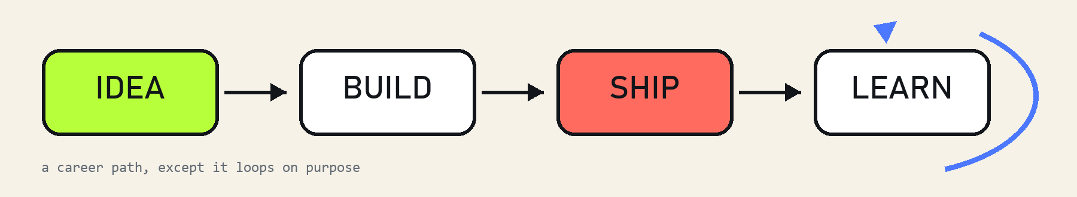
// not linear. still moving forward.
“I do the product thinking, the code, the weird middle part, and the last 10% that turns a demo into something people can actually use.”

01 / A TRAIL OF SHIPPED THINGS
My career is easier to understand as a sequence of things I cared enough to make real. Each project pulled me into a different layer of the stack; each one made the next project more ambitious.
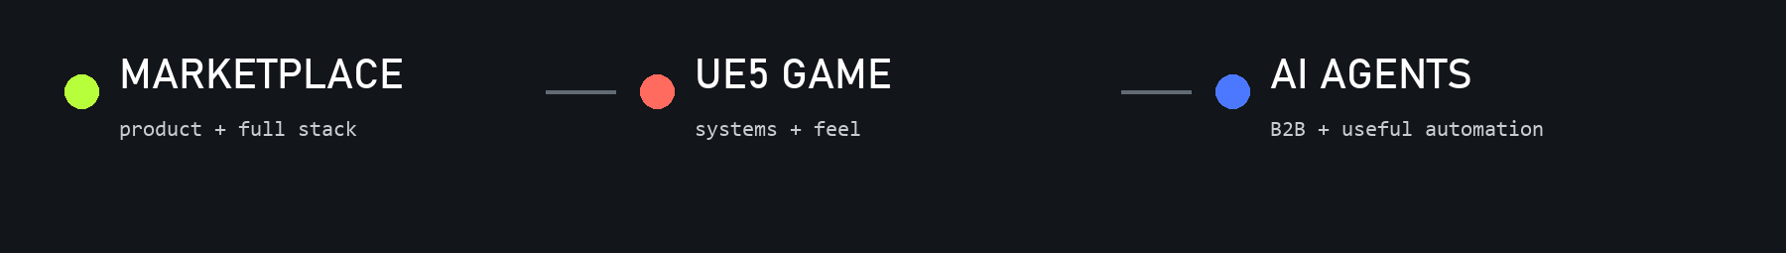
A gas.green / marketplace
I helped turn gas.green into a working marketplace, moving between product logic, user flows, frontend and backend until the parts became one usable thing. It is the kind of project I like most: commercial, technical, and real.
B Untitled UE5 project / game
I built a playable world in Unreal Engine 5, working where code, systems, pacing and feel collide. Games make every shortcut visible: if a system is not coherent, the player feels it before they can explain it.
C AI agents startup / B2B
I worked on B2B AI agents designed around actual company workflows. The goal was not AI as decoration; it was automation that could carry useful work, fit into existing systems, and earn trust.
// yes, I named the project chapters. no, I will not apologize.

HOW THE WORK HAPPENS
FULL STACK,
INCLUDING THE HUMAN PART.
I like owning the distance between a half-formed idea and a thing somebody can use. That means asking product questions, choosing the simplest architecture that survives reality, and caring about the tiny interactions people notice without knowing why.
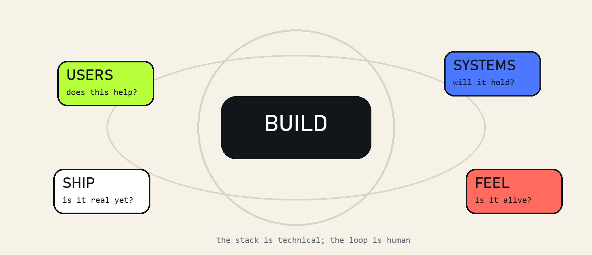
// architecture diagram, but emotionally accurate

02 / THE RANGE IS THE POINT
Web, mobile, games, AI, backend and product are not separate identities I switch between. They are different materials. I use whichever combination gets the idea out of my head and into the world with the least ceremony and the most useful result.
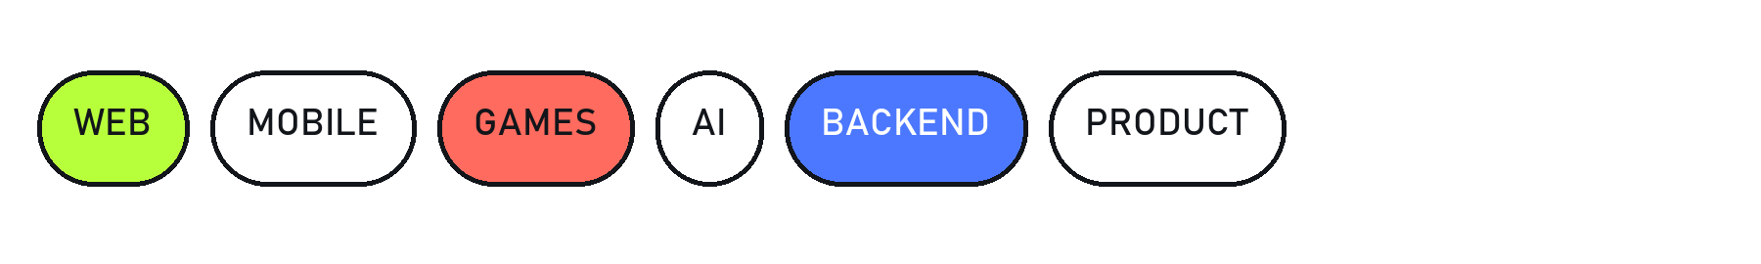

03 / WHAT I AM PROBABLY GOOD AT
Turning ambiguity into a build plan. Learning the missing part while building it. Moving between product detail and system design. Finding the line between ‘clever’ and ‘actually useful’. Shipping before the idea goes stale.

04 / THE PART A NORMAL CV CALLS SKILLS
My stack changes with the problem. I care about languages and frameworks, but I care more about choosing tools I can understand, bend, debug and ship. The names belong below; the reason for using them is always the product.
[ YOUR STACK → TypeScript / React / Node / … / Unreal Engine 5 / … ]

THE NEXT THING should be useful, slightly ambitious, and fun to explain at 1 a.m.
[YOUR NAME] · [EMAIL] · [GITHUB] · [PORTFOLIO]

