KAUNO TECHNOLOGIJOS UNIVERSITETAS

INFORMATIKOS FAKULTETAS

Mašininio mokymosi metodai (P160B124)

Laboratorinių darbų ataskaita

Atliko:

IFF-1/4 gr. studentas

Mildaras Karvelis

2023 m. gruodžio 4 d.

Priėmė:

Doc. Iešmantas Tomas

KAUNAS 2023

TURINYS

1. Lab 5.2 I 3

1.1. Task 1 3

1.2. Task 2 and 3 5

1.3. Task 4 5

1.4. Task 5 5

2. Lab 5.2 II 6

2.1. Task 1 6

2.2. Task 2 7

2.3. Task 3 7

2.4. Task 4 7

3. Lab 6.1 7

3.1. Task 1 7

3.2. Task 2 7

3.3. Task 3 8

4. Lab 7.1 9

4.1. Task 1 9

4.2. Task 2 9

4.3. Task 3 9

4.4. Task 4 10

# Lab 5.2 I

## Task 1

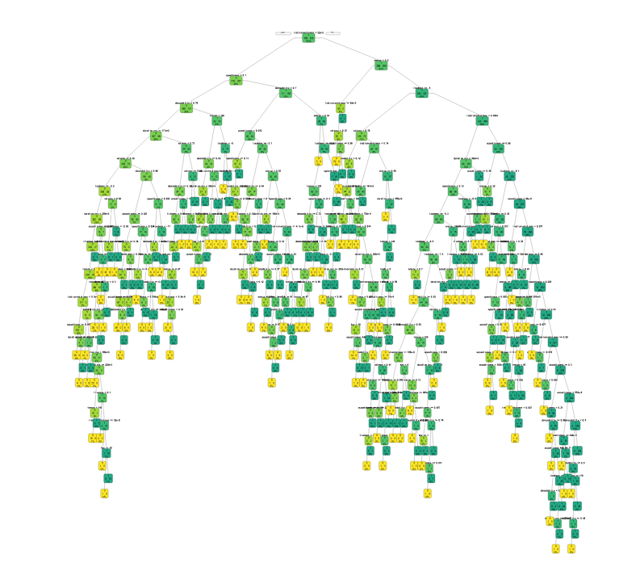

Galutinis medis gavo labai didelis ir sunku pamatyti jame pateiktus duomenis, nes lapų kiekis yra ypač didelis.

pav. Medžio šakų dydis ir sudėtingumas

## Task 2 and 3

Po „prune“ funkcijos panaudojimo, medis dabar yra įskaitomas, medis turi tik 39 lapus. Cross-Validation error – 1.

## Task 4

Iš viso panaudotos klasės: acousticness, danceability, duration_ms, energy, instrumentalness key, liveness, loudness, mode, speechiness, tempo, time_signature, valence.

## Task 5

Accuracy on the pruned tree: 69.97519 %

Accuracy on the unpruned: 65.26055 %

# Lab 5.2 II

## Task 1

Kadangi programa gražino 150, imame pirmus 20 C dydžius, mano manymu geriau yra naudoti 19 C dydį, nes jis mažiausias

|  |  |  |  |  |  |
| --- | --- | --- | --- | --- | --- |
| n | CP | nsplit | rel error | xerror | xstd |
| 1 | 3.344673e-02 | 0 | 1.000000000 | 1.0022553 | 0.001312758 |
| 2 | 2.696762e-02 | 1 | 0.966553266 | 0.9666679 | 0.001707379 |
| 3 | 1.697183e-02 | 3 | 0.912618019 | 0.9128091 | 0.002131523 |
| 4 | 1.681893e-02 | 4 | 0.895646191 | 0.8963342 | 0.002235901 |
| 5 | 1.658958e-02 | 5 | 0.878827262 | 0.8876190 | 0.002287446 |
| 6 | 1.408585e-02 | 6 | 0.862237682 | 0.8641489 | 0.002415114 |
| 7 | 1.353159e-02 | 8 | 0.834065976 | 0.8473682 | 0.002497485 |
| 8 | 1.066473e-02 | 9 | 0.820534383 | 0.8287527 | 0.002581148 |
| 9 | 9.728221e-03 | 10 | 0.809869653 | 0.8094874 | 0.002659977 |
| 10 | 9.097512e-03 | 12 | 0.790413211 | 0.7903750 | 0.002731049 |
| 11 | 7.644968e-03 | 13 | 0.781315699 | 0.7844501 | 0.002751727 |
| 12 | 7.339169e-03 | 14 | 0.773670731 | 0.7692366 | 0.002802036 |
| 13 | 6.192424e-03 | 16 | 0.758992393 | 0.7545201 | 0.002847040 |
| 14 | 5.982187e-03 | 17 | 0.752799969 | 0.7495126 | 0.002861564 |
| 15 | 5.695501e-03 | 21 | 0.728871221 | 0.7429762 | 0.002879934 |
| 16 | 5.657276e-03 | 22 | 0.723175720 | 0.7364397 | 0.002897651 |
| 17 | 5.619051e-03 | 23 | 0.717518443 | 0.7351019 | 0.002901198 |
| 18 | 5.504377e-03 | 24 | 0.711899392 | 0.7335729 | 0.002905219 |
| 19 | 5.236803e-03 | 25 | 0.706395015 | 0.7242842 | 0.002928902 |

## Task 2

Programa gražino, jog pruned medis turi 9536 lapus su panaudota C reikšme.

## Task 3

Accuracy on the pruned tree: 77.97433 %

Accuracy on the unpruned: 68.98745 %

## Task 4

Panaikinus dalį pikselių programa pagreitėjo, tačiau mano manymu duomenys turėtu būti netikslūs.

# Lab 6.1

## Task 1

Daugiausia yra red soil, grey soil ir very damp grey soil.

## Task 2

Kernel tipo turėtų pasirodyti geriau nei linear, nes kernel leidžia atlikti non-linear funkcija ant linear duomenų.

## Task 3

Overall Error Rate: 0.6055

|  |  |  |  |  |  |  |
| --- | --- | --- | --- | --- | --- | --- |
| pred | red soil | cotton | crop | grey soil | damp grey soil | soil with vegetation |
| red soil | 399 |  | 212 | 386 | 111 | 50 |
| cotton crop | 0 |  | 0 | 0 | 0 | 0 |
| grey soil | 0 |  | 0 | 0 | 0 | 0 |
| damp grey soil | 5 |  | 1 | 0 | 4 | 3 |
| soil with vegetation | 0 |  | 0 | 0 | 0 | 0 |
| very damp grey soil | 57 |  | 11 | 11 | 96 | 184 |

|  |  |
| --- | --- |
| pred | very damp grey soil |
| red soil | 74 |
| cotton crop | 0 |
| grey soil | 0 |
| damp grey soil | 10 |
| soil with vegetation | 0 |
| very damp grey soil | 386 |

# Lab 7.1

## Task 1

## Task 2

## Task 3

Dabar prieš išmokinant naural network pasiskirstymas yra gan didelis tarp 0.6 – 1.

Mano manymu pasiskirstymas turėtų išsilygin.

## Task 4

Testing Accuracy: 99.13109 %

Class 0 (Normal) Accuracy: 98.29322 %

Class 1 (Supraventricular) Accuracy: 99.24377 %

Class 2 (Ventricular) Accuracy: 99.4661 %

Class 4 (Unknown) Accuracy: 99.86005 %

