Howard University
College of Engineering and Architecture
Department of Electrical Engineering & Computer Science

Large Scale Programming
Fall 2024

Midterm Exam – Part I
October 17, 2024

Name: MILDNESS AKOMOIZE

Part I: 50 pts. (essay questions)

Instructions:
- Submit completed exam to your github repository under package org.howard.edu.lsp.midterm

Verify that the commit(s) completed successfully

- OPEN BOOK, OPEN NOTES. THERE IS NO COLLABORATION ON THIS EXAM
- Site any and ALL references for anything obtained off the internet.

Question 1. (10 pts.)

You are reviewing the following class in a Fitness Tracking System. The class is intended to manage various aspects of a user’s fitness activities.

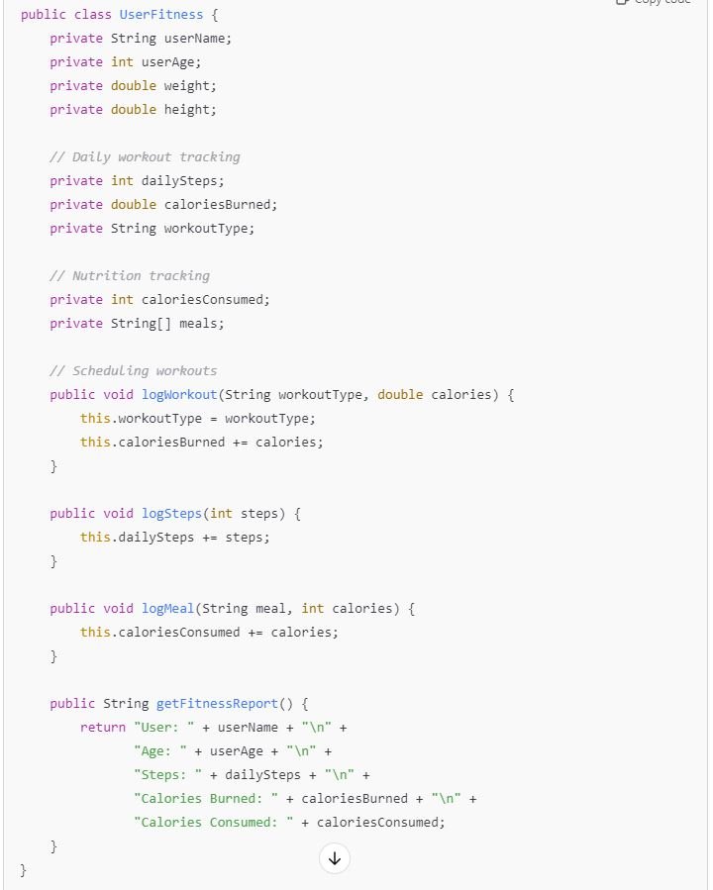

Tasks:
- Analyze the UserFitness class. Explain why this class has low cohesion. (5 pts.)
Answer: Cohesion refers to how closely related and focused the responsibilities of a class are. The UserFitness class in this example has low cohesion because it handles multiple responsibilities that are only loosely related.

- Describe, in general, how you would split the UserFitness class into more cohesive classes. Your answer should not be a complete design. (5 pts.)
Answer: To improve cohesion, we could split the UserFitness class into more focused classes, each with a specific purpose. For example:
- UserProfile Class:
  - Purpose: Store user information like name, age, weight, and height.
  - Attributes: userName, userAge, weight, height.
  - Methods: Methods to get or update user profile data, e.g., updateProfile().
- WorkoutTracker Class:
  - Purpose: Track workout-related data such as workout types and calories burned.
  - Attributes: workoutType, caloriesBurned.
  - Methods: logWorkout() for recording workouts and calories burned.
- StepTracker Class:
  - Purpose: Track the user’s steps on a daily basis.
  - Attributes: dailySteps.
  - Methods: logSteps() for recording the steps.
- NutritionTracker Class:
  - Purpose: Handle meal and calorie consumption tracking.
  - Attributes: meals, caloriesConsumed.
  - Methods: logMeal() to log meals and calories.
- FitnessReportGenerator Class:
  - Purpose: Collect data from the other classes and generate a fitness report.
  - Methods: getFitnessReport() to compile data from all trackers and provide a summary of the user’s fitness activities.
This breakdown would create a set of classes, each responsible for a distinct aspect of fitness tracking, leading to higher cohesion and making each class more manageable and easier to maintain or extend.

Question 2. (5 pts.)
Given the following, answer the below questions.

A university manages its students using a program that has a class Student with subclasses FirstYear, SecondYear, and ThirdYear for year-specific state and behaviors. The program has a List that contains all Students.

Should Student be a class, an abstract class or an interface? Explain your answer

Answer: Student should be an abstract class because all students (first-year, second-year, and third-year) share common behaviors and states, such as name, ID, etc., that can be implemented in the Student class. However, Student should not be instantiated directly, as there are only specific types of students (e.g., FirstYear, SecondYear, and ThirdYear). Each subclass can extend the abstract Student class to provide specific behavior for each year.

- At the end of each year, the third-year students graduate and must be removed. This is done by passing the list to the following method:

void removeThirdYears(List<Students> students) {
for (Student student : students) {
try {
ThirdYear = (ThirdYear) student;
students.remove(thirdyear);
}
}
}

Why is the above method flawed? Hint: Another Arthur Riel heuristic (5 pts.)

Answer: The method is flawed due to concurrent modification of the list while iterating over it. The issue arises because we're trying to modify (i.e., remove elements from) the list within a for-each loop. Java's List does not allow structural modifications (like removing elements) while iterating over it, which results in a ConcurrentModificationException.
- Arthur Riel's Heuristic 3.6: “Avoid modifying the structure of a collection while iterating over it.” Riel's heuristic suggests that modifying the list while traversing it leads to instability and exceptions, which is exactly what's happening here.
Here’s a corrected approach:

void removeThirdYears(List<Student> students) {
Iterator<Student> iterator = students.iterator();
while (iterator.hasNext()) {
Student student = iterator.next();
if (student instanceof ThirdYear) {
iterator.remove(); // Safe removal
}
}
}
Using an Iterator allows safe removal of elements from the list without causing concurrent modification issues.

Question 3. (5 pts.)
Given the following, answer the below questions.

public class BankAccount {
public String accountHolderName;
public String accountNumber;
public double balance;
public double interestRate;

public BankAccount(
String accountHolderName,
String accountNumber,
double initialDeposit,
double interestRate) {
this.accountHolderName = accountHolderName;
this.accountNumber = accountNumber;
this.balance = initialDeposit;
this.interestRate = interestRate;
}

// Exposed implementation for adding interest
public void addInterest() {
double interest = balance * (interestRate / 100);
balance += interest;
}

// Exposed implementation for deposits
public void deposit(double amount) {
balance += amount;
}

// Exposed implementation for withdrawals
public void withdraw(double amount) {
balance -= amount;
}
}

- Is BankAccount well-encapsulated? Why or why not? If so, describe what changes you would make to the class. Otherwise, state nothing. (5 pts.)
Answer: No, the BankAccount class is not well-encapsulated. Encapsulation is a fundamental principle of object-oriented programming (OOP) where the internal details of a class (its fields) are hidden from the outside world, and access to these details is provided through controlled interfaces (getters and setters or other methods). The main purpose of encapsulation is to protect the data and maintain control over how it is accessed and modified.
In the current BankAccount class:
The fields accountHolderName, accountNumber, balance, and interestRate are public, which allows direct modification from outside the class. This violates the principle of encapsulation because any external code can directly change these fields without any validation or control.
To improve encapsulation:
- Make the fields private: All instance variables should be private so they cannot be accessed directly from outside the class.
- Use getter and setter methods: Provide controlled access to the fields through getter and setter methods where appropriate. This ensures that changes to the state of the object can be validated and controlled.
- Add validation logic: For example, you may want to validate that the balance cannot be negative or that an account number has a specific format before setting it.

Question 4. (10 pts.)
Given the following, answer the below questions.

Given:
A car manufacturer uses Java software to track current vehicles being built. The UML diagram below shows an excerpt of the current software structure. You should assume the presence of other appropriate fields and methods

Car
getTrimLevel()
Engine
accelerate()
getFuelLevel()
Base
Sports
Luxury
Electric
Petrol

Each car can be built to one of three trim levels: Base, Luxury or Sport. They can also be configured with an electric or petrol engine. At various points in the manufacturing process the customer can choose to change the trim level.

Task:
- Explain in detail why the current structure does not support this. (5 pts.)
Answer: In the current UML diagram, the Car class has three subclasses: Base, Sports, and Luxury. This structure suggests that the trim level (Base, Sports, or Luxury) is hardcoded as a subtype of Car. Each car is essentially bound to its trim level by its class type, meaning that once a Car object is instantiated as a Base, Sports, or Luxury car, it cannot be changed dynamically at runtime.

The issue arises from inheritance being used to represent the trim levels. Since inheritance creates a static and fixed relationship between the Car and its subclasses, changing the trim level would require creating a new instance of a different subclass (i.e., Sports, Base, or Luxury), which does not reflect a dynamic change in the car's state. We would need to destroy the existing object and instantiate a new one, losing the car’s other state (e.g., its engine configuration, fuel level, etc.).

- Describe how to refactor the structure to allow trim-level change for a car to dynamically change. Hint: How would you modify Car to use composition to solve the problem? (5 pts.)

To support dynamic changes to the trim level, the structure should be refactored to use composition instead of inheritance. In this approach, Car will contain an object that represents the trim level, rather than having trim levels as subclasses of Car. This allows the trim level to be changed by switching the contained trim object without needing to create a new Car object.
We can refactor the structure by:
- Trim Interface: Create a Trim interface or class that represents the different trim levels (Base, Sports, Luxury).

public interface Trim {
String getTrimLevel();
}

- Implement Trim Levels: Implement the Base, Sports, and Luxury trim levels as separate classes that implement the Trim interface.

public class Base implements Trim {
public String getTrimLevel() {
return "Base";
}
}

public class Sports implements Trim {
public String getTrimLevel() {
return "Sports";
}
}

public class Luxury implements Trim {
public String getTrimLevel() {
return "Luxury";
}
}

- Modify Car Class: The Car class should now have a Trim object as a member variable instead of extending different trim-level subclasses. This will allow the car's trim level to be changed dynamically by assigning a new Trim object.

public class Car {
private Trim trim;
private Engine engine;

public Car(Trim trim, Engine engine) {
this.trim = trim;
this.engine = engine;
}

public String getTrimLevel() {
return trim.getTrimLevel();
}

public void setTrim(Trim trim) {
this.trim = trim;
}
}
- Changing Trim Levels Dynamically: Now, changing the trim level at runtime is straightforward. You can simply call setTrim() to switch between trim levels without needing to reinstantiate the car object.

Car myCar = new Car(new Base(), new PetrolEngine());
System.out.println(myCar.getTrimLevel()); // Outputs: Base

// Change trim level dynamically
myCar.setTrim(new Luxury());
System.out.println(myCar.getTrimLevel()); // Outputs: Lux

Question 5. (5 pts.)
Suppose you are about to code a particular class and find that you have written another class with nearly the functionality that you now are developing. This means that the two classes in large parts contain the same code, but in smaller parts have different code. Explain in detail why this may be a problem and how to solve it. Give your answer in terms of Arthur Riel’s design heuristics.
Answer: Problem with Duplicate Code in Two Classes
Having two classes that contain nearly the same code can lead to code duplication, which violates the principle of code reusability and maintainability. According to Arthur Riel's design heuristics, duplicating code introduces several problems:
- Violation of Reusability and Maintainability:
  - Heuristic 5.7: Riel suggests that “similar functionality should be factored out into a common base class or module.” When you duplicate code across multiple classes, any changes made to one class need to be duplicated across the other classes as well. This leads to maintenance issues, as fixing a bug or adding a feature requires modifying multiple locations. It increases the risk of introducing inconsistencies and errors.
- Increased Technical Debt:
  - The more code that’s duplicated duplicate, the more technical debt accumulatde, making the system harder to understand, debug, and extend. Over time, this can lead to a bloated codebase that is difficult to refactor or improve without significant risk of breaking functionality.
- Lack of Flexibility:
  - Heuristic 4.3: This heuristic emphasizes that “systems should be composed of modules that are as reusable as possible.” If you have duplicate code, the system becomes less flexible because the shared functionality is not encapsulated in a reusable form (such as an abstract class or common superclass). As a result, you may end up with inconsistent behavior when you modify the code in one place but forget to update the other class.
Solution: Apply Inheritance
To solve this problem, we can refactor your code using inheritance to promote reusability and eliminate duplication.
Inheritance:
- If the two classes share common functionality but are conceptually related (e.g., one class is a type of the other), we should use inheritance. Move the shared code into a base class (abstract or concrete) and let the two classes inherit from it. The base class will handle the common logic, while the subclasses will override or extend the behavior for their specific parts.
public abstract class CommonFunctionality {
public void sharedMethod() {
// Common code goes here
}

public abstract void specificMethod();
}

public class ClassA extends CommonFunctionality {
@Override
public void specificMethod() {
// Specific implementation for ClassA
}
}

public class ClassB extends CommonFunctionality {
@Override
public void specificMethod() {
// Specific implementation for ClassB
}
}

Question 6. (5 pts.)
Suppose we need to store instances of the classes Car and BankAccount in a database. To obtain low coupling it may seem as if the functionality to save an instance should be in precisely those classes, since they have the information that shall be saved. Why is it unwise to place the database calls there?
Answer: It is unwise to place database calls directly in classes like Car or BankAccount because it violates the Single Responsibility Principle (SRP), which states that a class should have only one reason to change. By mixing business logic with persistence logic, you increase coupling between the class and the database, making it harder to modify or test the class independently.
Instead, use a Data Access Object (DAO) or Repository pattern to separate the database interactions, promoting low coupling and allowing each class to focus solely on its domain-specific logic. This also makes it easier to switch databases or change persistence logic without affecting the core business logic.

Question 7. (5 pts.)
Given a set of requirements, what conditions must be met to make it appropriate to create a new class hierarchy using inheritance? Neither superclass nor subclass exist before, the question is about designing a new class hierarchy.
Answer: To create a new class hierarchy using inheritance, the following conditions should be met:
- Is-a Relationship: Subclasses should have a clear "is-a" relationship with the superclass, representing a natural hierarchy (e.g., a Dog is a type of Animal).
- Shared Behavior: The superclass should encapsulate common behavior that will be inherited by all subclasses.
- Specialization: Subclasses should provide specific behavior or attributes that extend or modify the superclass's functionality.
- Low Coupling: The subclasses should not be overly dependent on each other or on the superclass’s internal details.
- Polymorphism: The design should benefit from the ability to treat subclass instances as instances of the superclass, using polymorphism.
Only when these conditions are satisfied does inheritance create a meaningful and maintainable hierarchy.

Question 8. (2.5 pts.)
Describe the difference between inheritance and composition why would you choose one over the other.
Answer: Inheritance is a "is-a" relationship where a subclass inherits behavior and attributes from a superclass. It's used when you need to create a natural hierarchy and allow polymorphism, enabling shared behavior across related classes.

Composition is a "has-a" relationship where one class contains another class as a member. It's used to combine behaviors without creating a rigid class hierarchy, promoting flexibility and easier code reuse.

We choose inheritance when classes share a common identity and behavior, and composition when you need more flexibility and want to avoid the limitations of a fixed hierarchy. Composition is often preferred as it promotes lower coupling and greater adaptability.

Question 9. (2.5 pts.)
Explain the meaning of cohesion and describe whether low or high cohesion is better.
Answer: Cohesion refers to how closely related and focused the responsibilities of a class or module are.
- High cohesion means that a class or module has a clear, focused purpose, with all its methods and attributes working towards that purpose.
- Low cohesion means that a class or module has many unrelated responsibilities, making it harder to understand, maintain, and reuse.
High cohesion is better because it leads to more understandable, maintainable, and reusable code, as each class or module performs a single, well-defined task.

RESOURCES

- https://www.geeksforgeeks.org/cohesion-in-java/
- https://www2.ccs.neu.edu/research/demeter/related-work/riel/heuristics2.txt
- https://www.geeksforgeeks.org/encapsulation-in-java/
- https://www.geeksforgeeks.org/unified-modeling-language-uml-introduction/
- https://www.javatpoint.com/inheritance-in-java
- https://www.freecodecamp.org/news/abstract-classes-in-java-explained-with-examples/
- https://www.scaler.com/topics/composition-in-java/

