Subject: Get the 2026 QUE Group Conference app before you arrive

Hi [First Name],
The 2026 QUE Group Conference is almost here (San Diego, September 16–18), and this year we have a companion app to help you get the most out of it — your personal schedule, the attendee directory, session Q&A, sponsor info, and more, all in one place on your phone.
It only takes a minute to set up, and we'd love for you to do it before you land so you're not fumbling with it during registration. Here's how:

1. Open the app
- Visit this link on your phone's browser (Safari on iPhone, Chrome on Android):
- https://quegroup.mikecarey.tech
- Or just scan this QR code:
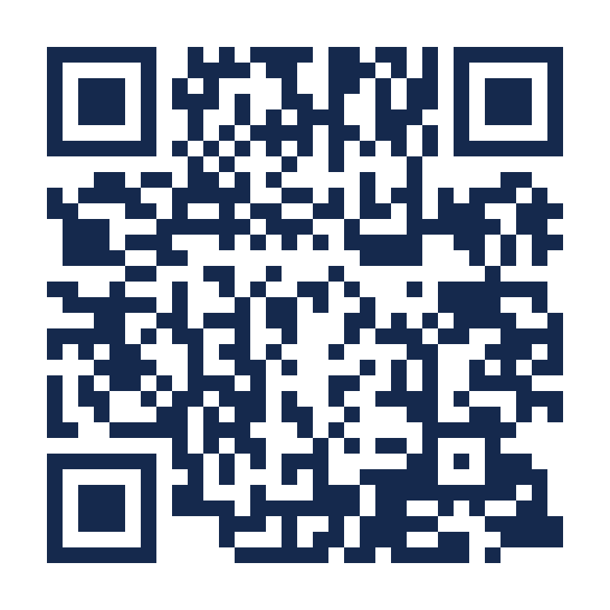

2. Add it to your home screen
This makes it work like a regular app — an icon you tap, even offline.
- iPhone/iPad: tap the Share icon (square with an arrow) in Safari, then “Add to Home Screen.”
- Android: tap the menu (⋮) in Chrome, then “Add to Home screen” or “Install app.”

3. Verify your email
- Tap “Verify your email” and enter the email address you registered with. You'll get an 8-digit code by email — enter that in the app to unlock your personal agenda, the attendee directory, and Q&A upvoting.
- You can browse the schedule, sponsors, and conference info without verifying, but verifying is quick and unlocks the full experience.

What you can do in the app
- Browse the full schedule and build your own personal agenda
- Look up other attendees in the directory
- Submit and upvote questions for the Day 2 panel and Day 3 discussion
- Check out sponsors and speakers
- Find venue maps and conference info
- Share photos from the event
- Works offline once you've loaded it — handy if the venue WiFi is spotty

Questions or trouble?
If anything doesn't work right, use the “Report an issue” link inside the app (no verification required to send it), or just reply to this email.
See you in San Diego!
— The QUE Group Conference Team

