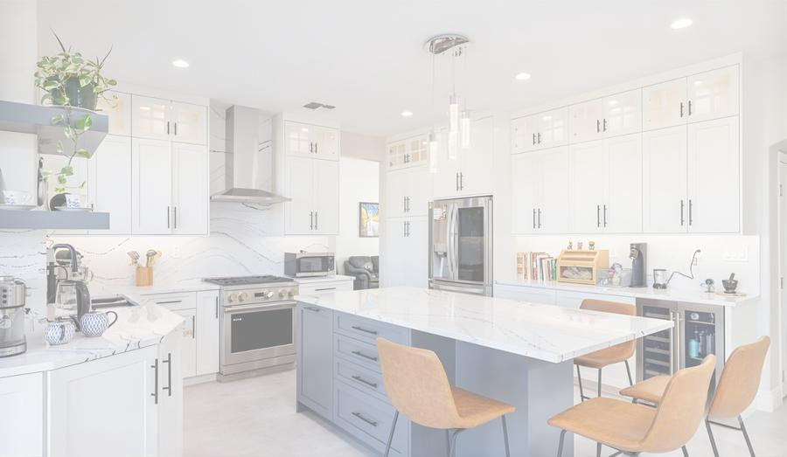
ABODABLE RENOVATIONS
Kitchen Cabinet Renovation Services

INTRODUCTION PROPOSAL
Imagine Your Dream Kitchen Before We Build It
Virtual Design Technology Powered by Mile High AI Labs
www.milehighlabs.ai

ABOUT US

Renovation You Can See Before It Happens

At Abodable Renovations, we believe every homeowner and real estate investor deserves the confidence of seeing their finished kitchen before the project begins. That's why we've partnered with Mile High AI Labs to bring AI-powered virtual design technology directly to your renovation process.
Our service starts with imagination — a high-fidelity visual rendering of your renovated kitchen cabinets in the style, finish, and hardware of your choice. Once you love what you see, we move forward with a detailed price estimation and a clear path to making it real.
Whether you're transforming your family home or maximizing ROI on an investment property, our process is designed to eliminate guesswork, save time, and deliver results that exceed expectations.

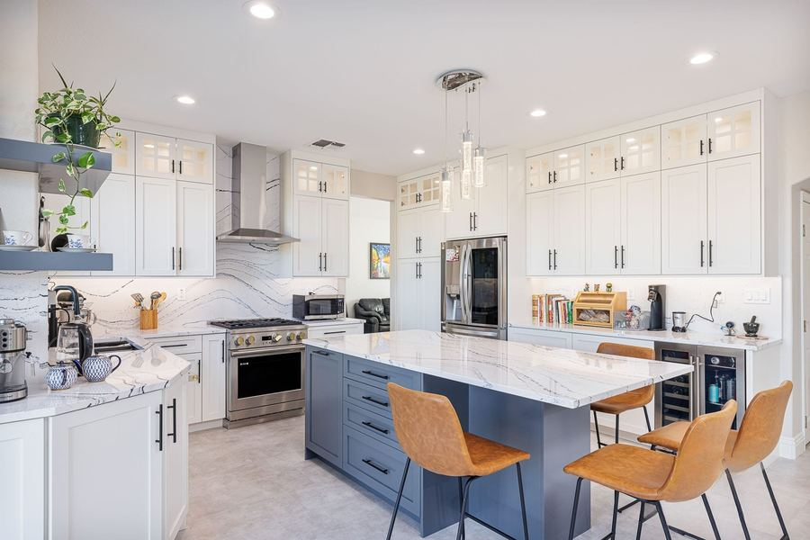

TECHNOLOGY PARTNER
Mile High AI Labs
Mile High AI Labs is a cutting-edge virtual design studio that transforms property renovation concepts into photorealistic renders. Their AI-driven platform allows us to show you multiple cabinet styles, finishes, handle options, and materials — all mapped onto images of your actual kitchen — before any physical work begins.
Visit milehighlabs.ai →

WHAT WE OFFER

Our Services

From first concept to final installation, Abodable Renovations guides you through a seamless, technology-enhanced renovation journey.

  AI-Powered Virtual Design  Using Mile High AI Labs technology, we render photorealistic visualizations of your kitchen with new cabinets in your chosen style, color, material, and hardware — before any work begins. |   Style Consultation  Our renovation specialists explore cabinet styles — from modern high-gloss to classic shaker — paired with a variety of knobs, handles, and premium materials tailored to your taste.
  Detailed Price Proposal  Once your virtual design is approved, we provide a comprehensive, itemized price estimate covering materials, hardware, labor, and installation with full transparency. |   Cabinet Renovation & Installation  Our skilled craftsmen handle every aspect — from precision cabinet removal to expert installation — ensuring the finished result matches your approved design exactly.
  Hardware & Material Selection  Choose from an extensive range of cabinet hardware, finishes, and materials. We source premium options across multiple price tiers to match both your aesthetic vision and budget. |   Investment Property Packages  Real estate investors benefit from our portfolio-focused renovation approach — rapid turnarounds, cost-efficient selections, and ROI-maximizing design choices that appeal to buyers and renters.

THE PROCESS

How It Works

A streamlined, four-step journey from imagination to installation.

1  Share Your Space  Send us photos of your current kitchen. Our team reviews your existing layout, cabinet structure, and overall space to understand your starting point. | 2  Design Consultation  We discuss your preferred styles, materials, colors, and hardware preferences. Our specialists guide you through options that suit your taste and goals. | 3  Virtual Visualization  Mile High AI Labs renders photorealistic images of your new kitchen. Review and refine your design until it matches your vision — before committing a dollar. | 4  Proposal & Build  You receive a detailed price proposal aligned with your approved design. Once confirmed, our team handles the full renovation from start to stunning finish.

TRANSFORMATION GALLERY

Before & After

Every project below was visualized virtually before the first nail was driven. Click through to experience each transformation.

BEFORE  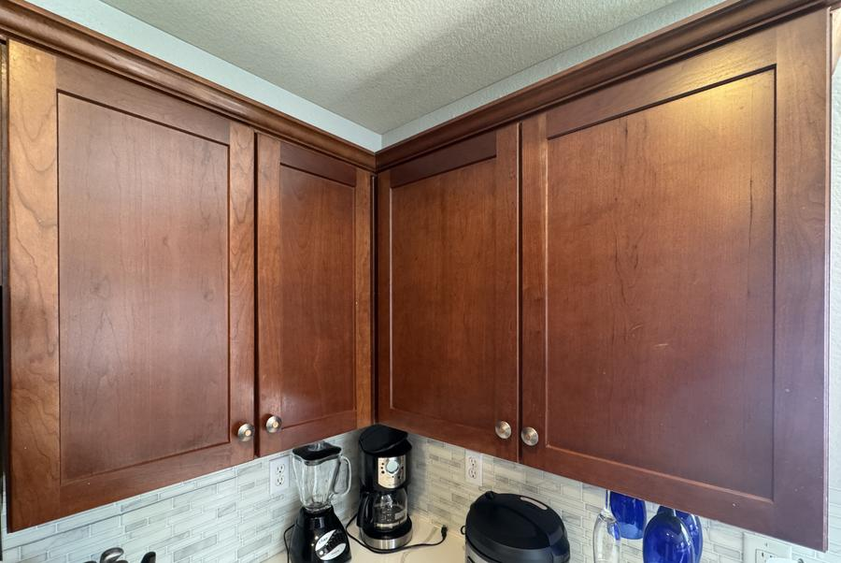 | AFTER  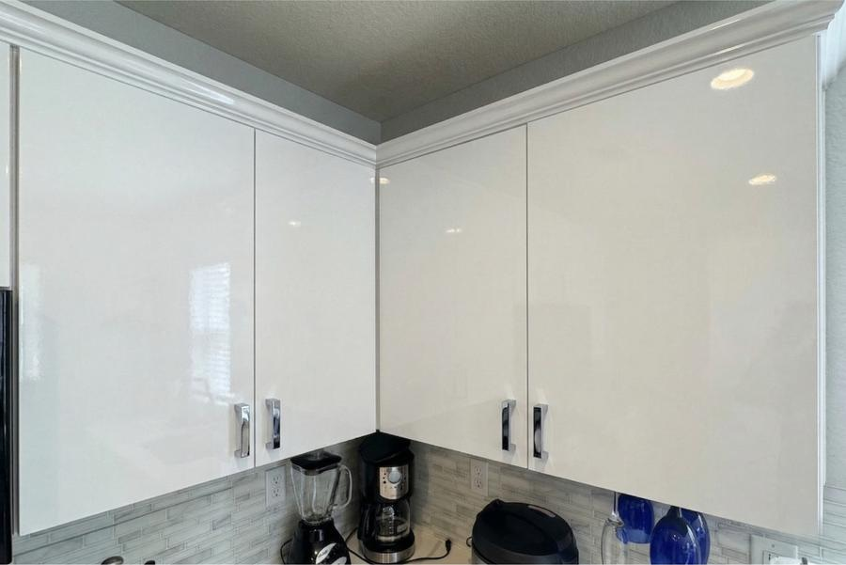
Classic Brown → Modern White High-Gloss
Silver bar handles · High-gloss finish · Contemporary style

BEFORE  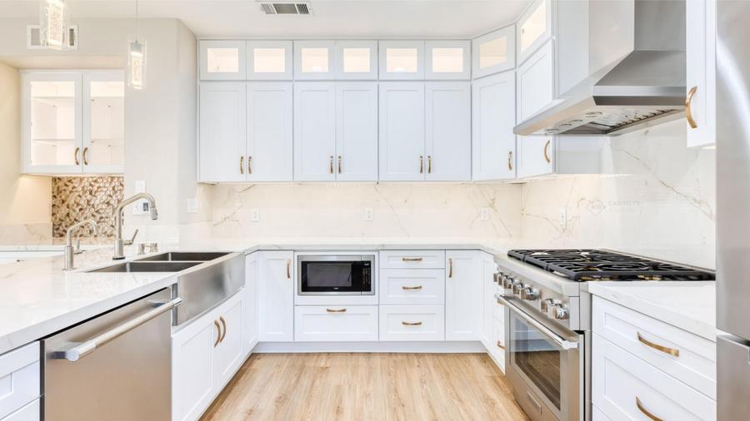 | AFTER  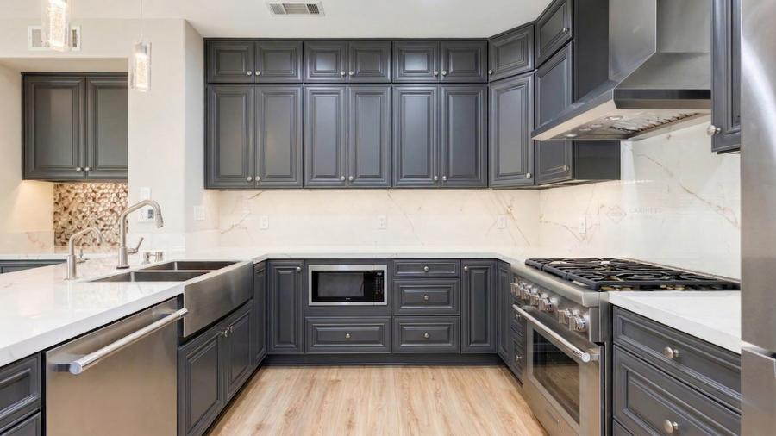
Charcoal Gray → Bright White Shaker
Gold pull handles · Shaker door profile · Quartz countertops

BEFORE  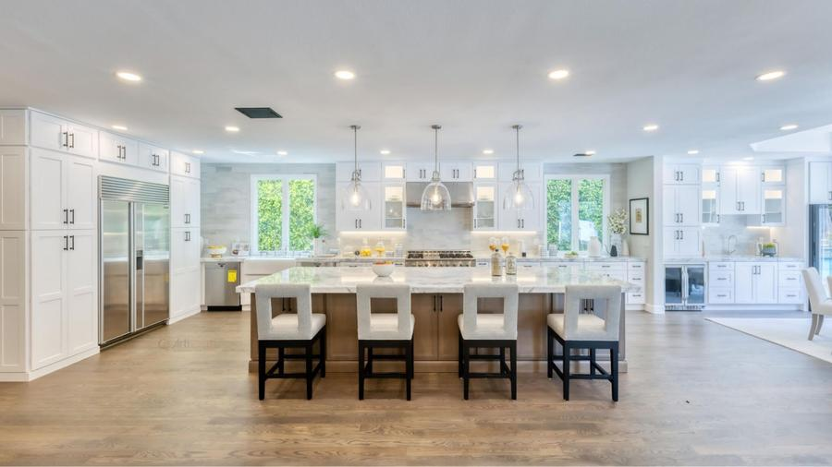 | AFTER  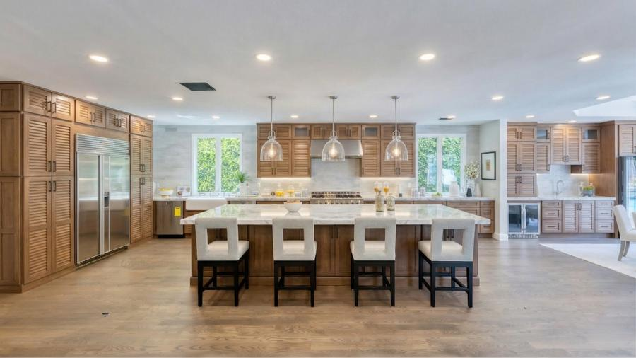
Warm Oak → Crisp White Open Kitchen
Black hardware · Open shelving accents · Full kitchen transformation

BEFORE  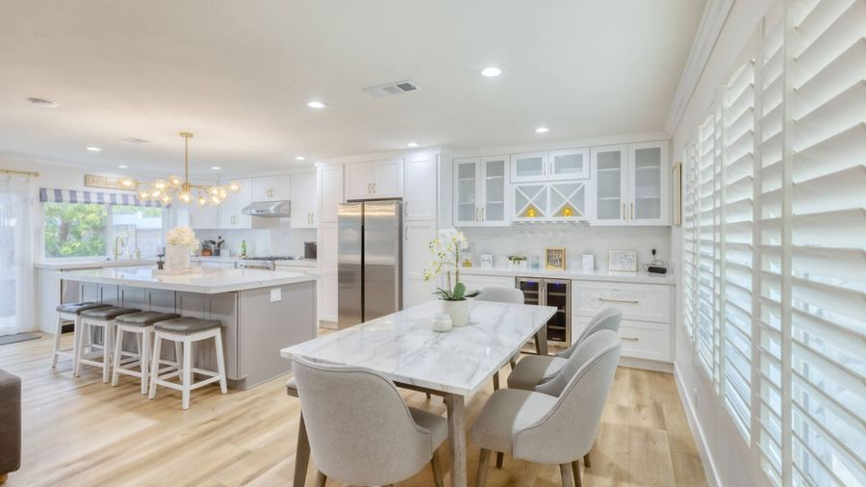 | AFTER  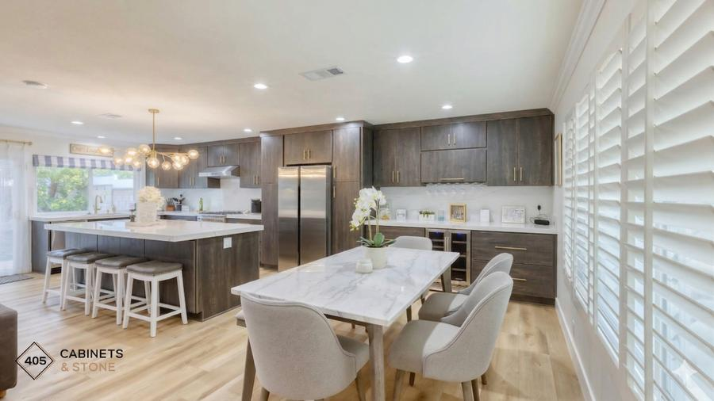
Bright Open Kitchen → Elevated White & Gold
Gold cabinet hardware · Marble backsplash · Open concept layout

BEFORE  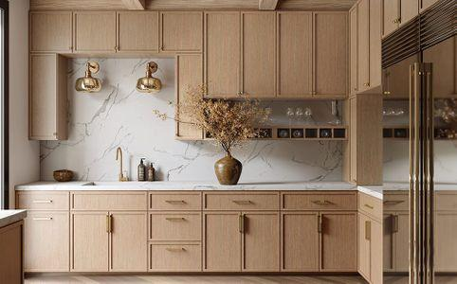 | AFTER  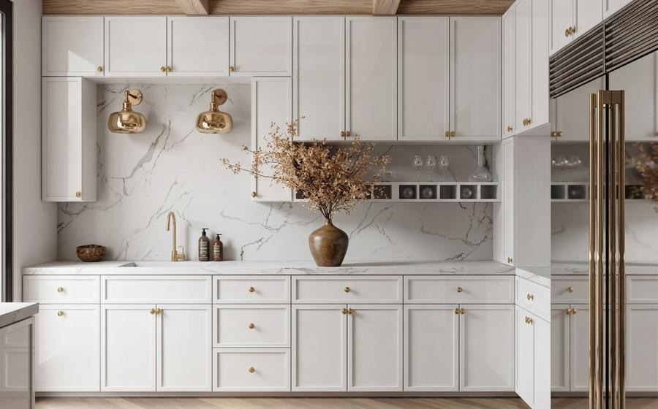
Natural Oak → Elegant Cream & Gold
Gold round knobs · Marble countertops · Luxury finish

BEFORE  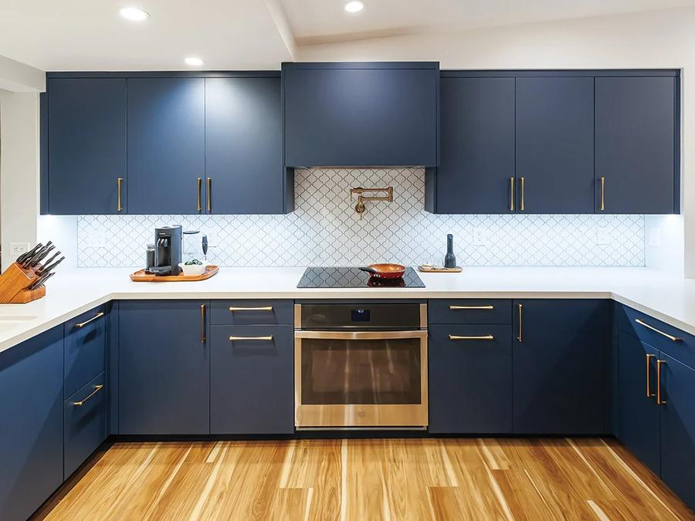 | AFTER  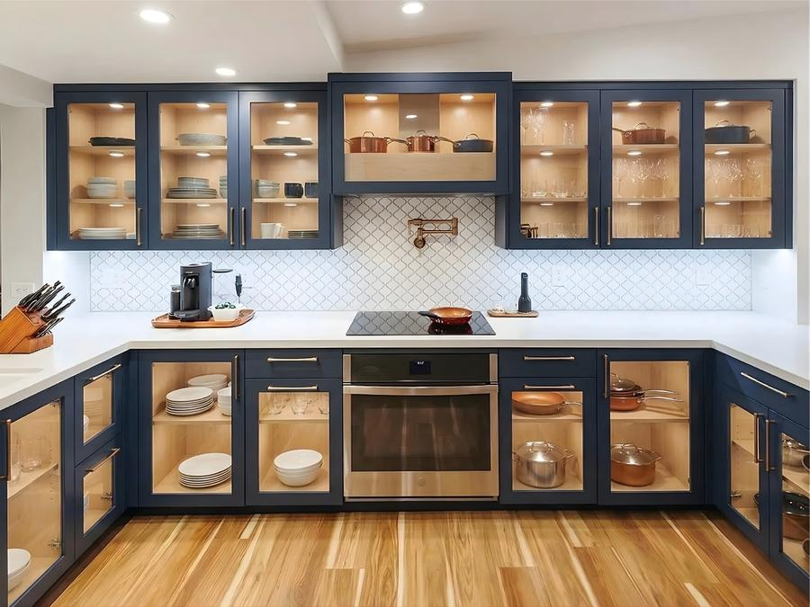
Dated Cabinetry → Fresh Modern Finish
Updated hardware · New door profiles · Complete restyling

BEFORE  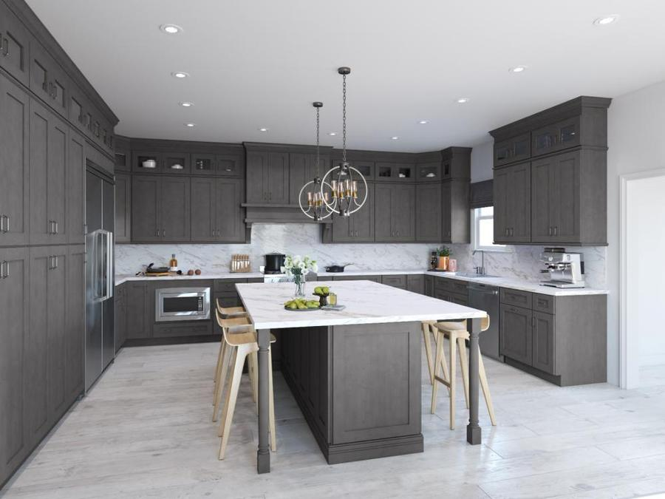 | AFTER  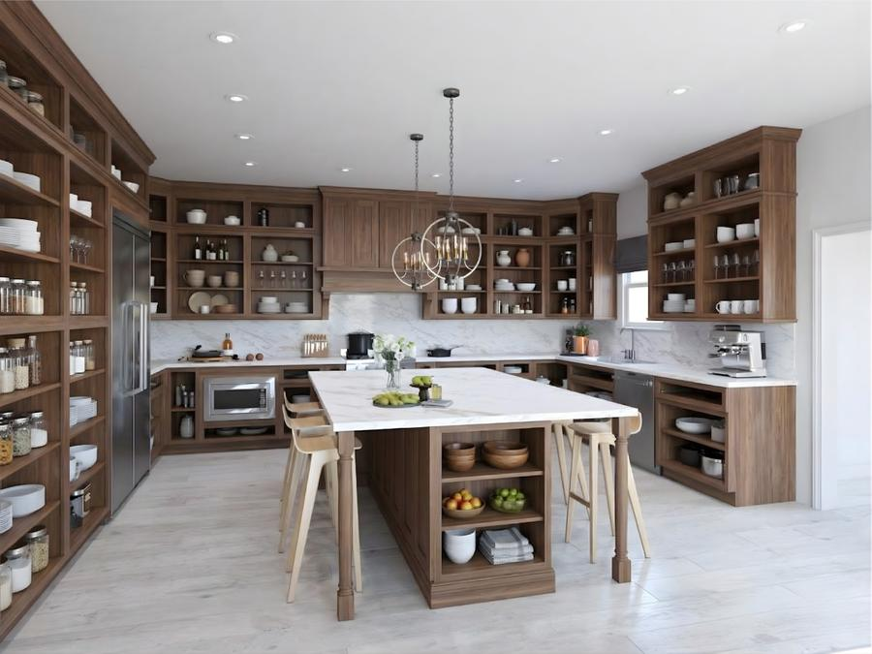
Traditional Style → Contemporary Upgrade
Brushed nickel hardware · Clean panel doors · Bright finish

BEFORE  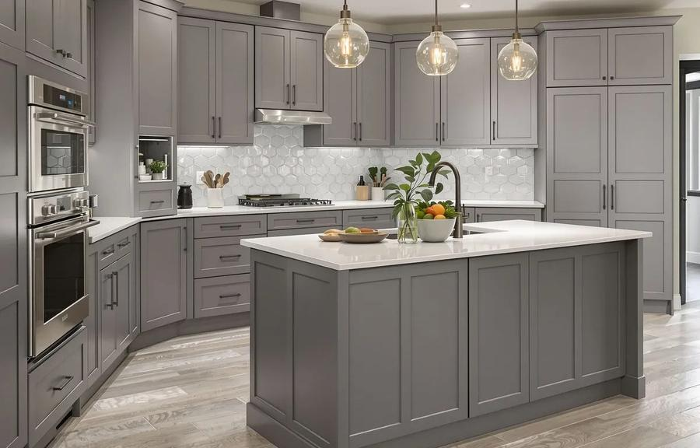 | AFTER  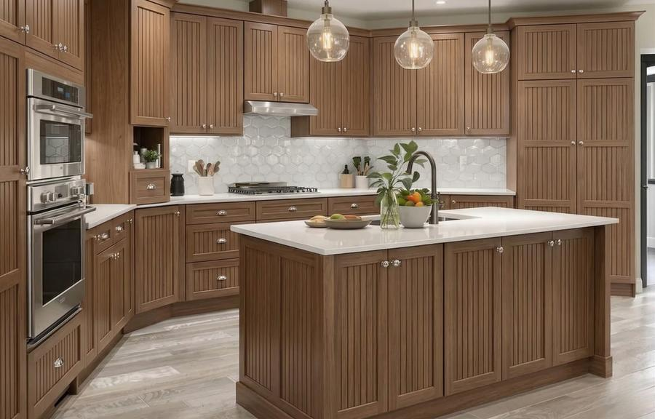
Worn Finish → Refreshed & Refined
Matte hardware · Two-tone color option · Improved storage

BEFORE  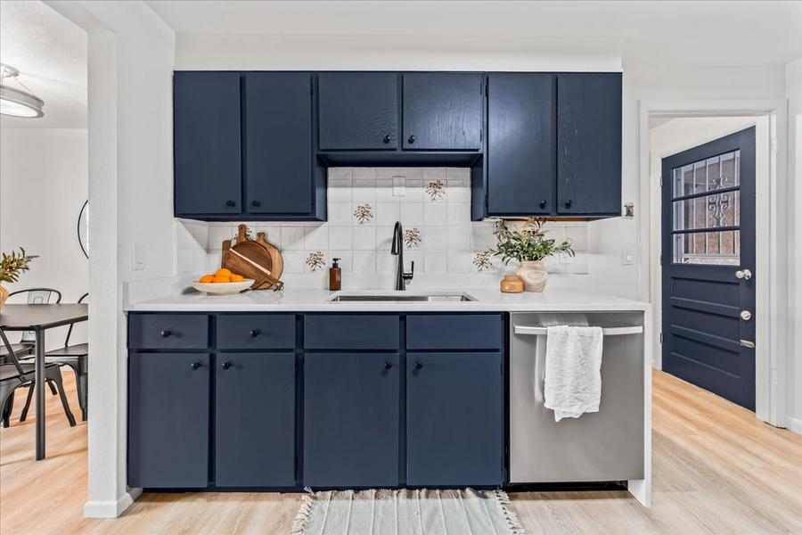 | AFTER  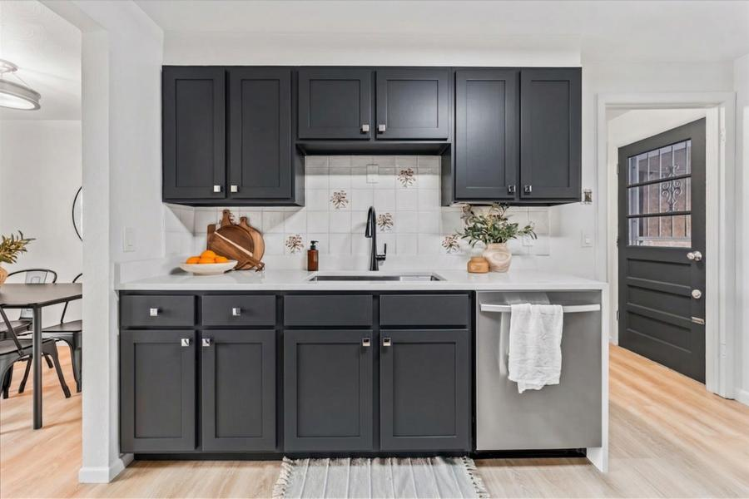
Builder-Grade → Custom Elevated Look
Statement hardware · Premium material upgrade · Designer aesthetic

BEFORE  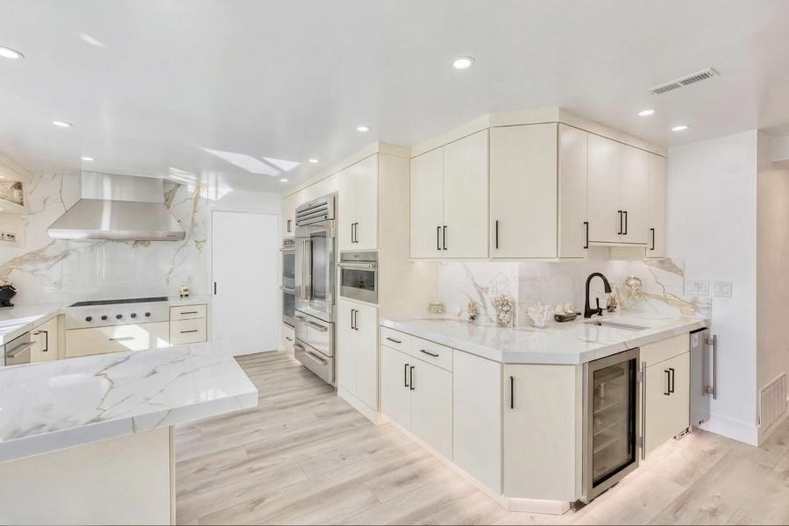 | AFTER  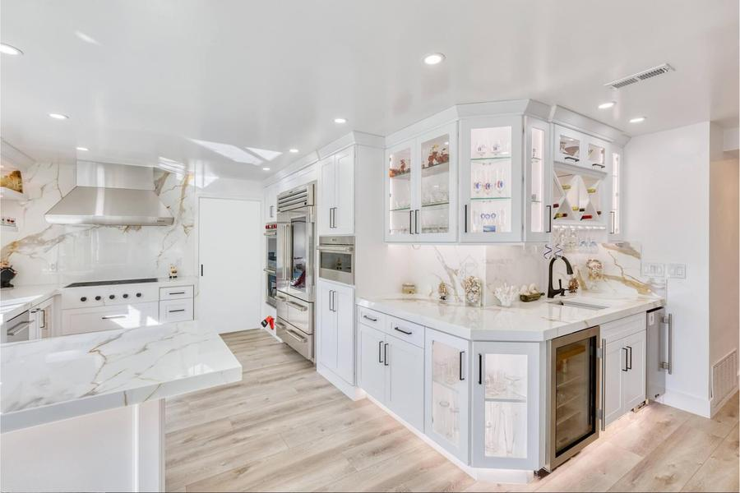
Outdated Kitchen → Showroom-Ready
Mixed metal accents · Custom panel inserts · Full transformation

WHY CHOOSE US

The Abodable Advantage

We combine the latest AI visualization technology with expert craftsmanship to deliver a renovation experience unlike any other.

  See It Before You Build It  AI-powered virtual renders eliminate all guesswork. You approve the design before a single cabinet is touched. |   Unlimited Style Options  Explore dozens of cabinet styles, finishes, and hardware combinations virtually — with no commitment until you're ready.
  Transparent Pricing  Our detailed proposals break down every cost — materials, hardware, labor, and installation. No hidden fees, no surprises. |   Built for Everyone  Whether creating your forever home kitchen or maximizing rental value, our packages are tailored to your specific goals.
  Fast Turnaround  From virtual design approval to completed installation — engineered to minimize disruption to your daily life. |   End-to-End Service  From consultation and virtual design to material sourcing, installation, and final walkthrough — we manage every step.

LET'S GET STARTED

Ready to Reimagine Your Kitchen?

Schedule a free consultation today. We'll review your space and show you what's possible before you commit to a single dollar of renovation spend.

 | PHONE  +1 (303) 578 2580 | EMAIL  services@milehighlabs.ai

ABODABLE RENOVATIONS
Kitchen Cabinet Renovation · Powered by Mile High AI Labs
www.milehighlabs.ai
→ Book a Free 15-Min Consultation

