## Problem 2 – Corporate Landing Page

Create a Web site (HTML5 + CSS3 + images) that looks and behaves like the screenshots below:



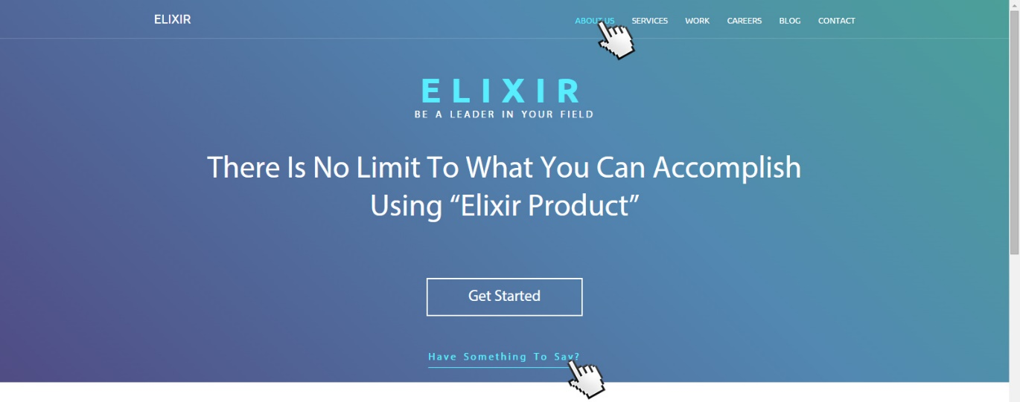

* The hand cursors in the screenshots show what happens when the mouse moves over certain elements.

### Input

You are given the above screenshots + the texts on the site + the images.

### Output

The output should be valid HTML5 + CSS3 + images that implement the above Web site.

### Constraints

* Fonts:
  + Site title: Ubuntu, bold, 54px, <http://fonts.googleapis.com/css?family=Ubuntu:300,400,700>
  + Site Navigation: 13px / Ubuntu.
  + Big Slogan: 60px / Ubuntu.
  + Small Slogan: 16px / Ubuntu.
  + Button Get Started: 24px / Ubuntu.
  + Title of sections: 28px / Ubuntu.
  + Article subtitle and Top Logo text: 20px / Ubuntu.
  + “Have something to say?” text and “So our clients say” content: 16px / 'Myriad Pro'.
  + Site content: 13px / 'Myriad Pro'.
  + Footer text: 12px / 'Myriad Pro'.
* Layout: fluid, but content has max-width 1100px.
* Try to make gradient properly. There are generators online to help you with.
* The site should open correctly in Chrome 35.
* Responsive design is not required.
* Pixel-perfect implementation is not required.