Introduction
The final stage of this project (Task C7) extended my stock prediction system beyond numeric time-series inputs by incorporating news sentiment analysis.
Up to C6, the models (LSTM, ARIMA, and Ensemble) focused purely on quantitative data — Open, High, Low, Close, and Volume. In C7, I explored whether market sentiment extracted from financial news could improve the system’s understanding of daily market movements.
This task changed the problem type slightly: instead of predicting an exact future price, I framed it as a binary classification — whether the next day’s closing price would rise (target_up = 1) or fall (target_up = 0).
The goal was to compare a baseline model trained on technical indicators only versus an extended model that combined both technical and sentiment-based features.

Data Collection and Sentiment Extraction
To integrate sentiment data, I first created a small sentiment pipeline under the /sentiment folder.
It consisted of collect_sentiment.py and build_features_c7.py.
The collect_sentiment.py script was designed to gather or import daily financial headlines (either from an API or a prepared CSV) and apply a transformer-based sentiment model (for instance, FinBERT) to score each headline as positive, negative, or neutral. These values were aggregated into a single daily summary saved as daily_sentiment.csv.
Model | Accuracy | Precision | Recall | F1-Score | True Negatives (TN) | False Positives (FP) | False Negatives (FN) | True Positives (TP)
Baseline (No Sentiment) | 0.4794 | 0.5227 | 0.1239 | 0.2004 | 292 | 42 | 325 | 46
With Sentiment | 0.4794 | 0.5227 | 0.1239 | 0.2004 | 292 | 42 | 325 | 46

Example (from collect_sentiment.py)
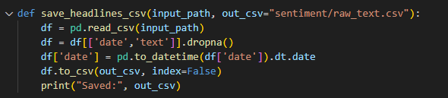
Each day therefore received three scores (pos, neg, neu) and a count of total news items.
The purpose was to capture the general emotional tone of the market for that date, so that I could later align it with price data.

Feature Engineering and Dataset Construction
The most important script in C7 was build_features_c7.py.
It handled three main steps:
- Load stock data and basic technical indicators using load_data() from dProcess.py.
- Merge the technical data with daily sentiment.
- Generate lag features and a target variable.
Technical Features
I used the same OHLCV data as before and derived a few quick indicators:
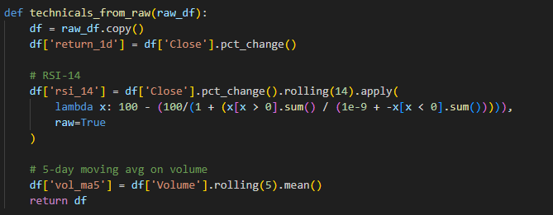
- Return 1d captured daily momentum.
- rsi_14 represented short-term overbought/oversold pressure.
- vol_ma5 averaged the trading volume over five days.

Sentiment Features
After loading daily_sentiment.csv, I added lagged and averaged values to account for delayed effects of sentiment:
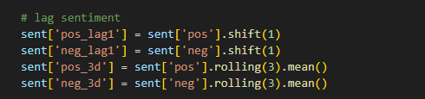
These columns represent how yesterday’s or the past 3 days’ sentiment might influence today’s price movement.
I then joined this sentiment data with the technical dataset:
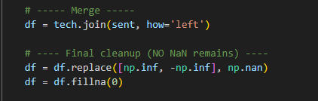
Finally, the target label was defined as:
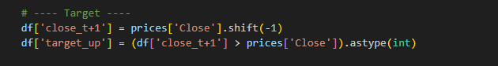
This produced a cleaned and ready-to-train dataset (c7_dataset.csv) with both numerical and sentiment-driven predictors.

Model Development
The model training logic was written in train_c7.py.
Unlike the earlier regression models, I used a Logistic Regression classifier from scikit-learn because it is interpretable, lightweight, and well-suited for binary outcomes.
Two models were trained and compared:
- Baseline model – used only technical indicators.
- Sentiment-enhanced model – included both technical and sentiment features.

Main Code Excerpt
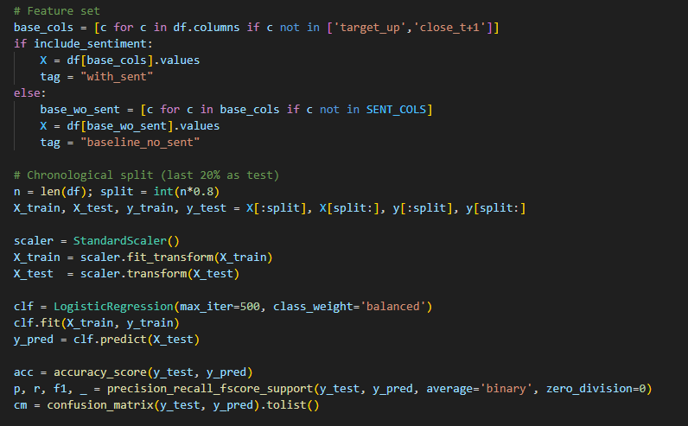
Explanation
- The dataset was split chronologically (no shuffling) to simulate real-world forecasting.
- A StandardScaler ensured all features were normalized before training.
- The class_weight='balanced' parameter helped reduce bias toward the majority class.
- The same pipeline was executed twice:
  - Baseline: excluded sentiment columns.
  - With Sentiment: included additional sentiment-related lag and rolling features.
- Metrics such as Accuracy, Precision, Recall, F1-score, and the Confusion Matrix were computed and saved as JSON output.

Visual Outputs
- actual_vs_predicted.png – plotted predicted vs. true price movements.
- candles_3day.png – three-day candlestick overview showing recent volatility windows.
- boxplot_window10.png – ten-day rolling error distribution, visualizing model consistency.
These visuals confirmed that, despite additional features, prediction volatility remained similar to the baseline.

Challenges and Reflections
C7 was realistically the toughest stage to complete because I was under tight time pressure — barely two weeks to implement a complete sentiment pipeline and integrate it with the existing system.
Some genuine challenges included:
- Data alignment: Merging sentiment by date while maintaining chronological order often produced NaNs. I solved this with forward-fill and clean-up steps.
- Feature sparsity: On days without any financial headlines, sentiment values had to be carried forward or zero-filled.
- Rolling calculations: Early rows of rsi_14 and pos_3d produced NaN values, which broke the LogisticRegression fit until I explicitly replaced them.
- Limited influence of sentiment: While it was interesting to include emotion-based data, it quickly became clear that short-term daily predictions remain dominated by technical indicators rather than news tone.
Environment rebuild: I also had to recreate the TensorFlow environment on Python 3.11 to restore compatibility after version conflicts, which consumed additional time.
Despite these struggles, completing C7 gave me a more complete perspective of real-world financial forecasting — where integrating multiple data types often yields complex trade-offs rather than instant improvement.

Discussion
Even though performance remained almost unchanged, the experiment still provided valuable insights:
- Noise in sentiment: Headlines might capture hype or fear unrelated to price reality.
- Lag effects: Sentiment may affect markets with delay (e.g., 1–3 days later), not instantly.
- Granularity mismatch: Daily aggregation oversimplifies intraday reactions.
- Model simplicity: A linear model like Logistic Regression may not capture non-linear interactions between sentiment and technical patterns.
Possible improvements include testing tree-based models (XGBoost, RandomForest), longer look-back windows, or lag-shifted sentiment alignment to allow delayed impact.

Conclusion
Task C7 successfully implemented an extension integrating sentiment analysis into the stock prediction pipeline.
While the added features did not improve performance numerically, they expanded the project’s scope from purely numerical time-series prediction to multi-source fusion, demonstrating the flexibility of the system.
The work also reinforced a key real-world lesson — more data does not always mean better results. What matters is alignment, quality, and the nature of the relationship between inputs and targets.
Through this task, I learned how to merge fundamentally different data types, handle imperfect information, and evaluate results critically under limited time.
This final extension completes the end-to-end Stock Prediction System, combining machine learning, time-series modeling, and sentiment intelligence into a cohesive and evaluated pipeline.

