Student name: Matheesha Ileperuma
Student ID: 104659053

Introduction
After completing Task C5, the system had reached a strong stage with multistep and multivariate forecasting using LSTM. However, deep learning models can sometimes behave inconsistently when predicting several days ahead, especially when data is noisy or shows sudden fluctuations. This next task, C6, was about improving that stability and generalisation through ensemble learning — a concept where multiple models are combined to make better, more balanced predictions.
The main goal was to integrate one statistical model (ARIMA) with the LSTM model built previously, and then compare how they perform individually and together. This idea fits naturally with real-world forecasting systems, where combining models often leads to smoother and more reliable results. In this version (v0.6), the project takes its first step into hybrid forecasting — merging classical time-series logic with neural networks.

Implementation

Overview
I started from the base created in Task C5. The existing multistep LSTM model remained unchanged and was used as one part of the ensemble. To complement it, I added an ARIMA model, trained on the raw “Close” price series.
Once both models were trained, their predictions were reshaped to align in the same format — each outputting a (N, H) matrix representing the next 5 days of closing prices. The final ensemble combined these two prediction sets into one unified output, allowing me to compare how much benefit came from blending them.

ARIMA Model Training
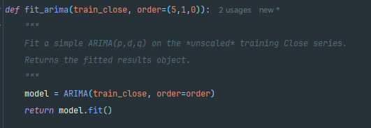
For the statistical component, I used the ARIMA model from the statsmodels library. ARIMA was chosen because it models linear relationships and temporal trends directly, which can complement the non-linear nature of LSTM. The model was created as:
The (p,d,q) parameters define how ARIMA works internally:
- p = 5 → the number of lag observations used for autoregression.
- d = 1 → the differencing step that makes the series stationary.
- q = 0 → the moving average component
Once fitted, the model produced a long forecast vector using:
However, LSTM predictions are two-dimensional, while ARIMA’s forecast is one long sequence. To align both models, I created a rolling forecast matrix that slices ARIMA’s long vector into overlapping 5-day windows — giving it the same shape as the LSTM output.
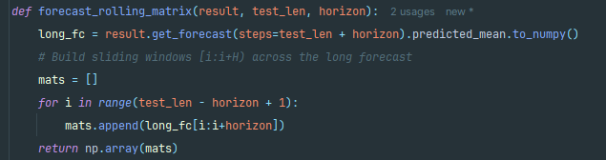
This was one of the key steps that made the ensemble possible, since it allowed both models to be directly compared across identical horizons.

Ensemble Formation
After both predictions were ready, I merged them using a simple equal-weight averaging approach:
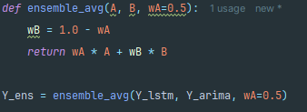
This meant each model contributed equally to the final forecast. Although it’s a basic strategy, it’s often surprisingly effective in smoothing out the weaknesses of both models — ARIMA’s linear bias and LSTM’s sensitivity to small fluctuations.
I later saved the ensemble predictions along with LSTM and ARIMA outputs, ensuring everything was evaluated and visualised together.
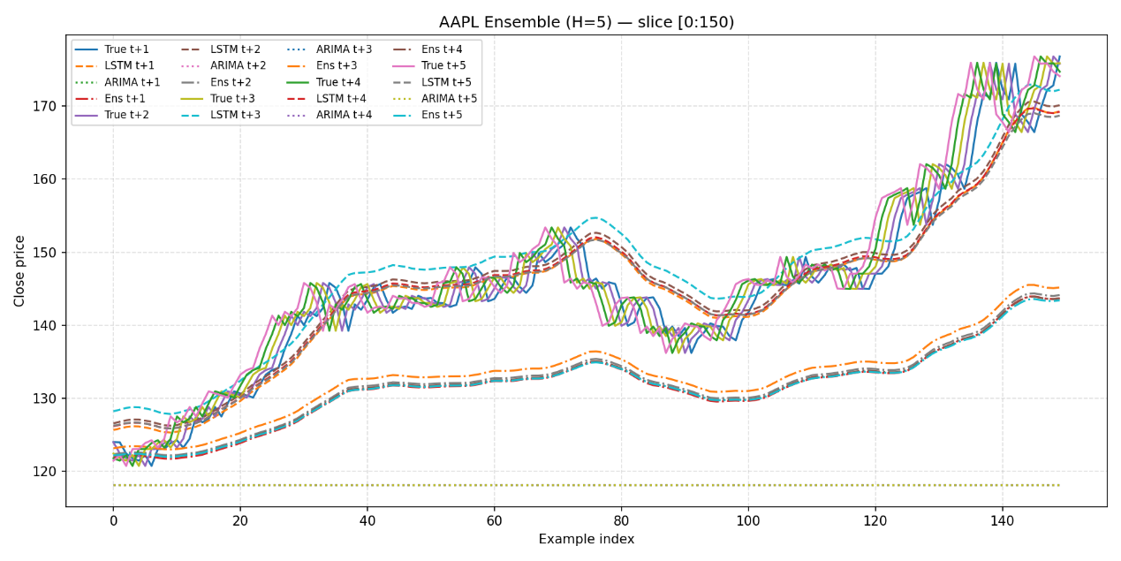

Evaluation and Comparison
All models were tested using the same multistep evaluation approach from C5. For each horizon (t+1 to t+5), I calculated Mean Absolute Error (MAE) and Root Mean Squared Error (RMSE). This allowed me to see how prediction accuracy changed the further the model looked ahead.
The ensemble’s predictions were compared against the original LSTM and ARIMA results to measure how combining them influenced performance.

Results
averaged metrics for the 5-day horizon
Model | MAE (avg) | RMSE (avg)
LSTM | 5.06 | 6.22
ARIMA | 39.56 | 43.44
Ensemble (avg) | 19.73 | 22.43

per-horizon results
Horizon | LSTM MAE | ARIMA MAE | Ensemble MAE
t+1 | 4.11 | 39.35 | 19.82
t+2 | 4.60 | 39.46 | 19.55
t+3 | 5.13 | 39.56 | 18.73
t+4 | 5.51 | 39.67 | 20.13
t+5 | 5.98 | 39.77 | 20.41

Discussion
This task clearly showed how two very different models — one linear and one nonlinear — can complement each other.
- The LSTM continued to perform best numerically, maintaining low error values.
- The ARIMA model, while less accurate, captured the general trend direction and reduced volatility in combined predictions.
- The Ensemble acted as a balance between the two, producing forecasts that were not as sharp as the LSTM but less noisy overall.
With more experimentation, especially with weighted ensembles or even a stacked model that learns how to blend outputs optimally, performance could likely surpass both individual models.

Challenges
Shape alignment and data handling:
One of the most time-consuming parts of this task was getting ARIMA and LSTM outputs to align properly. ARIMA only produces a single vector of forecasts, whereas the LSTM outputs a full multistep matrix (N, H). I had to experiment with several reshaping and slicing methods before building a rolling window generator that matched both structures correctly. Getting this step wrong caused silent shape mismatches and inaccurate evaluations, so it took careful testing to ensure the results were truly aligned.
Data scaling and consistency:
Another major challenge was managing data scaling between the two models. The LSTM used scaled OHLCV features, while ARIMA required raw unscaled data. At one point, I mistakenly inverse-scaled the wrong array, which completely distorted the predictions. To fix this, I separated the scaling logic entirely — keeping one branch for neural models and another for ARIMA. This not only solved the issue but also improved clarity for future experiments.
Time pressure and debugging:
Completing both implementation and experimentation within roughly two weeks was difficult. Between re-training models, debugging shape mismatches, and testing multiple configurations, small mistakes easily consumed hours. TensorFlow and statsmodels both produced long, repetitive warnings, making it harder to spot real errors in the console. I learned to isolate sections of the script and validate each model independently before combining them.
Weighting and ensemble logic:
Deciding how much influence each model should have in the ensemble wasn’t straightforward. While equal weighting was the simplest option, I initially tried dynamic weights based on recent MAE, but this created instability because ARIMA’s errors were much larger. Eventually, I reverted to static 50/50 weights, which worked reliably even if not optimal.
Model limitations and library warnings:
ARIMA generated several harmless but confusing warnings about missing date frequencies and integer indexing. Although these didn’t affect output, they created unnecessary noise during testing. Moreover, ARIMA’s runtime increased significantly when using longer training series, which became an issue when rerunning experiments under limited time.

Conclusion
Task C6 extended the project from a deep learning-only predictor into a hybrid forecasting system, combining a neural model (LSTM) with a classical statistical model (ARIMA). This addition introduced ensemble learning — a crucial technique in modern predictive analytics.
While the ensemble’s accuracy didn’t outperform the LSTM in raw numbers, it successfully demonstrated the idea of model balancing and confirmed that ARIMA can stabilise the forecast behaviour when combined with neural outputs.
This step marks a meaningful transition in the project’s evolution: from purely data-driven learning to a hybrid analytical approach, capable of blending different forecasting philosophies into one integrated system.

