Introduction
In Task C4, I built a flexible model factory that could generate different recurrent neural networks (LSTM, GRU, or RNN) with varying depths, units, and dropout. The experiments in that stage focused on identifying architectures that perform well for single-step forecasting — predicting the next day’s closing price from historical sequences.
However, this design only targeted a simplified problem: one feature (Close) and one prediction (Close at t+1). In reality, stock forecasting is both multivariate (multiple features matter, such as Open, High, Low, Volume) and multistep (traders want to see multiple days into the future, not just tomorrow).
Task C5 therefore required me to extend the project into a new version (v0.5) that supports:
- Multistep prediction: forecasting a sequence of future values, such as the next 3 or 5 days.
- Multivariate prediction: using all OHLCV features instead of just the closing price.
- Combined multivariate + multistep prediction: predicting several days of closing prices, using all features as inputs.
This shift meant carefully rethinking the data pipeline, labels, model head, and evaluation metrics.
Implementation
1. Multistep Windowing
In C4, my helper create_sequences produced windows of length sequence_length and a single label (the next closing price). For multistep, I needed each label to be a vector of length k.
The new helper function create_multistep_sequences generates both inputs X and labels Y where:
- X.shape = (N, sequence_length, num_features)
- Y.shape = (N, horizon)

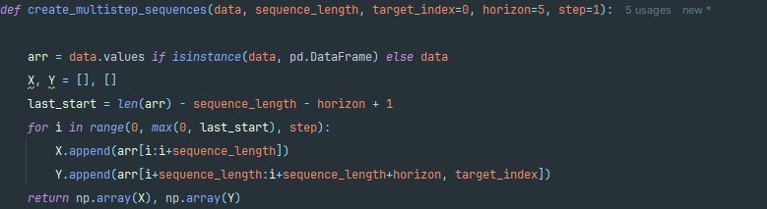

This was the most important change. It converts the target from a scalar to a vector of future values, which transforms the problem into true sequence-to-sequence prediction.
The key line is:
This ensures each input window is paired with the next k closes. Without this, the model would remain locked to single-step predictions.

Multivariate Inputs
Fortunately, the pipeline already supported multivariate data through the use_all_features=True flag in load_data. This automatically keeps the Open, High, Low, Close, and Volume columns, scaling them independently with MinMaxScaler.
This means X windows are not just sequences of one column, but 5-dimensional feature vectors for each day. In other words, instead of giving the network just “yesterday’s close,” I now provide richer context including how high and low the stock traded and how much volume was exchanged.

Model Head — From Scalar to Vector Outputs
In Task C4, the model factory finished with a Dense(1) head for single-step regression. For C5, I reused the same factory but simply changed the parameter to Dense(HORIZON).
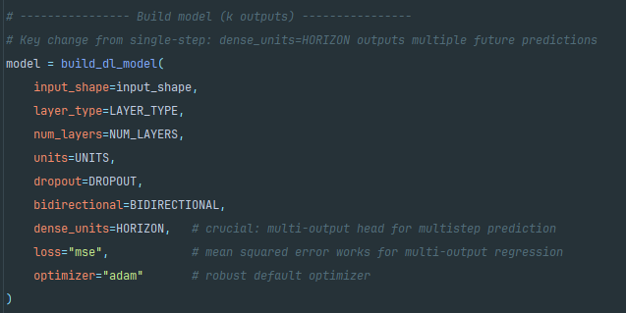
This was an elegant extension: the recurrent backbone (LSTM/GRU/RNN) stays identical, but the head emits a sequence of k numbers instead of one. In my experiments, I used HORIZON=5, so each prediction was a vector [Close_t+1, Close_t+2, Close_t+3, Close_t+4, Close_t+5].

Inverse-Scaling the Predictions
Specifically, since the MinMaxScaler was fitted on all 5 OHLCV features, the multi-output predictions (shape: (N, 5)) must be padded to match the scaler’s expected input dimension (N, 5_features) before inverse transformation. This ensures the predicted values are correctly mapped back to real stock prices without contamination from missing features.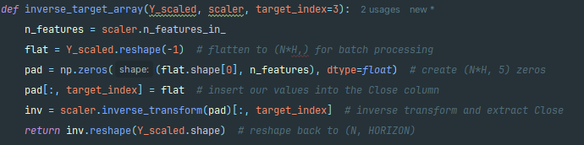

The key step is the padding (pad): each prediction is temporarily expanded to the full input width, so the scaler can process it correctly. After the inverse transform, I take only the target column back out.

Evaluation: Per-Horizon Metrics
In C4, I computed MAE and RMSE for one-step predictions. In C5, the evaluation loop runs these metrics separately for each horizon (t+1, t+2, …, t+k). This gave me both per-horizon error and an average error across all horizons.
Example output for HORIZON=5:
Horizon | MAE | RMSE
t+1 | 4.11 | 5.07
t+2 | 4.60 | 5.68
t+3 | 5.13 | 6.51
t+4 | 5.51 | 6.65
t+5 | 5.98 | 7.18
Avg | 5.07 | 6.22

This table is crucial evidence that the model really predicts multiple future values instead of just one.

Visual Output — Multistep Slice Plot
Numbers are useful, but a plot makes the multistep prediction immediately visible. I saved a “slice plot” where true vs predicted curves are shown for each horizon.
Each line in the legend corresponds to either “True t+1” vs “Pred t+1,” “True t+2” vs “Pred t+2,” and so on. This plot clearly shows how predictions track the actual prices for the next 5 days, and how the error gradually grows as the horizon lengthens.
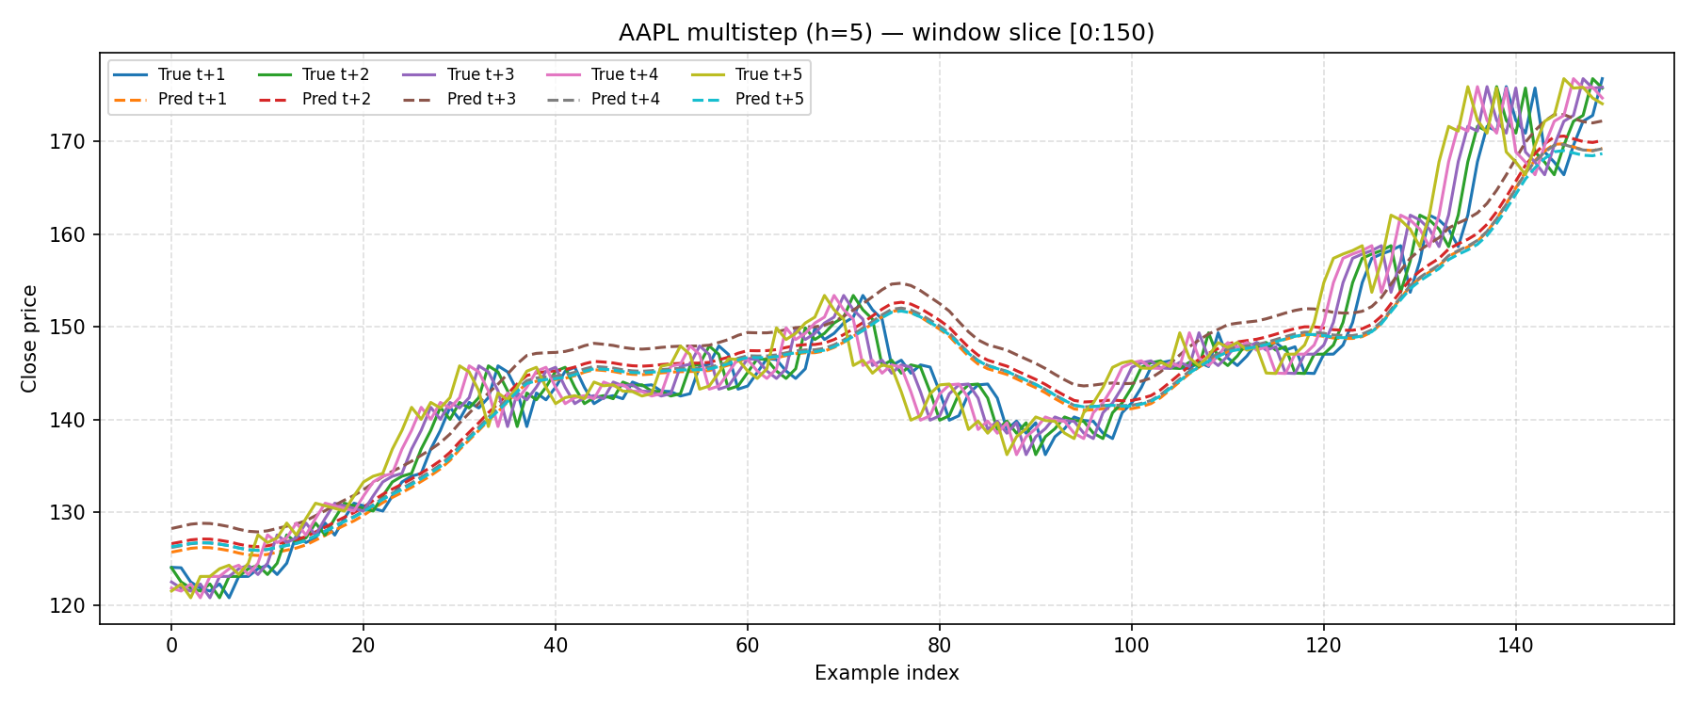

Results
- The model successfully predicted 5 days ahead using all OHLCV features.
- As expected, error was lowest for the nearest step (t+1) and grew with each further horizon.
- Average error across 5 horizons was MAE ≈ 5.07 and RMSE ≈ 6.22.
- The slice plot confirmed the model outputs a vector of future predictions, not just a single day.

Conclusion
Task C5 extended my project from single-step, univariate forecasting into a more realistic setting: multistep and multivariate forecasting.
The new multistep windower and padded inverse-scaling were the two most important technical contributions. These allowed me to reshape the problem into vector prediction without rewriting the entire pipeline.
The results showed predictable error growth with horizon, but overall confirmed that the model was functioning correctly. The multistep slice plot provided visual proof of vector outputs, while the metrics table quantified accuracy at each horizon.
By completing C5, my project now sits at version v0.5, capable of forecasting multiple future days using multiple features — a significant step closer to real-world financial forecasting problems.

