Task C3
Student Name: Matheesha Ileperuma
Student ID : 104659053
After finishing Task C.2, the project moved from preparing data to also producing useful visualisations. In Task C.2 the main focus was on improving the data loading and preparation pipeline. This meant adding a function to fetch OHLCV data from Yahoo Finance, scaling features with MinMaxScaler, handling missing values, and splitting into training and testing sets by either ratio or random shuffle. At that stage the challenge was to make the pipeline flexible enough to support multiple features (Open, High, Low, Close, Volume) instead of only Close. Research mainly involved looking at the yfinance documentation and examples from the P1 GitHub project referenced in the brief, to understand how to correctly structure the data loading and splitting functions.
In Task C.3, the focus shifted from preprocessing to visualisation. The requirement was to add a candlestick chart with support for grouping multiple trading days into one candle, and a rolling-window boxplot. This brought new types of challenges that required careful reading of external tutorials (such as the CoderzColumn guide on candlesticks) and experimentation with mplfinance.
Candlestick Implementation
The candlestick chart required grouping rows into blocks of n trading days. At first, a simple .resample() was attempted, but it created misleading gaps. The fix was to group by index position and aggregate OHLCV manually.
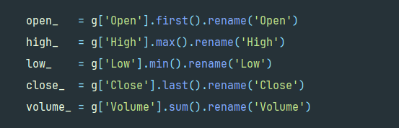

This ensures that each candle really represents the right open, high, low, close, and volume for its block. The index was then reset to use the last real date of the block, avoiding the “fake years” issue seen earlier.
Boxplot Implementation
For the rolling boxplot, the idea was to reveal volatility over time. This was achieved by sliding a 10-day window across the Close column.
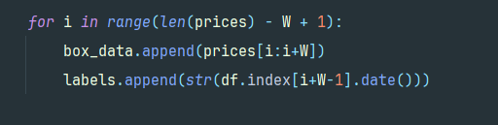

The tricky part here was creating overlapping windows and labelling each box with the final date of the window. Online searches on “rolling boxplot matplotlib” clarified that no built-in function exists, so the only way was manual slicing. Choosing i+W-1 for labels was critical to keep the chart readable and accurate.

Challenges faced
- From Close-only to OHLCV: In Task C.2, expanding from single-feature (Close) to multiple features required changes in both the data loading and the sequence creation logic. It was not difficult conceptually but did require careful checking of documentation and confirming column orders.
- Candlestick grouping: Implementing n-day grouping was harder than expected. Most tutorials only covered one-day candles. The main challenge was avoiding synthetic dates and ensuring the aggregated OHLCV values were true to trading behaviour.
- Rolling window boxplots: Because there was no ready-made function, the biggest challenge was building the loop and keeping axis labels from becoming readable.
- Scaler mismatch: In evaluation, handling the mismatch between model outputs and scaler expectations caused repeated errors until the padding method was discovered.
- Practical debugging: Issues such as locked CSV files (Excel open in background), “too much data” warnings from mplfinance, and synthetic dates stretching far into the future required repeated testing and searching for solutions.

Overall, the effort involved a cycle of coding, testing, encountering subtle issues, and researching possible fixes. The final code looks compact, but each of these lines represents deliberate choices informed by documentation, tutorials, and community discussions.

