Luminary
An AI-powered cross-media recommendation assistant for books, articles, and movies
Final-Year Portfolio Project

Product Definition Document
Project Name: Luminary
Document: Product Definition Document
Version: 0.1 (Draft)
Date: 21 May 2026
Author: Matheesha Peruma
Status: Draft for review

Document Control / Revision History
Version | Date | Author | Summary of Changes
0.1 | 21 May 2026 | Matheesha | Initial draft.

Table of Contents
1. Executive Summary
2. Problem Statement
3. Vision and Objectives
4. Target Users and Personas
5. Competitive Analysis
6. Unique Value Proposition
7. Scope (In Scope / Out of Scope)
8. Functional Requirements (MoSCoW)
9. Non-Functional Requirements
10. User Stories
11. Use Case Diagram
12. Use Case Descriptions
13. Success Metrics
14. Assumptions and Dependencies
15. Glossary

1. Executive Summary
Luminary is a web application that helps people decide what to read or watch next. It has three dedicated sections — Books, Articles, and Movies — and uses an AI assistant to ask the user a small number of conversational questions, learn what they like, and recommend one strong primary pick plus a row of closely related similar items in whichever section the user is browsing. Movies include an embedded YouTube trailer; books and articles include a cover image (or featured image) and a short, plain-language description.
What sets Luminary apart from existing tools (Goodreads, Letterboxd, Pocket, Netflix) is that it treats reading and viewing as a single "taste profile" and remembers it across visits. When a returning user opens the app, the assistant greets them with context — "Welcome back. You loved slow-burn psychological thrillers last week; here are three new picks in that vein." — instead of asking them to start from scratch.
This document is the first of three planning artefacts for the project. It defines the problem, the intended users, the feature set, and how success will be measured. The Technical Design Document and Project Plan that follow describe how the product will be built and when.
2. Problem Statement
Readers and viewers today face a paradox of choice. There is more content available than ever — millions of books on Amazon and Google Books, tens of thousands of films across streaming services, and an endless supply of articles online — but the tools meant to help people choose are fragmented. Goodreads handles books, Letterboxd handles films, Pocket handles articles, and each streaming service has its own walled-garden recommender. None of them talk to each other.
The result: a user who clearly loves Gillian Flynn novels gets no signal from Netflix that they would enjoy the film adaptation of Gone Girl, and no signal from a news aggregator that there is a long-read Atlantic feature about the case that inspired the book. Recommendation quality is also shallow on first contact — most platforms require the user to rate dozens of items before personalisation feels useful, and they do not carry that effort forward in a portable way the user owns.
Pain points this product will address
- Users have to maintain separate accounts and re-build taste profiles on every platform.
- Recommendations in one medium do not inform recommendations in another (no cross-media linking).
- First-time experience is either an empty homepage or an exhausting questionnaire.
- Returning users are not greeted with continuity — the app does not say "based on what you loved last time…".
- Discovering items "close to" a known favourite is hidden behind subscription tiers or complex filters.
3. Vision and Objectives
3.1 Vision Statement
To be the calm, single home for someone deciding what to read or watch next — an assistant that knows their taste across books, articles, and movies and gets a little smarter every visit.
3.2 Project Objectives
- Deliver a working web application with three media sections (Books, Articles, Movies) by end of Phase 1.
- Build a conversational onboarding flow that captures useful preferences in under five minutes.
- Persist user preferences so that the second visit is measurably more personalised than the first.
- For every primary recommendation, surface at least four genuinely close "similar" items.
- Maintain a calming, light-themed UI with no aggressive engagement loops (no infinite scroll, no streaks).
- Demonstrate, through the portfolio write-up, end-to-end ownership of product, architecture, and delivery.
4. Target Users and Personas
Luminary is built for adults who consume long-form content for enjoyment and growth and who feel underserved by the algorithms of mainstream platforms. Three primary personas are described below.
Persona 1 — "Curious Commuter"
Attribute | Detail
Name | Priya, 28
Role | Marketing analyst, urban professional
Media habits | Reads 1–2 books a month, listens to longform articles on commute, watches 2–3 films a week.
Goals | Find one good thing to start tonight without wasting 30 minutes scrolling.
Pain points | Goodreads feels social and noisy; Netflix "top picks" repeat the same titles.
Quote | "Just tell me what to read next — and remember that I hate horror."

Persona 2 — "Returning Reader"
Attribute | Detail
Name | Tom, 45
Role | Schoolteacher, parent of two
Media habits | Falls in and out of reading depending on the term; loves film adaptations of books.
Goals | Pick up where he left off; see what's new that fits his historical-fiction taste.
Pain points | Forgets which apps he uses; doesn't want to rebuild a profile each time.
Quote | "If something remembered what I liked six months ago, I'd actually use it."

Persona 3 — "Cross-Media Explorer"
Attribute | Detail
Name | Aisha, 22
Role | University student in literature
Media habits | Reads heavily; loves connections between source books, screen adaptations, and essays about them.
Goals | When she falls in love with a book, find the film version and a smart article about it.
Pain points | No single tool links the three; she ends up with browser tabs everywhere.
Quote | "I want one place where the book, the movie, and the essay all live together."

5. Competitive Analysis
Five existing products were reviewed as direct or partial competitors. The table below summarises where each is strong and where Luminary intends to differentiate.
Product | Strengths | Weaknesses | Luminary differentiator
Goodreads | Huge book catalogue, social reviews, lists. | Books only; cluttered UI; weak personalisation on first visit. | Cross-media (books → film → article); calmer UI; chat-based onboarding.
Letterboxd | Strong film community, sharp lists, tasteful design. | Movies only; relies on social signal, not personalisation. | Single-user personalisation that remembers across sessions; covers books and articles too.
Pocket / Instapaper | Great for saving and reading articles later. | No recommendation engine; pure read-it-later utility. | Active recommendations of articles tied to user's broader taste, not just URLs they saved.
Netflix "top picks" | Mature recommender; integrated viewing. | Walled to Netflix catalogue; opaque; promotes Netflix originals. | Catalogue-agnostic (TMDb / OMDb); transparent reasons ("why we picked this").
ChatGPT / generic LLM | Conversational; can recommend anything. | No persistent memory of preferences, no images, no trailers, no structured browsing. | Persistent profile, structured sections, trailers, similar-items strip, light theme.
6. Unique Value Proposition
Luminary is the only assistant that learns your taste once and applies it across books, articles, and movies — so the second time you visit, it already knows what to suggest.
Three pillars of differentiation
- Cross-media memory — a single taste profile that applies to all three media types.
- Returning-user warmth — the home screen opens with context, not a blank form.
- Close similars by default — every primary pick is paired with four genuinely related items.
7. Scope
7.1 In Scope — Phase 1 (MVP)
- User sign-up and log-in (email + password).
- Conversational onboarding chatbot that captures genre, tone, and length preferences per media type.
- Three browsing sections: Books, Articles, Movies (mutually exclusive — search in one only returns that type).
- AI-generated primary recommendation in each section with image, short description, and trailer (movies only).
- Similar-items strip (minimum four close items) for every primary recommendation.
- Persistent preference store so returning users see contextual greetings and personalised picks.
- Lightweight feedback controls (love it / not for me / save / show another).
- Light, calming colour palette and accessible typography.
7.2 In Scope — Phase 2 (Enhanced)
- Cross-media linking ("You loved this book; here's the film and a long-read article that inspired it").
- Mood-based recommendations across all three sections ("I want something light tonight").
- Weekly personalised digest email summarising new picks.
- Vector-based similarity using pgvector embeddings of user taste.
- Caching layer to speed up repeat queries.
- Lightweight analytics dashboard for the portfolio review (engagement, return rate, similarity quality).
7.3 Out of Scope
- Streaming the actual film or full text of the book inside Luminary.
- Social features: following other users, public reviews, comments.
- Mobile native apps (responsive web only in this version).
- Payment, subscriptions, or affiliate commerce.
- Multi-language UI (English only).
- Importing existing libraries from Goodreads, Letterboxd, or other services.

8. Functional Requirements (MoSCoW)
Requirements are tagged using the MoSCoW method: Must-have (M), Should-have (S), Could-have (C), and Won't-have-this-time (W). "Phase" indicates whether the requirement is targeted at the Phase 1 MVP or Phase 2 enhanced release.
ID | Requirement | Priority | Phase
FR-01 | User can register an account using email and password. | M | 1
FR-02 | User can log in and log out securely (JWT-based session). | M | 1
FR-03 | On first sign-in, the chatbot conducts an onboarding conversation to capture media preferences. | M | 1
FR-04 | User can navigate between three sections: Books, Articles, Movies. | M | 1
FR-05 | Each section returns recommendations restricted to that media type only. | M | 1
FR-06 | Each recommendation displays a representative image (book cover / poster / article hero). | M | 1
FR-07 | Movie recommendations display an embedded YouTube trailer. | M | 1
FR-08 | Each recommendation includes a short, plain-language description. | M | 1
FR-09 | Every primary recommendation shows a strip of at least four similar items. | M | 1
FR-10 | User preferences are persisted to the database and tied to the account. | M | 1
FR-11 | Returning users see a personalised greeting that references their stored preferences. | M | 1
FR-12 | User can give feedback on a recommendation (love / not for me / save / show another). | S | 1
FR-13 | Feedback updates the user's taste profile for subsequent recommendations. | S | 1
FR-14 | Cross-media linking surfaces related items from other media types. | S | 2
FR-15 | User can request a recommendation tuned to a current mood (e.g. "light", "intense"). | S | 2
FR-16 | User receives a weekly digest email summarising new personalised picks. | C | 2
FR-17 | User can edit or delete stored preferences through a settings screen. | S | 2
FR-18 | User can export a JSON copy of their preferences (data portability). | C | 2
FR-19 | Admin can view aggregated, anonymised metrics on engagement and quality. | C | 2
FR-20 | Social features (following / public reviews). | W | —
9. Non-Functional Requirements
ID | Category | Requirement
NFR-01 | Performance | A recommendation request must return a primary pick + similar items in ≤ 3 seconds at the 95th percentile.
NFR-02 | Performance | The home screen must be interactive within 2 seconds on a 4G connection.
NFR-03 | Scalability | Architecture must support at least 1,000 concurrent users without code change (Phase 2).
NFR-04 | Availability | Production uptime target: 99.0% (suitable for a portfolio-grade demo).
NFR-05 | Security | Passwords must be hashed with bcrypt; never stored in plaintext.
NFR-06 | Security | All client–server traffic must use HTTPS; secrets must live in environment variables, never the repo.
NFR-07 | Privacy | User preferences must be deletable on request (GDPR-style right to erasure).
NFR-08 | Usability | Interface must follow WCAG 2.1 AA contrast guidelines.
NFR-09 | Usability | Colour palette must be soft / light; no aggressive reds or saturated accents.
NFR-10 | Maintainability | Backend code coverage from unit tests must be ≥ 70% by end of Phase 1.
NFR-11 | Maintainability | All public APIs must be documented (OpenAPI / Swagger auto-generated by FastAPI).
NFR-12 | Portability | App must run in any modern browser (Chrome, Firefox, Safari, Edge — latest two versions).
NFR-13 | Observability | Server-side errors must be logged and accessible via the hosting platform's log viewer.
10. User Stories
User stories below are grouped by feature area and follow the standard format: "As a [user], I want [goal] so that [benefit]." Acceptance criteria are listed underneath each story.
US-01 (Onboarding)
As a new visitor, I want to chat briefly with the assistant about what I like, so that the app can start recommending things that actually fit me.
Acceptance criteria:
- The chat covers all three media types (books, articles, movies).
- The conversation ends within ten exchanges or less.
- The captured preferences are visible to me on a confirmation screen before I land on the home page.
US-02 (Browsing)
As a logged-in user, I want to choose one of three clear sections (Books / Articles / Movies), so that I can focus on one decision at a time.
Acceptance criteria:
- The home page surfaces the three sections as equally weighted entry points.
- Selecting a section opens that section only — results never include items of other media types.
US-03 (Recommendation)
As a logged-in user, I want to see one strong primary pick with an image, a short description, and (for movies) a trailer, so that I can decide quickly.
Acceptance criteria:
- Image loads within 1 second.
- Description is no more than 80 words and explains why the pick fits me.
- Movie cards include a working embedded YouTube trailer.
US-04 (Similar items)
As a logged-in user, I want to see a row of similar items beneath each primary pick, so that I have a fallback if the main suggestion isn't quite right.
Acceptance criteria:
- At least four similar items are shown.
- Each similar item is clickable and opens its own detail view.
- Similar items are visibly closer to the primary pick than to a random sample of the catalogue.
US-05 (Memory / return visit)
As a returning user, I want the app to greet me with context about what I liked before, so that I feel known and don't have to start from scratch.
Acceptance criteria:
- The greeting names at least one specific preference (e.g. a genre or theme).
- The home page surfaces fresh items that match the stored profile.
- If I have not used the app for 30+ days the greeting acknowledges that gently.
US-06 (Feedback)
As a logged-in user, I want quick feedback buttons on each recommendation, so that I can shape future picks without writing a review.
Acceptance criteria:
- Buttons: Love it, Not for me, Save, Show another.
- "Show another" returns a different pick of the same media type within 3 seconds.
- Feedback adjusts the next recommendation noticeably (verified in testing).
US-07 (Settings)
As a returning user, I want to view and edit my stored preferences, so that I can correct things the chatbot misunderstood.
Acceptance criteria:
- Settings page lists captured preferences per media type.
- Each preference can be removed or down-weighted.
- Changes take effect on the next recommendation request.
US-08 (Cross-media (Phase 2))
As a returning user who just loved a book, I want to be shown the film adaptation and any great article about it, so that I can keep exploring the same topic.
Acceptance criteria:
- Cross-media links appear on the book detail page.
- At least one related item from each other media type is shown if available.

11. Use Case Diagram
The diagram below shows the Luminary system boundary, the actors who interact with it (the human Reader and the external data APIs), and the main use cases supported by the MVP. Dotted arrows indicate <<include>> relationships, where one use case always invokes another.
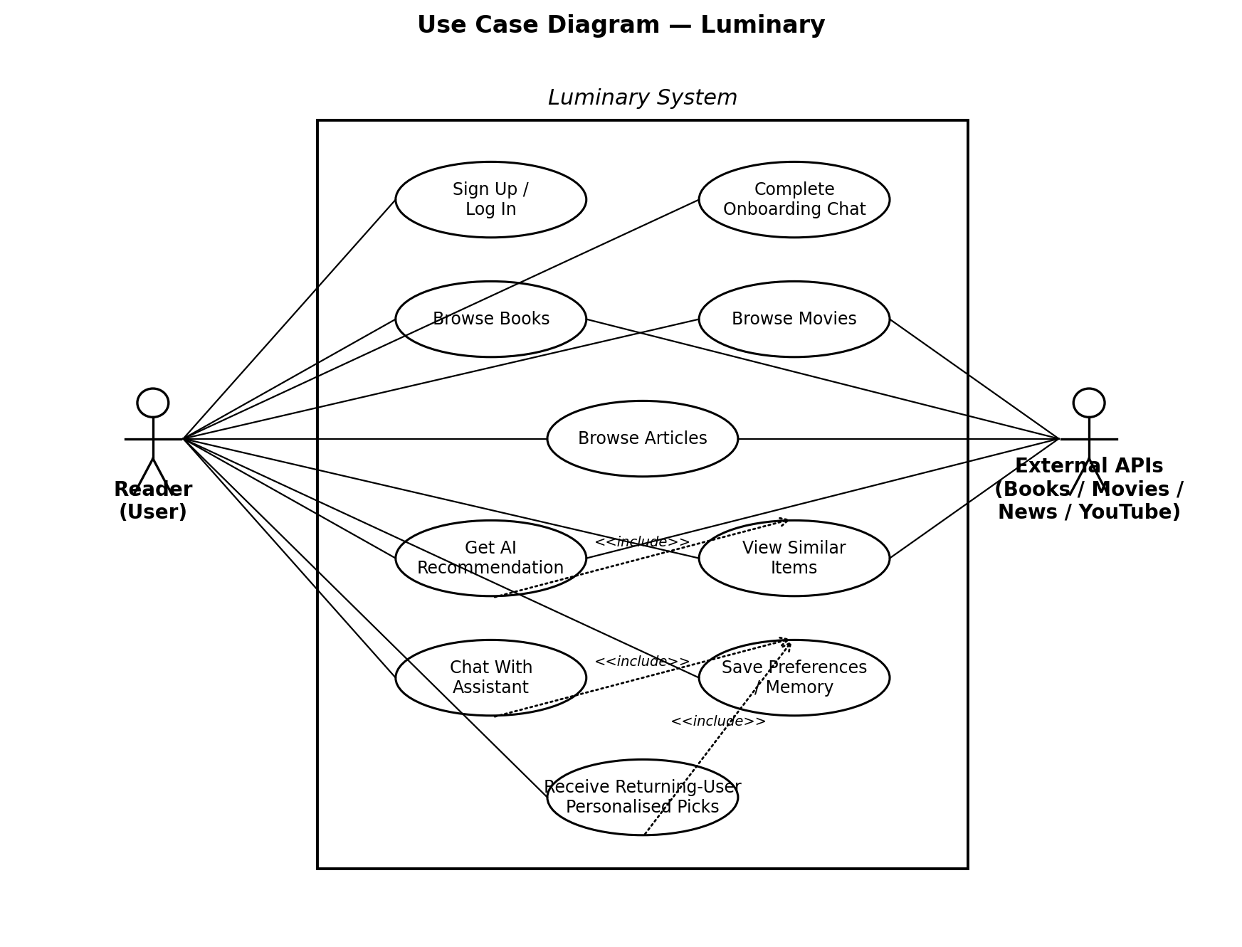
Figure 1. Use case diagram for Luminary (Phase 1 scope).
12. Use Case Descriptions
Two of the highest-value use cases are described in full below. The remainder are summarised in the Technical Design Document.
UC-01: Complete Onboarding Chat
Field | Detail
Actor | Reader (new user)
Preconditions | User has just created an account and is logged in.
Main flow | 1. System opens the chat panel with a friendly greeting.  2. Assistant asks about preferred media type to start with.  3. Assistant asks 2–4 follow-up questions per media type (genre, tone, length).  4. Assistant summarises captured preferences.  5. User confirms or edits the summary.  6. System persists preferences and routes user to the home page.
Alternate flows | 5a. User edits one field → system updates summary and re-confirms.  5b. User abandons chat → partial preferences are saved; onboarding can resume later.
Postconditions | User has at least one preference per media type stored in their profile.
Success metric | ≥ 80% of new users complete the chat in ≤ 5 minutes.

UC-02: Receive Returning-User Personalised Picks
Field | Detail
Actor | Reader (returning user)
Preconditions | User has previously completed onboarding and has at least one stored preference.
Main flow | 1. User logs in.  2. Frontend requests a personalised welcome from the Memory Service.  3. Memory Service loads stored preferences and last activity.  4. Recommendation Service produces fresh picks matching the profile.  5. Frontend renders a greeting that references a specific preference and displays the new picks.
Alternate flows | 3a. No stored preferences → fall back to generic greeting and prompt to redo onboarding.  4a. External APIs fail → show cached picks from previous session with a notice.
Postconditions | User sees fresh picks tied to their existing taste profile.
Success metric | ≥ 70% of returning users click on at least one picked item within the first session.
13. Success Metrics
These metrics are defined for the portfolio demo, not a commercial launch. They translate the objectives in Section 3 into measurable outcomes.
Metric | Target (end of Phase 1) | Stretch (end of Phase 2)
Onboarding completion rate | ≥ 80% of new sign-ups complete the chat | ≥ 90%
Time to first recommendation | ≤ 5 minutes from sign-up | ≤ 3 minutes
Return visit personalisation lift | Returning users rate picks ≥ 1 point higher (5-point scale) than first-visit picks | ≥ 1.5 point lift
Similar-items relevance | ≥ 3 of 4 similar items judged "close" in manual review | ≥ 4 of 4
Performance (P95 latency) | ≤ 3 s per recommendation request | ≤ 1.5 s
Crash-free sessions | ≥ 98% | ≥ 99.5%
Test coverage (backend) | ≥ 70% | ≥ 85%
14. Assumptions and Dependencies
14.1 Assumptions
- Free tiers of the chosen external APIs (Google Books, OMDb / TMDb, News API, YouTube Data API) will be sufficient for development and demo traffic.
- An LLM API (Claude or OpenAI) will be available with a personal developer key throughout the build.
- The target user is comfortable with English and with a chat-based interface.
- Project is built as a solo undertaking, sized for a single developer working evenings and weekends.
14.2 Dependencies
- External catalogues (Google Books, TMDb, OMDb, News API, YouTube Data API) must remain available with stable schemas.
- Hosting providers (Render / Railway for backend, Vercel for frontend) must remain on free or low-cost plans.
- PostgreSQL with the pgvector extension must be available on the chosen hosting platform.
15. Glossary
Term | Definition
MVP | Minimum Viable Product — the smallest version of the product that delivers core value and can be demonstrated.
MoSCoW | A prioritisation method that tags each requirement as Must, Should, Could, or Won't have.
UVP | Unique Value Proposition — the single most important reason a user would choose this product over alternatives.
Persona | A fictional but realistic representation of a target user, used to focus design decisions.
pgvector | A PostgreSQL extension that stores and indexes vector embeddings for similarity search.
Embedding | A numerical representation of text (or other content) that captures meaning, used for similarity comparison.
LLM | Large Language Model — the AI service that powers the conversational chatbot and the natural-language summaries.
WCAG | Web Content Accessibility Guidelines — the international standard for accessible web content.

