Luminary
System architecture, tech stack, data model, and API design
Final-Year Portfolio Project

Technical Design Document
Project Name: Luminary
Document: Technical Design Document
Version: 0.1 (Draft)
Date: 21 May 2026
Author: Matheesha Peruma
Status: Draft for review

Document Control / Revision History
Version | Date | Author | Summary of Changes
0.1 | 21 May 2026 | Matheesha | Initial draft.

Table of Contents
1. Introduction
2. System Architecture
3. Technology Stack and Justifications
4. Data Model and Database Schema
5. API Design
6. Key Sequence Diagrams
7. Memory and Personalisation Design
8. AI / LLM Integration
9. User Interface and Wireframes
10. Security
11. Deployment Architecture
12. Testing Strategy
13. Open Technical Questions

1. Introduction
This Technical Design Document (TDD) describes how Luminary will be built. It is the companion to the Product Definition Document, which describes what Luminary is and why it exists. The intended reader is a developer or technical reviewer who already understands the product goals and wants to evaluate the engineering approach.
Decisions captured in this document apply to the Phase 1 MVP unless explicitly marked Phase 2. Where multiple options were considered, the reasoning is documented in line with the decision so that the trade-offs are visible to the reviewer.
1.1 Architectural Principles
- Favour boring, well-documented technology over novel frameworks.
- Keep the frontend and backend cleanly separated, communicating only over JSON over HTTPS.
- Hide all third-party APIs behind internal service interfaces so they can be swapped without UI changes.
- Persist enough data to make the second visit measurably better than the first.
- Log enough that a failure in the live demo can be diagnosed without re-running locally.
2. System Architecture
Luminary is a three-tier web application: a client-side single-page app (React + Vite) talks to a FastAPI backend over JSON, the backend talks to PostgreSQL (with the pgvector extension) for structured data and embeddings, and it talks out to external content APIs and an LLM provider for catalogue data and natural-language generation respectively.
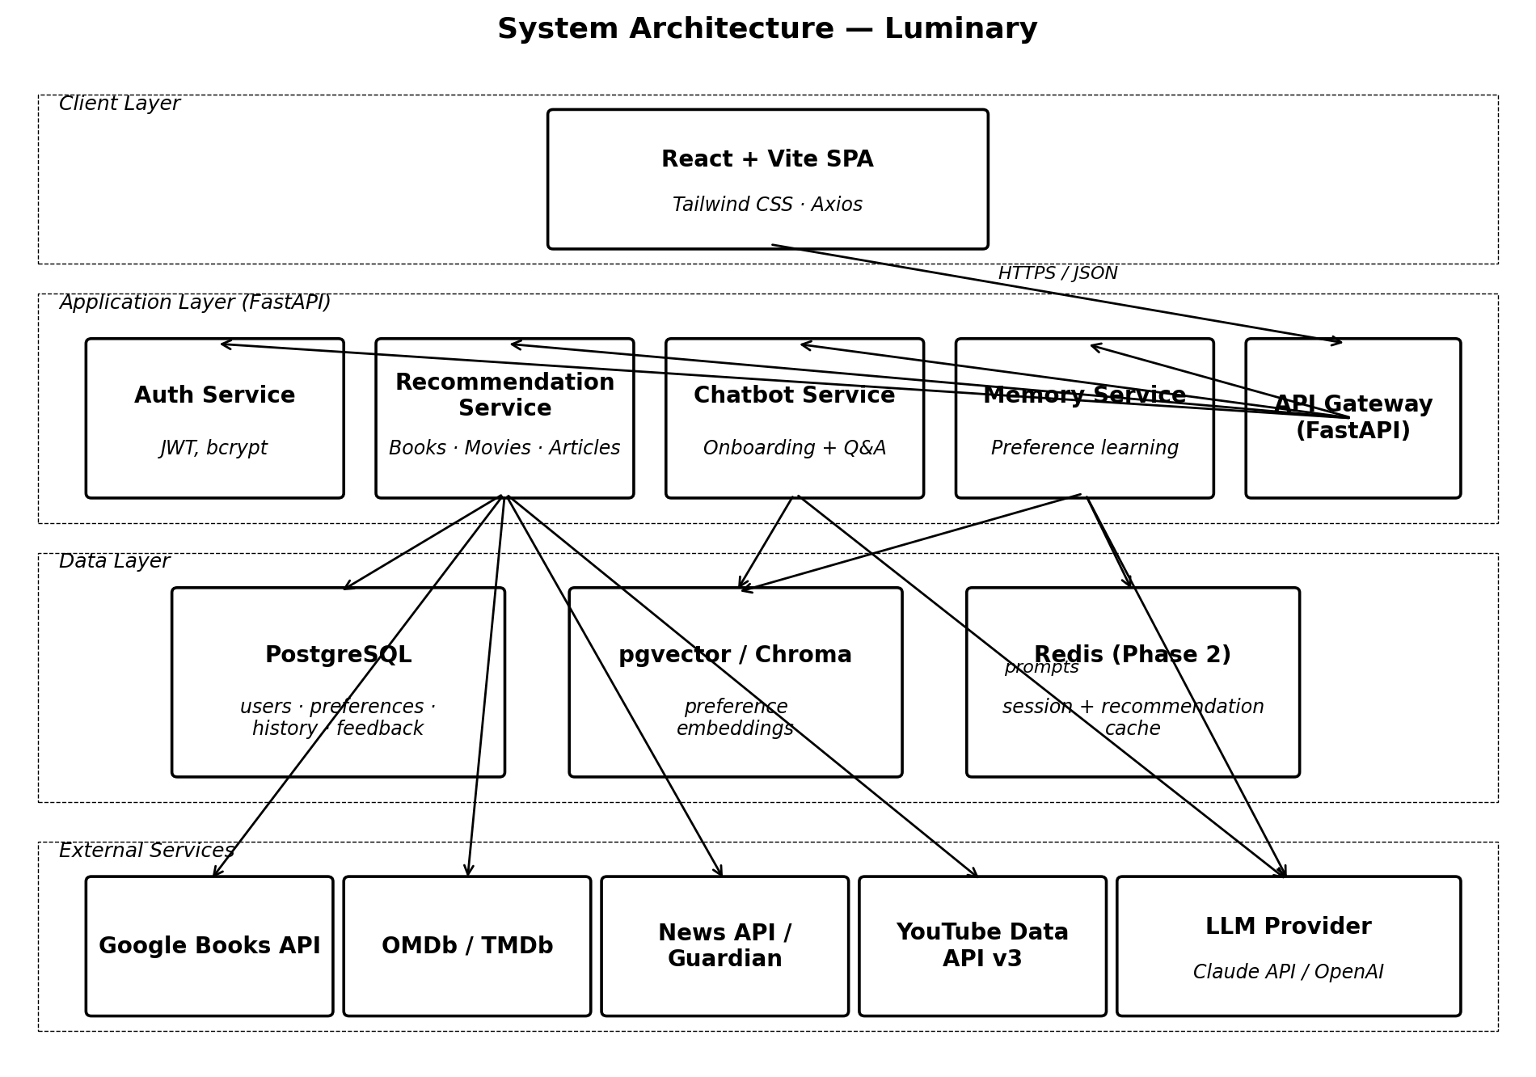
Figure 2.1. Logical system architecture - layers, services, and external dependencies.
2.1 Why this shape
A small set of well-named backend services (Auth, Recommendation, Chatbot, Memory) sits behind a single FastAPI gateway. Each service owns a single concern and has a tight contract with the client. This is not a microservice deployment - all services run in one Python process - but the boundaries are drawn so that breaking them into separate deployables in Phase 2 would be mechanical rather than architectural.
2.2 Component Responsibilities
Component | Responsibility
React + Vite SPA | Renders the three media sections, the recommendation cards, the chatbot panel, and the settings screen. Calls the backend over Axios.
FastAPI Gateway | Single HTTP entry point; handles routing, auth middleware, validation, OpenAPI generation.
Auth Service | Sign-up, log-in, password hashing (bcrypt), JWT issue and verify.
Recommendation Service | Builds a recommendation by querying the right external API, ranking results, and writing the result to the database.
Chatbot Service | Runs the onboarding conversation and the in-app assistant; calls the LLM and writes captured preferences to the Memory Service.
Memory Service | Owns the preference store and the embedding store; provides read APIs for personalised greetings and write APIs for new preferences.
PostgreSQL + pgvector | Persistent storage for users, preferences, chat history, recommendations, feedback, and preference embeddings.
Redis (Phase 2) | Short-lived cache for popular recommendation results and session data.
External APIs | Google Books, OMDb / TMDb, News API or The Guardian, YouTube Data API for trailers.
LLM Provider | Claude API (preferred) or OpenAI API for chat responses and natural-language summaries.

3. Technology Stack and Justifications
Each technology choice below is paired with the alternatives considered and the reason the chosen option was selected. This is deliberately verbose because demonstrating reasoned decisions is part of the portfolio value.
Layer | Choice | Alternatives considered | Reason
Frontend framework | React 18 + Vite | Next.js, SvelteKit, Vue 3 | React is the most widely demanded skill in entry-level job listings; Vite gives sub-second hot reload without the Next.js complexity that this app does not need.
Styling | Tailwind CSS | CSS Modules, styled-components | Utility-first lets a solo developer maintain the calm light theme without writing a parallel CSS system; ships only the classes used.
Backend framework | FastAPI (Python 3.12) | Django REST Framework, Express (Node) | FastAPI gives async I/O for external API calls, auto-generated OpenAPI docs, and Pydantic validation in one package - ideal for an AI-leaning solo project.
Database | PostgreSQL 16 + pgvector | MongoDB, MySQL, SQLite | Relational schema fits user / preference / recommendation cleanly; pgvector handles preference embeddings in the same database so there is no second data system to operate.
Auth | JWT + bcrypt | Session cookies, Auth0, Supabase Auth | Self-issued JWT is enough for a single-tenant app, keeps the demo free of third-party login dependencies, and is interview-friendly to explain.
LLM | Claude API (primary), OpenAI as fallback | Self-hosted Llama, Hugging Face Inference | Hosted Claude removes GPU and ops cost; the architecture wraps the LLM in a single adapter so providers are interchangeable.
Books catalogue | Google Books API | Open Library, Amazon PA-API | Free, no approval gate, covers ISBN + cover image + description in one call.
Movies catalogue | TMDb (primary), OMDb (fallback) | JustWatch, Rotten Tomatoes | TMDb has the richest free metadata including poster URLs and trailer keys that can be combined with the YouTube Data API.
Articles | The Guardian Open Platform (primary), News API | RSS aggregation, Reddit | Guardian gives free, high-quality long-form content with stable categorisation and images.
Trailers | YouTube Data API v3 | Vimeo, direct TMDb video links | Universal coverage and easy iframe embed; only requires an API key.
Testing | pytest + httpx + Vitest | unittest, Jest, Playwright | pytest is idiomatic for FastAPI; httpx covers the async API client tests; Vitest matches the Vite frontend.
Hosting (backend) | Render (free / starter) | Railway, Fly.io, AWS Elastic Beanstalk | Render's PostgreSQL add-on supports pgvector and the free tier is enough for the demo.
Hosting (frontend) | Vercel | Netlify, GitHub Pages | Zero-config for Vite, free, instant preview URLs per pull request.
CI / CD | GitHub Actions | CircleCI, GitLab CI | Native to the repository, free for the project size, simple YAML.
4. Data Model and Database Schema
All persistent state lives in a single PostgreSQL database. The entity relationship diagram below shows the seven tables required for the MVP. Embedding storage uses the pgvector extension, which adds a native vector column type and approximate-nearest-neighbour indexing.
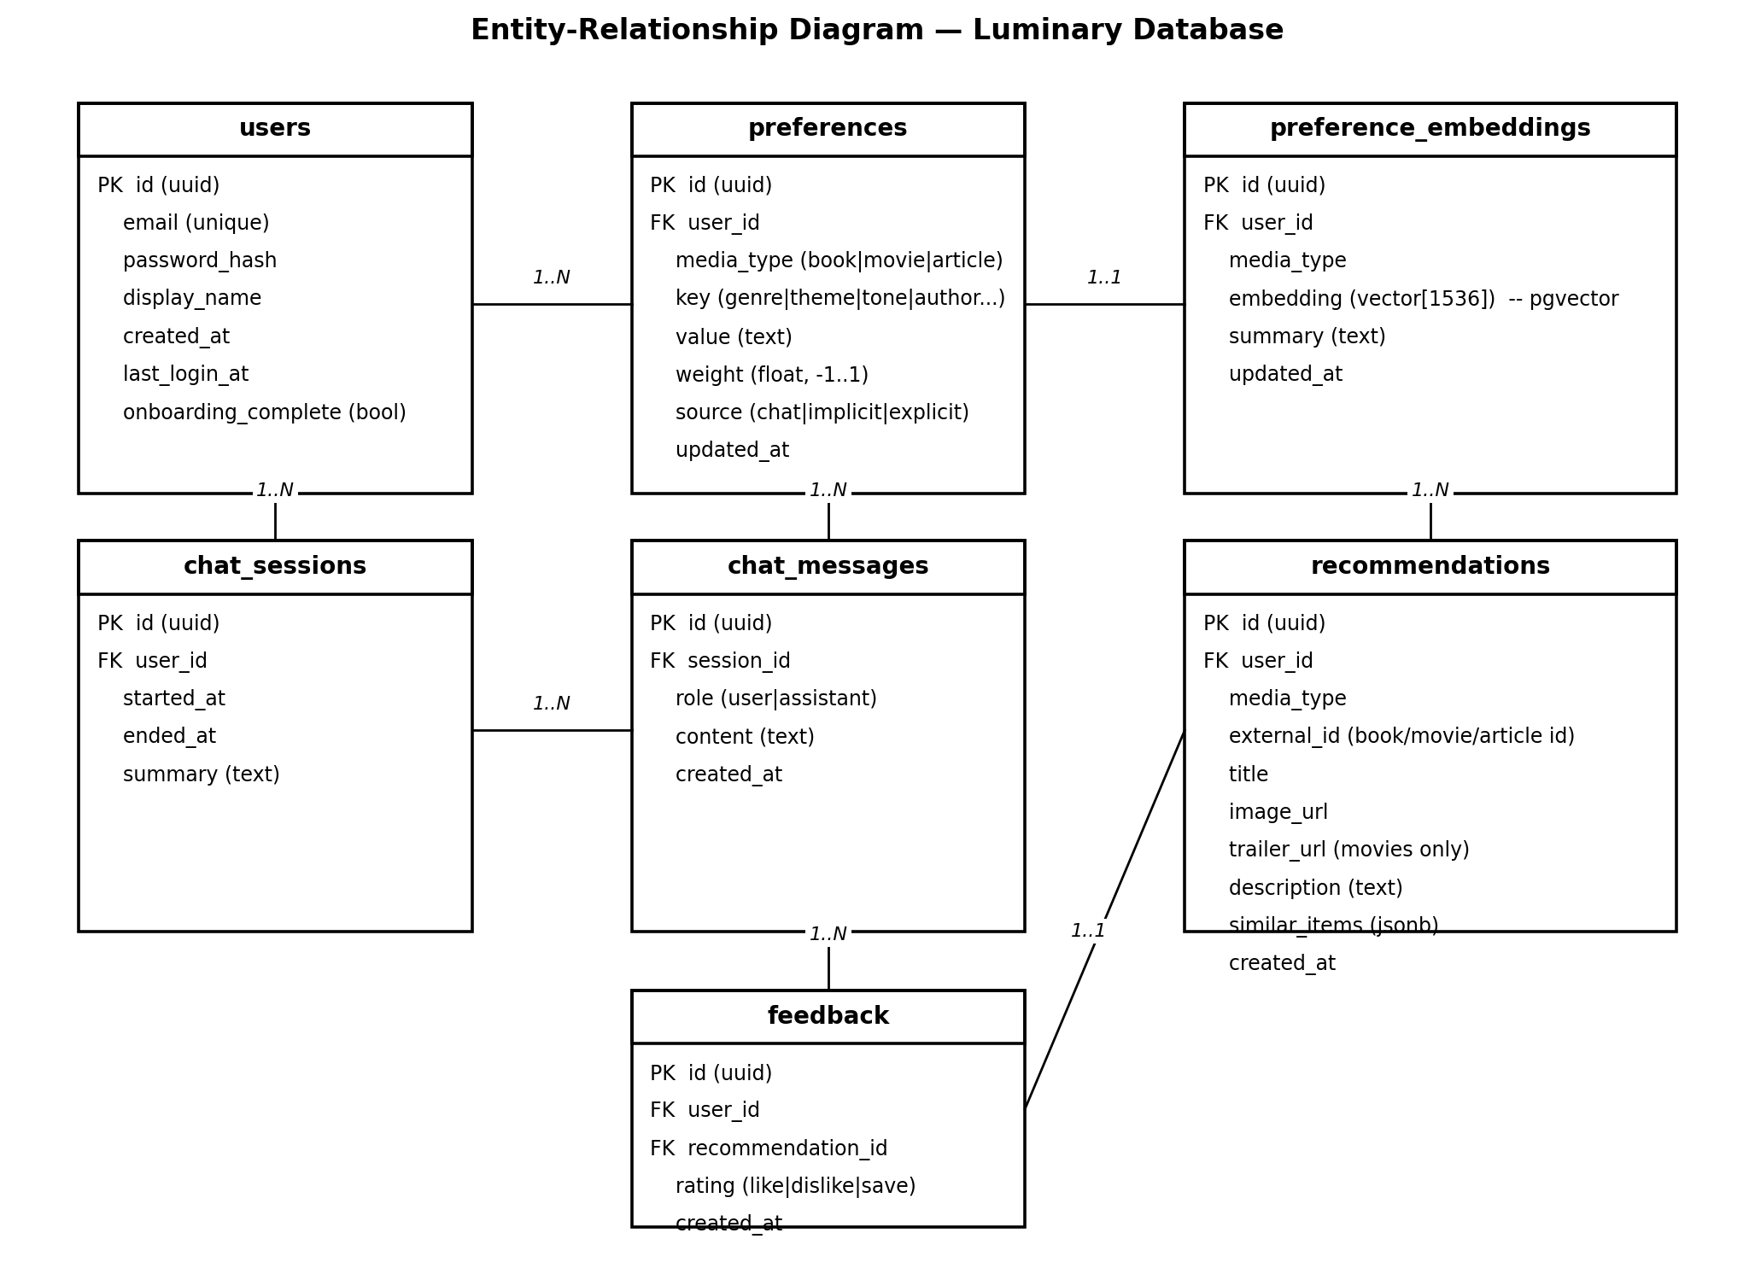
Figure 4.1. Entity-relationship diagram for Luminary.
4.1 Table notes
Table | Notes
users | One row per registered user. Password is bcrypt-hashed; last_login_at supports the returning-user greeting logic.
preferences | Many rows per user. Each row is a typed key-value pair (e.g. genre=psychological thriller, weight=0.9). Weight is signed so dislikes can be recorded.
preference_embeddings | One row per user per media type. Stores the vector representation of that user's accumulated preferences for fast similarity search.
chat_sessions | Container for a single conversation, used both for onboarding and for in-app chat.
chat_messages | Append-only log of messages within a session; supports re-sending context to the LLM.
recommendations | Persistent record of every recommendation served, including the LLM-written summary and the JSON list of similar items. Enables analytics and "show me again".
feedback | Captures the user's reaction to a recommendation. Joined back into preference weights on a schedule.
4.2 Indexing
- users.email - unique index for log-in lookup.
- preferences(user_id, media_type) - composite index for fast profile load.
- preference_embeddings.embedding - ivfflat index (pgvector) for top-K similarity.
- recommendations(user_id, created_at desc) - powers "recent picks" rendering.
- feedback(recommendation_id) - one-to-one lookup on user feedback.

5. API Design
All endpoints are RESTful JSON over HTTPS. Authenticated endpoints require a Bearer JWT in the Authorization header. The backend auto-generates an OpenAPI 3.0 specification at /docs so the table below is a curated subset, not the full contract.
Method | Path | Purpose | Auth
POST | /api/auth/register | Create a new user account. | No
POST | /api/auth/login | Exchange email + password for a JWT. | No
GET | /api/auth/me | Return the authenticated user's profile. | Yes
POST | /api/chat/start | Open a chat session (onboarding or general). | Yes
POST | /api/chat/message | Send a user message; receive an assistant reply. | Yes
POST | /api/preferences | Bulk-write captured preferences after onboarding. | Yes
GET | /api/preferences | List the current user's stored preferences. | Yes
PATCH | /api/preferences/{id} | Edit or down-weight a stored preference. | Yes
DELETE | /api/preferences/{id} | Remove a stored preference. | Yes
POST | /api/recommendations | Request a primary pick + similar items for a media type. | Yes
GET | /api/recommendations/{id} | Fetch a previous recommendation. | Yes
POST | /api/feedback | Record a user's reaction (love / not for me / save). | Yes
GET | /api/memory/welcome | Return the personalised greeting + fresh picks on log-in. | Yes
GET | /api/health | Liveness probe for the hosting platform. | No
5.1 Example request / response (POST /api/recommendations)
Request:
{ "media_type": "movie", "mood": null, "include_similar": true }
Response:
{
"recommendation_id": "a8e5...",
"primary": {
"external_id": "tmdb:603692",
"title": "John Wick: Chapter 4",
"image_url": "https://image.tmdb.org/...",
"trailer_url": "https://www.youtube.com/embed/qEVUtrk8_B4",
"description": "Because you said you like stylised, kinetic action with..."
},
"similar": [ { ... }, { ... }, { ... }, { ... } ]
}
6. Key Sequence Diagrams
6.1 Get Recommendation flow
Triggered when the user clicks "Get a pick" on any of the three sections. The Recommendation Service is responsible for orchestrating the external catalogue API, the LLM call, and the database write.
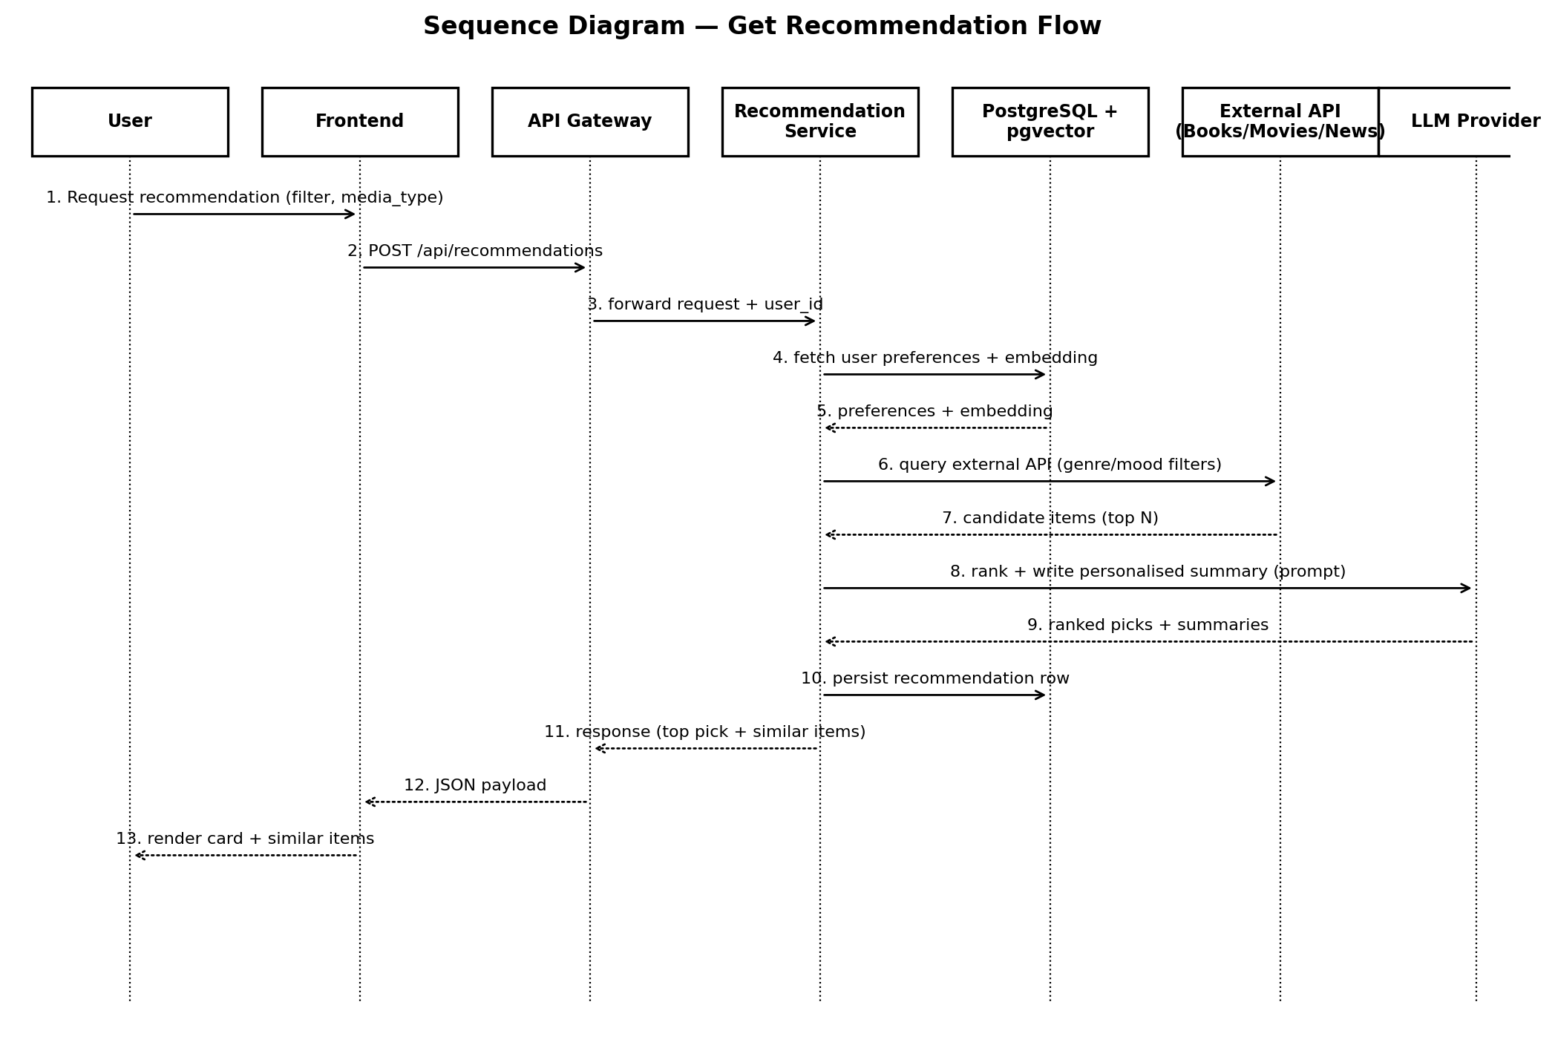
Figure 6.1. Sequence diagram - Get Recommendation.
6.2 Returning-User Memory Recall flow
Triggered automatically after a successful log-in. The Memory Service builds a contextual greeting from the user's stored profile and asks the Recommendation Service to produce fresh picks aligned with that profile.
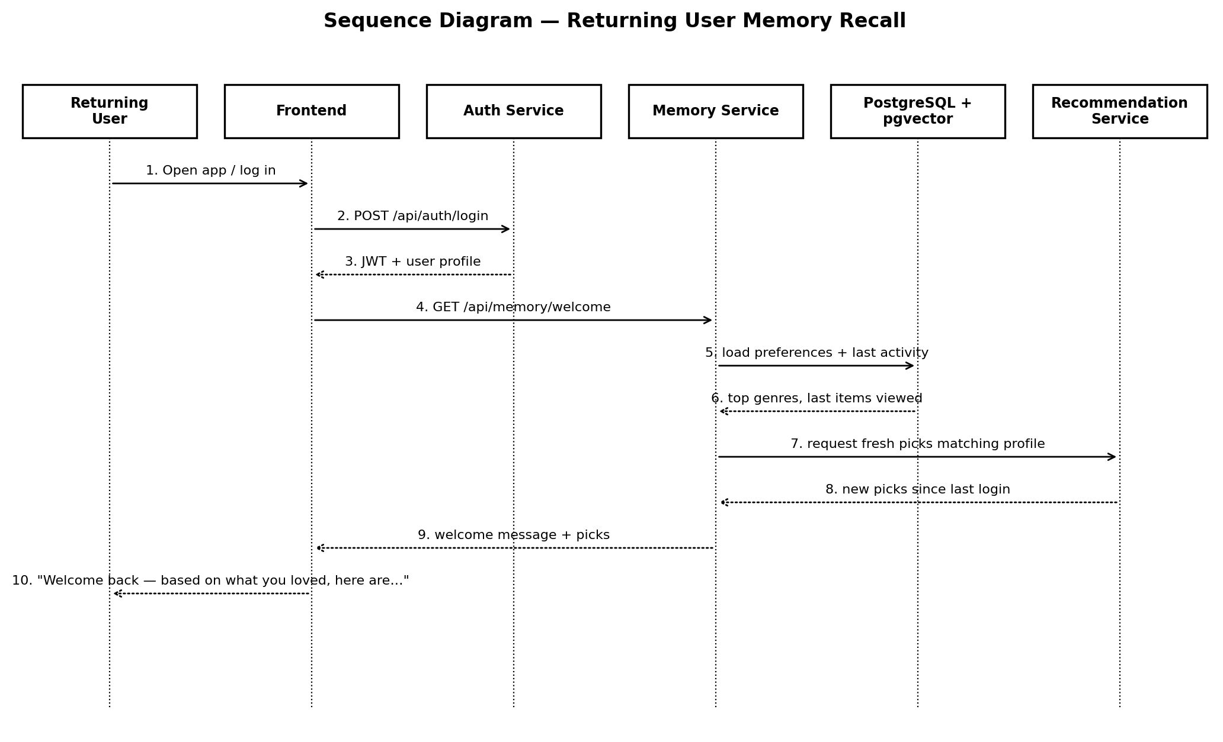
Figure 6.2. Sequence diagram - Returning user memory recall.
7. Memory and Personalisation Design
The personalisation layer is the part of the product that competitors do not have. It works in two tiers: a structured tier for human-readable preferences, and a vector tier for nuance.
7.1 Structured tier
Every preference captured during the chatbot onboarding or inferred from feedback is written to the preferences table as a typed key-value pair: media_type, key (e.g. genre, theme, author, length), value, weight (signed, -1.0 to +1.0), and source (chat, explicit, implicit). This is what powers the human-readable greeting ("You loved psychological thrillers...").
7.2 Vector tier
Periodically, the Memory Service rebuilds a per-user, per-media-type embedding vector from the structured preferences plus the descriptions of items the user has loved. The vector is stored in preference_embeddings.embedding (pgvector type vector[1536]). Similar-items lookups and Phase 2 mood-based recommendations both use this vector to do top-K nearest-neighbour search against candidate items' embeddings.
7.3 Feedback loop
Event | Effect on profile
Love it | Boost weights for the matched preferences by +0.1 (capped at +1.0). Queue embedding rebuild.
Not for me | Reduce weights for the matched preferences by 0.15. Queue embedding rebuild.
Save | No weight change. Adds the item to a saved-for-later list.
Show another | No weight change. Logged as a soft negative for the same session.

8. AI / LLM Integration
The LLM is wrapped in a single LLMClient adapter so the rest of the codebase never imports the vendor SDK directly. The adapter exposes three methods: chat(messages), summarise(text), and explain_recommendation(user_profile, item).
8.1 Prompt design
All prompts are stored as templates under backend/prompts/*.md so a non-developer reviewer can read and tweak them without touching code. Each template has a system prompt, an example user turn, and an example assistant turn. Three templates exist at MVP: onboarding_chat.md, recommendation_summary.md, and welcome_back.md.
8.2 Cost and rate control
- All calls go through the adapter, which records token usage to a rolling log file.
- A daily token budget is set as an environment variable; the adapter refuses calls once the budget is exceeded and falls back to a templated string.
- Recommendation summaries are cached in the recommendations.description column so the same item never re-bills the LLM.
- Onboarding chat is capped at 10 turns per session to keep cost bounded.
8.3 Safety
- User input is passed to the LLM as a `user` role message, never spliced into the system prompt - prompt-injection resistance by construction.
- The adapter strips control characters from output before rendering to the browser.
- External API responses are validated against Pydantic schemas before being included in prompts.
9. User Interface and Wireframes
Two key screens are wireframed below: the home / landing page (which presents the three sections and the returning-user chat) and the recommendation detail screen (which presents one primary pick, the trailer for movies, and the similar-items strip).
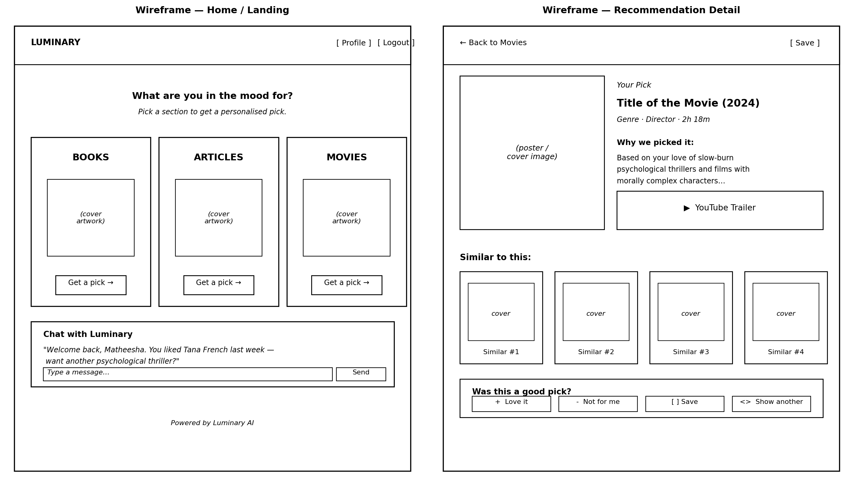
Figure 9.1. Wireframes - home and recommendation detail screens.
9.1 Visual style guide
Aspect | Decision
Palette | Off-white background (#FAF8F5). Charcoal ink (#2A2A2A). One muted accent (#7E9CB0 soft blue) for active states only.
Typography | Body: Inter 16 px / 1.55 line-height. Headings: Fraunces (serif) for warmth on titles only.
Spacing | 8 px base grid. Generous whitespace - never more than three primary elements visible at once.
Motion | Subtle fades only. No bouncy animations, no autoplay video, no notification dots.
Density | One primary card per section, surrounded by air. Similar items strip below in a quieter weight.
Accessibility | Minimum text contrast ratio 4.5 : 1. All interactive elements reachable by keyboard.
10. Security
Concern | Mitigation
Password storage | bcrypt with cost factor 12. No plaintext anywhere.
Session hijack | Short-lived JWT (60 min); refresh on each authenticated request; secrets rotated via env vars.
Transport security | HTTPS enforced at the hosting layer; HSTS header set.
Injection (SQL) | ORM-based queries via SQLModel / SQLAlchemy with parameterised statements only.
Injection (LLM / prompt) | User input passed as user-role message; system prompts immutable; output sanitised before render.
XSS | React escapes by default; no dangerouslySetInnerHTML; trailer iframes have a strict sandbox attribute.
CSRF | Bearer-token auth (no cookies) avoids the classic CSRF surface.
Secrets | All API keys read from environment variables; .env files git-ignored; production secrets injected by the hosting platform.
Dependency risk | Dependabot enabled; weekly pip-audit run as a GitHub Action.
Personal data | Preference deletion endpoint (FR-17) and full account delete supported.

11. Deployment Architecture
Both ends of the stack are deployed as managed services. The pipeline below runs on every push to main; pull-request branches get isolated preview URLs.
Stage | Tool | Outcome
Source control | GitHub | Single mono-repo with /backend and /frontend folders.
CI | GitHub Actions | Lints, runs unit tests, builds the frontend, builds the backend image.
Frontend hosting | Vercel | Static build of the React SPA; preview URL per pull request.
Backend hosting | Render web service | Containerised FastAPI app, auto-deploy on push to main.
Database | Render PostgreSQL | Managed Postgres 16 with pgvector extension enabled.
Secret management | Render env vars + Vercel env vars | No secrets in the repo or in CI logs.
Monitoring | Render log viewer + Sentry (free tier) | Errors surfaced in real time during the demo.
12. Testing Strategy
Layer | Tool | Coverage target | Notes
Unit (backend) | pytest | 70%+ | Cover business logic in each service module.
Integration | pytest + httpx | Critical paths | Spin up FastAPI app + Postgres in test-containers; cover auth, recommendation, memory recall flows end-to-end.
LLM contract | Recorded fixtures | All prompts | Snapshot one known-good LLM response per template; assert structure not exact text.
Frontend unit | Vitest | Components with logic | Test the chat panel state machine and the feedback widget.
E2E (smoke) | Playwright (Phase 2) | Happy path | Sign-up -> onboarding -> first recommendation.
Accessibility | axe-core in CI | Home + recommendation detail screens | Fail build on AA violations.
13. Open Technical Questions
Questions left deliberately open for the build phase; each will be resolved with a small spike before the relevant feature is built.
# | Question | Resolution approach
Q1 | Which embedding model offers the best price / quality for preference vectors? | Compare OpenAI text-embedding-3-small vs Voyage AI on a labelled internal set of 30 items.
Q2 | Should the chatbot use streaming responses for perceived speed? | Spike a server-sent-events route in week 3; measure perceived latency.
Q3 | How aggressively should similar items be re-ranked by the user's profile vs the catalogue's own similarity? | Manual relevance review of 20 outputs at 0/50/100 mix; choose the winning blend.
Q4 | Are the free tiers of the chosen APIs sustainable for an unattended demo? | Two-week monitoring window with synthetic traffic at expected demo levels.

