Luminary
Charter, work breakdown, timeline, risks, and definition of done
Final-Year Portfolio Project

Project Plan
Project Name: Luminary
Document: Project Plan
Version: 0.1 (Draft)
Date: 21 May 2026
Author: Matheesha Peruma
Status: Draft for review

Document Control / Revision History
Version | Date | Author | Summary of Changes
0.1 | 21 May 2026 | Matheesha | Initial draft.

Table of Contents
1. Project Charter
2. Scope Statement
3. Stakeholders and Roles
4. Work Breakdown Structure (WBS)
5. Timeline and Milestones
6. Risk Register
7. Assumptions and Constraints
8. Communication Plan
9. Quality Plan
10. Definition of Done
11. Out of Scope
12. Closure Criteria

1. Project Charter
This charter authorises the Luminary project and records the high-level commitments made by the project author. As a portfolio project there is no external sponsor; the developer is the accountable party for delivery, quality, and presentation.
Field | Value
Project name | Luminary
Project type | Final-year portfolio project (solo)
Project author / owner | Matheesha Peruma
Start date | 26 May 2026
Target Phase 1 (MVP) completion | 21 July 2026 (8 weeks)
Target Phase 2 (Enhanced) completion | 1 September 2026 (further 6 weeks)
Estimated effort | ~8 hours / week during full-time study; ~20 hours / week during breaks
Budget (cash) | USD 0 - 30 (LLM token spend within free credits + minor hosting overages)
Primary deliverables | Working web app, three planning documents (this set), portfolio write-up, demo video, public GitHub repository
Success criteria | All Phase 1 functional requirements pass acceptance; success metrics in Section 13 of the Product Definition Document hit their Phase 1 targets
2. Scope Statement
Scope is owned by the Product Definition Document (Section 7). The summary here is for reviewers of this Project Plan in isolation.
2.1 Phase 1 - MVP (in scope)
- Account creation and log-in.
- Chatbot-driven onboarding capturing preferences for books, articles, and movies.
- Three browsing sections with AI-generated primary pick and at least four similar items each.
- Movie cards include an embedded YouTube trailer.
- Returning-user personalised greeting based on stored preferences.
- Feedback controls that adjust the profile.
- Light, calming UI with WCAG AA contrast.
- Deployed publicly on a free-tier host.
2.2 Phase 2 - Enhanced (in scope, time-boxed)
- Cross-media linking (book -> film adaptation -> related article).
- Mood-based recommendations applied across all three sections at once.
- Weekly personalised digest email.
- Vector similarity using pgvector for similar-items ranking.
- Redis caching layer.
- Lightweight analytics dashboard for the portfolio write-up.
3. Stakeholders and Roles
Although Luminary is a solo build, multiple roles still need to be served. Listing them explicitly helps prevent any one role from being neglected.
Stakeholder | Role on this project | What they need
Project author (Matheesha) | Product owner + designer + engineer + tester | Realistic plan; clear definition of done.
Course tutor / academic reviewer | Reviewer of process and quality | Evidence of structured planning, design, and delivery.
Future employer (portfolio reader) | Evaluator | A clear story of why this was built, how it works, and what was learned.
Pilot users (3-5 friends) | Source of acceptance feedback | Easy way to try the app and a short feedback form.
External API providers | Dependency owners | Compliance with their terms of use and rate limits.
LLM provider | Dependency owner | Compliance with usage policy; no PII in prompts.

4. Work Breakdown Structure (WBS)
The WBS decomposes the project into five top-level work packages: Initiation, Planning and Design, Phase 1 MVP, Phase 2 Enhanced, and Close-out. Each is further broken into deliverable-level elements that can be tracked individually.
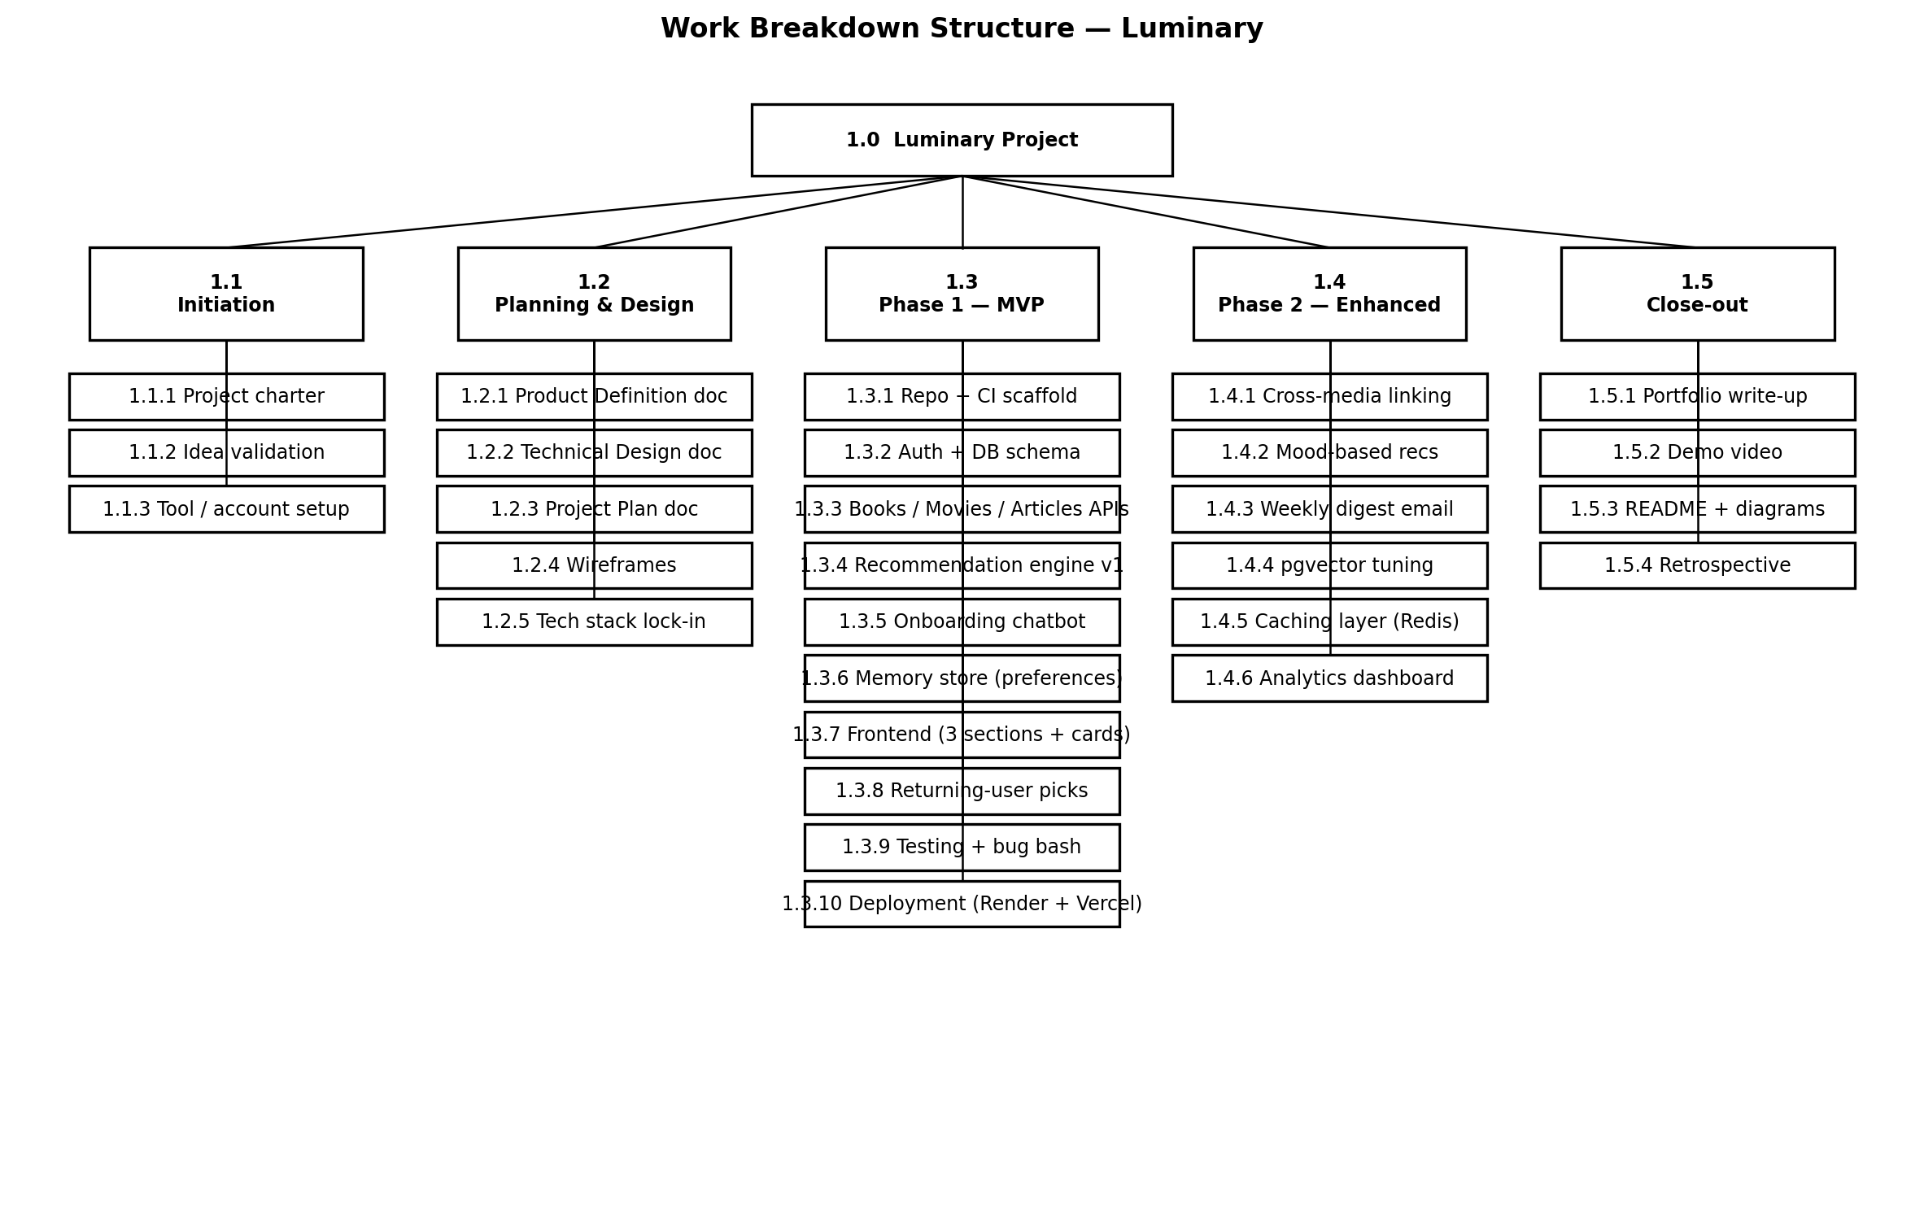
Figure 4.1. Work breakdown structure for Luminary.
4.1 WBS dictionary (selected)
WBS ID | Work package | Deliverable
1.2.1 | Product Definition Document | Approved Product Definition Document v1.0 (this document set).
1.2.2 | Technical Design Document | Approved Technical Design Document v1.0.
1.2.3 | Project Plan | Approved Project Plan v1.0.
1.3.2 | Auth + DB schema | Working sign-up / log-in flow against PostgreSQL with all MVP tables migrated.
1.3.4 | Recommendation engine v1 | POST /api/recommendations endpoint returning a primary pick + 4 similar items.
1.3.5 | Onboarding chatbot | Multi-turn chat that completes within 10 turns and writes preferences to the database.
1.3.8 | Returning-user picks | Personalised greeting + fresh picks on log-in for any user with stored preferences.
1.3.10 | Deployment | Production URL on Vercel + Render with health-check green.
1.4.1 | Cross-media linking | Book detail page shows at least one related item per other media type.
1.4.3 | Weekly digest email | Scheduled job that sends one personalised email per opted-in user, on a 7-day cadence.
1.5.1 | Portfolio write-up | Two-page README + linked architecture diagrams + demo video URL.

5. Timeline and Milestones
Phase 1 is sized for 8 weeks of part-time work (~8 hours per week, increasing during semester breaks). Phase 2 is a further 6 weeks, with deliberate slack at the end for portfolio polish.
5.1 Milestone calendar
Milestone | Target date | Definition met when...
M0 - Project kick-off | 26 May 2026 | GitHub repo created, environments set up, planning docs v1 signed off.
M1 - Auth + DB live (locally) | 9 June 2026 | User can register, log in, and see an empty home page; tables migrated.
M2 - Recommendation engine v1 | 23 June 2026 | All three sections return a primary pick + 4 similar items locally.
M3 - Onboarding chatbot complete | 7 July 2026 | New user can complete onboarding and see personalised picks.
M4 - Returning-user memory complete | 14 July 2026 | Second log-in shows a contextual greeting based on stored preferences.
M5 - Phase 1 deployed (MVP done) | 21 July 2026 | Public URL passes the full FR-01..FR-13 acceptance checklist.
M6 - Cross-media + mood-based recs | 11 August 2026 | FR-14 and FR-15 pass acceptance on the live URL.
M7 - Weekly digest + vector search | 25 August 2026 | FR-16 sends real emails; pgvector similarity replaces v1 ranking.
M8 - Portfolio polish + demo video | 1 September 2026 | README, diagrams, and 3-minute demo video are linked from the portfolio.
5.2 Sprint structure
Sprint | Weeks | Focus | Exit criteria
Sprint 0 | Wk 0 | Plan + scaffold | Repo, CI, hosting accounts, env vars; planning docs v1.
Sprint 1 | Wk 1-2 | Auth + DB + skeleton UI | M1 met.
Sprint 2 | Wk 3-4 | Recommendation engine | M2 met.
Sprint 3 | Wk 5-6 | Chatbot + preferences | M3 met.
Sprint 4 | Wk 7 | Returning-user memory | M4 met.
Sprint 5 | Wk 8 | Deploy + bug bash + a11y audit | M5 met.
Sprint 6 | Wk 9-11 | Cross-media + mood-based | M6 met.
Sprint 7 | Wk 12-13 | Weekly digest + pgvector | M7 met.
Sprint 8 | Wk 14 | Polish + portfolio assets | M8 met.

6. Risk Register
Risks are scored on Likelihood (L) and Impact (I), each rated Low / Med / High. The overall rating uses High > Med > Low precedence between the two scores.
ID | Risk | L | I | Overall | Mitigation | Owner
R-01 | LLM API costs exceed free credits during development. | Med | Med | Med | Wrap all LLM calls in the adapter; cap daily token budget; cache recommendation summaries. | Author
R-02 | Scope creep delays MVP past portfolio review window. | High | High | High | Lock Phase 1 scope at sign-off; route any new idea to a Phase 3 backlog; enforce sprint exit criteria. | Author
R-03 | External API (TMDb / Guardian / Google Books) deprecates or rate-limits. | Low | Med | Med | Wrap each in its own adapter; record a fallback provider; cache last good response. | Author
R-04 | Vector search complexity blocks the Phase 2 schedule. | Med | Med | Med | Time-box pgvector spike to one week; if not working, fall back to keyword + weight scoring. | Author
R-05 | Solo developer illness / academic load reduces capacity. | Med | High | High | Two weeks of buffer built into the timeline (after M5, after M8). Triage backlog weekly. | Author
R-06 | Hosting free tier becomes insufficient during demo. | Low | Med | Low | Pre-test under expected demo load. Have a paid-tier upgrade path documented. | Author
R-07 | User data (preferences) leaks via insecure endpoint. | Low | High | Med | Auth middleware on every preference endpoint; integration tests on every endpoint; weekly dependency scan. | Author
R-08 | Recommendation quality is poor in subjective review. | Med | High | High | Manual relevance review at M2 and M3; iterate prompt and ranking before M5; record pass / fail per item. | Author
R-09 | Chatbot prompt regresses after LLM provider update. | Med | Med | Med | Snapshot tests on prompt outputs; CI flags structural changes in responses. | Author
R-10 | Portfolio assets (write-up, video) deprioritised until last minute and slip. | Med | Med | Med | Treat them as a sprint deliverable (Sprint 8); block M8 sign-off on them. | Author
7. Assumptions and Constraints
7.1 Assumptions
- The author has at least 8 hours per week available for the duration of the project.
- Free tiers of all chosen services remain available without policy change.
- Test users (3-5) will be available for a one-hour usability session in week 7.
- Reviewer (tutor / employer) will accept a portfolio web app rather than a native mobile build.
7.2 Constraints
- Solo team of one developer.
- Total cash budget capped at USD 30.
- Hard portfolio submission date: end of Phase 2 (1 September 2026).
- Must run in any modern browser without plug-ins.
- Must not require user payment information.
8. Communication Plan
Solo build, but a lightweight communication discipline is still valuable - mostly with the future self reviewing decisions, and with the portfolio reader.
Channel | Audience | Cadence | Content
GitHub commits | Self + reviewer | Daily on active days | Atomic commits with descriptive messages; one feature per branch.
Sprint log (Markdown in /docs) | Self + reviewer | End of each sprint | What shipped, what slipped, what was learned.
Risk register update | Self | Weekly | Re-score risks; close mitigated ones; add any new ones.
Pilot user feedback form | 3-5 friends | Once in week 7 | Quantitative usability ratings + open feedback.
Portfolio README | Future employer / reviewer | End of Sprint 8 | One-page story of the project + links to demo + diagrams.
Demo video | Future employer / reviewer | End of Sprint 8 | 3 minutes: problem, walkthrough, what was hard, what was learned.
9. Quality Plan
Quality controls are applied at three layers: code, product, and process.
Layer | Control | Frequency
Code | Pre-commit lint (ruff for Python, eslint for TypeScript). | Every commit.
Code | Unit tests run in CI; build fails on failure. | Every PR.
Code | Test coverage report; warn if backend coverage drops below 70%. | Every PR.
Product | Manual relevance review of recommendation outputs. | End of Sprints 2, 3, 5.
Product | Accessibility audit using axe-core. | End of Sprints 5 and 8.
Product | Pilot user usability session. | Week 7.
Process | Sprint exit checklist signed off before next sprint starts. | End of each sprint.
Process | Risk register review. | Weekly.
Process | Retrospective entry in sprint log. | End of each sprint.

10. Definition of Done
10.1 Story-level Definition of Done
- Code merged to main via pull request with at least a self-review checklist completed.
- All acceptance criteria for the story pass manually.
- Unit tests cover the new logic (or a justified note if not applicable).
- OpenAPI spec auto-updates and is committed.
- No new linter errors introduced.
- Story marked done in the sprint log with a one-line summary.
10.2 Phase-level Definition of Done
- All Phase 1 (or Phase 2) functional requirements pass acceptance on the live URL.
- Non-functional requirements measured and recorded against targets.
- Risk register up to date; outstanding High risks have explicit mitigation status.
- Sprint log entries complete for every sprint in the phase.
- Phase release notes drafted (one paragraph per major feature).
10.3 Project-level Definition of Done
- Portfolio README published.
- Demo video published.
- All planning documents stored in /docs as PDF + DOCX.
- Public GitHub repository tagged v1.0 (Phase 1) and v2.0 (Phase 2).
- Retrospective document written and committed.
11. Out of Scope
Explicitly out of scope for both phases - listed here so a reviewer can verify nothing was silently dropped.
- Native mobile apps.
- Social features (following users, public reviews, comments).
- Subscription billing or commerce.
- Streaming media playback (full film, full book text) inside Luminary.
- Multi-language UI.
- Importing existing Goodreads / Letterboxd libraries.
- Federated or third-party login (Google / Apple sign-in).
12. Closure Criteria
The project is considered formally closed when all of the following are true.
- Project-level Definition of Done (Section 10.3) is fully satisfied.
- Reviewer (tutor or employer audience) confirms acceptance of the portfolio deliverables.
- Public hosting accounts are either kept running on the free tier or gracefully wound down with a static snapshot left in the repo.
- Final retrospective is written and added to the portfolio.

