Documentation for Ford Mustang website

Introduction
This document covers the planning and design for a Ford Mustang website. The site is meant to highlight the history, evolution, and performance of the Mustang, giving fans and car enthusiasts a place to learn more about the iconic nameplate. This documentation includes the objectives, target audience, content breakdown, sitemap, and wireframes for the project.

Objective
To showcase the beauty, quality, reliability of the Ford Mustang
Goals
- Get people interested in the Ford Mustang
- Highlight the beauty of the Ford Mustang
- Showcase the great performance of the newer Mustangs

Target Audience
The target audience for the website is performance car lover, Classic car enthusiasts and fellow Ford Mustang fans.
Users of this website are expected to have basic to moderate technical aptitude, meaning they should be comfortable performing simple web interactions such as navigating between pages, clicking links, hovering over images, and reading content on different sections of the site.
Demographics:
- Age – 18+
- Gender – Both genders

Website content
This website will contain educational content about the Ford Mustang, beginning with a Home page that welcomes visitors and introduces the purpose of the site, followed by a dedicated About page that explains the Mustang’s background and key historical facts, such as its debut on April 17, 1964, where Ford sold 22,000 units on the first day, marking one of the most successful vehicle launches in history, as well as the Mustang’s status as Ford’s longest-running continuous nameplate since 1964. The Generations/Evolution page will expand on this by teaching users about all seven Mustang generations. The New Models page will provide educational information about the newest Mustangs, explaining modern technologies such as the digital cockpit with a 12.4-inch instrument cluster and 13.2-inch SYNC 4 display powered by Unreal Engine graphics, along with performance upgrades like Brembo brakes and MagneRide suspension used in more recent models. Altogether, the site delivers informative content covering the Mustang’s history, evolution, engines, modern features, and advanced technologies

Site maps
Home

New Models
Feedback
Evolution
History

Home page
- Links to the other pages
- A brief intro to the intro the website
- A bio about Ford and the mustang
History
- Links to the other pages
- A brief history on the name plate
- Mustangs first year
Evolution
- Links to the other pages
- Information on each generation of the mustang, from 1 to 7
New models page
- Links to the other pages
- Information on the new technologies found in the newer models
- Information on engine specs of newer models
Feedback page
- A feedback form to collect information from the users

Technical brief
This website will be created using HTML5 to structure the content and CSS3 to style the pages with colours, layout, and fonts. Bootstrap will be used to help make the site responsive and mobile-friendly by using its ready-made grid system and components. JavaScript will add simple interactivity such as navigation effects and small dynamic features. All coding will be done in Visual Studio Code, which provides useful tools like syntax highlighting and extensions. For planning and documentation, Visual Paradigm will be used to create diagrams such as UML or structural layouts, and Lucidchart will be used to design the sitemap, storyboard, and flowcharts. Wireframes.cc will also be used to create the wireframes.

Wireframes

Home page
Low Fidelity
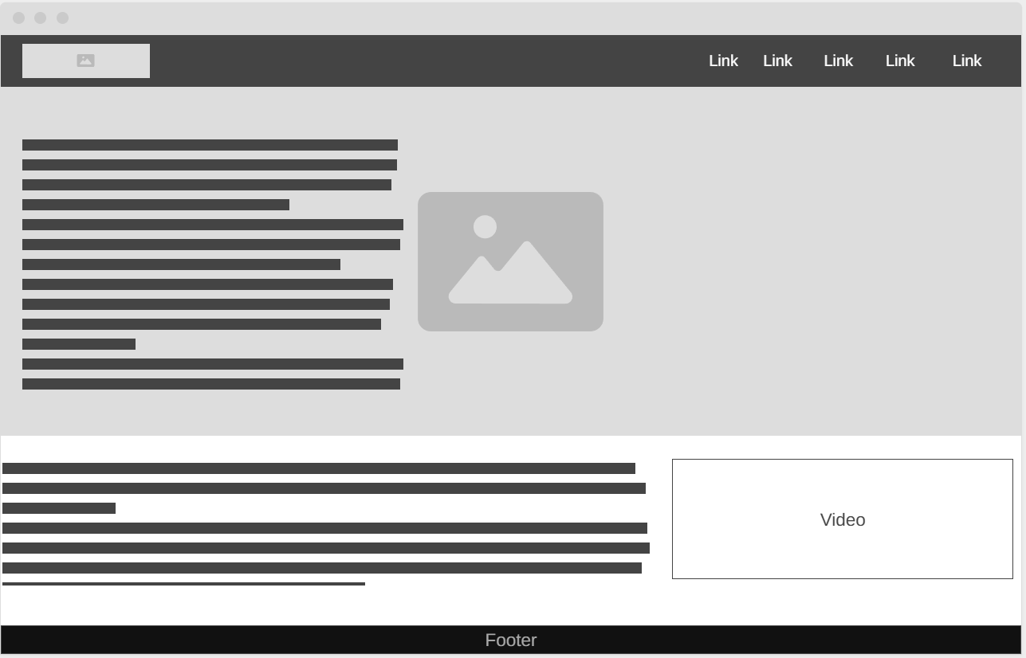
High Fidelity
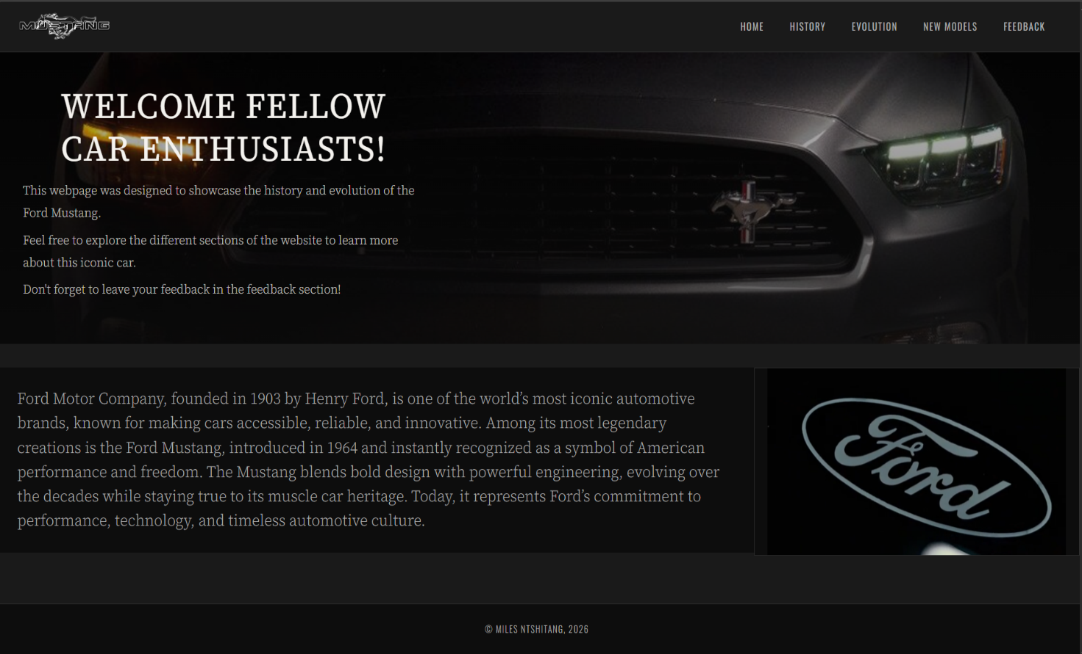

History
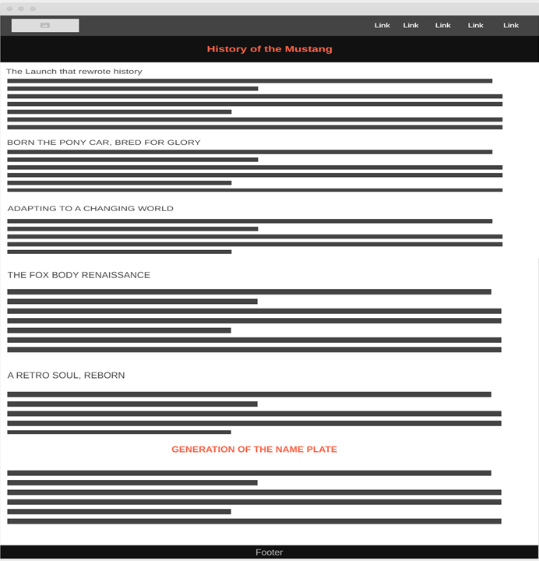
High Fidelity
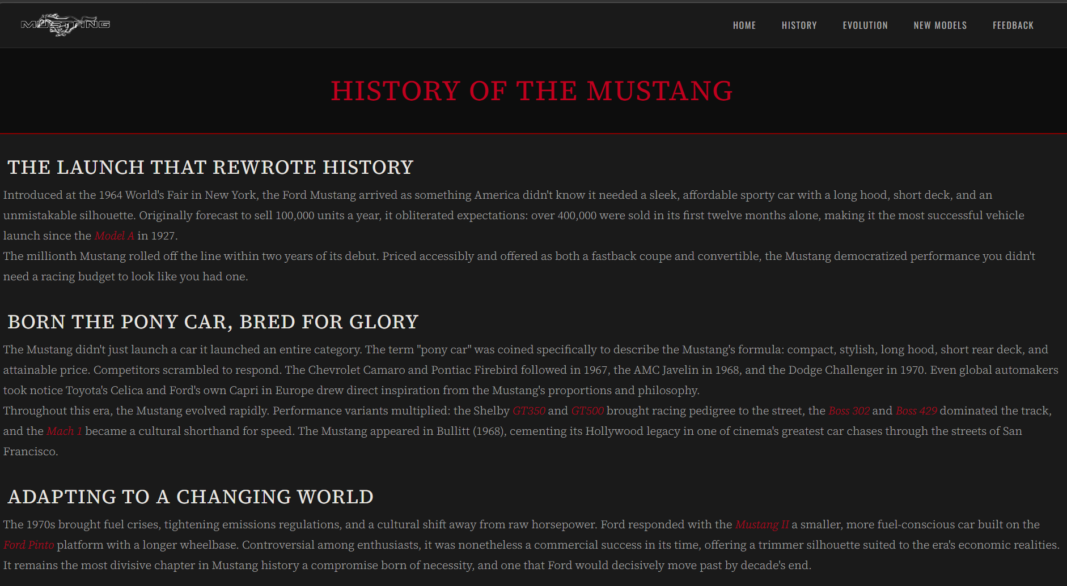
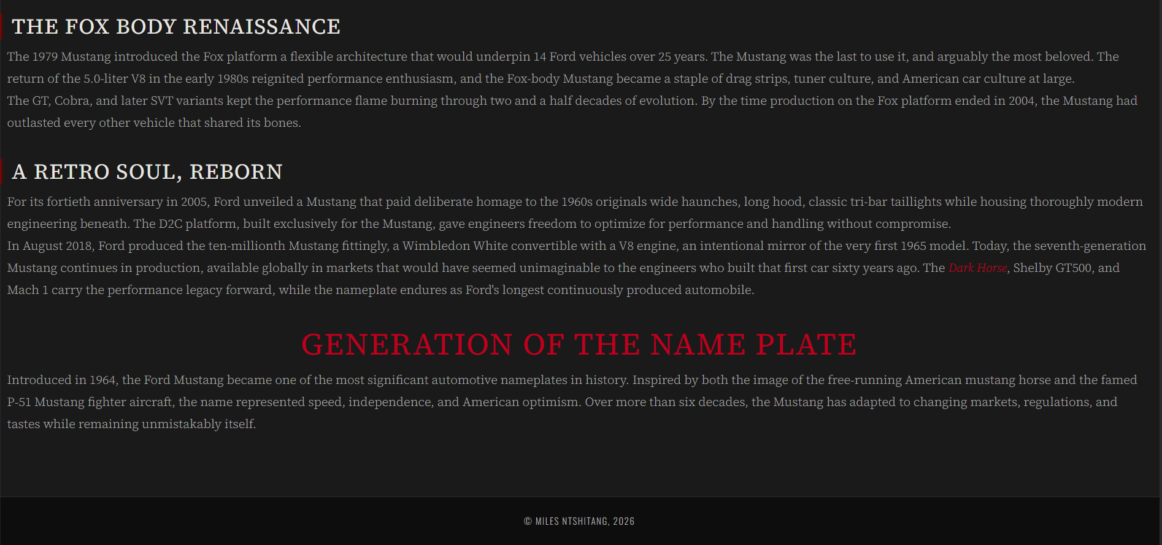

Evolution
Low Fidelity
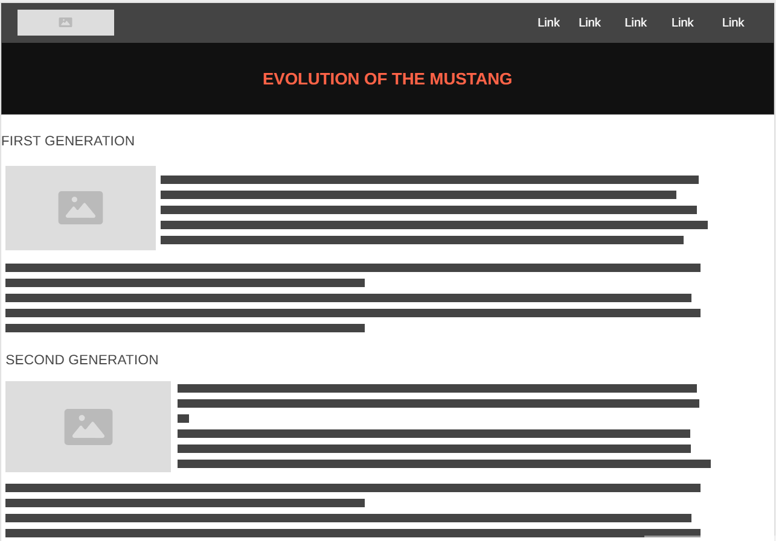
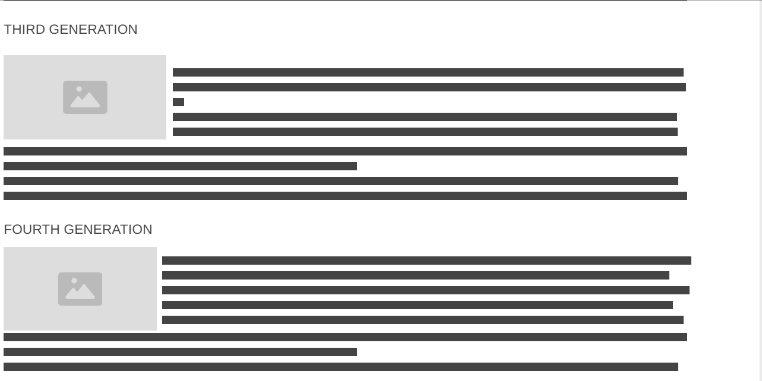
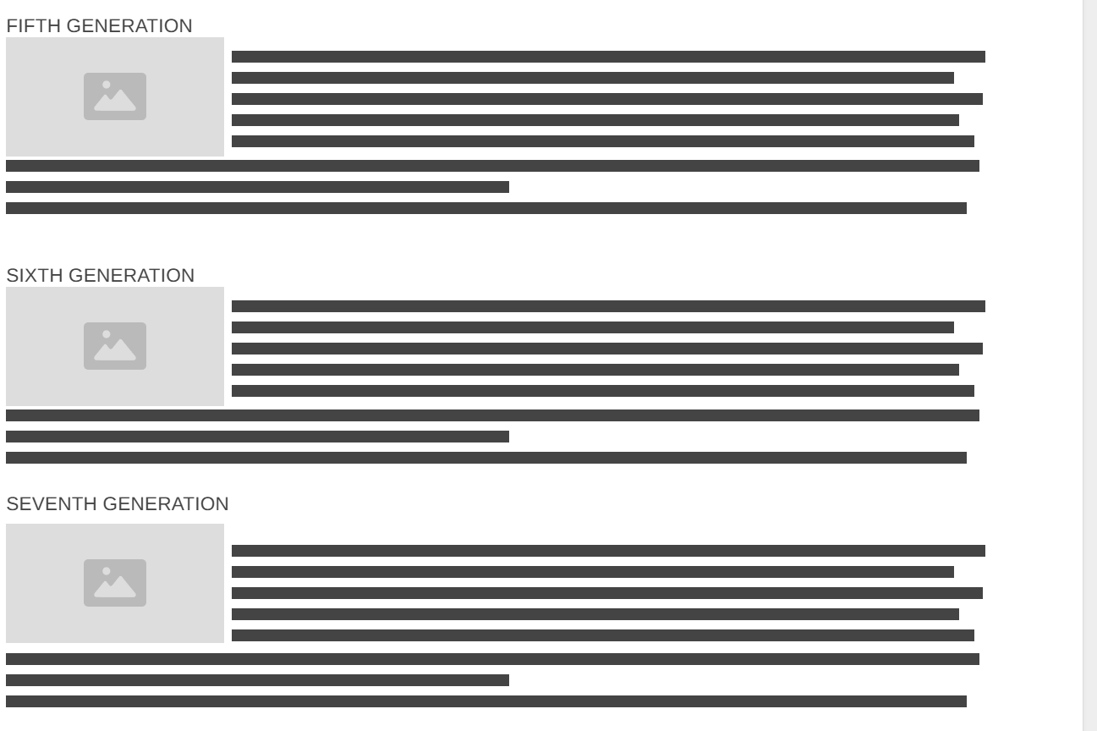

High Fidelity
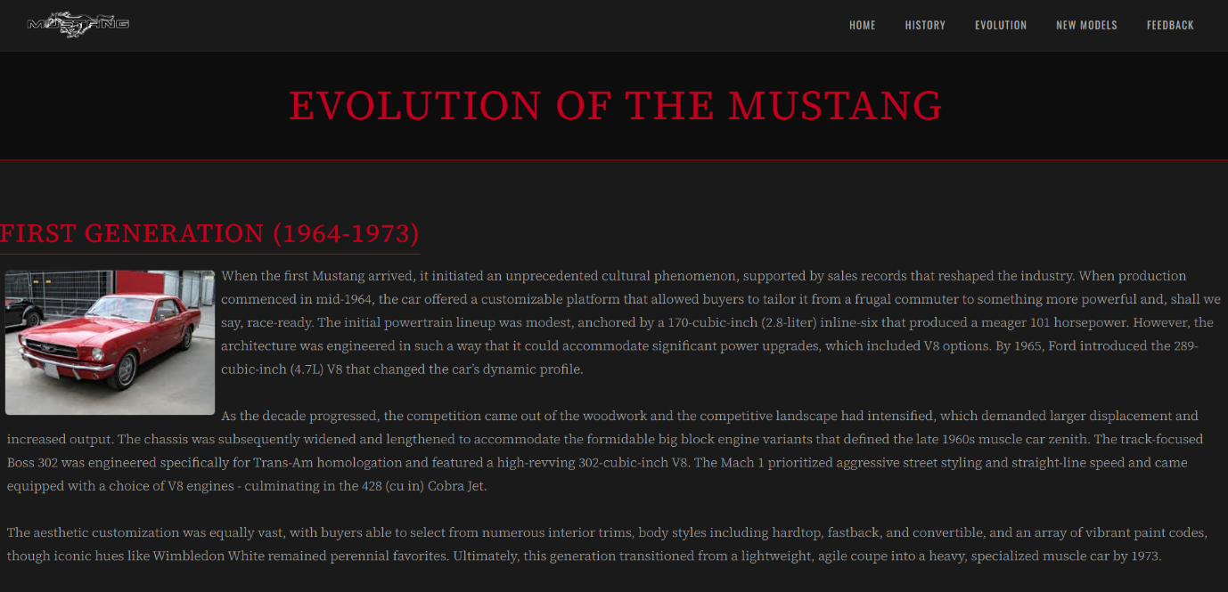
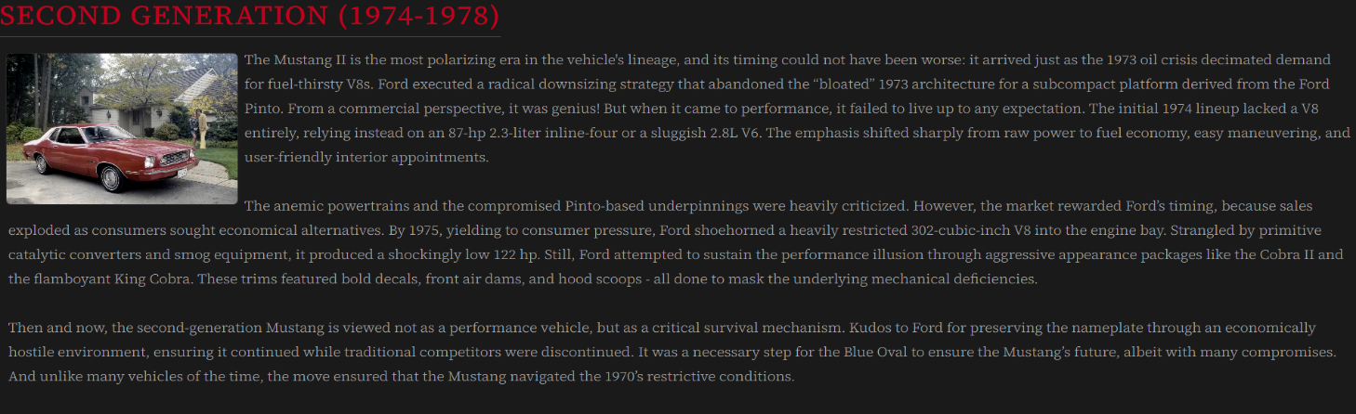
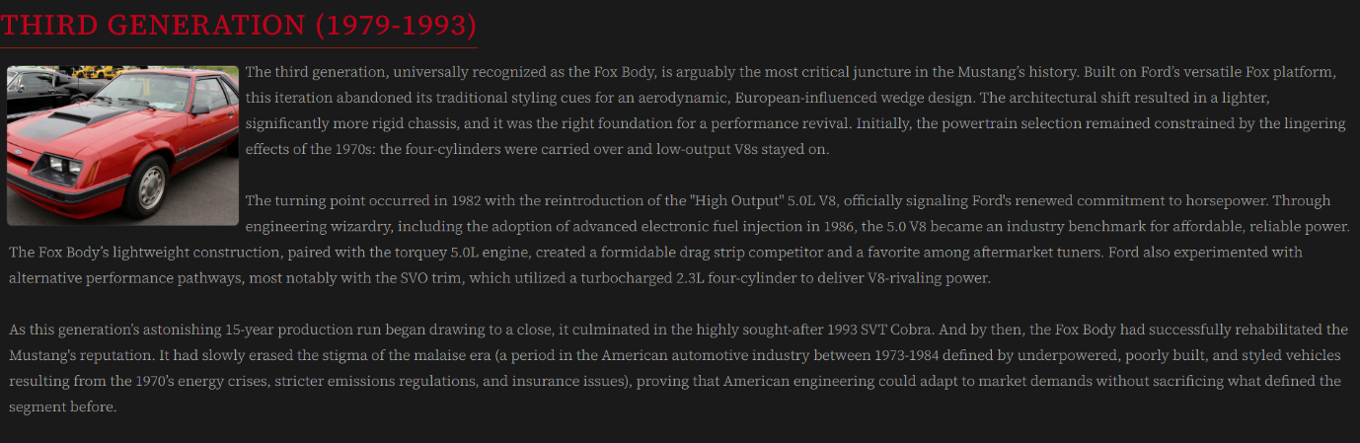


New models
Low Fidelity
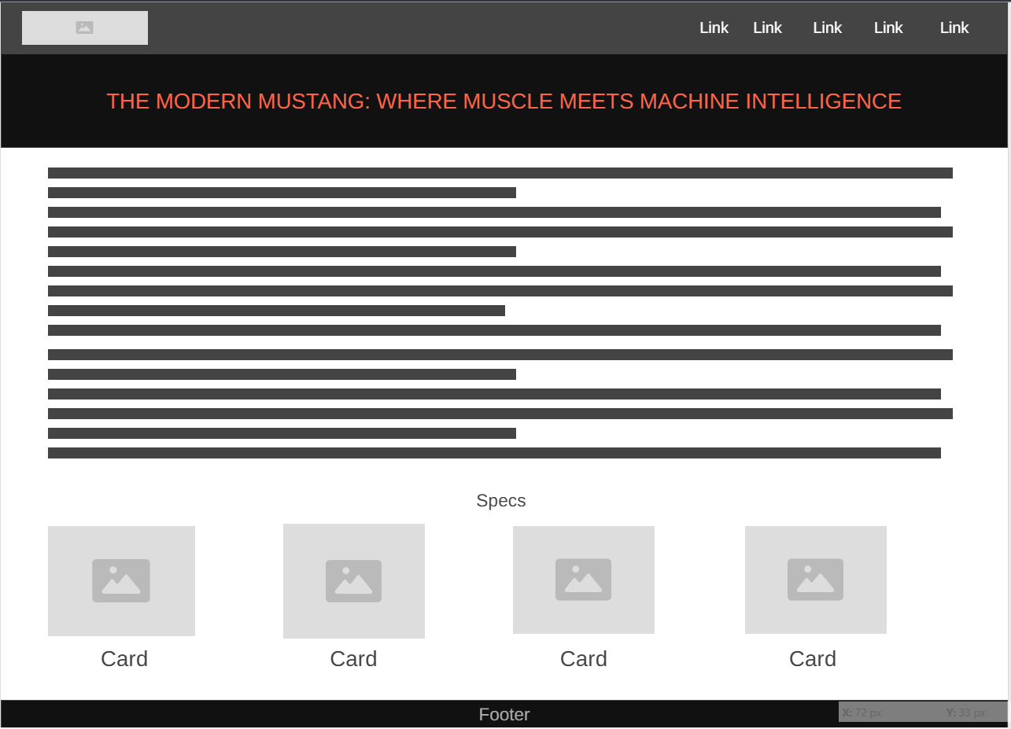
High Fidelity
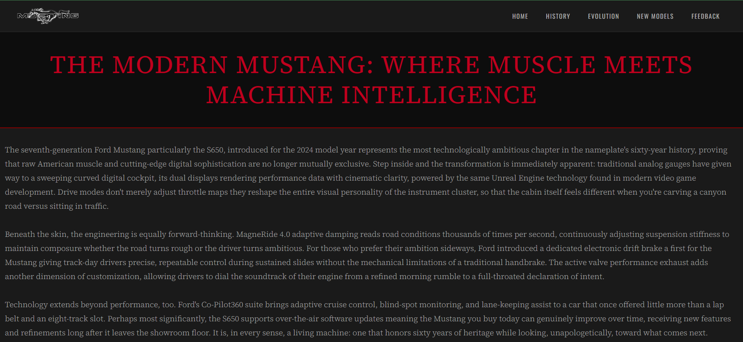
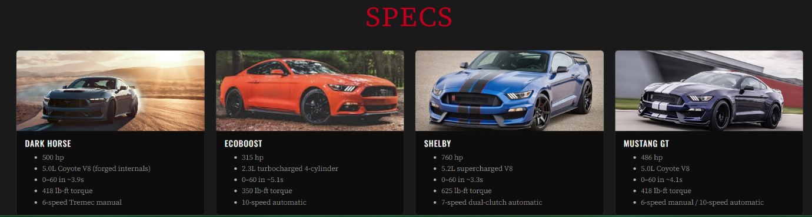

Feedback
Low Fidelity
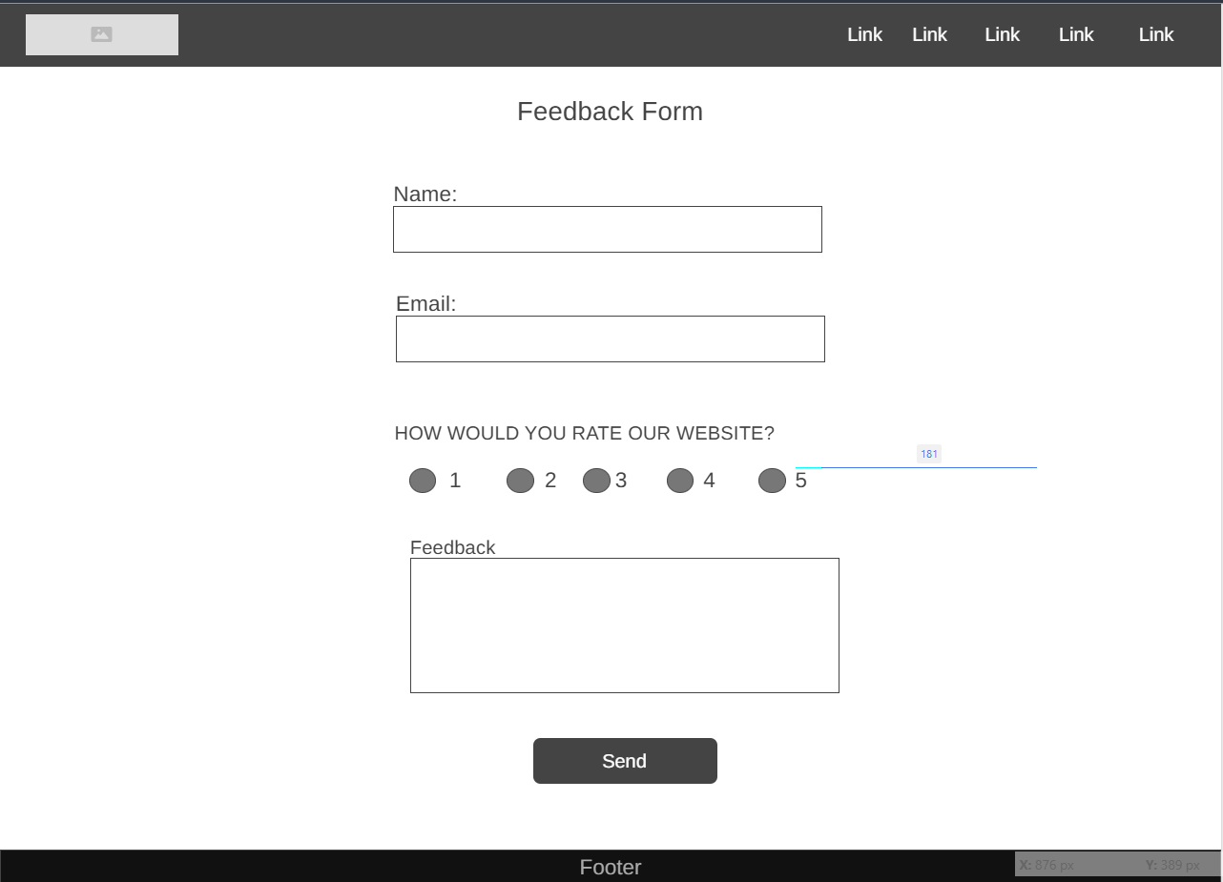
High Fidelity
