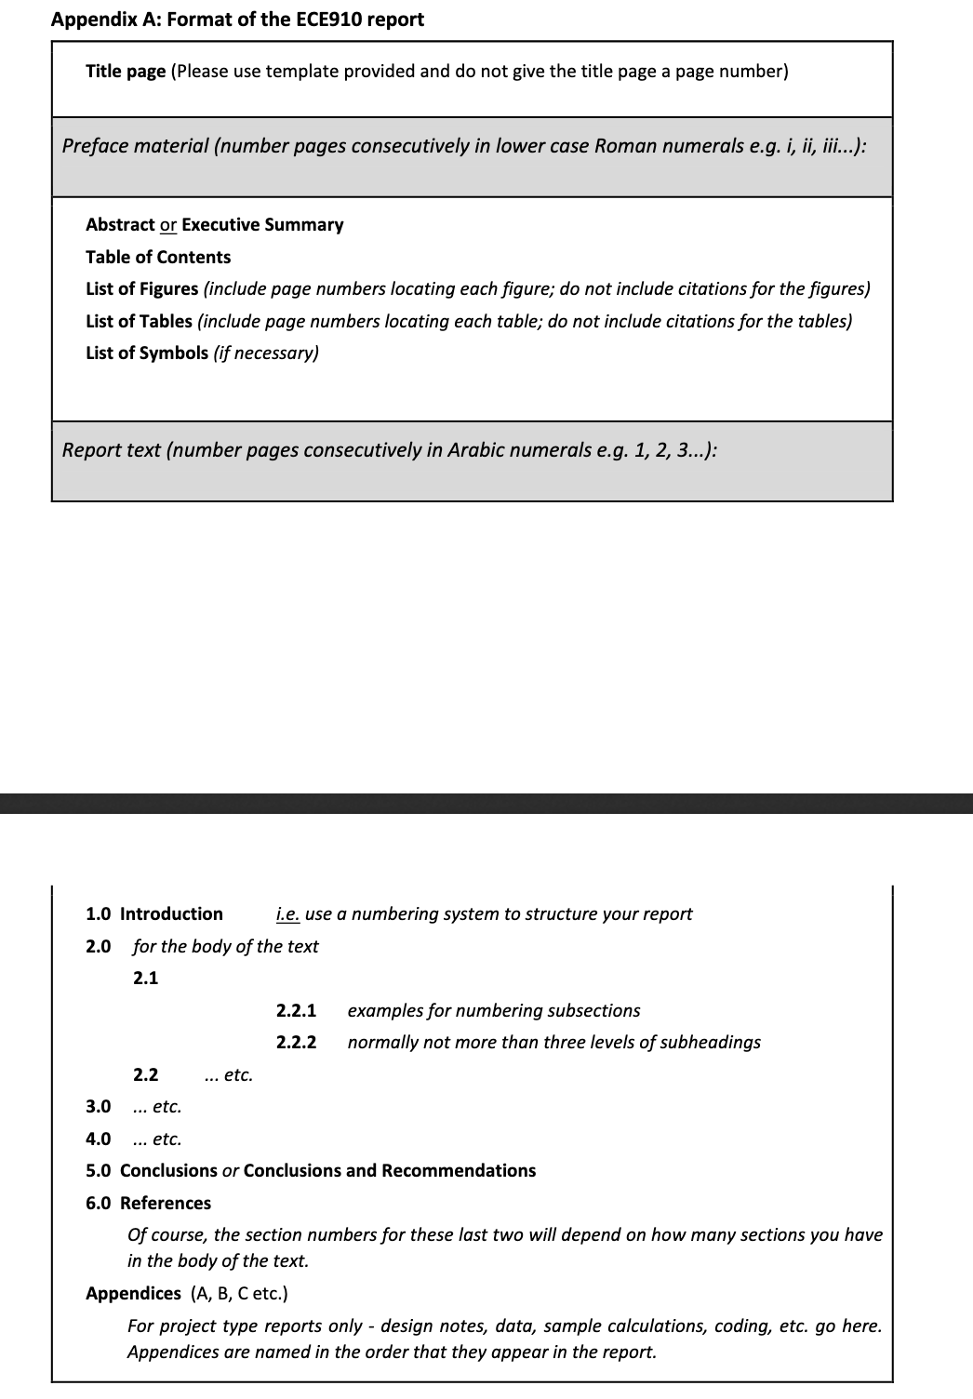

1. Introduction:
   1. Slung Load System
   2. Motion control
   3. Software in the loop (SITL): PX4, ROS, Gazebo, QG Control
2. Quadrotor Modelling
   1. Rotation Dynamic of the UAV
   2. Physical inputs
   3. Pendulum and Translational UAV Variable (PT) Dynamic
3. Controller: Quasi-Static Feedback Linearization
   1. Quasi-Static Feedback Algorithm (QSFA)
   2. SLS Controller Design Using QSFA
   3. Output Tracking
   4. Domain of the Dynamic State Feedback Linearization
4. Matlab Simulation
   1. compared with cascade PID controller
5. SITL Simulation
6. Conclusion

Reference

Appendix

