BUSINESS PROPOSAL
Outbound AI Voice Agent
Development & Deployment for Chloride Exide
Automotive Batteries · Solar Products · Energy Storage
Prepared for | Dominic and Team, Chloride Exide
Prepared by | Kamunya Maina
Date | 4 October 2026
Implementation | 30 days to live production
Investment | $4,000 one-time setup · $100 / month maintenance · third-party usage at cost
Version | 1.0 — for client review and sign-off
Confidential. Prepared exclusively for Chloride Exide.
Contents

Right-click the table and choose "Update Field" if page numbers do not appear.

1. Document Details
Chloride Exide can have an outbound AI voice agent live in 30 days for a $500 trial deposit. The full $4,000 setup is committed only after real call results are reviewed.
Field | Detail
Prepared for | Dominic and Team, Chloride Exide
Prepared by | Kamunya Maina
Business lines in scope | Automotive Batteries (incl. Dial-a-Battery), Solar Products, Energy Storage / Inverters
Engagement model | 30-day build and launch within a 3-month onboarding period, then a monthly maintenance retainer
Total one-time setup | $4,000 USD (KSh 520,000)
Ongoing maintenance | $100 USD / month (KSh 13,000), from Month 4
Third-party usage | Paid directly by Chloride Exide (telephony, AI speech processing, SMS)
Currency basis | USD contract currency; KES shown at a fixed 130 KES = 1 USD
Version | 1.0, for client review and sign-off
Classification | Confidential, prepared exclusively for Chloride Exide

2. Executive Summary & Business Objective
This engagement deploys a dedicated outbound-only AI voice agent. It follows up on leads, triages Tier-1 battery and solar questions, and records every call in Chloride Exide's CRM. All inbound calls continue straight to the human support team.
Chloride Exide's products are bought rarely but matter when they fail. A flat battery, an inverter fault or an underperforming solar system needs a fast, competent response. Leads that go unanswered go cold. Routine diagnostic questions take up staff who should be handling complex cases.

2.1 Business Objectives
- Consistent follow-up: about 20 outbound calls per working day to approved lead and customer lists, with an instant redial whenever the first attempt goes unanswered (power-calling).
- Tier-1 technical triage: automotive batteries (including Dial-a-Battery qualification) and solar/inverter systems, using only Chloride Exide–approved knowledge base material.
- Human escalation and booking: warm live transfer to staff for complex cases or on request, plus direct calendar booking of technician visits and sales consultations.
- Complete CRM record: full transcript, structured summary and disposition tags written to the customer record as soon as each call ends.
- SMS confirmation: diagnostic links, Dial-a-Battery links and booking confirmations sent by SMS during the call, while the customer is still on the line.

2.2 Design Principles
Principle | How it is applied
Outbound only | The AI only places outbound calls. No inbound AI agent is included. Every inbound call bypasses the AI and goes directly to human support.
Power-calling | An unanswered first attempt is redialled instantly, lifting pick-up rates without adding calling days.
Stateless per call | Each call starts from the context in its trigger (CRM record and call list). Nothing is remembered between calls; the CRM is the system of record.
SMS-only follow-up | Messages go by SMS only, sent during the call. Email sequencing and campaigns are excluded.
Approved content only | Guidance is limited to documentation Chloride Exide has approved. Anything beyond Tier-1 goes to a person.
Transparent usage costs | Chloride Exide pays infrastructure providers directly at their rates, with no markup.

2.3 Commercial Summary
Item | USD | KES (@130)
Trial deposit: due at signing; funds the 30-day build and Month 1 optimization | $500 | KSh 65,000
Milestone 2: due before Month 2 optimization, if Chloride Exide elects to proceed | $3,500 | KSh 455,000
Total one-time setup investment | $4,000 | KSh 520,000
Maintenance retainer, from Month 4 | $100 / month | KSh 13,000 / month
Third-party usage | Paid directly by Chloride Exide | Usage-based

Chloride Exide's initial commitment is $500. The decision to continue comes after the agent has been built, launched and measured against real call outcomes.

3. Detailed Scope of Work
The engagement delivers 11 defined outbound capabilities. Inbound AI, email automation and cross-call memory are explicitly excluded.

3.1 Included Deliverables
# | Deliverable | Description | Acceptance criteria
D1 | Outbound follow-up & lead engagement | Scheduled outbound calls to approved customer and lead lists at about 20 calls per working day (Mon–Fri), pulled from the CRM or an approved list. If a lead does not pick up, the agent redials instantly (power-calling) to lift pick-up rates. | Calls run within agreed windows, at target pace, to approved lists only; instant redial fires on every unanswered first attempt.
D2 | Tier-1 automotive battery triage | Structured questioning on common symptoms (slow cranking, no-start, warning lights, battery age), plus Dial-a-Battery qualification: vehicle, location and urgency, then routing to purchase or booking. | Responses match the approved knowledge base and qualification logic in UAT scripts.
D3 | Tier-1 solar & inverter triage | Guidance on common panel, inverter and storage questions (backup duration, charging behaviour, error indicators, basic checks) from approved documentation only. | Responses match approved documentation; out-of-scope questions trigger transfer or booking.
D4 | Warm live transfer | Live handoff to a designated staff line when a query exceeds Tier-1 logic or the customer asks for a person, with context introduced where telephony supports it. | Transfers connect in testing for both triggers.
D5 | Calendar booking | Real-time availability checks and direct booking of technician visits and sales consultations. | Bookings land on the correct calendar with customer details and call reference.
D6 | Post-call CRM sync | Immediately after each call: full transcript, structured summary and disposition tags (e.g. Qualified, Booked, Transferred, Callback Requested, Not Interested, No Answer). | 100% of completed test calls write back correctly.
D7 | In-call SMS | SMS sent while the customer is still on the call, via Chloride Exide's provider: diagnostic links, Dial-a-Battery links, branch details, booking confirmations. | SMS delivered for each defined trigger in UAT, using approved templates.
D8 | Static inbound forwarding | Forwarding rules that send all inbound calls directly to human support, with no AI involvement. | Test calls reach the support desk with no AI interaction.
D9 | Authorized production voice clone | Production voice built from clean reference audio supplied by Chloride Exide, with explicit written consent from the voice owner. A stock voice is used until both are received. | Signed consent on file; voice approved before go-live.
D10 | Launch, handover & documentation | Production launch, launch-week monitoring, and a handover pack: system overview, escalation contacts, disposition definitions, change-request process. | Pack delivered; walkthrough session held.
D11 | 3-month optimization program | Monthly tuning of prompts, triage logic, transfer thresholds and SMS triggers from real call outcomes (Section 6). | Monthly performance review delivered.

3.2 Explicit Out-of-Scope Exclusions
Any item below needs a separate written change request with its own scope, timeline and price.
Exclusion | Clarification
Inbound conversational AI agent | Inbound AI is out of scope. No inbound AI agent, conversational IVR, AI receptionist or AI call answering. All inbound calls bypass the AI and are statically forwarded to human support.
Email marketing, sequencing & campaigns | No automated emails, drip sequences or newsletters. Messaging is SMS only, sent during the call.
Dynamic cross-call / in-session memory | No real-time customer profiles across calls. Context arrives with each outbound trigger; results are written to the CRM after the call.
Tier-2+ technical support | Advanced diagnostics, warranty decisions, pricing exceptions and complaints go to staff.
Payment processing | No card or M-Pesa payments on calls. The agent may SMS a link to an existing ordering channel (e.g. Dial-a-Battery).
Knowledge base authoring | Chloride Exide supplies and approves all technical content; this engagement structures it, not writes it.
CRM / SMS procurement or re-platforming | Integration uses existing CRM, calendar and SMS tools. No new licences, migrations or custom CRM work.
High-volume or multi-campaign dialing | Pacing is designed for about 20 calls per working day. Larger volumes are scoped separately.
Third-party usage fees | Telephony, AI speech and SMS fees are paid by Chloride Exide, outside the setup and retainer fees.
Unconsented voice cloning | No voice is cloned without written consent and clean reference audio from Chloride Exide.

4. System Architecture & Routing Flow
Telephony splits traffic into two separate paths at the edge. Inbound calls never reach the AI. Outbound calls are started by the system and handled by the AI agent.
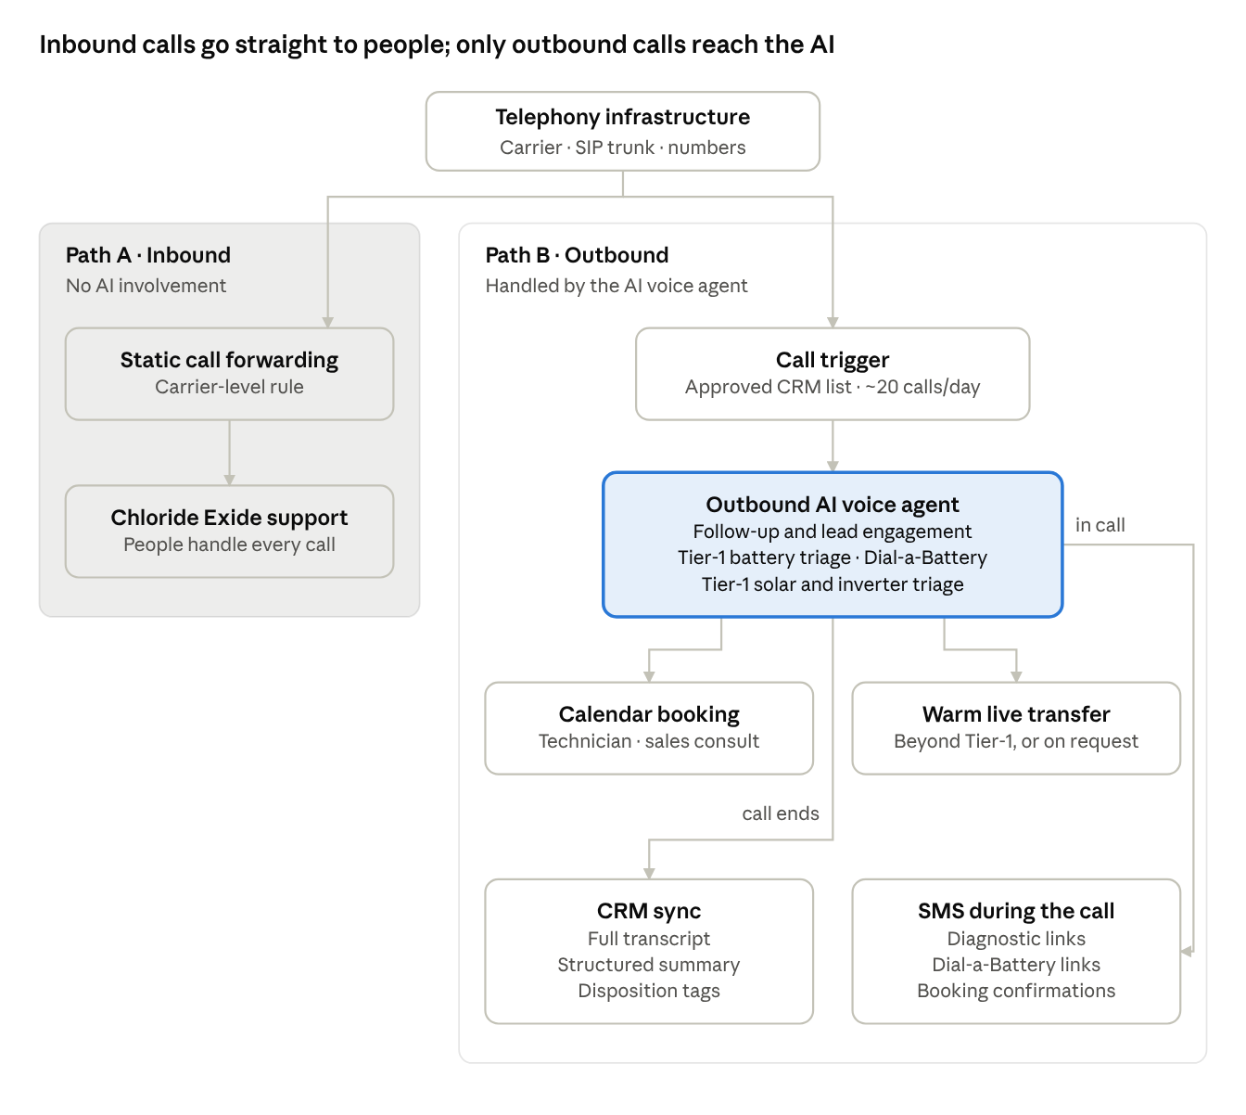
Figure 1. Call routing: inbound to people, outbound through the AI agent

4.1 Inbound vs. Outbound Routing
Attribute | Path A: Inbound calls | Path B: Outbound calls
Who starts the call | Customer | System, from an approved call list
AI involvement | None. The AI is bypassed completely | Outbound AI voice agent
Routing mechanism | Static carrier-level forwarding | SIP trunk with configured outbound caller ID
No-answer handling | Not applicable | Instant redial (power-calling), then tagged No Answer
Destination | Chloride Exide human support team | Customer or lead
Escalation | Not applicable (already with people) | Warm live transfer to designated staff
CRM write-back | Chloride Exide's existing process | Automatic: transcript, summary, disposition tags
SMS | None | Sent during the call (links, confirmations)
Volume | Unchanged from current operations | About 20 calls per working day

4.2 Outbound Call Lifecycle
- Trigger: the next approved contact is pulled from the CRM during the calling window, within the daily pacing limit (name, product history, lead source, call purpose).
- Power-call: if the first attempt is not answered, the agent redials the lead instantly.
- Conversation: greeting and identity check, purpose of call, then scripted Tier-1 triage against the approved knowledge base.
- Resolution: Tier-1 guidance, a calendar booking, a warm transfer, a noted callback, or a polite close. Any relevant SMS (link or booking confirmation) is sent while the customer is still on the line.
- Post-call: the full record is written to the CRM.

4.3 Power-Calling
When a lead does not answer the first attempt, the agent redials immediately. Someone who just missed a call is far more likely to answer a second ring seconds later, so power-calling raises the pick-up rate without adding calling days. If the redial also goes unanswered, the record is tagged No Answer in the CRM for the next scheduled attempt.

4.4 Integration Components
Component | Function | Integration method
Telephony | Outbound dialing with caller ID and instant redial; static forwarding of inbound numbers | SIP trunk / carrier configuration
CRM & customer database | Source of call lists and context; system of record for transcripts, summaries and dispositions | REST API and/or webhooks
SMS gateway | SMS sent during the call | Chloride Exide's SMS provider API
Calendar | Availability lookup and booking for technician visits and sales consultations | Calendar API
Knowledge base | Approved Tier-1 troubleshooting and Dial-a-Battery qualification content | Ingested and version-controlled at build
Voice model | Authorized clone or approved stock voice | AI speech synthesis provider

4.5 Escalation Rules
The agent transfers the call to a person when any of the following applies:
- The customer asks to speak with a person.
- The question falls outside the approved Tier-1 knowledge base.
- The customer reports a safety concern: a swollen, leaking or overheating battery, a burning smell, or an electrical hazard.
- The customer raises a complaint, warranty dispute or pricing exception.
- The agent cannot reach a confident Tier-1 outcome after the set number of clarification attempts.
If no transfer line is staffed, the agent records a callback request, sends a confirmation SMS before the call ends and tags the CRM record.

5. 30-Day Phased Implementation Schedule
The agent is live at about 20 calls per day by Day 30. The build runs in four phases with UAT sign-off at Day 23.
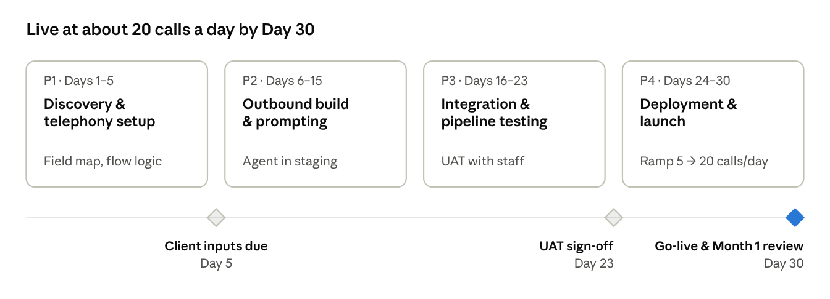
Figure 2. 30-day build: four phases, three checkpoints

5.1 Phase Detail
Phase | Days | Key activities | Deliverables | Client inputs
P1: Discovery & telephony setup | 1–5 | Kickoff workshop; map battery, Dial-a-Battery and solar/inverter decision logic; define CRM fields; confirm SMS credentials and templates, forwarding targets, caller ID, escalation lines, calling windows, pacing and redial rules | Signed-off discovery document; disposition taxonomy; integration field map; telephony plan | Knowledge base documents; CRM, SMS and calendar access; forwarding numbers; transfer lines; voice consent and audio
P2: Outbound build & prompting | 6–15 | Ingest approved documentation; build follow-up, battery, Dial-a-Battery and solar/inverter flows; configure power-calling, transfer and booking logic; build SMS triggers; calibrate voice | Working agent in staging; flow documentation; SMS templates; voice sample | Review of flows and SMS templates; voice approval
P3: Integration & pipeline testing | 16–23 | End-to-end CRM write-back tests; SMS delivery per trigger; instant redial tests; warm transfer tests; booking validation; inbound forwarding check (AI bypassed); UAT with staff | UAT log; defect log; UAT sign-off | 1–2 UAT participants; sign-off
P4: Deployment & launch | 24–30 | Controlled live batches ramping to ~20 calls/day; live monitoring of transfers, bookings and CRM sync; same-day tuning (Month 1 optimization begins); handover | Live system; launch-week summary; handover pack; Month 1 review | Production call lists; staff available for transfers

5.2 Launch-Week Ramp
Launch day | Calls per day | Focus
Day 24 | ~5 | Controlled pilot, every call reviewed
Days 25–26 | ~10 | Validate transfers, bookings, redials and SMS in production
Days 27–28 | ~15 | Stability and CRM data quality
Days 29–30 | ~20 | Target steady-state pacing

5.3 Schedule Dependencies
Day 1 is the day both the signed proposal and the $500 deposit are received. The schedule assumes:
- Knowledge base documents, system access and telephony details arrive by Day 5.
- Feedback on conversation flows returns within 2 working days.
- UAT participants are available on Days 16–23.
Delays in client inputs move the schedule by the same number of days.

6. 3-Month Engagement Roadmap & Retainer Phasing
The engagement runs three funded months with one go/no-go gate at Day 30, then moves to a $100/month retainer from Month 4.
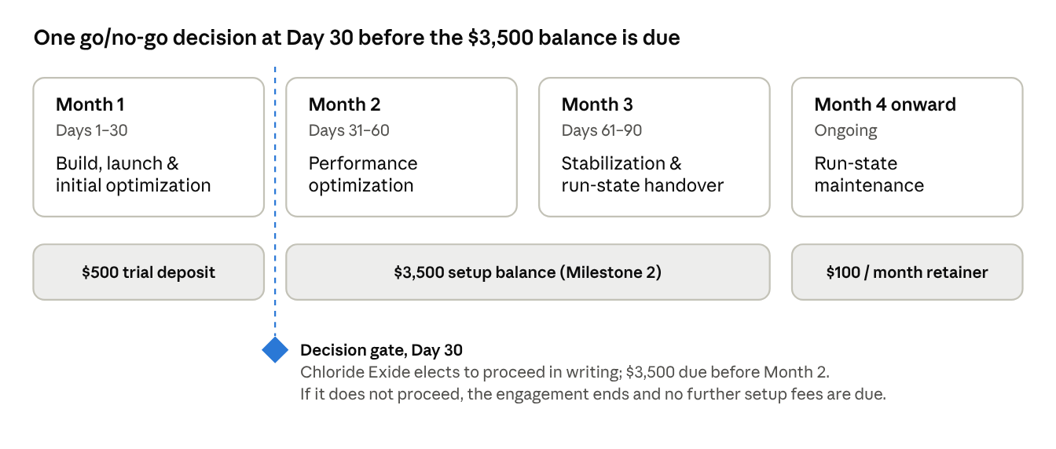
Figure 3. Engagement roadmap: three onboarding months, one decision gate, then retainer

6.1 Month-by-Month Detail
Period | Objective | Key activities | Outputs
Month 1 (Days 1–30) | Build, launch, validate | 30-day implementation (Section 5); launch-week live tuning; initial optimization of prompts, triage paths and transfer thresholds | Live system; launch-week summary; Month 1 review
Decision gate (Day 30) | Go / no-go | Joint review of call outcomes, pick-up rates, CRM data quality, transfer and booking rates, customer feedback | Written election to proceed
Month 2 (Days 31–60) | Improve performance | Tune flows from real transcripts; improve troubleshooting accuracy; refine Dial-a-Battery qualification; adjust SMS content and triggers; cut unnecessary transfers | Month 2 optimization report with before/after metrics
Month 3 (Days 61–90) | Stabilize, move to run-state | Confirm end-to-end CRM data integrity; finalize disposition taxonomy; document run-state procedure; confirm maintenance and change-request process | Run-state readiness review; final handover
Month 4+ | Reliable ongoing operation | Maintenance retainer (6.3) | Monthly health check

6.2 Performance Metrics Tracked
Metric | Definition | Why it matters
Connect rate | Answered calls ÷ leads dialled | List quality and calling-window fit
Redial pick-up rate | Leads answering the instant redial ÷ unanswered first attempts | Measures the lift from power-calling
Tier-1 resolution rate | Calls resolved by approved guidance without transfer | Load removed from human support
Booking rate | Bookings ÷ connected calls | Conversion to technician or sales activity
Dial-a-Battery qualification rate | Qualified leads ÷ relevant connected calls | Direct revenue pipeline
Warm transfer rate & success | Transfers started, and the share that connect | Escalation health and staff coverage
CRM sync integrity | Completed calls with a full, correctly mapped record | Data reliability (target 100%)
SMS delivery rate | SMS delivered ÷ SMS triggered | Follow-up reliability

6.3 Maintenance Retainer: $100/month from Month 4
Included in retainer | Change request required
Uptime and webhook health monitoring | New conversation flows, campaigns or use cases
API and carrier connection maintenance | Any inbound AI agent
Routine bug fixes and error resolution | Email automation or campaigns
Minor prompt updates for changed product specs or troubleshooting steps | New integrations or CRM migration
Disposition tag and SMS template wording changes | Material increases in call volume or new campaigns
Monthly health check summary | Third-party usage fees

7. Commercial Investment Schedule & Third-Party Cost Model
Professional fees total $4,000 setup plus $100/month from Month 4, or $4,900 (KSh 637,000) in year one. Usage costs are paid directly to providers.

7.1 Setup Investment Schedule
Milestone | Due | Covers | USD | KES (@130)
1. Trial deposit | At signing | 30-day build (P1–P4), production launch and Month 1 optimization | $500 | KSh 65,000
2. Setup balance | Before Month 2 optimization, on electing to proceed at the Day 30 gate | Month 2 optimization; Month 3 stabilization and run-state transition | $3,500 | KSh 455,000
Total one-time setup |  |  | $4,000 | KSh 520,000
Maintenance retainer | Monthly from Month 4 | Section 6.3 | $100 / month | KSh 13,000 / month

7.2 First-Year Professional Fees
Period | Fees (USD) | Cumulative (USD) | Cumulative (KES)
Month 1 | $500 | $500 | KSh 65,000
Month 2 | $3,500 | $4,000 | KSh 520,000
Month 3 | $0 | $4,000 | KSh 520,000
Months 4–12 (9 × $100) | $900 | $4,900 | KSh 637,000

7.3 Third-Party Usage Costs
Chloride Exide pays these directly to providers, through accounts held or connected in its own name, with no markup.
Category | Covers | Billing basis
Telephony | Outbound carrier minutes (including power-call redials), SIP trunking, number rental, forwarded inbound minutes (where charged), transfer-leg minutes | Per minute; per number per month
AI speech processing | Speech-to-text, text-to-speech and language model processing | Per minute or usage unit
SMS | In-call SMS carrier fees | Per message segment

7.4 Illustrative Monthly Volume
These volumes let Chloride Exide budget against its own provider rates. Power-calling adds a short redial on each unanswered first attempt; how unanswered dials are billed depends on the carrier's terms. Actual rates are confirmed in Phase P1, before live traffic.
Assumption | Value | Basis
Working days per month | ~22 | Monday–Friday
Leads dialled per month | ~440 | 20 calls × 22 days
Connect rate (planning assumption) | ~60% | Validated in Month 1
Connected conversations per month | ~264 | 440 × 60%
Average connected call length | ~4 minutes | Includes triage and booking
AI talk minutes per month | ~1,056 | 264 × 4
SMS per month | ~264 | About one per connected call

Monthly usage cost ≈ (AI talk minutes × telephony rate) + (AI talk minutes × AI speech/model rate) + (transfer-leg minutes × telephony rate) + (SMS sent × SMS rate) + number rental.
A provider-specific estimate is delivered at the end of Phase P1.

7.5 Commercial Terms
- Currency: USD contract currency. KES is shown at 130 KES/USD; invoices may be settled in KES at that equivalent.
- Start: the 30-day schedule begins once the signed proposal and $500 deposit are both received.
- Decision gate: at the end of Month 1, Chloride Exide confirms in writing whether to proceed. If not, the engagement ends and no further setup fees are due.
- Milestone 2: the $3,500 balance is received before Month 2 work begins.
- Retainer: billed monthly in advance from Month 4.
- Usage costs: paid directly to providers, outside all professional fees.
- Scope changes: any Section 3.2 exclusion needs a written change request with separate scope and pricing.
- Validity: pricing holds for 30 days from the date of issue.

8. Technical Prerequisites & Sign-Off Checklist
Twelve inputs from Chloride Exide are needed by Day 5 to hold the 30-day schedule. Signing confirms the scope boundaries below.

8.1 Technical Prerequisites (due by Day 5, owner: Chloride Exide)
# | Prerequisite | Description | Done
1 | Inbound forwarding target | Support team number(s) that all inbound calls will be forwarded to | ☐
2 | Outbound caller ID & numbers | Approved caller ID and number(s); carrier or SIP provider confirmed | ☐
3 | Warm transfer lines | Staff line(s) for live transfers, with staffed hours | ☐
4 | CRM access & field mapping | API or webhook access; fields for full transcript, summary text and disposition tag | ☐
5 | Call list source | Approved lead and customer lists or CRM views, with contact consent confirmed | ☐
6 | Troubleshooting materials | Approved guides for automotive batteries, Dial-a-Battery qualification, solar panels, inverters and energy storage | ☐
7 | SMS gateway credentials | API access to the preferred provider; approved sender ID | ☐
8 | Calendar access | Technician and sales calendars; booking rules (slot length, regions, lead time) | ☐
9 | Voice clone consent & audio | Explicit written consent from the voice owner and clean reference audio (quiet room, no music) | ☐
10 | Provider accounts | Telephony, AI speech and SMS accounts in Chloride Exide's name, with billing set up | ☐
11 | Compliance confirmation | Outbound calling, power-call redials, recording/transcription disclosure and SMS follow Chloride Exide's obligations under the Kenya Data Protection Act, 2019 and internal policy | ☐
12 | Project contacts | A named decision-maker and a technical contact for integrations and UAT | ☐

8.2 Scope Acknowledgements
# | Chloride Exide acknowledges that… | Initials
A1 | Inbound AI is out of scope. All inbound calls bypass the AI and are statically forwarded to human support.
A2 | The AI agent is outbound only, uses power-calling (an instant redial when the first attempt is not answered) and is paced at about 20 calls per working day.
A3 | Guidance is Tier-1 only, from approved documentation. Anything beyond it, or any request for a person, is warm-transferred to staff.
A4 | There is no cross-call or in-session memory. Context comes from the call trigger; results go to the CRM after each call.
A5 | Automated messaging, sent during the call, is SMS only. Email sequencing and campaigns are excluded.
A6 | The production voice clone needs explicit written consent and clean reference audio from Chloride Exide.
A7 | Third-party usage costs (telephony, AI speech, SMS) are paid directly by Chloride Exide.

8.3 Next Steps
- Review and approve this proposal, including the acknowledgements in 8.2.
- Sign the authorization below.
- Remit the $500 trial deposit (KSh 65,000) to secure Day 1.
- Nominate the project decision-maker and technical contact.
- Schedule the Day 1 kickoff workshop and begin handing over the 8.1 prerequisites.

8.4 Authorization
 | Chloride Exide | Service provider
Name |  | Kamunya Maina
Title
Signature
Date

Confidential. Prepared exclusively for Chloride Exide.

