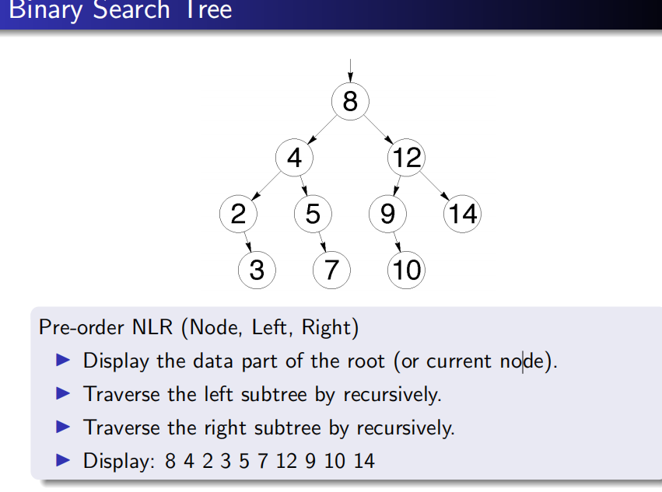
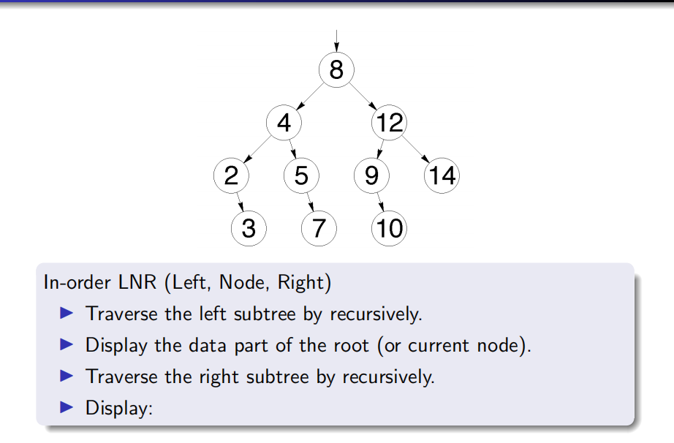
2 - 3 - 4 - 5 - 7 - 8 - 9 - 10 - 12 - 14
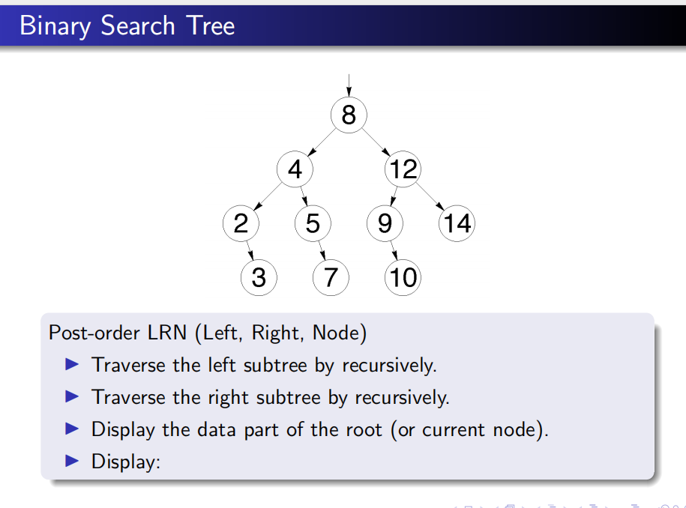
3 - 2 - 7 - 5 - 4 - 10 - 9 - 14 - 12- 8
• Start at the Root (8): Go Left to 4.
• • At Node 4: Go Left to 2.
• • At Node 2: Node 2 has no left child, so go Right to 3.
• • Process 3: It’s a leaf. Visit 3.
• • Back to 2: Left and Right are done. Visit 2.
• • Back to 4: Left is done, go Right to 5.
• • At Node 5: No left child, go Right to 7.
• • Process 7: It’s a leaf. Visit 7.
• • Back to 5: Left and Right are done. Visit 5.
• • Back to 4: Left and Right are done. Visit 4.
• • Back to 8: Left is done, go Right to 12.
• • At Node 12: Go Left to 9.
• • At Node 9: No left child, go Right to 10.
• • Process 10: It’s a leaf. Visit 10.
• • Back to 9: Left and Right are done. Visit 9.
• • Back to 12: Left is done, go Right to 14.
• • Process 14: It’s a leaf. Visit 14.
• • Back to 12: Left and Right are done. Visit 12.
• • Back to 8: Left and Right are done. Visit 8.
•

