**ScMiles 2.0 Update:**

**Restart option:**

The script is able to restart where it left off if something goes wrong and it is stopped midway through. You can either turn this on in your input file using the following

*restart True*

**Multiple Trajectories per script:**

This is a user inputted option that allows you to have multiple trajectories on each submit script for seek, sampling, and for free trajectories. I have noticed that is you use about 10 trajectories per script (assuming like 50-100 trajPerLaunch), ScMiles goes significantly faster since so many less jobs are submitted.

To use this, your input file needs something like the following line:

*traj_per_script 5,5,10*

Where there are two comma separated values. The first value is for seek and the second value is for sampling, and the third is for free trajectories. For example, with traj_per_script, your seek submit scripts will look like this:

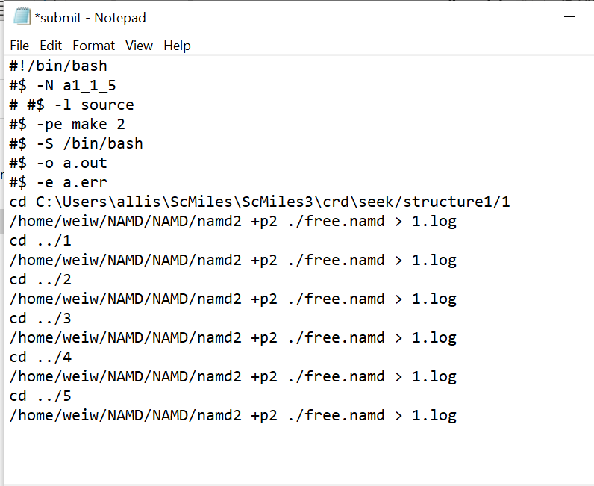

**New Milestones**

There are a few different ways that you can deal with new milestones with this version of the script. First we have the ignoreNewMS option from Wei’s version of the script. If this is turned on, it should ignore all new milestones that it finds.

I have added two other options as well.

**new_ms_iterations:** the number of iterations that the script should look for new milestones. After a certain iteration is reached, it will just start ignoring new milestones rather than continuing to find new ones. This can only be used with exact milestoning. Enter an integer for the number of iterations.

**new_ms_trajs:** It will look for new trajectories each iteration and only add milestones that were hit with a certain amount of trajectories. So if you enter ‘10’ as the value, only milestones hit with 10 or more trajectories will be kept, otherwise they are ignored. If there is an iteration where no new milestones are added, ignoreNewMS will be turned on and it will no longer look for new milestones (This can be changed, it is just how it currently works).

**Running Additional Trajectories**

**MS_list:** You can set a custom MS_list in input.txt using a comma separated value. They must be inputted like this:

MS_list MS1_2,MS4_5, MS5_7

Make sure there are no spaces in between the commas and you start each with MS.

**additional_sampling:** If you are using classic milestoning and would like to sample more thanwhat you sampled on originally, you can use this. Turn it on and adjust your numbers in input.txt accordingly. This can be used in combination with MS_list if you would like to sample only on a specific set of milestones.

**Grid Option (this option is a work in progress)**

The largest addition to the script is the addition of the Grid Option in addition to Voronoi Cell. This can be used by changing the value of the already defined parameter, milestone_search, which can equal any of the following:

0 Traverse, Voronoi Cell

1 Seek, Voronoi Cell

2 Traverse, Grid

3 Seek, Grid

**Bug Fixes**

-Small bug in compute.py, changed from standard deviation to standard deviation of the mean

-Bug fix with enhancement. There was an issue with NVT, did not work with smaller timesteps.