Changing from traditional Bayesian optimization to batched Bayesian optimization only need the change in step 2.
Here’s the flowchart of each iteration in batched Bayesian optimization:
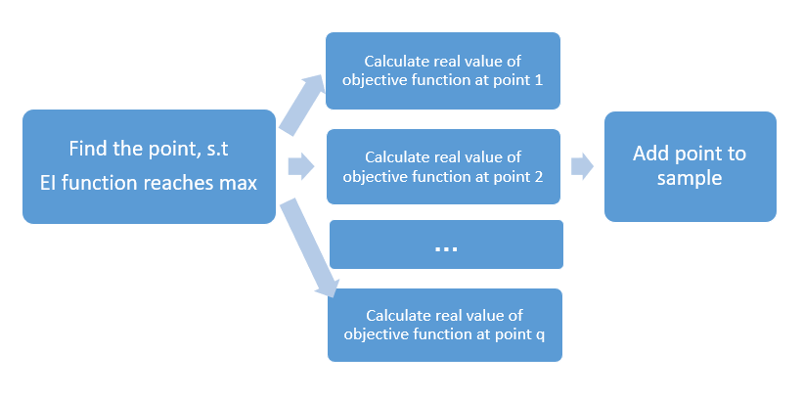
In step 2, we select a batch of points at one time (suppose the batch size is q), and calculate them in parallel, then in step 3, we add q points to the sample at each iteration.

Chapter 3
Delivery
This chapter will cover the implementation of three algorithms, as well as the experiments.
The author decided to apply three popular algorithms on five existing functions, and find the minimum value of them, in order to compare the performances.

Function name | Num of dimensions | Minimum value
Sixhump | 2 | -1.0316
Sasena | 2 | 1.4565
Ellipsoid | 10 | 0
Rosenbrock | 20 | 0
Ackley | 50 | 0
Figure 3.1 Different functions with their minimum value and number of dimensions for testing

To reduce the occasionality, the following efforts were made:
1. Used functions with mathematical expression, instead of black box functions. As for these functions, we already know their minimum value and it will be convenient for us to analyzing their performance.
2. Used sample points with different number of dimensions.
3. As sample points are selected randomly, which will affect the input data, the author conducted each experiment for 10 times, and calculate the average value of outcomes.
Knowing that larger batch size will improve the performance, for each algorithm, the author set the batch size to be 1,2,4,8, and made experiments separately.
The testing process of each algorithm including the following process:
1. Before testing, upper and lower bound of the function was set. Then the author set dimension of the random dataset to be selected. The threshold number to stop iteration was set to 20.
2. Selecting sample points: as this is a controlled experiment, we need to omit the influence of irrelevant variables. Thus, for each algorithm, the same method, Latin hypercube sampling (LHS) was applied.
3. Apply the Matlab Kriging toolbox, where zero order polynomial was used as regression model, and gaussian kernel (as mentioned in 2.1.3) was used as kernel function.
4. In each iteration, apply different algorithms to select a batch of points, and update the model.
5. Repeat step 4 until the number of iteration reaches its maximum.

3.1 Multi-model Expected Improvement
From Chapter 2, we know that the promising point is the point where Experiment Improvement function reaches its maximum. Thus, to select a batch of (q) points at one iteration, we can select the top q points where EI function reaches its top q maximum value. And from figure 2.4, we noticed that EI function has many local maximum values (see below).
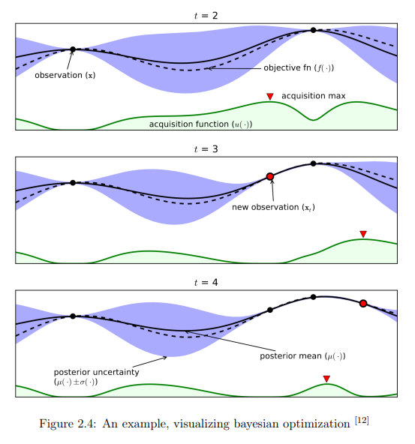
This kind of shape brings the idea that when searching the next point to be evaluated, we can exclude the “peak” whose local maximum was selected, and only search other peaks.
To implement this idea, an algorithm was developed: to set a constraint at the first “peak”, and ignore points within the constraint when searching. From pre-existing works, we know that there is an relationship between constraint and difference between lower and upper bound:
Constraint = θ (upperbound – lower bound) (12)
The author tried θ to be 0.001, 0.0001, 0.00001 on each function, and found out that, the optimal θ was 0.001.
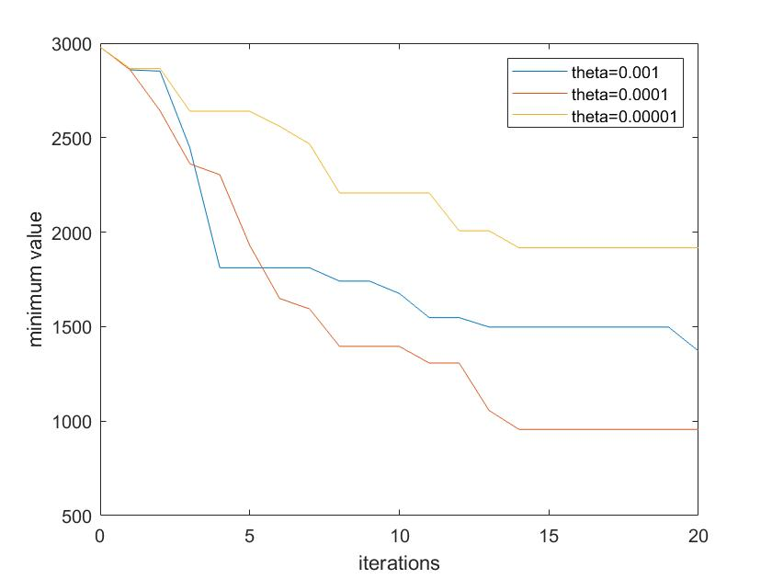
Figure 3.2 Trying different theta on function Rosenbrock

3.2 Kriging Believer
4. In each iteration, apply different algorithms to select a batch of points, and update the model.
5. Repeat step 4 until the number of iteration reaches its maximum.
3.3 Constant Liar

Reference:
[1] 2016-05-10, Playtypus Innovation. A Simple Intro to Gaussian Process (a great data modeling tool) [Online]. [Accessed Oct.29 2020]. Available from: http://platypusinnovation.blogspot.com/2016/05/a-simple-intro-to-gaussian-processes.html
[2] YANSONG, 2019, Zhihu, 14 July. A Popular understanding of Gaussian process and its application (in Chinese) [Online]. [Accessed Nov.6 2020]. Avaliable from: https://zhuanlan.zhihu.com/p/262907455
[3] Barber, David (2012). Bayesian Reasoning and Machine Learning. Cambridge University Press. ISBN 978-0-521-51814-7. [Accessed Nov.17 2020]
[4] Rasmussen, C.E.; Williams, C.K.I (2006). Gaussian Processes for Machine Learning. MIT Press. ISBN 978-0-262-18253-9. [Accessed Nov.17 2020]
[5] By Cdipaolo96 - Own work, CC BY-SA 4.0, [Online]. [Accessed April 16, 2021]. Avaliable from: https://commons.wikimedia.org/w/index.php?curid=47589433
[6] Caiyuan, 2019, Zhihu, 13 Oct. Gaussian Process and Bayesian Optimization (in Chinese). [Online]. [Accessed April 16, 2021] Available from: https://zhuanlan.zhihu.com/p/86386926
[7] Eric Schulz, Maarten Speekenbrink, Andreas Krause, A tutorial on Gaussian process regression: Modelling, exploring, and exploiting functions, Journal of Mathematical Psychology, Volume 85, 2018, Page 3, ISSN 0022-2496 [Accessed April 18, 2021]
[8] Martin Krasser, 2018, Bayesian Optimization [Online]. [Accessed April 18, 2021] Available from: http://krasserm.github.io/2018/03/21/bayesian-optimization/
[9] Gao Peng, 2019, ggaoooopennnggg, 14 Oct. Using GP model in Bayesian Optimization [Online]. [Accessed April 18, 2021] Available from: https://ggaaooppeenngg.github.io/zh-CN/2019/10/14
[10] Yeliang Fan, 2020, YeBlog, Feb 6. Bayesian Optimization (in Chinese) [Online]. [Accessed April 22, 2021]https://leovan.me/cn/2020/06/bayesian-optimization/
[11] Mockus, J. B., & Mockus, L. J. (1991). Bayesian approach to global optimization and application to multiobjective and constrained problems. Journal of Optimization Theory and Applications, 70(1), 157-172.
[12] picture on Bayesian Optimization [Online]. [Accessed April 22, 2021] Available from: https://miro.medium.com/max/3074/1*PhKGj_bZlND8IEfII426wA.png

