A MINI PROJECT REPORT ON
ATTENDANCE TRACKER
A Python-Based Attendance Management System
Submitted by
MILIN MATHUR
Registration No.: [Enter Registration Number]
Under the guidance of
[Faculty Guide Name, Designation]
Bachelor of Technology
Computer Science and Engineering (AI/ML)
First Year
VIT Bhopal University
Bhopal, Madhya Pradesh, India
Academic Year 2026–27

Declaration
I, Milin Mathur, hereby declare that the project report entitled “Attendance Tracker: A Python-Based Attendance Management System” is a record of original work carried out by me as part of my first-year B.Tech programme at VIT Bhopal University. The work has not been submitted, in part or in full, to any other institution or university for the award of any degree, diploma or certificate.
All sources of help and reference material used in this project have been duly acknowledged.

Place: Bhopal
Date: [DD/MM/YYYY]
Milin Mathur
(Signature)

Acknowledgement
I would like to express my sincere gratitude to my faculty guide, [Faculty Guide Name], for the guidance, encouragement and valuable feedback provided throughout the development of this project.
I am also thankful to VIT Bhopal University and the Department of Computer Science and Engineering for providing the learning environment and resources needed to complete this work. Finally, I thank my family and friends for their constant support.
Milin Mathur

Abstract
Keeping accurate attendance records is an important administrative task in every educational institution, especially where a minimum attendance percentage is required to become eligible for examinations. Maintaining such records manually in paper registers is time-consuming, error-prone and makes percentage calculation tedious.
This project presents Attendance Tracker, a lightweight attendance management system developed in Python. The application allows a user to add and remove students, record daily attendance as Present or Absent for any date, view the attendance history of an individual student, and generate a summary report showing each student’s attendance percentage. Students whose attendance falls below the 75% threshold are automatically flagged. All data is stored persistently in a JSON file, so no external database or third-party library is required.
The system was first built as a menu-driven terminal application and was later extended with a graphical user interface using Python’s built-in Tkinter library. Both versions share the same data file. The project demonstrates the practical use of core Python concepts such as functions, dictionaries, file handling, exception handling, input validation and GUI programming.
Keywords: Python, Attendance Management, JSON, Tkinter, File Handling
Table of Contents

Chapter 1: Introduction

1.1 Background
Attendance is a key indicator of student participation and is closely linked to academic performance. Most universities require students to maintain a minimum attendance, commonly 75%, to be allowed to appear in examinations. Teachers and class representatives therefore need a reliable way to record attendance every day and to calculate the percentage for each student.
In many classrooms this is still done with paper registers or ad-hoc spreadsheets. As the number of students and the number of classes grow, these methods become difficult to manage and the chance of calculation errors increases.

1.2 Problem Statement
Manual attendance registers require repeated arithmetic to find each student’s percentage, make it hard to look up the history of one student, and offer no automatic warning when a student’s attendance drops below the required limit. A simple, free and easy-to-use software tool is needed to record attendance and calculate percentages automatically.

1.3 Objectives
- To design a simple program that records daily attendance (Present/Absent) for a list of students.
- To calculate each student’s attendance percentage automatically.
- To flag students whose attendance is below the minimum required percentage (75%).
- To store data permanently so that records are available the next time the program is run.
- To validate user input so that invalid dates, names and choices do not corrupt the records.
- To provide both a terminal interface and a graphical interface for the same data.

1.4 Scope of the Project
The project covers a single class or group of students. It supports adding and removing students, marking attendance for any valid date, viewing the complete history of one student, and generating a summary report. The following are outside the scope of the current version: multiple users or login, subject-wise attendance, biometric or automatic attendance capture, and integration with a central database.

Chapter 2: System Analysis

2.1 Existing System
The existing approach in most classes is a paper attendance register or a manually maintained spreadsheet. Its main drawbacks are:
- Percentages must be calculated by hand or by writing formulas.
- Records can be lost, damaged or altered.
- Finding the attendance history of one student requires searching through many pages.
- There is no automatic alert for students with low attendance.

2.2 Proposed System
The proposed system is a Python application that automates recording, calculation and reporting. Data is saved in a JSON file after every change, percentages are computed on demand from the stored records, and students below the threshold are labelled LOW in the report. The program needs only a standard Python installation and no extra libraries.

2.3 Feasibility Study
Type | Assessment
Technical | Feasible. Uses only Python standard-library modules (json, os, datetime, tkinter) and runs on any operating system with Python installed.
Economic | Highly feasible. All tools used are free and open source, and no special hardware is needed.
Operational | Feasible. The menu-driven interface and the GUI are simple enough for a teacher or student to use without training.

Chapter 3: Requirement Specification

3.1 Hardware Requirements
Component | Requirement
Processor | Any modern dual-core processor
RAM | 2 GB minimum (4 GB recommended)
Storage | Less than 50 MB of free disk space
Display | Standard monitor or laptop screen

3.2 Software Requirements
Component | Requirement
Operating System | Windows, Linux or macOS
Language | Python 3.7 or later
Libraries | json, os, datetime (standard library); tkinter (for the GUI version)
Development Environment | Jupyter Notebook, or any Python IDE / terminal
Data Storage | JSON file (attendance.json)

3.3 Functional Requirements
ID | Requirement
FR1 | The system shall allow the user to add a new student; duplicate and empty names shall be rejected.
FR2 | The system shall allow the user to mark each student Present or Absent for a chosen date (default: today).
FR3 | The system shall reject dates that are not in the YYYY-MM-DD format.
FR4 | The system shall calculate and display each student’s attendance percentage.
FR5 | The system shall flag students whose percentage is below 75% as LOW.
FR6 | The system shall display the date-wise attendance history of a selected student.
FR7 | The system shall allow the user to remove a student and all of his or her records.
FR8 | The system shall save all data to a file and reload it on the next start.

3.4 Non-Functional Requirements
- Usability: clear menus, prompts and messages.
- Reliability: data is written to disk after each change, so a crash does not lose earlier records.
- Portability: runs on any platform that supports Python.
- Performance: responds instantly for classes of typical size.
- Maintainability: each operation is a separate function, which makes the code easy to modify and extend.

Chapter 4: System Design

4.1 System Architecture
The system follows a simple three-layer structure. The presentation layer (terminal menu or Tkinter window) collects input and shows output. The application logic layer contains the functions that perform each operation. The data layer is the JSON file in which all records are stored.
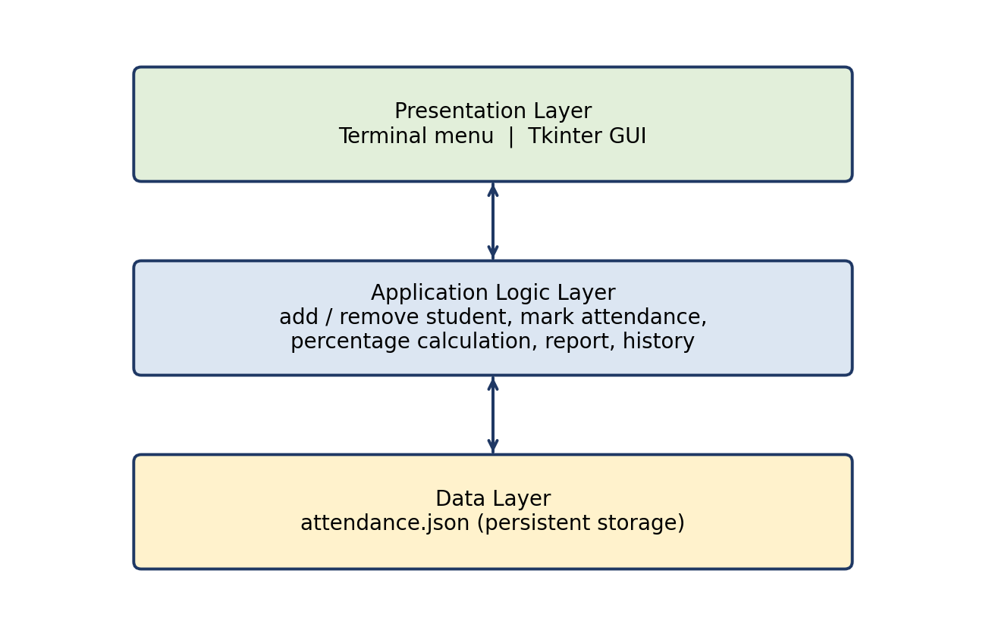
Figure 4.1: Layered architecture of the Attendance Tracker

4.2 Program Flow
When the program starts it loads the saved data and then repeatedly displays the menu. The chosen operation is executed, any changes are saved to the file, and the menu is shown again until the user selects Exit.
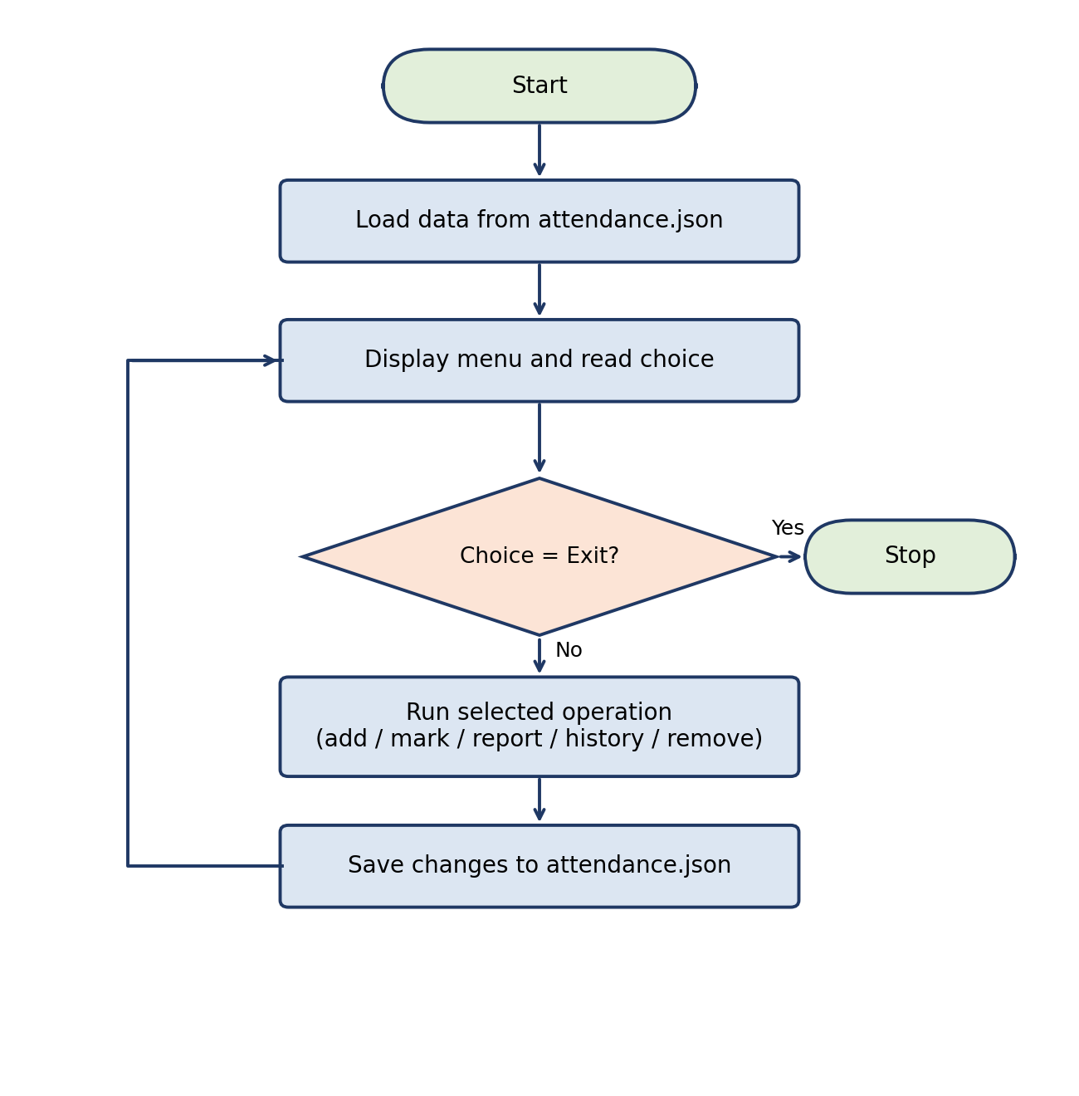
Figure 4.2: Flowchart of the main program loop

4.3 Data Design
All data is held in a Python dictionary and stored as JSON. Each key is a student’s name and its value is another dictionary that maps a date (in ISO format) to a status: “P” for Present or “A” for Absent. This structure makes it easy to add a new date for every student and to count the records of one student.
{
"Aarav Sharma": {
"2026-09-21": "P",
"2026-09-22": "P"
},
"Priya Verma": {
"2026-09-21": "P",
"2026-09-22": "A"
}
}
Figure 4.3: Structure of attendance.json

4.4 Module Description
Function | Purpose
load_data() | Reads attendance.json and returns the data; returns an empty dictionary if the file does not exist.
save_data(data) | Writes the current data to attendance.json in a readable, indented format.
add_student(data) | Reads a name, formats it in title case, rejects empty or duplicate names, and adds the student.
mark_attendance(data) | Reads a date, validates it, and asks Present/Absent for every student.
percentage(records) | Returns (number of Present days ÷ total days) × 100 for one student.
show_report(data) | Prints a table of present days, total days, percentage and OK/LOW status.
student_history(data) | Prints the date-wise status of one student in chronological order.
remove_student(data) | Deletes a student and all of his or her records.
main() | Runs the menu loop and calls the selected function.

4.5 Attendance Percentage Calculation
The attendance percentage of a student is calculated as:
Attendance % = (Days Present ÷ Total Days Recorded) × 100
A student is marked OK if this value is greater than or equal to the minimum limit (MIN_PERCENT = 75) and LOW otherwise. The limit is stored in a single constant at the top of the program so that it can be changed easily.

Chapter 5: Implementation

5.1 Tools and Technologies
- Python: core programming language.
- json module: serialising the dictionary to a file and loading it back.
- os module: checking whether the data file already exists.
- datetime module: obtaining today’s date and validating user-entered dates.
- tkinter module: building the graphical interface.

5.2 Data Persistence
The functions load_data() and save_data() handle storage. If the file is missing on the first run, an empty dictionary is used. After every add, mark or remove operation, save_data() is called so that the file always reflects the latest state.
def load_data():
if os.path.exists(DATA_FILE):
with open(DATA_FILE, "r") as f:
return json.load(f)
return {}

def save_data(data):
with open(DATA_FILE, "w") as f:
json.dump(data, f, indent=2)

5.3 Input Validation
Validation is applied at every point where the user enters data. Names are stripped of extra spaces and converted to title case, so “aarav sharma” and “Aarav Sharma” are treated as the same student. Dates are checked with date.fromisoformat(), which raises a ValueError for invalid values such as 2026-13-45; this is caught and reported without stopping the program. The Present/Absent prompt repeats until the user types p or a, and an invalid menu option displays an error message.
try:
date.fromisoformat(day)
except ValueError:
print("Invalid date format.")
return

5.4 Marking Attendance
mark_attendance() first asks for a date; pressing Enter uses today’s date. It then loops over every student and stores “P” or “A” under that date. Because the date is used as a dictionary key, marking the same date again simply overwrites the earlier entry, which allows mistakes to be corrected.

5.5 Report Generation
show_report() goes through every student, counts the Present entries, computes the percentage using percentage(), and prints a formatted table. Students below MIN_PERCENT receive the label LOW.
def percentage(records):
if not records:
return 0.0
present = sum(1 for s in records.values() if s == "P")
return present / len(records) * 100

5.6 Graphical User Interface (Tkinter)
The GUI version is implemented as a class named AttendanceApp in a separate file and uses the same attendance.json file as the terminal version. Its main features are:
- A table (ttk.Treeview) listing every student with today’s status, days present, total days and percentage.
- Double-clicking a row toggles the student between Present and Absent for the selected date.
- Rows of students below 75% are highlighted in red.
- Buttons for Add Student, Remove Student, Save Attendance and Refresh; dialogs from simpledialog and messagebox confirm actions and report errors.
Screenshot of the GUI: [Run attendance_tracker_gui.py, take a screenshot and insert it here as Figure 5.1]

Chapter 6: Testing

6.1 Testing Approach
The terminal application was tested manually using black-box functional testing. Each function was run with valid input and with invalid or boundary input, and the actual behaviour was compared with the expected behaviour.

6.2 Test Cases
ID | Test | Input | Expected Output | Result
T1 | Mark attendance with no students | Menu 2 | “No students yet. Add some first.” | Pass
T2 | Add student with empty name | Menu 1, blank | “Name can’t be empty.” | Pass
T3 | Add a valid student | Aarav Sharma | “Added Aarav Sharma.” | Pass
T4 | Add duplicate (different case) | aarav sharma | “Aarav Sharma already exists.” | Pass
T5 | Invalid date | 2026-13-45 | “Invalid date format.” | Pass
T6 | Invalid status, then valid | x, then p | Prompt repeats; saved for today | Pass
T7 | History of unknown student | Nobody | “Student not found.” | Pass
T8 | History of existing student | Aarav Sharma | Date-wise status listed | Pass
T9 | Remove unknown student | Nobody | “Student not found.” | Pass
T10 | Remove existing student | Aarav Sharma | “Removed Aarav Sharma.” | Pass
T11 | Invalid menu option | 9 | “Invalid choice.” | Pass
T12 | Low attendance flag | 1 of 4 days present | 25.0% shown with status LOW | Pass

Chapter 7: Results and Discussion
To demonstrate the system, three students were added and attendance was recorded for four consecutive days. Aarav Sharma was present on three days, Priya Verma on one day, and Rohan Gupta on all four. The report generated by the program is shown below.
Name Present Total % Status
-------------------------------------------------------
Aarav Sharma 3 4 75.0 OK
Priya Verma 1 4 25.0 LOW
Rohan Gupta 4 4 100.0 OK
Figure 7.1: Attendance report generated by the program
The report shows that Aarav Sharma has exactly 75.0% and is therefore marked OK, since the condition is “greater than or equal to” the limit. Priya Verma, with 25.0%, is marked LOW. The history option for Priya Verma produced the following output:
2026-09-21: Present
2026-09-22: Absent
2026-09-23: Absent
2026-09-24: Absent
Figure 7.2: Attendance history of one student
All twelve test cases passed. The program handled invalid dates, empty and duplicate names, unknown students and invalid menu choices without crashing, and the data was correctly stored in and reloaded from attendance.json.

Chapter 8: Limitations and Future Scope

8.1 Limitations
- Only one class or group can be managed per data file.
- Attendance is not separated by subject or lecture period.
- There is no login system, so anyone with access to the file can change the records.
- JSON file storage is suitable for small classes but not for very large amounts of data or many simultaneous users.
- Attendance is entered manually; there is no export to CSV or Excel.

8.2 Future Scope
- Subject-wise and period-wise attendance.
- Exporting reports to CSV or Excel using the pandas library.
- Replacing the JSON file with a database such as SQLite or MySQL.
- User authentication for teachers and read-only access for students.
- Charts showing attendance trends, using matplotlib.
- Automatic email or SMS alerts to students whose attendance drops below 75%.
- Automatic attendance capture using face recognition, which can be built with machine-learning libraries.

Chapter 9: Conclusion
The Attendance Tracker project successfully meets its objectives. It replaces the manual register with a simple program that records attendance, calculates percentages automatically, flags students with low attendance and stores everything permanently. The use of only standard-library modules keeps the tool easy to install and run anywhere.
Developing the project gave practical experience with functions, dictionaries, file handling, exception handling, input validation and GUI programming in Python. The layered, function-based design also makes it easy to extend the system with the improvements listed in the future scope.

References
[1] Python Software Foundation, “json — JSON encoder and decoder,” Python 3 Documentation. https://docs.python.org/3/library/json.html
[2] Python Software Foundation, “datetime — Basic date and time types,” Python 3 Documentation. https://docs.python.org/3/library/datetime.html
[3] Python Software Foundation, “tkinter — Python interface to Tcl/Tk,” Python 3 Documentation. https://docs.python.org/3/library/tkinter.html

Appendix A: Source Code (Terminal Version)
import json
import os
from datetime import date

DATA_FILE = "attendance.json"
MIN_PERCENT = 75 # minimum attendance required

def load_data():
if os.path.exists(DATA_FILE):
with open(DATA_FILE, "r") as f:
return json.load(f)
return {} # {student_name: {"2026-09-21": "P", ...}}

def save_data(data):
with open(DATA_FILE, "w") as f:
json.dump(data, f, indent=2)

def add_student(data):
name = input("Student name: ").strip().title()
if not name:
print("Name can't be empty.")
elif name in data:
print(f"{name} already exists.")
else:
data[name] = {}
save_data(data)
print(f"Added {name}.")

def mark_attendance(data):
if not data:
print("No students yet. Add some first.")
return

day = input("Date (YYYY-MM-DD, press Enter for today): ").strip()
if not day:
day = str(date.today())
else:
try:
date.fromisoformat(day)
except ValueError:
print("Invalid date format.")
return

for name in data:
while True:
status = input(f"{name} - Present or Absent? (p/a): ").strip().upper()
if status in ("P", "A"):
data[name][day] = status
break
print("Please type p or a.")

save_data(data)
print(f"Attendance saved for {day}.")

def percentage(records):
if not records:
return 0.0
present = sum(1 for s in records.values() if s == "P")
return present / len(records) * 100

def show_report(data):
if not data:
print("No data yet.")
return

print(f"\n{'Name':<20}{'Present':<10}{'Total':<8}{'%':<8}Status")
print("-" * 55)
for name, records in data.items():
present = sum(1 for s in records.values() if s == "P")
total = len(records)
pct = percentage(records)
status = "OK" if pct >= MIN_PERCENT else "LOW"
print(f"{name:<20}{present:<10}{total:<8}{pct:<8.1f}{status}")

def student_history(data):
name = input("Student name: ").strip().title()
if name not in data:
print("Student not found.")
return
if not data[name]:
print("No records yet.")
return
for day in sorted(data[name]):
label = "Present" if data[name][day] == "P" else "Absent"
print(f"{day}: {label}")

def remove_student(data):
name = input("Student to remove: ").strip().title()
if name in data:
del data[name]
save_data(data)
print(f"Removed {name}.")
else:
print("Student not found.")

def main():
data = load_data()
actions = {
"1": ("Add student", add_student),
"2": ("Mark attendance", mark_attendance),
"3": ("Attendance report", show_report),
"4": ("Student history", student_history),
"5": ("Remove student", remove_student),
}

while True:
print("\n=== Attendance Tracker ===")
for key, (label, _) in actions.items():
print(f"{key}. {label}")
print("6. Exit")

choice = input("Choose: ").strip()
if choice == "6":
print("Bye!")
break
elif choice in actions:
actions[choice][1](data)
else:
print("Invalid choice.")

if __name__ == "__main__":
main()

Appendix B: Source Code (GUI Version)
import json
import os
import tkinter as tk
from tkinter import ttk, messagebox, simpledialog
from datetime import date

DATA_FILE = "attendance.json"
MIN_PERCENT = 75

def load_data():
if os.path.exists(DATA_FILE):
with open(DATA_FILE, "r") as f:
return json.load(f)
return {}

def save_data(data):
with open(DATA_FILE, "w") as f:
json.dump(data, f, indent=2)

class AttendanceApp:
def __init__(self, root):
self.root = root
self.root.title("Attendance Tracker")
self.root.geometry("650x450")

self.data = load_data()

# ---- Top frame: date + actions ----
top = ttk.Frame(root, padding=10)
top.pack(fill="x")

ttk.Label(top, text="Date:").pack(side="left")
self.date_var = tk.StringVar(value=str(date.today()))
ttk.Entry(top, textvariable=self.date_var, width=12).pack(side="left", padx=5)

ttk.Button(top, text="Add Student", command=self.add_student).pack(side="left", padx=5)
ttk.Button(top, text="Remove Student", command=self.remove_student).pack(side="left", padx=5)
ttk.Button(top, text="Save Attendance", command=self.save_attendance).pack(side="left", padx=5)
ttk.Button(top, text="Refresh", command=self.refresh_table).pack(side="left", padx=5)

# ---- Table ----
columns = ("name", "status", "present", "total", "percent")
self.tree = ttk.Treeview(root, columns=columns, show="headings", height=15)
headings = {
"name": "Name",
"status": "Today",
"present": "Present",
"total": "Total",
"percent": "%",
}
widths = {"name": 150, "status": 80, "present": 70, "total": 60, "percent": 60}
for col in columns:
self.tree.heading(col, text=headings[col])
self.tree.column(col, width=widths[col], anchor="center")
self.tree.pack(fill="both", expand=True, padx=10, pady=10)

# store per-row status toggles in memory
self.today_status = {}

self.tree.bind("<Double-1>", self.toggle_status)

self.refresh_table()

def refresh_table(self):
self.tree.delete(*self.tree.get_children())
for name, records in self.data.items():
present = sum(1 for s in records.values() if s == "P")
total = len(records)
pct = (present / total * 100) if total else 0.0
status = self.today_status.get(name, "P")
tag = "low" if pct < MIN_PERCENT and total else ""
self.tree.insert("", "end", iid=name,
values=(name, status, present, total, f"{pct:.1f}"),
tags=(tag,))
self.tree.tag_configure("low", background="#ffdddd")

def toggle_status(self, event):
item = self.tree.identify_row(event.y)
if not item:
return
current = self.today_status.get(item, "P")
self.today_status[item] = "A" if current == "P" else "P"
self.refresh_table()

def add_student(self):
name = simpledialog.askstring("Add Student", "Student name:")
if not name:
return
name = name.strip().title()
if name in self.data:
messagebox.showwarning("Duplicate", f"{name} already exists.")
return
self.data[name] = {}
save_data(self.data)
self.refresh_table()

def remove_student(self):
selected = self.tree.selection()
if not selected:
messagebox.showinfo("Select", "Click a row first to select a student.")
return
name = selected[0]
if messagebox.askyesno("Confirm", f"Remove {name}?"):
del self.data[name]
self.today_status.pop(name, None)
save_data(self.data)
self.refresh_table()

def save_attendance(self):
day = self.date_var.get().strip()
try:
date.fromisoformat(day)
except ValueError:
messagebox.showerror("Invalid date", "Use YYYY-MM-DD format.")
return

if not self.data:
messagebox.showinfo("No students", "Add some students first.")
return

for name in self.data:
status = self.today_status.get(name, "P")
self.data[name][day] = status

save_data(self.data)
messagebox.showinfo("Saved", f"Attendance saved for {day}.")
self.refresh_table()

if __name__ == "__main__":
root = tk.Tk()
app = AttendanceApp(root)
root.mainloop()

