**Overview of the Hydraulic Systems Condition Monitoring Dataset**

**Dataset Title:** Condition Monitoring of Hydraulic Systems

**Source:**

* **Link:** <https://archive.ics.uci.edu/dataset/447/condition+monitoring+of+hydraulic+systems>
* **Creator:** Nikolai Helwig, ZeMA gGmbH, Saarbrücken
* **Donors:** M. Bastuck, T. Schneider
* **Date:** April 2018

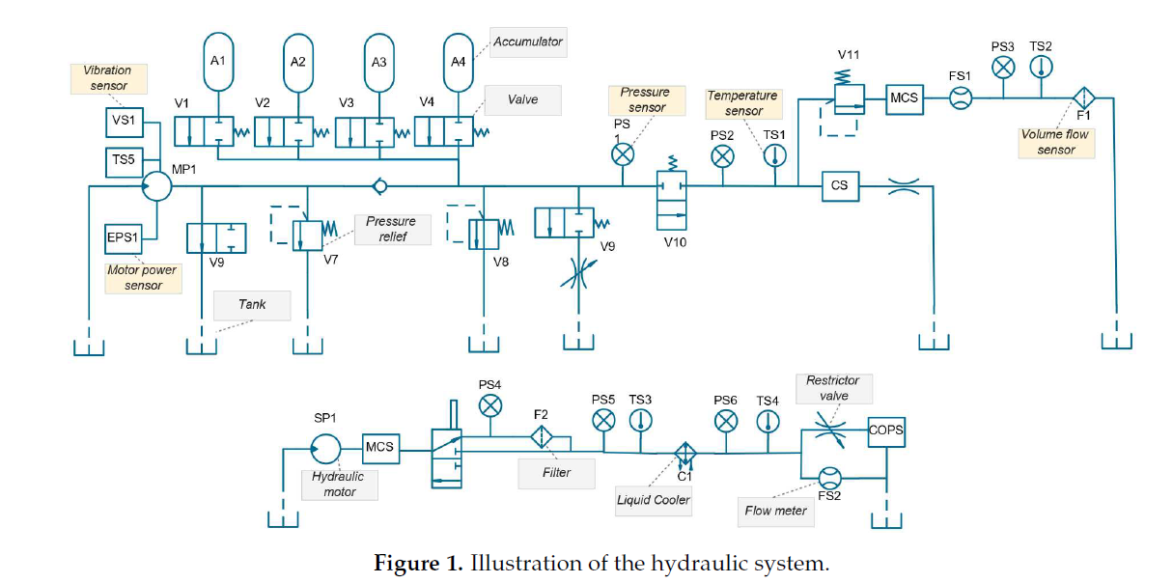

**Dataset Characteristics:**

* **Instances:** 2205
* **Attributes:** 43680, derived from sensors measuring:
  + **Pressure sensors (PS1-6):** 6000 attributes each at 100 Hz
  + **Motor power sensor (EPS1):** 6000 attributes at 100 Hz
  + **Volume flow sensors (FS1/2):** 600 attributes each at 10 Hz
  + **Temperature sensors (TS1-4):** 60 attributes each at 1 Hz
  + **Vibration sensor (VS1):** 60 attributes at 1 Hz
  + **Efficiency factor (SE), Cooling Efficiency (CE), and Cooling Power (CP):** 60 attributes each at 1 Hz

**Relevant Information:**

* **Experimental Setup:** Data was acquired using a hydraulic test rig simulating real-world conditions with both a primary working circuit and a secondary cooling-filtration circuit. The system undergoes 60-second load cycles.
* **Objective:** To monitor and predict the condition of four critical components: cooler, valve, pump, and hydraulic accumulator.

**Attribute Details:**

* Sensors measure different parameters at varying frequencies, providing a comprehensive view of the system's operational state over time.

**Past Usage:**

1. **Feature Extraction and Classification:**
   * Utilized multivariate statistics for monitoring, with automated feature extraction showing perfect classification for simpler targets like coolers and valves, but more challenging for accumulators.
   * Techniques like Pearson correlation and various classification algorithms were applied.
2. **Sensor Fault Compensation:**
   * Methods to detect and compensate for sensor drift or failure were developed, allowing for continued system monitoring.
3. **Advanced Feature Selection:**
   * Techniques like Automatic Learning Algorithms (ALA) and Recursive Feature Elimination with Support Vector Machines (RFESVM) significantly reduced classification error rates for complex components.

**Class Distribution:**

* **Cooler Condition:** Reflects efficiency degradation.
* **Valve Condition:** Indicates switching behavior degradation.
* **Pump Leakage:** Monitors internal leakage levels.
* **Hydraulic Accumulator:** Tracks pressure maintenance capability.
* **Stable Flag:** Indicates whether static conditions were achieved during measurement.

**Usage for Predictive Maintenance:**

* **Predictive Modeling:** This dataset is ideal for developing predictive models to forecast component failures or degradation.
* **Fault Detection:** The detailed sensor data allows for robust fault detection systems, which can predict when maintenance is required before a failure occurs.
* **Optimization:** By understanding component behavior under various conditions, maintenance schedules can be optimized to reduce downtime and costs.

**Relevant AI models for this dataset:**

**1. Long Short-Term Memory (LSTM):**

* **Why:** LSTMs are excellent for sequential data analysis due to their ability to remember long-term dependencies. This makes them ideal for time-series data from hydraulic systems where past states can significantly influence future conditions.
* **Application:** Predicting future component degradation or system failure based on historical sensor data patterns

**2. Gated Recurrent Unit (GRU):**

* **Why:** GRUs are simpler alternatives to LSTMs with similar capabilities in handling sequential data but with fewer parameters, making them faster to train while still capturing temporal dependencies.
* **Application:** Predicting future states of hydraulic components or detecting anomalies in system behavior over time, useful for early warning systems in maintenance.

**3. Random Forest:**

* **Why:** Random Forests are great for handling large datasets with numerous features, providing insights through feature importance, and are less prone to overfitting.
* **Application:** Classification of component health states or predicting failure types and severities.

**4. Gradient Boosting Machines (GBM) or XGBoost:**

* **Why:** These models build upon decision trees with a boosting mechanism, often yielding high accuracy and can handle missing data (if any occurs in future datasets).
* **Application:** Predicting remaining useful life of components or optimizing maintenance schedules.