SEQOME-DL: An Integrated toolkit for rapid development and optimization of Deep Learning models

Software User Guide

SEQOME

CONTENTS-

1. General Information
2. Installing the necessary libraries
3. Input formats
4. Running auto mode for neural network creation
5. Running manual mode for neural network creation
6. Running feature selection for the input files
7. Running test for new data
8. General Information

* The scripts in this repository are to be used for creation of neural network architecture for classification purposes without writing any code.
* To make it easier to use, the scripts have been deployed on command prompt.
* By following the procedures in the following sections, the user can easily.
* For further information/ improvement contact either SEQOME or Milind Choudhary([milindc02@gmail.com](mailto:milindc02@gmail.com))

1. Installing the necessary Libraries

* The scripts utilise a lot of libraries and following is a comprehensive list of the libraries:-
  1. sys
  2. tensorflow
  3. numpy
  4. keras
  5. time
  6. matplotlib
  7. pandas
  8. sklearn
  9. seaborn
  10. pathlib
  11. os
* It is necessary to have all these dependencies installed for smooth functioning of the scirpts.

1. Input Formats

* The scripts expect a universal input format of the files.
* There must be one feature file which contains id as the first columns and features in the rest of the columns.
* There should be another meta/output file with id as first column and corresponding outputs as the second column.
* Following is an image of the feature file:

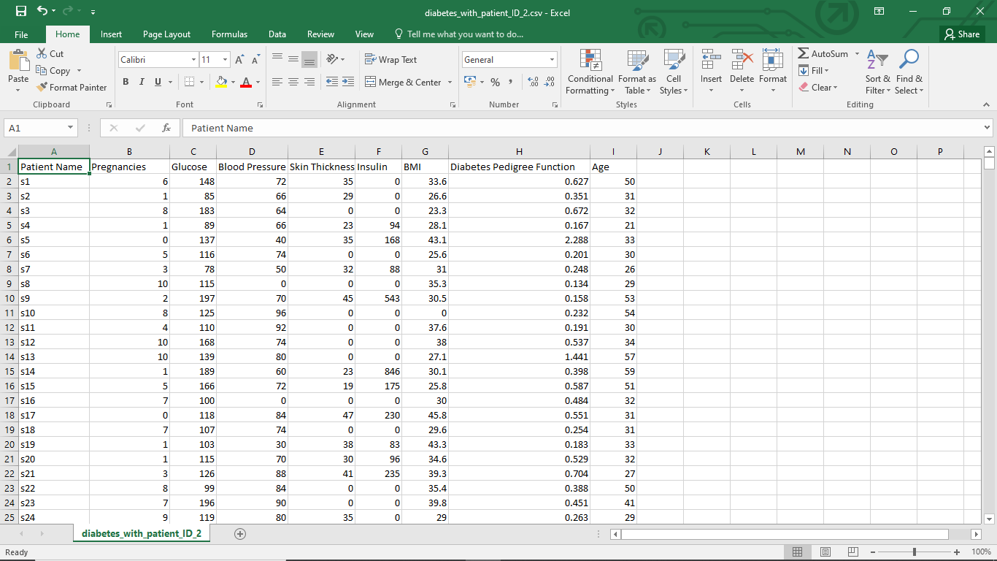

* Following is an example image of meta/output file:

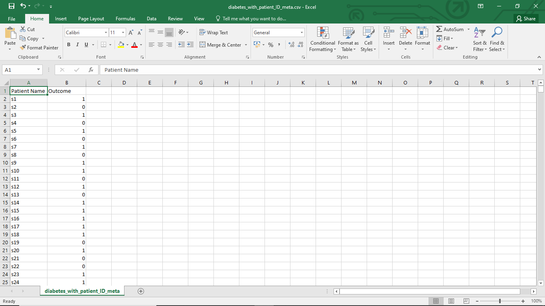

1. Running auto mode for neural network creation

* This mode is the most user friendly and the user just has to give the feature and meta/output file as input in command line to get a trained neural network architecture.
* The user need to navigate to the folder where the scripts are kept.

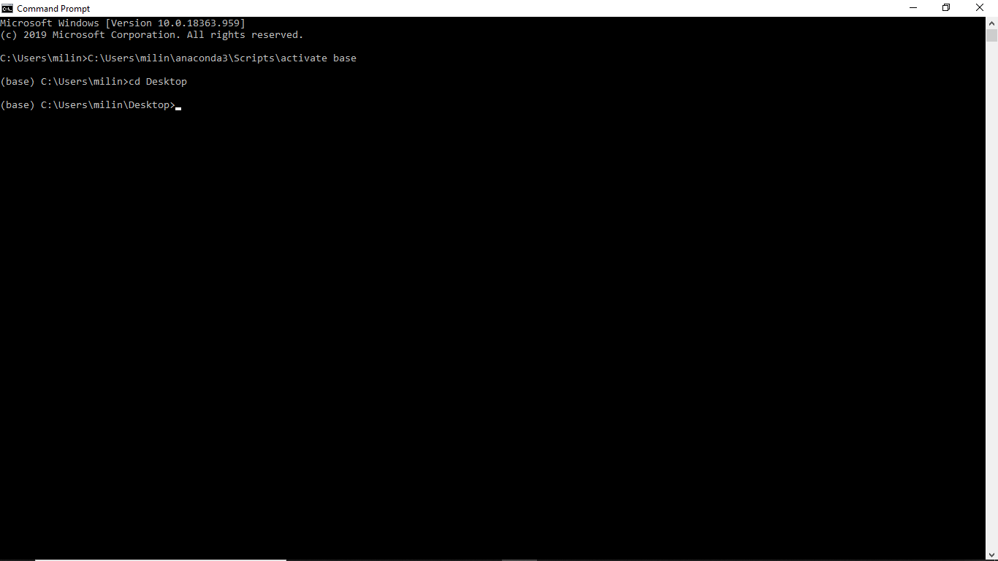

* Thereafter, the user can run the script using the python and the command has a structure like “python s_create_n_train_auto.py C:\Users\Desktop\diabetes_with_patient_ID_2.csv C:\Users\Desktop\diabetes_with_patient_ID_meta.csv”

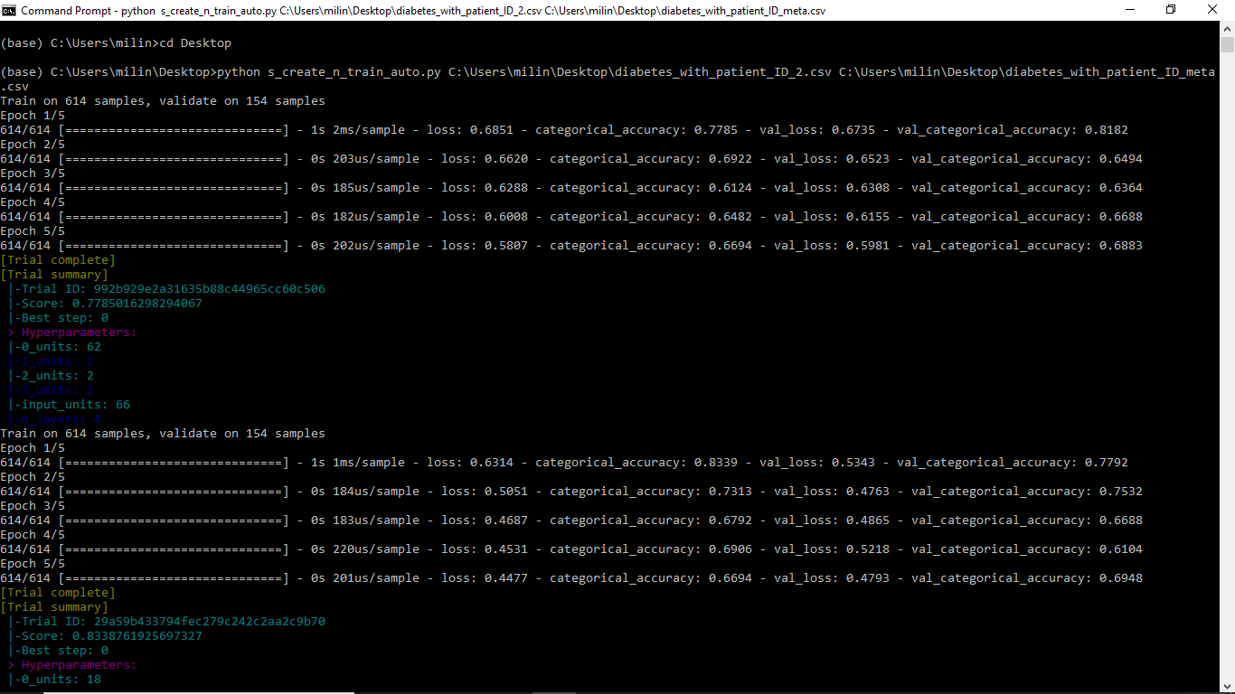

* The file will take a few minutes to run depending on the input size since it finds the most optimal neural network architecture.
* Once the training is completed, a network summary along with block diagram of network will be shown.

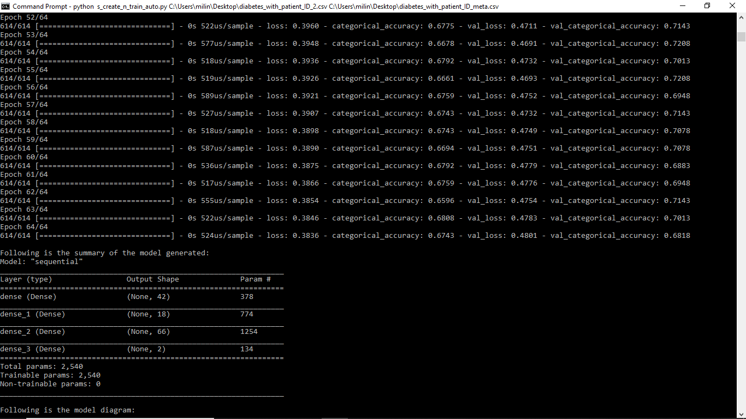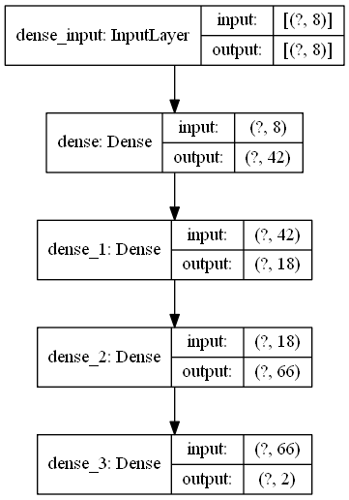

1. Running manual mode for neural network creation

* This mode is the most user interactive and the user has to give the feature and meta/output file as input in command line to get a series of prompts to create his desired neural network architecture.
* The user need to navigate to the folder where the scripts are kept.



* Thereafter, the user can run the script using the python and the command has a structure like “python s_create_n_train_man.py C:\Users\Desktop\diabetes_with_patient_ID_2.csv C:\Users\Desktop\diabetes_with_patient_ID_meta.csv”

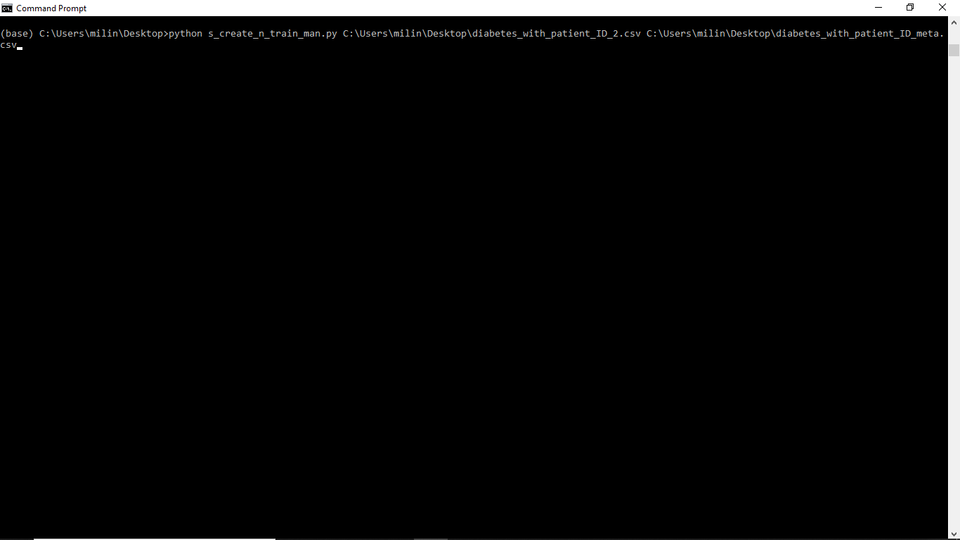

* Now prompts will be asked regarding the number of nodes, activation of the nodes and if the user wants to add another layer. The moment user selects the option that he doesn’t want to add another layer, a network summary and model diagram will be shown along with a trained neural network.

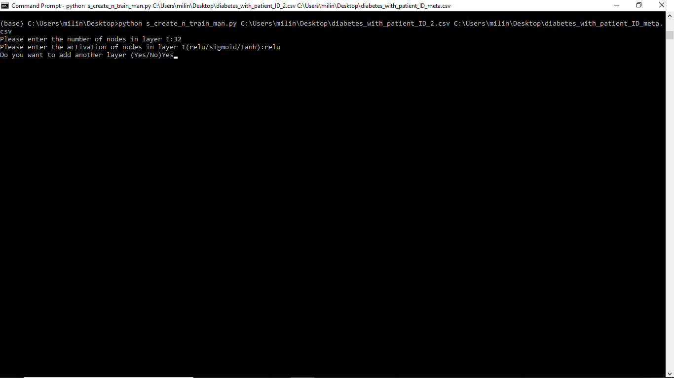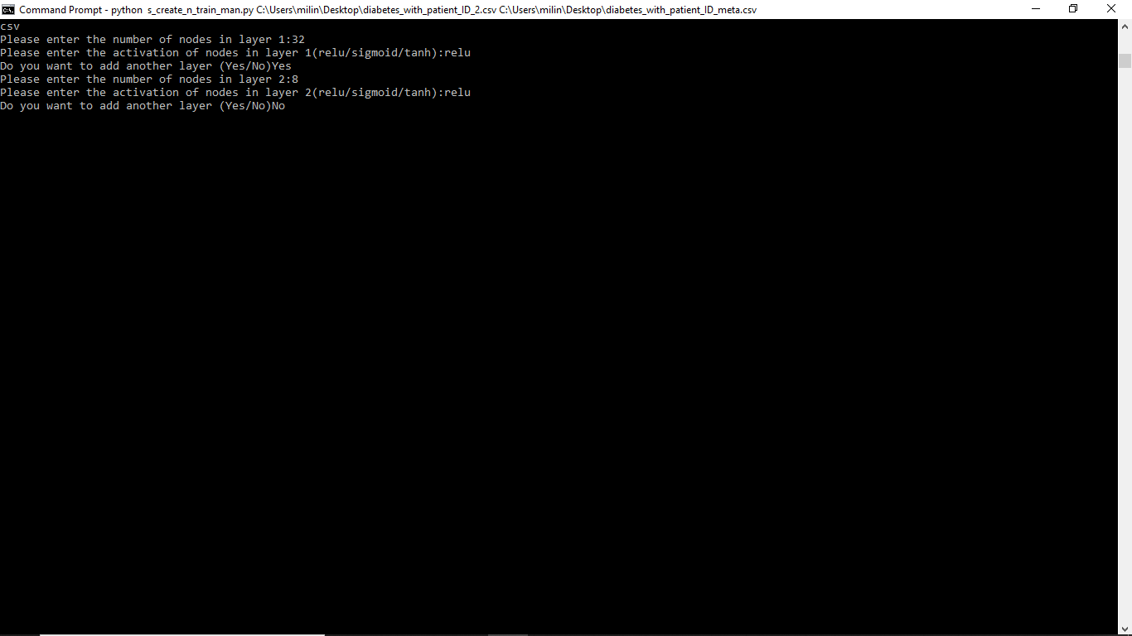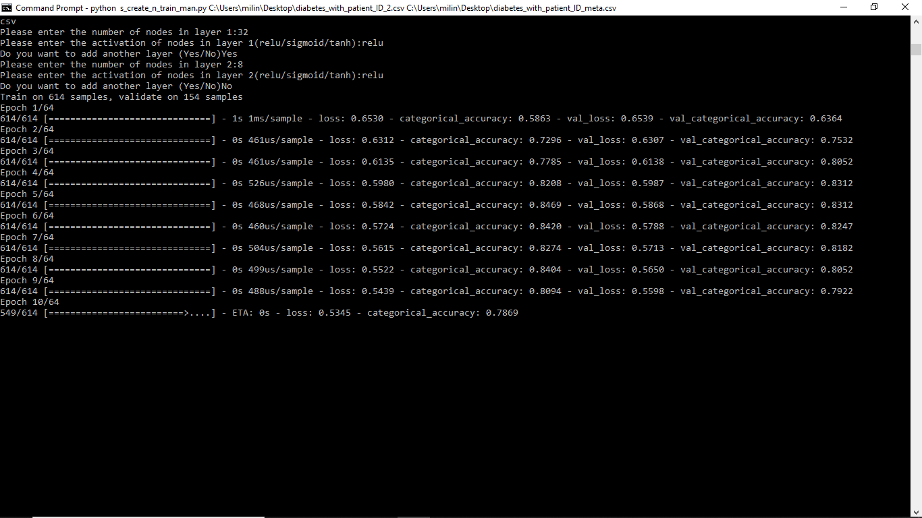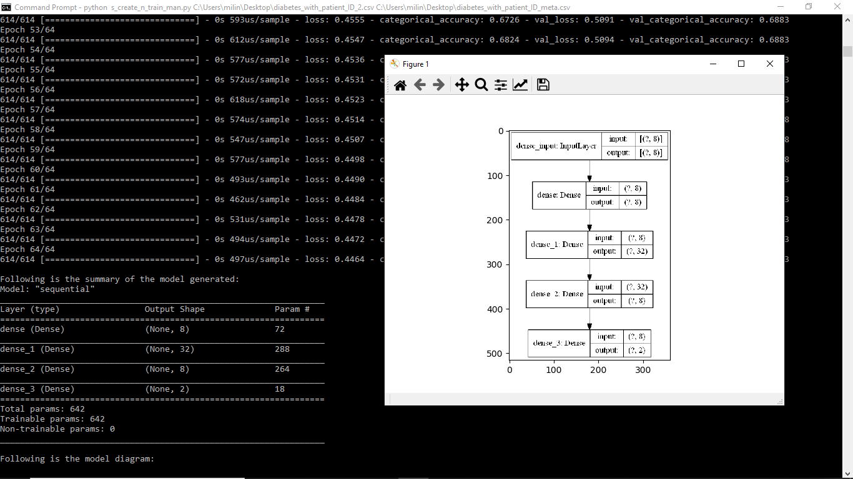

1. Running feature selection for the input files

* This mode is used to get analysis on features for feature selection and the user has to give the feature and meta/output file as input in command line to get a series of prompts to get his desired parameters for feature selection.
* It must be noted that once the user decides to alter his features, he needs to modify the input files accordingly and retrain using the auto or manual mode of network creation.
* The user need to navigate to the folder where the scripts are kept.



* Thereafter, the user can run the script using the python and the command has a structure like “python s_find_feature.py C:\Users\Desktop\diabetes_with_patient_ID_2.csv C:\Users\Desktop\diabetes_with_patient_ID_meta.csv”

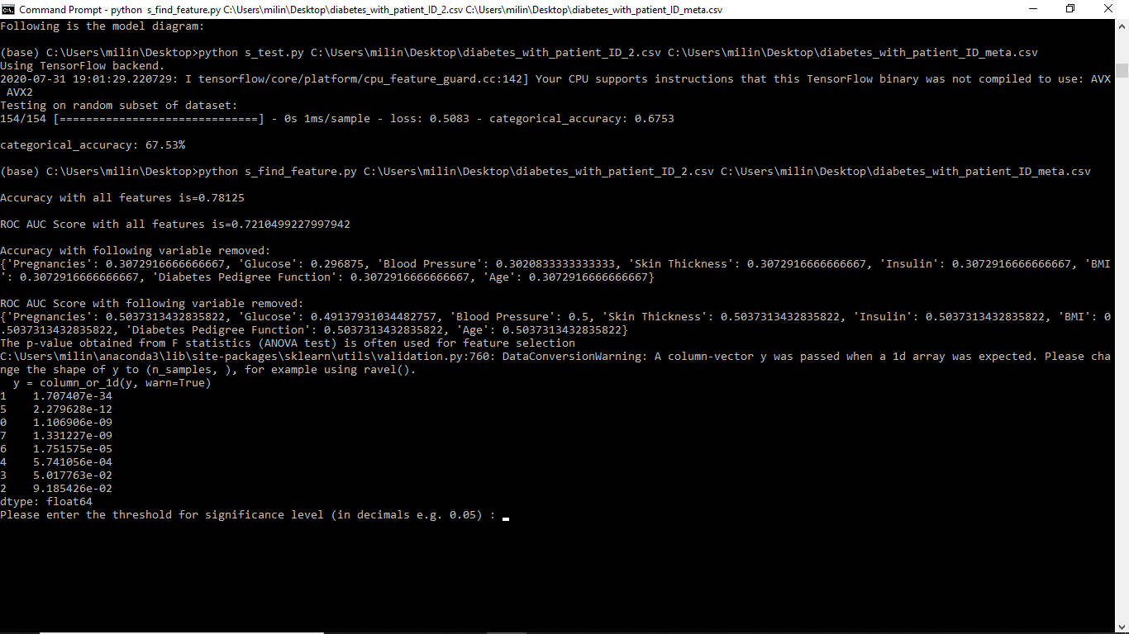

* Then the user enters the threshold value he wants for the ANOVA analysis to get the final results along with a pair plot and heat map showing the correlation in between features along with correlation between feature and output.

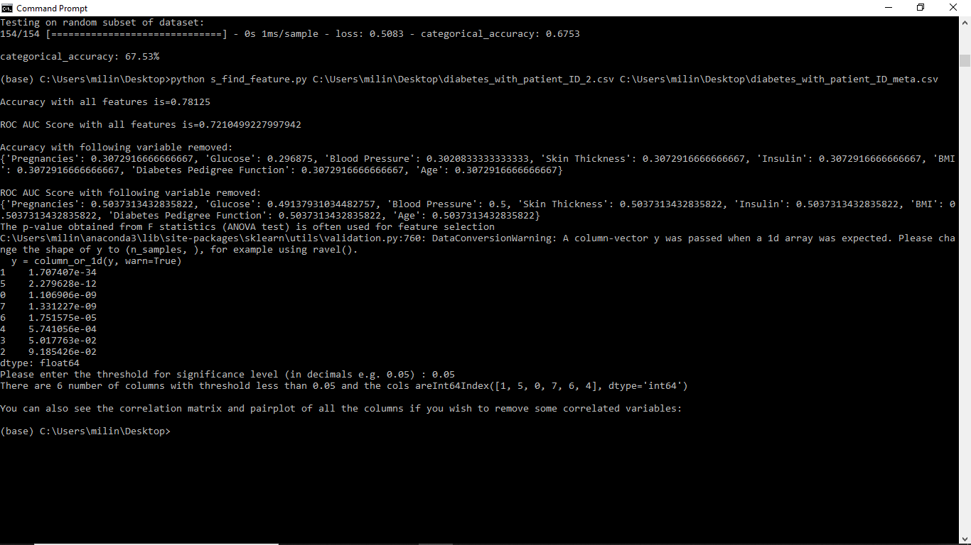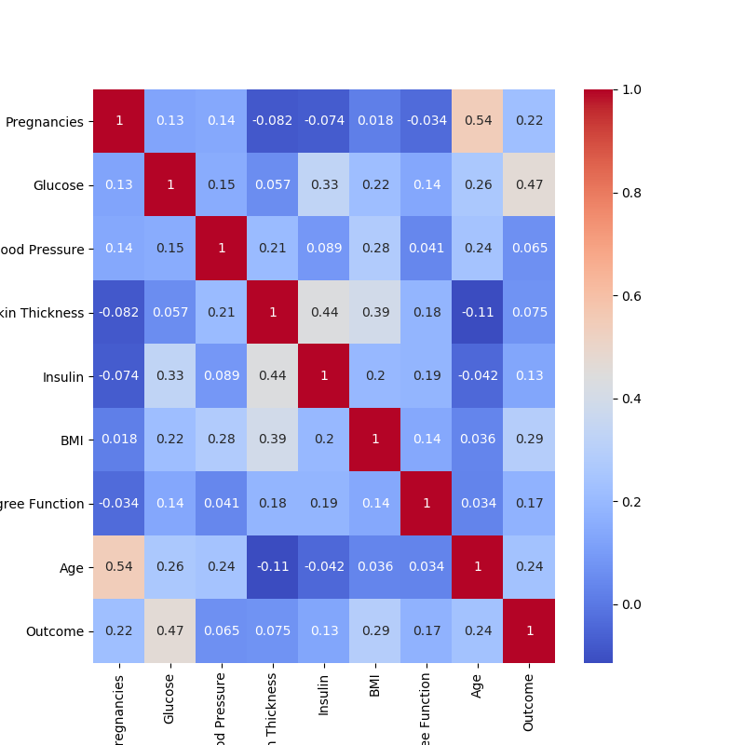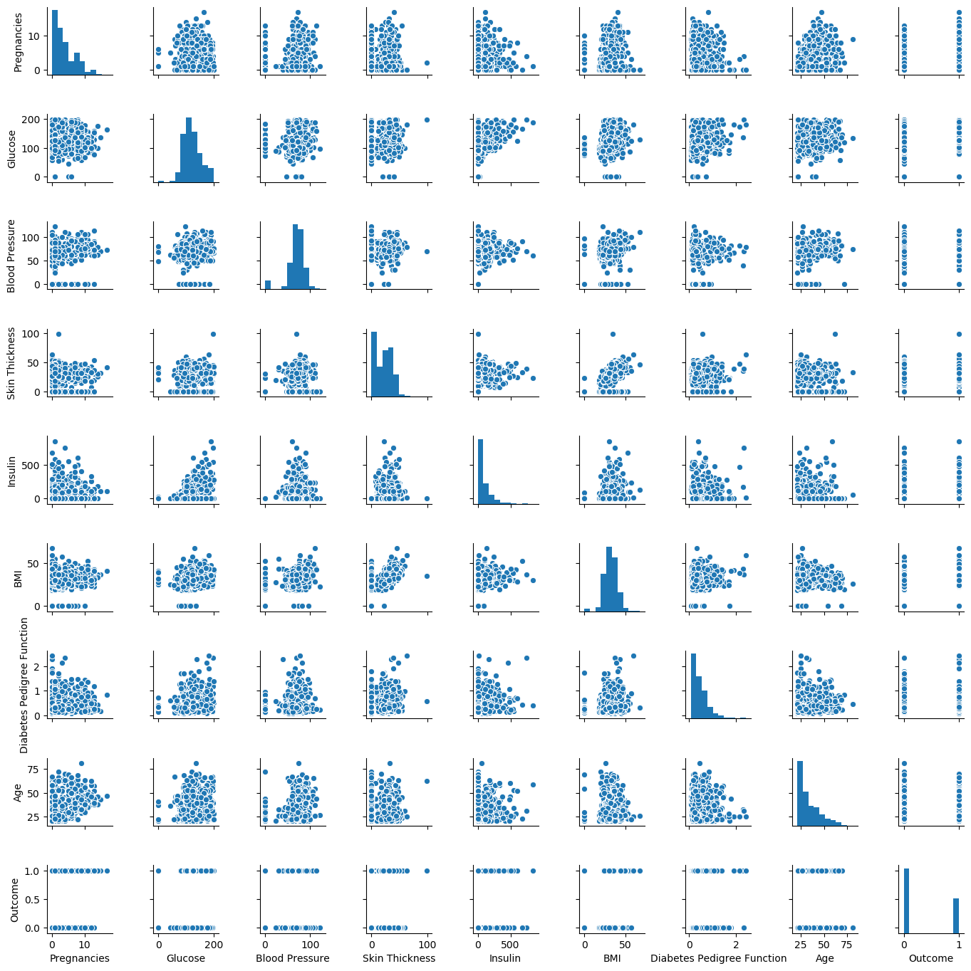

1. Running test for new data

* This mode is used to test on new files and check the accuracy of the model.
* The user need to navigate to the folder where the scripts are kept.



* Thereafter, the user can run the script using the python and the command has a structure like “python s_test.py C:\Users\Desktop\diabetes_with_patient_ID_2.csv C:\Users\Desktop\diabetes_with_patient_ID_meta.csv”

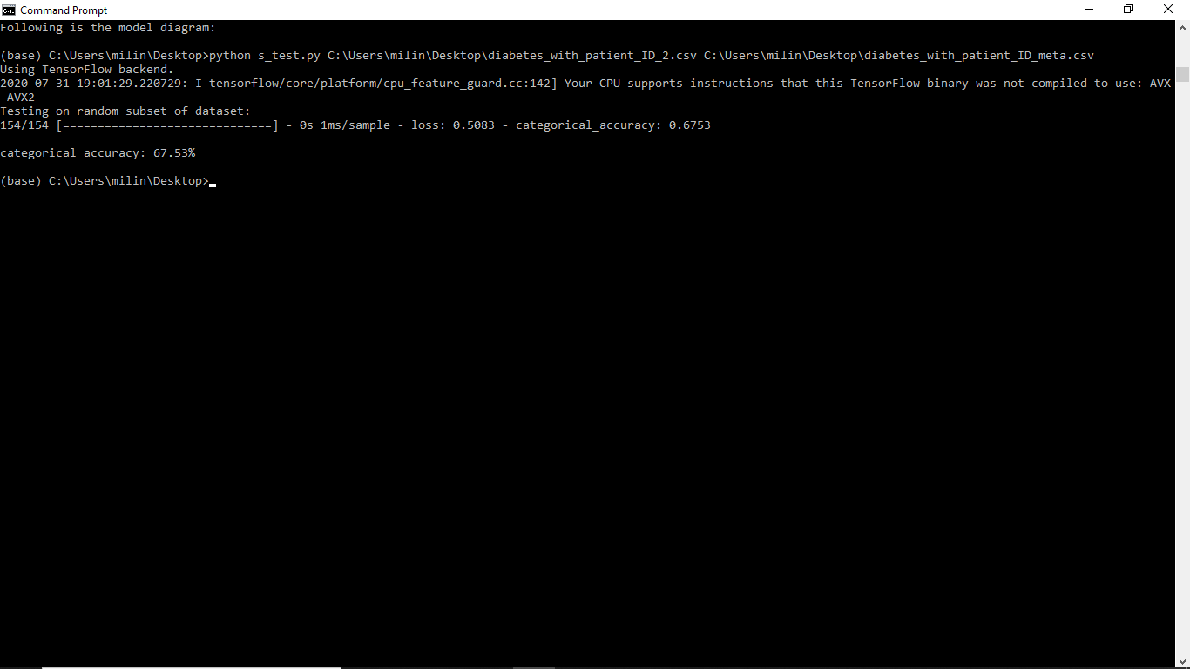

* The output is an accuracy of the model.