Getting Started:

4 Trades are added by Default.

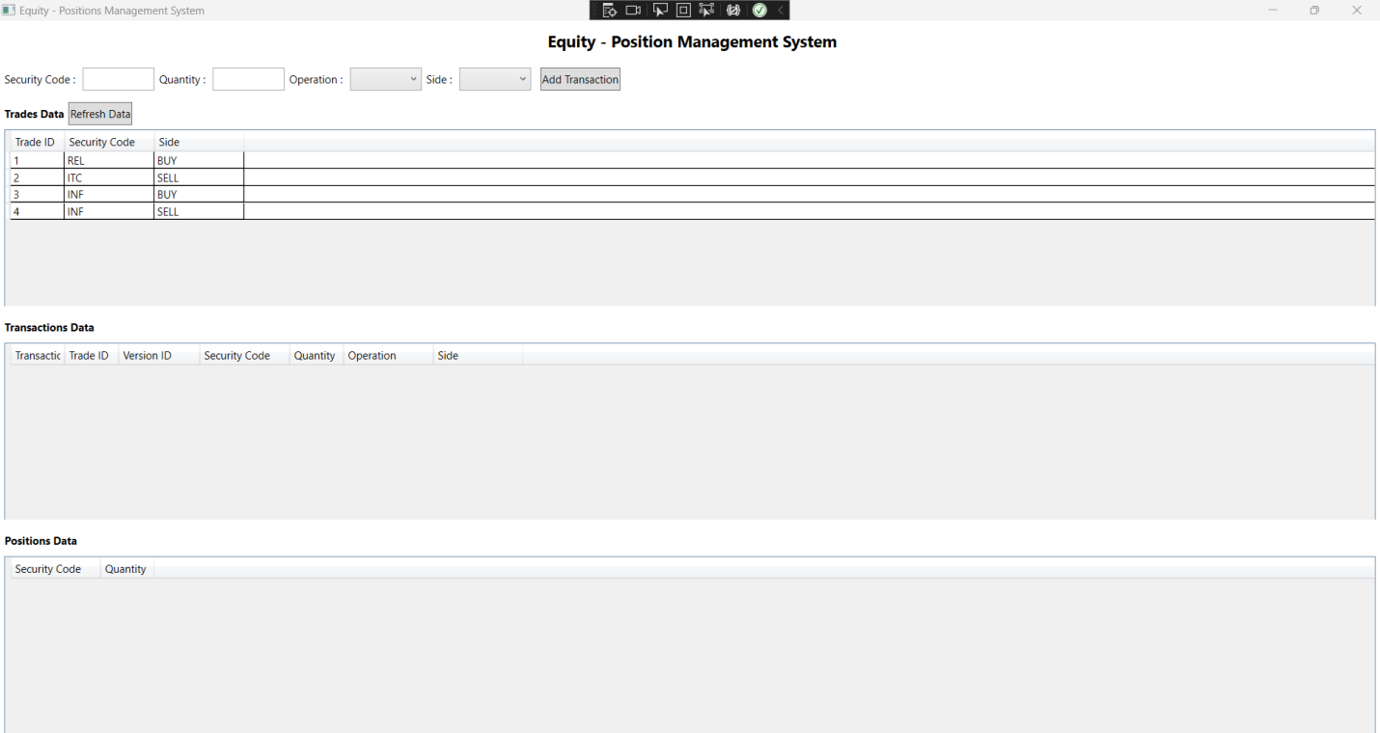

After 1st transaction:

|  |  |  |  |  |  |  |
| --- | --- | --- | --- | --- | --- | --- |
| **TransactionID** | **TradeID** | **Version** | **SecurityCode** | **Quantity** | **Insert/Update/Cancel** | **Buy/Sell** |
| 1 | 1 | 1 | REL | 50 | INSERT | BUY |

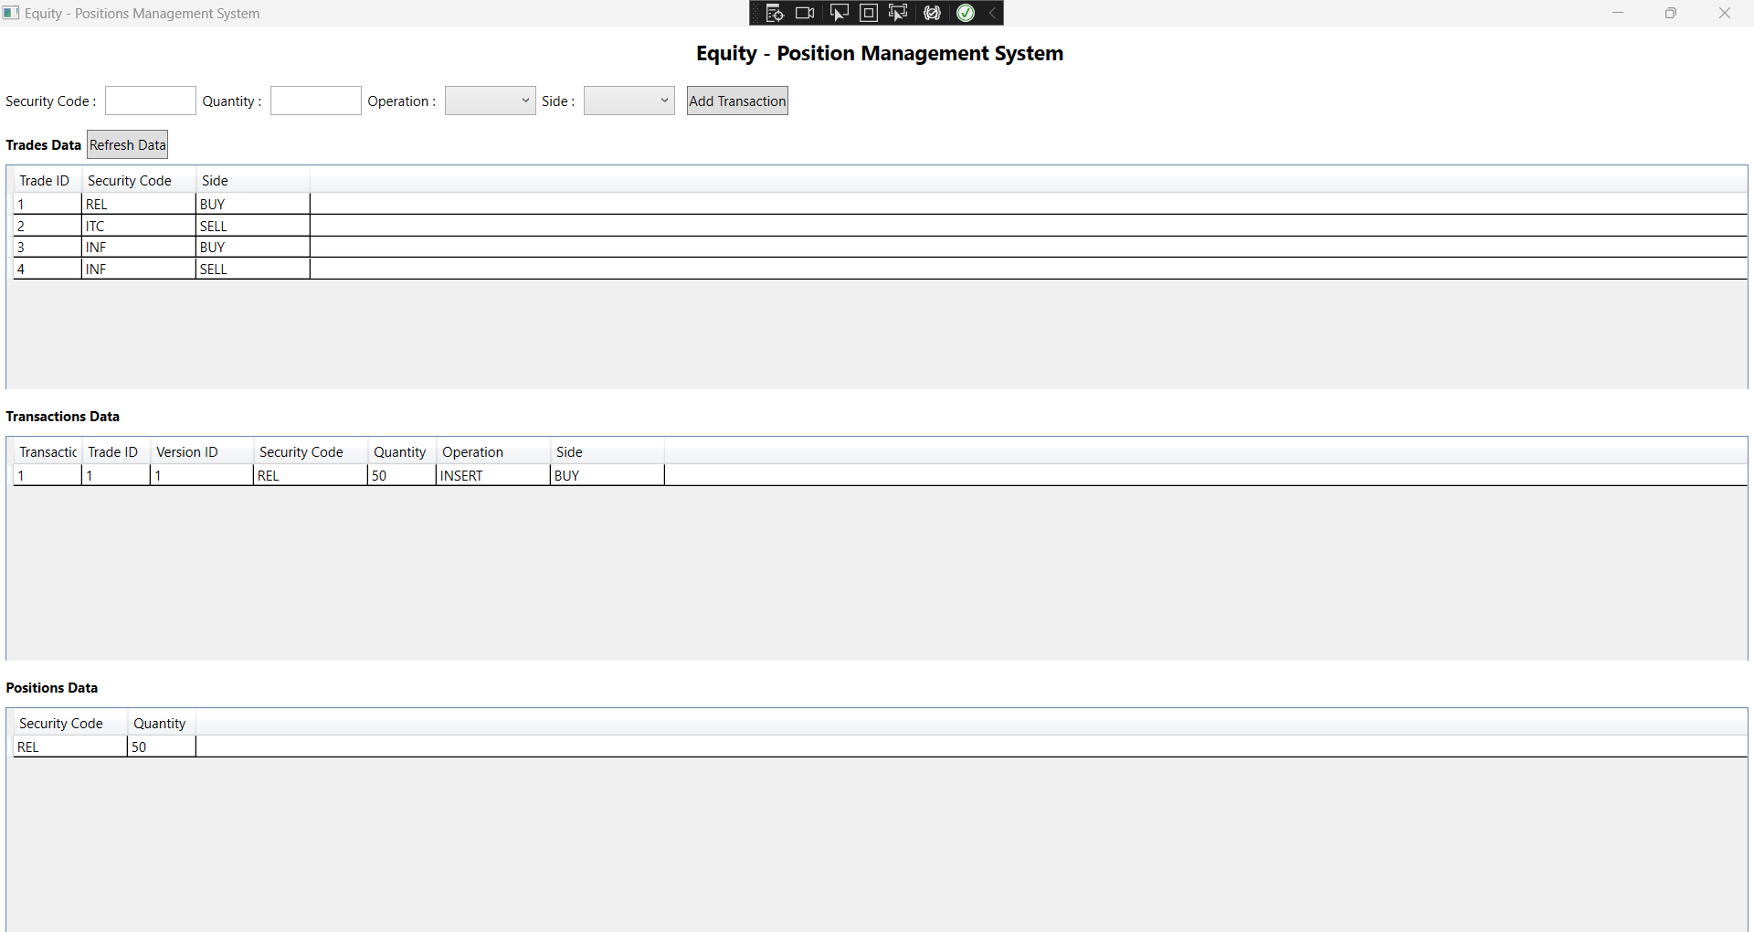

After 2nd Transaction:

|  |  |  |  |  |  |  |
| --- | --- | --- | --- | --- | --- | --- |
| **TransactionID** | **TradeID** | **Version** | **SecurityCode** | **Quantity** | **Insert/Update/Cancel** | **Buy/Sell** |
| 2 | 2 | 1 | ITC | 40 | INSERT | SELL |

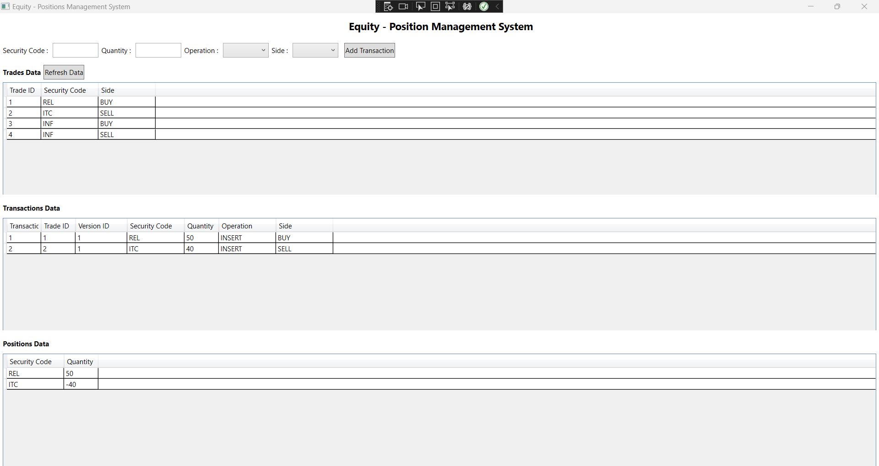

After 3rd Transaction

|  |  |  |  |  |  |  |
| --- | --- | --- | --- | --- | --- | --- |
| **TransactionID** | **TradeID** | **Version** | **SecurityCode** | **Quantity** | **Insert/Update/Cancel** | **Buy/Sell** |
| 3 | 3 | 1 | INF | 70 | INSERT | BUY |

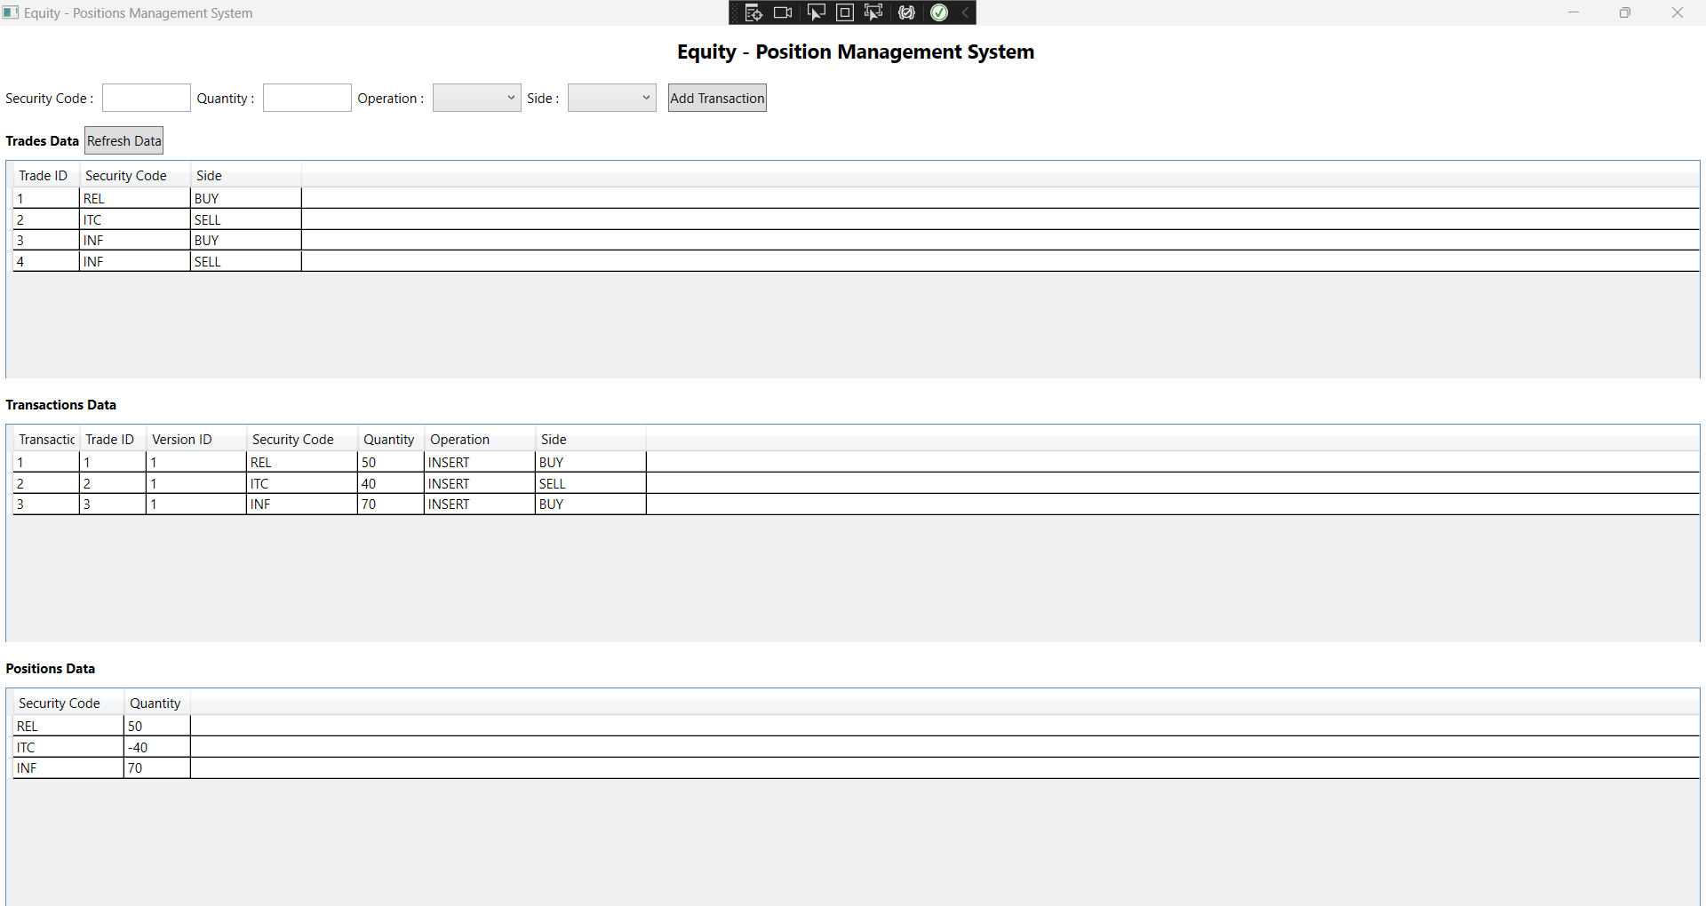

After 4th transaction:

|  |  |  |  |  |  |  |
| --- | --- | --- | --- | --- | --- | --- |
| **TransactionID** | **TradeID** | **Version** | **SecurityCode** | **Quantity** | **Insert/Update/Cancel** | **Buy/Sell** |
| 4 | 1 | 2 | REL | 60 | UPDATE | BUY |

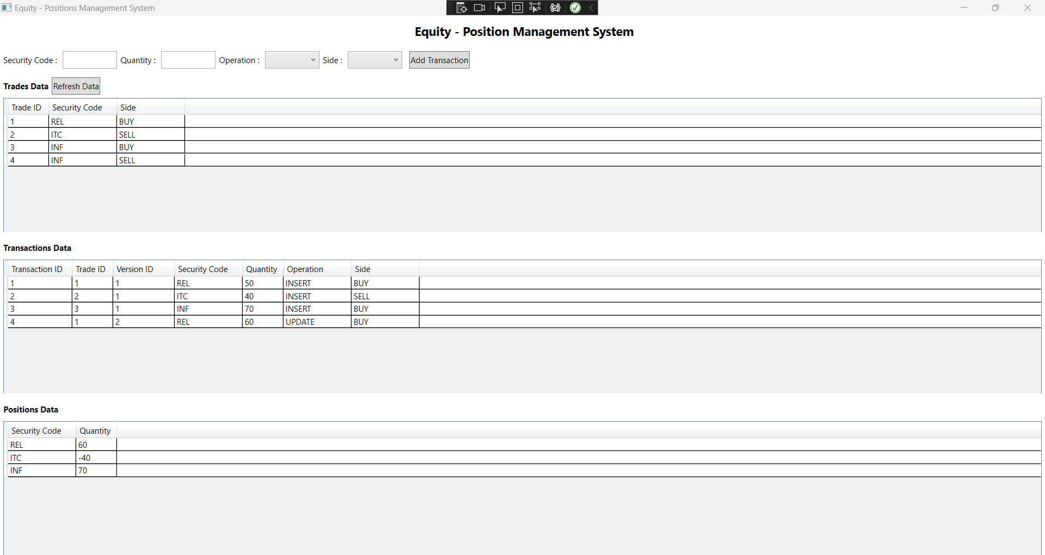

After 5th Transaction:

|  |  |  |  |  |  |  |
| --- | --- | --- | --- | --- | --- | --- |
| **TransactionID** | **TradeID** | **Version** | **SecurityCode** | **Quantity** | **Insert/Update/Cancel** | **Buy/Sell** |
| 5 | 2 | 2 | ITC | 30 | CANCEL | BUY |

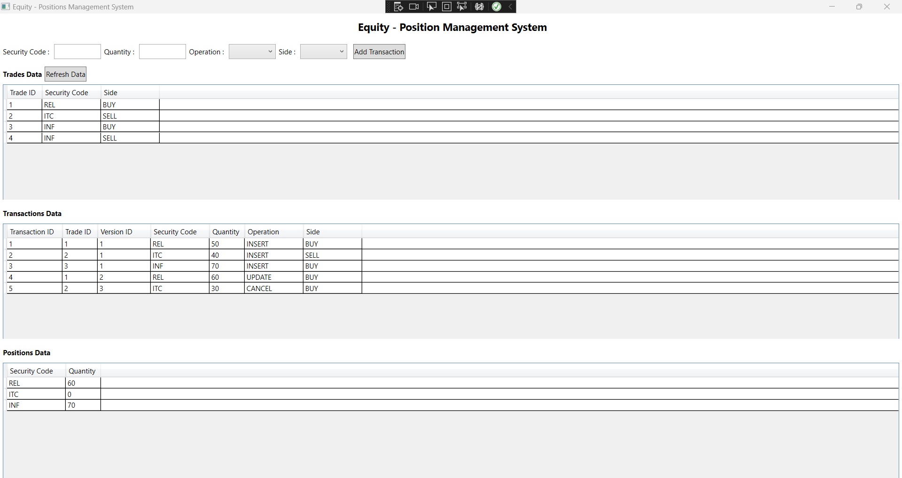

After 6th Transaction:

|  |  |  |  |  |  |  |
| --- | --- | --- | --- | --- | --- | --- |
| **TransactionID** | **TradeID** | **Version** | **SecurityCode** | **Quantity** | **Insert/Update/Cancel** | **Buy/Sell** |
| 6 | 4 | 1 | INF | 20 | INSERT | SELL |

