<!DOCTYPE IUCR-ART PUBLIC "IUCr//DTD IUCr article dtd V1.1//EN"><iucr-art jid="" aid="" access="pay" docsubty="" crt="International Union of Crystallography" language="0"><jnlinfo name="" yr="" issue="1" volume="" abbrtitle="" coden="" editor="" issn="" fpage="0" lpage="0"><fm><atl>Olex2: A Complete Structure Solution, Refinement and Analysis Program </atl>
Oleg V. Dolomanov*, <aug><au><fnm>Luc J. Bourhis, Richard J. Gildea, Judith A. K. Howard, </snm></au><orf id="">Horst Puschmann*
<aff><oid id="">Department of Chemistry, Durham University, South Road, Durham DH1 3LE, <cny>UK</cny></aff></aug>.
Correspondence e-mail: oleg.dolomanov@durham.ac.uk, horst.puschmann@durham.ac.uk
Submitted to Journal of Applied Crystallography as a Computer Program Abstract

Received
Accepted
The program OLEX provides tools for the visualisation and topological analysis of extended network structures, as well as allowing more conventional representations.
We have developed new software, Olex2, for the determination, visualisation and analysis of molecular crystal structures. The software has a portable, mouse-driven, workflow-oriented and fully comprehensive graphical user interface (GUI). Olex2 provides the user with a GUI for structure solution, refinement and report generation as well as novel tools for structure analysis. Olex2 seamlessly links all aspects of the structure solution, refinement and publication process and presents them in a single, workflow-driven package – with the ultimate goal of producing an application which will be useful to both chemists and crystallographers.
visualisation and analysis; graphical user interface; metadata; data harvesting
- Introduction
More and more frequently, chemists are expected to perform many aspects of the X-ray structural analysis process including structure solution and structure refinement without expert help. This requires not only basic knowledge of crystallography but – crucially – also reasonable understanding of the quirks of associated software. The majority of the crystallographic programs currently in use were written a long time ago and are often lacking in user-friendliness and/or comprehensive graphical user interfaces. This leads to a situation in which the optimal use of both staff time as well as available crystallographic techniques is not achieved. We have approached this problem by the creation of simple-to-use software with the aim of providing numerical as well as visual feedback to the user. The main purpose of Olex2 is to provide a comprehensive GUI which will not require any specialist training and will be accessible and usable to both knowledgeable chemists and experienced crystallographers.
- Program Description
Olex2 provides 3D graphical visualisation of the crystallographic structure as well as means to manipulate and analyse it. Olex2 reads several chemical/crystallographic file formats and displays the structure on the screen. The user can interact with the structure model using either the mouse or the command line. A screenshot of Olex2 is shown in Fig 1.
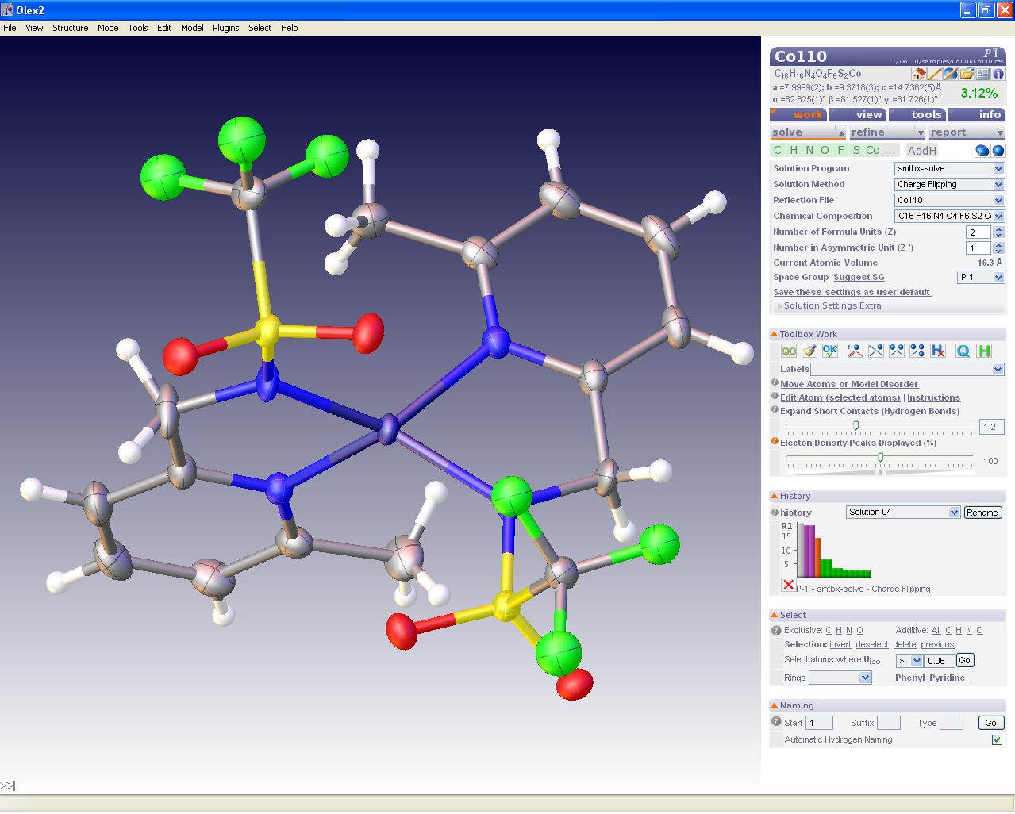
Figure 1. View of the Olex2 main window

  - OpenGL: 3D Graphics
OpenGL® (The Khronos™ Group, 2008) is an application programming interface (API) to hardware accelerated graphics. This enables the generation of high quality and fully customisable display of 3D objects on a standard computer monitor. In particular, up to eight uniform or directional light sources can be employed, different visual appearance (e.g. ambient or diffuse colours) for the displayed objects can be set and various lighting models (which define ambient scene light intensity and how light reflection angles are calculated) can be defined. The program provides a user interface to customise these settings as well as visual appearance of all graphical objects.
  - Atom Display
Olex2 provides all of the conventional representations of molecules: thermal ellipsoids, balls and sticks, wireframe and sphere packing drawings. The thermal ellipsoids drawing for an isotropic model displays atom radii proportional to the U_{iso} and helps with visual observation of errors in current model. The translucent representation of the residual electron density peaks proportional to the peak heights helps to highlight missing atoms on the background of the difference electron map artefacts.
  - Design and Implementation
Olex2 is fully portable and runs on Windows, MacOSX Leopard and Linux platforms. The Olex2 GUI is written in an extended HTML language and provides the user with a set of GUI controls supporting event driven execution, allowing the user to perform structure solution, refinement and report generation utilising a clearly laid-out and easy-to-follow workflow path. The GUI can be easily modified and extended to suit the individual user’s requirements. With the automatic updates option switched on, the Olex2 development framework allows us to update the GUI in an incremental fashion on program start-up.
Olex2 is designed as a set of libraries, which can be re-used separately to build applications with as few dependencies as possible.
Olex2 uses wxWidgets (wxWidgets, 2008) for its GUI; however the underlying libraries are designed to avoid this dependency. These libraries provide most of the API for Olex2 and manage crystallographic file input/output operations and symmetry related tasks.
The program is built as a Unicode (The Unicode standard, 2008) program and the Olex2 GUI has multilingual capabilities with website support. Users interested in translation of the Olex2 GUI can register on the Olex2 website (Puschmann, 2008) and provide translation of given phrases in the language of interest. We update this information on a regular basis; however we cannot guarantee consistency or correctness of the translation.
    - Implementation Languages
The core of Olex2 is written in C++ while some of its extended functionality is provided by the Python (Python, 2008) programming language. Most of the utilities provided by the Olex2 core are accessible from the command line as well as from the task-oriented GUI.
The Olex2 executable and underlying libraries export some functionality into the Python scripting language. These functions are used in the GUI to interact with the Olex2 core and also provide the basis for extending functionality while taking full advantage of Python: ease of development, fast prototyping, readability and portability of code. There is also a facility in Olex2 to register python functions to be called on certain events (call-back functions) or to expose them to the user through the console/HTML.
A Python layer allows the integration of the smtbx (Bourhis et al., 2007) structure determination and refinement procedures into the Olex2 GUI. This layer exploits the Olex2 functionality to communicate data between Olex2 and smtbx. Olex2 exposes the structure model and relevant information, such as available restraints and atom treatment to the Python layer, which makes it easy to control, read and write the model from/to Olex2.
A simple macro language, designed for the users to develop their own console commands is also provided. These commands are intended to group together other commands and can be used from the GUI or directly accessed through the command line. A user-editable macro file is provided with Olex2 and can be used by the user to customise behaviour of certain operations, such as file loading, application start-up etc. These macros are also used internally to synchronise the states of Python and Olex2 core and the GUI and provide a powerful tool to intervene into various states of structure solution and refinement stages.
    - User Interface
The Olex2 main window consists of the graphical display and an HTML panel of adjustable width and position. The main window also has a customisable menu bar and an input console.
Olex2 provides a mouse-driven interface to interact with the graphical model as well as a console to input commands using the keyboard. Most of the console commands are accessible from the task-oriented GUI. The syntax of the command line input resembles that of the XP program [part of the SHELXTL system of computer programs, (Sheldrick, 2008)], whilst providing more functionality and flexibility through the use of built-in or user-defined functions and a reference to the graphical objects via the selection.
The GUI is dynamically adjusted according to other known crystallographic software that is installed on the system and allows the user to select any particular software for the structure solution and refinement stages. All default parameters of these programs can be inspected and modified; any relevant help information is provided when needed.
  - Functionality
Olex2 aims to be an all-encompassing tool for performing the analysis of small-molecule crystal structures. Following the three step workflow (structure solution, refinement and report generation), there are some further tools which assist with structure analysis and publication.
    - History
Some of the extended Olex2 features include History, which records every structure solution/refinement step and provides visual feedback of the related R-factors. The History module facilitates easy switching between different structure solution and refinement steps.
There is a CIF (crystallographic information file, Hall et al., 1991) metadata module in the Olex2 GUI, which helps with data harvesting and report generation. This module analyses the files in the structure directory and extracts all possible information. This information is later used to resolve missing items in the CIF and structure report. The metadata GUI provides the user with comprehensive controls to input data into the CIF. This information, as well as harvested data, is stored internally and the CIF is updated every time the report is created thus ensuring that all of the information provided by the user is not lost in the structure refinement or solution steps.
    - File I/O and File Manipulations
The software can import and export structural data via a number of crystallographic file formats (SHELXL model files, CIF, MDL MOL, PBD, XYZ, XD master files), generate the extended structure if required, produce an output image and provide a structure refinement report.
    - Data Analysis
The user can open a P4P (proprietary Bruker AXS file format; file containing experimental details such as unit cell dimensions, asymmetric unit content, data collection temperature and radiation wavelength used), HKL, or raw data reflection file (provided the cell dimensions are given) to initiate the Olex2 space group determination routine. If the space group determination routine comes to a single choice of the space group, Olex2 attempts to solve the structure automatically and displays the result to the user. Otherwise the user can input the known space group or investigate the output of the Olex2 space group analysis procedure to make a decision.
The space group determination routine implemented in Olex2 uses analysis of systematic absences and merging statistics complemented by the Wilson statistics (Wilson, 1949) for the determination of the centre of symmetry.
    - Structure Determination
Currently Olex2 features our own charge flipping (Oszlányi and Süto, 2008) structure solution routine based on smtbx as well as supporting SHELX structure solution programs; we are also working towards the support of other available structure solution programs as SIR97 (Altomare et al., 1999).
In addition to our own smtbx-based refinement (Bourhis et al., in preparation), Olex2 also supports the SHELXL refinement program. Olex2 provides tools to visualise the output of the refinement (e.g. occupancies) on screen as well as tools to manipulate the model, restrain refinement parameters, model disorder and for structure analysis. The refinement module provides a completely transparent mechanism of changing the reflection file against which the structure is refined.
    - Structure Analysis
The structure analysis tools include calculation and visualisation of voids and Fourier maps. Different drawing styles, such as 2D projection on the screen or 3D surface/mesh drawing, are available. Other tools include fragment matching and alignment (Kearsley, 1989). The alignment works either automatically for fragments with the same connectivity or can be interactively driven by the user. A number of tools and modes are available for structure growing and packing. Other standard functions include distance and angles calculation between atoms, bonds or user-defined planes; standard uncertainties of these parameters can also be estimated when a variance–covariance matrix is available from the refinement. The tools to calculate molecular composition and isotope pattern distribution of the current structure or provided formula are also included in Olex2.
- Software Environment and System Requirement
Olex2 for Windows is pre-compiled and runs under 32- and 64-bit 2000/XP/Vista. Some Linux distributions are available at the Debroglie repository (http://www.debroglie.net); others can be compiled using the provided scripts and documentation (currently tested for Fedora version 7 and 8, Suse version 10.1 [32-bit] and 10.3 [64-bit] and Ubuntu version 7.10 [32-bit]). The user interface is developed using the wxWidgets library. The source code of the program is developed using Microsoft® Visual Studio Free Edition 2005/2008.
The system requirements for running Olex2 are: 128 Mb of free RAM, 50 Mb of disk space and a graphics card which supports OpenGL.
- Documentation, Support and Availability
Olex2 is in the ongoing development phase and we are striving to document all aspects of Olex2 comprehensively. There is a web portal at www.olex2.org, which contains descriptions of the Olex2 functionality and some of its functions. Anybody interested in Olex2 or Olex2 GUI development is welcome to join the portal.
Olex2 is an open source project and executables are available in pre-compiled form at www.olex2.org. The source code resides at the sourceforge website (http://www.sourceforge.net) and can be freely downloaded and compiled for any system. Olex2 is distributed under a BSD-style licence
We thank EPSRC (UK) for financial support. We are grateful to our testers and contributors (Sebastian Cirkel, Helena Shepherd, John Warren, Ilia Guzei) for their time, attention and thorough evaluation of the program and Ehmke Pohl for assistance in preparation of this publication and Aileen Congreve for the provision of the structure in Fig 1 (Congreve, 2003).

References
The Khronus™ Group (2008). The industry’s Foundation for High Performace Graphics, http://www.opengl.org.
wxWidgets (2008). Cross-Platform GUI Library, http://www.wxwidgets.org.
The Unicode consortium (2008). The Unicode standard, http://www.unicode.org.
Python (2008), Python Programming Language, http://www.python.org.
L. J. Bourhis, R. W. Grosse-Kunstleve and P. D. Adams (2007). Commission on Crystallographic Computing International Union of Crystallography 8, 74-80, http://www.iucr.org/iucr-top/comm/ccom.
Sheldrick, G.M. (2008). Acta Cryst. A64, 112-122.
S. R. Hall, F. H. Allen and I. D. Brown (1991). Acta. Cryst. A47, 655-685.
G. Oszlányi and A. Süto (2008). Acta. Cryst. A64, 123-134.
A. Altomare, M. C. Burla, M. Camalli, G. L. Cascarano, C. Giacovazzo, A. Guagliardi, A. G. G. Moliterni, G. Polidori and R. Spagna (1999). J. Appl. Cryst. 32, 115-119.
L. J. Bourhis, O. V. Dolomanov, R. J. Gildea, J. A. K. Howard, H. Puschmann (2008), in preparation.
S. K. Kearsley (1989). Acta Cryst. A45, 208-210.
H. Puschmann (2008). The Olex2 website, http://www.olex2.org.
A.Congreve, R.Kataky, M.Knell, D.Parker, H.Puschmann, K.Senanayake, L.Wylie (2003), New J. Chem. 27, 98-106.

