General Project Description

This document presents the complete development of a database system called gestion_academica_universidad, designed to simulate academic management within a university setting. The project includes the creation of relational tables, data insertion, SQL queries, views, constraints, transactions, and access control.
The attached screenshots serve as visual evidence that all features and operations were implemented correctly, including:
- Creation and design of tables with appropriate keys and constraints.
- Data insertion into all main tables (students, teachers, courses, enrollments).
- Successful execution of SQL queries using JOIN, GROUP BY, aggregate functions, and subqueries.
- Structural modifications such as adding columns and using ON DELETE CASCADE for foreign keys.
- Creation of a view (vista_historial_academico) displaying relevant academic history.
- Transaction simulation using SAVEPOINT, ROLLBACK, and COMMIT.
- Assignment of limited access permissions to a user with read-only rights.
These screenshots demonstrate that the system works properly and meets all the specified requirements.

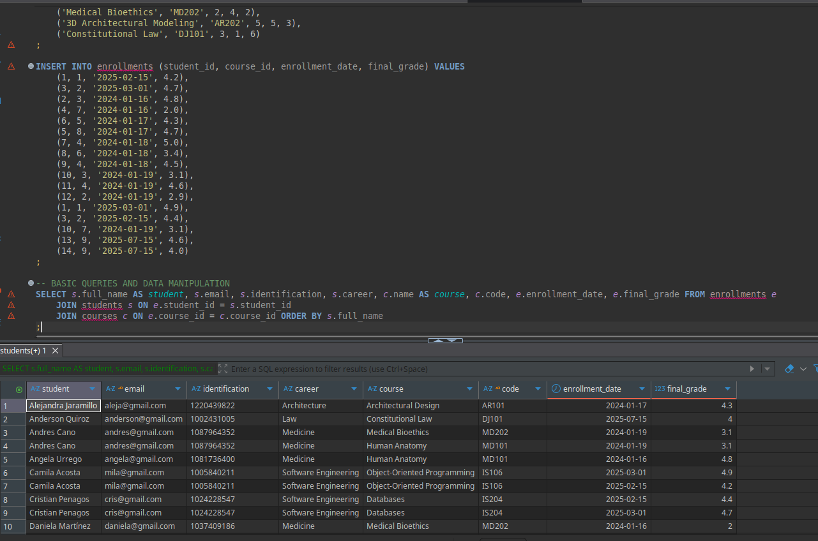
This query lists each student’s personal and academic details along with the courses they are enrolled in and their final grades. It joins students, courses, and enrollments, and orders the results by student name.

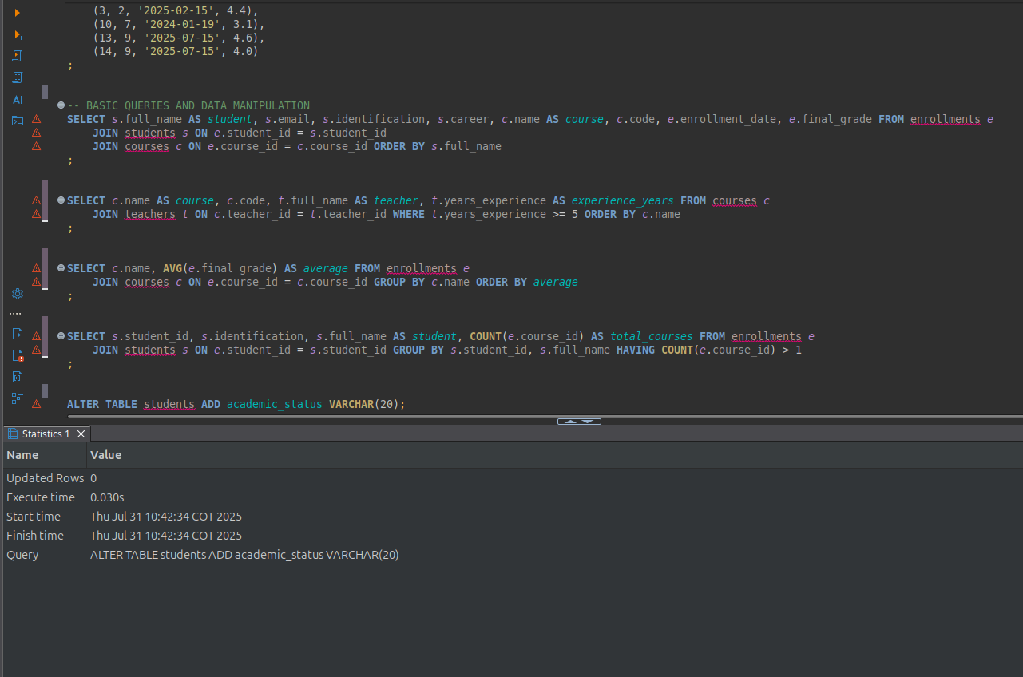
This command adds a new column academic_status to the students table to track the current academic standing of each student.

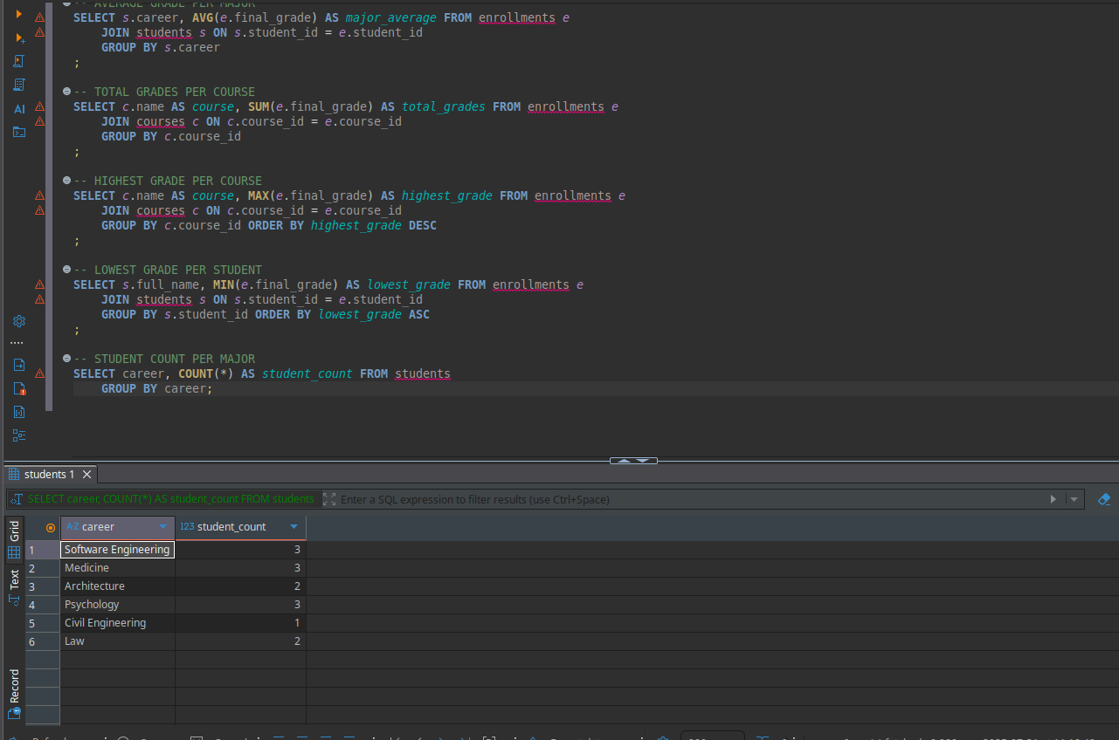

This query counts the number of students grouped by their career/major.

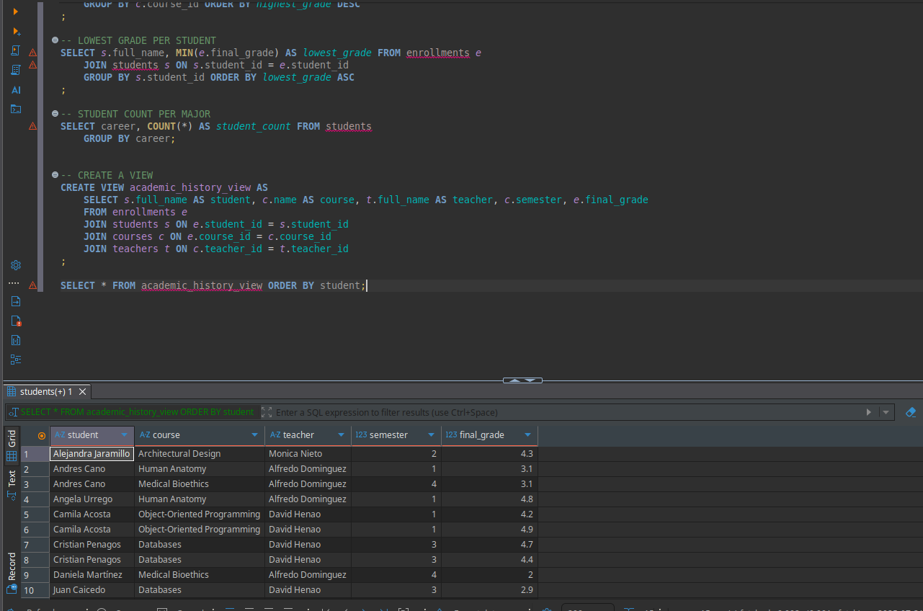
Creates a view that shows each student’s name, course, teacher, semester, and final grade. The view simplifies retrieving academic history information.
The SELECT query fetches all records from this view ordered by student name.

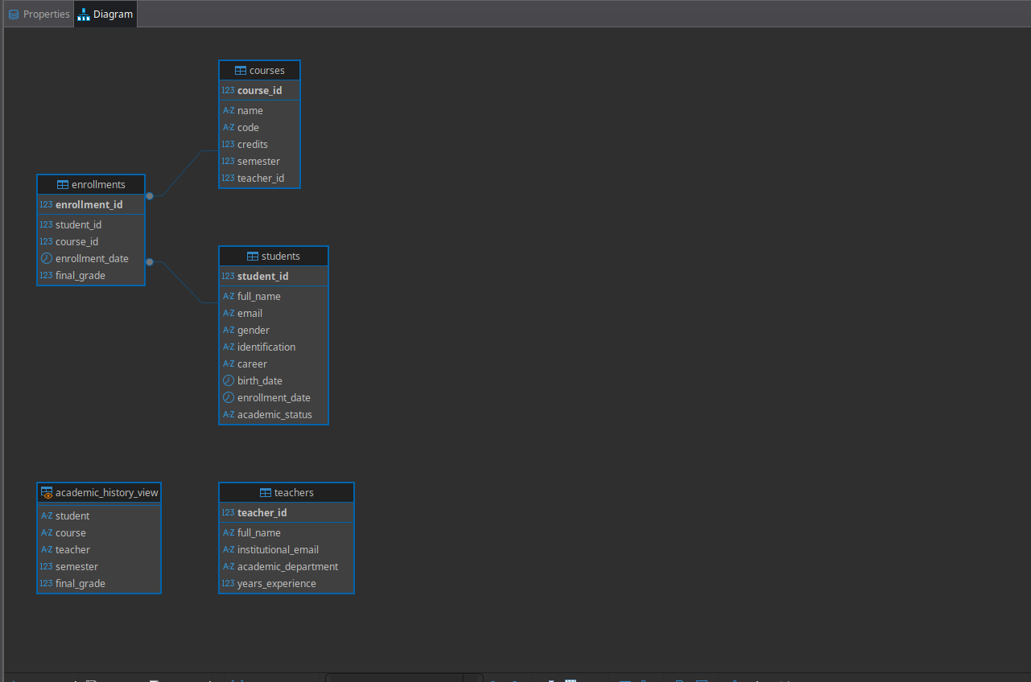
The diagram illustrates the structure of the academic_history_view, showing how it integrates data from students, courses, teachers, and enrollments.

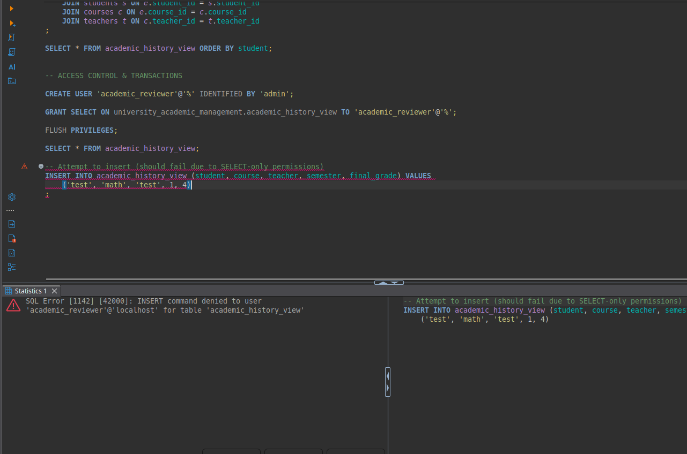
This snippet shows an attempted INSERT into the academic_history_view which fails as expected, because the view has SELECT-only permissions for the user academic_reviewer.
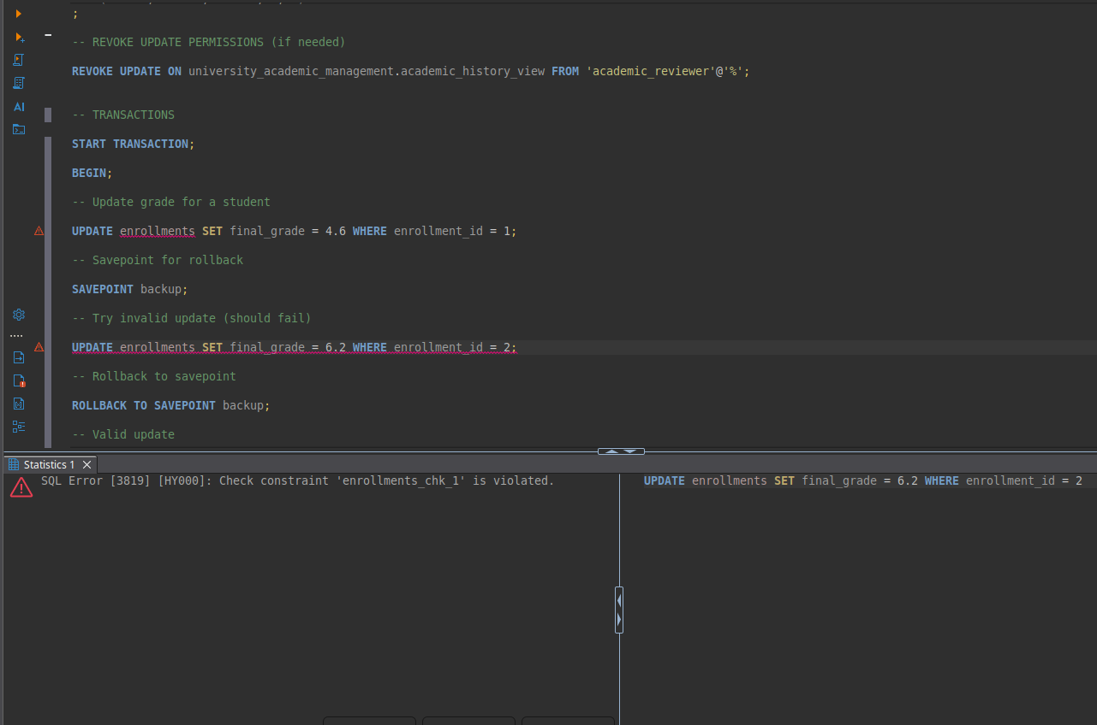
This snippet demonstrates a transaction with a savepoint and rollback. An invalid update on final_grade violates a check constraint (enrollments_chk_1), triggering an error and rollback to the savepoint.
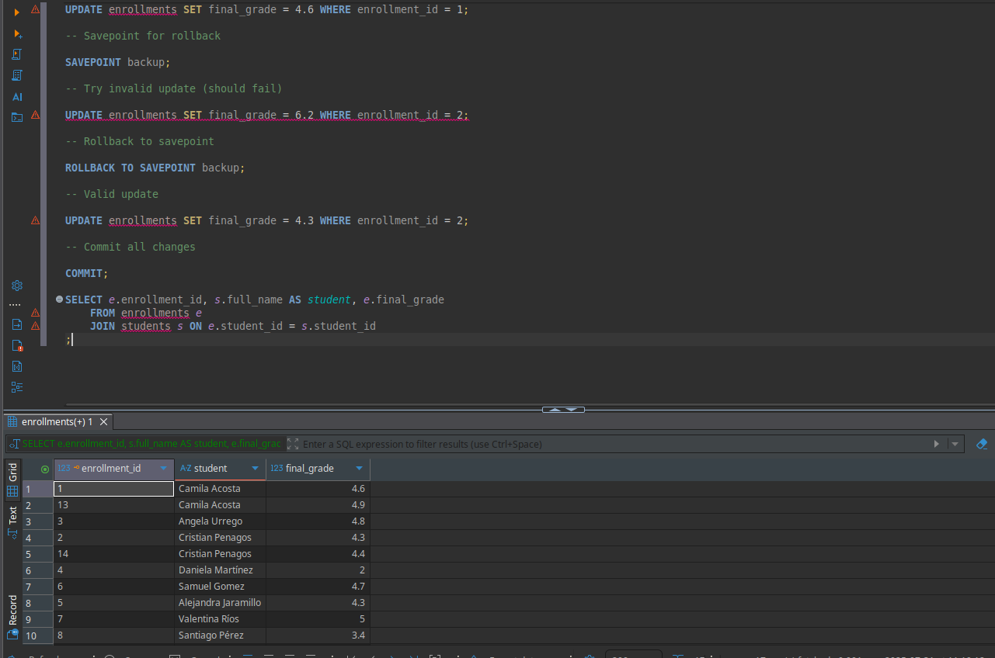
This code shows a transaction with a savepoint to handle updates on student grades. An invalid update violates a constraint and is rolled back to the savepoint, then a valid update is committed. Finally, a query lists enrollment IDs, student names, and final grades.

