Computer programming

Final Project

Report

I.E.S. San Vicente
San Vicente del Raspeig (Alicante)
2017/2018

Teachers:
José Ignacio Cabanes / Ignacio Iborra

Student:
Miguel Pastor Carratalá

1. Introduction
Project name
No-Color (Plattformer)

Made by
Miguel Pastor Carratalá

Short description of the project
The Plattformer Game, it will be only for one player, and it’ll be 5 playable levels I think, probably using SDL in this case

2. Functionality of the project
After entering the program, a welcome screen will we displayed, where the user can choose between:

• Play
• Help
• Credits
• Quit

The images for the pieces and the background screen are read from file at the beginning of the game including music.

The game will start at the first level, while it wasn’t closed in another level or if it wasn’t finished the complete game, (the level will start when you left it if you close inside the level correctly)

If lose all lives the game screen will go to the Game Over Screen and if the HiScore is on the top 10 it will show your HiScore with the remaining HiScores, if not, then you’ll go to the Title Screen.

Pause menu with their quit and continue option, jump and swim moves and enemies, items that give points and item goal that makes us pass to the next level, the help screen, credits screen and points screen will need space to continue, it will use an horizontal scroll for the background

3. Screen prototype

Prototype in Paint -> Is a plattformer like Mario

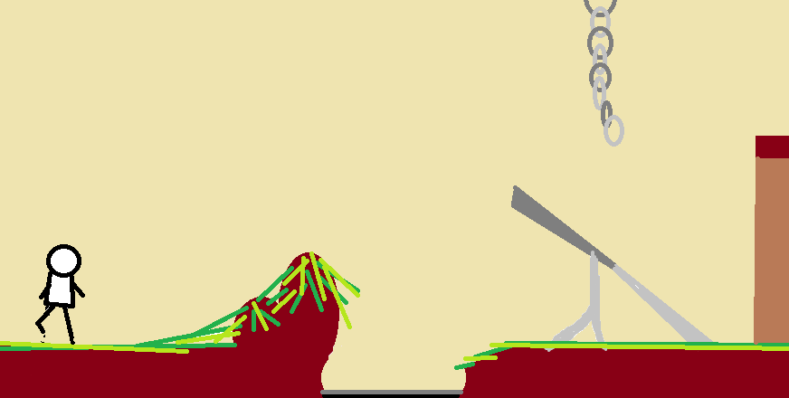

Actual Sprites -> Imitating a Mario Game with Wario or Waluigi in a Background of Black and White

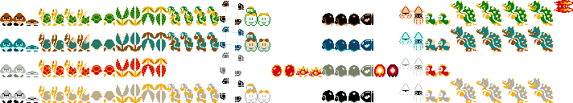

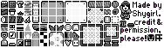

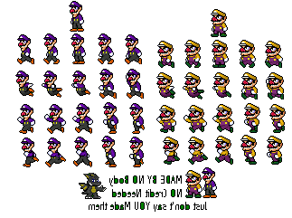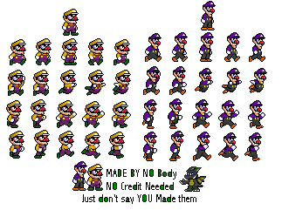

4.Analysis

4a. Requisites
Requisite | Date achieved
Prepare all clases and resources (Some Classes like Items aren’t Implemented Yet) | X
Intro Screen Menu | X
Block Sprites Added with Collisions (Can’t check opening the game and because there aren’t levels yet) | X
Code to Move Sprites and Controller Added | X
Help Screen Submenu at Intro
Code to Jump Sprites and Controller Added | X
Code to Enemies Sprites and Controller Added
Credits Screen Submenu at Intro
Game Over Screen | X
Lose Lives Screen
End of Level added and Background Level Music
Pause Submenu while Playing
Add Timer and Some (white) Background
Choose Character Screen | -
Add All Sprites to remaining Main Character
Level txt and code | X
(...)

4b. Basic pseudocode
(...)

4c. Classes diagram

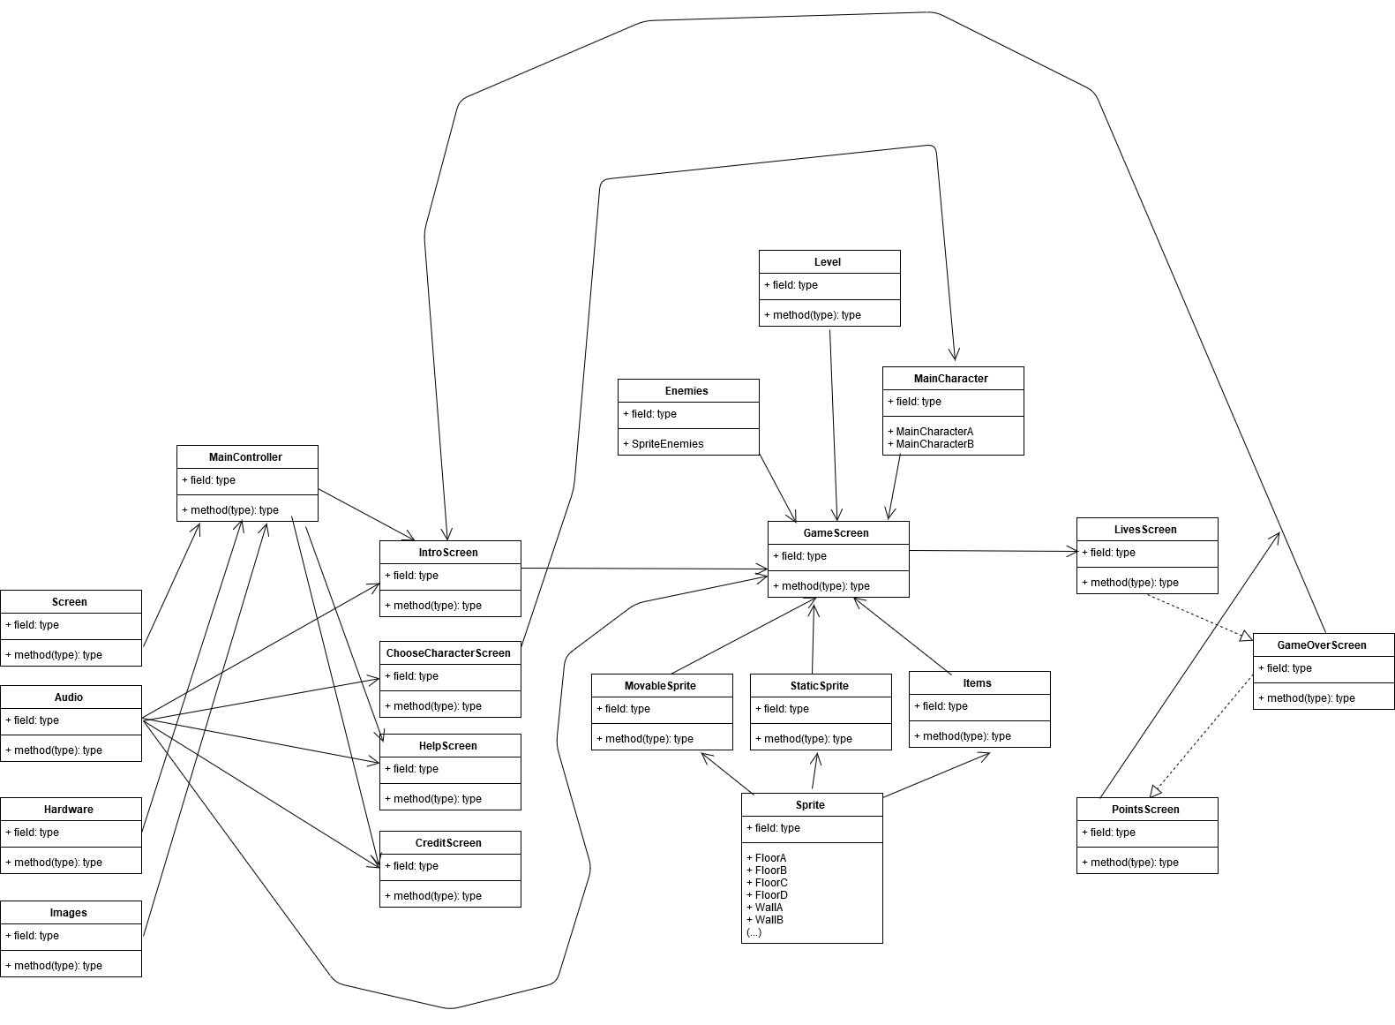
[No-Colors] (I did this with 15 mins for send the assignments, it only contains the main classes, not subclasses like sprite (A,B,C...), staticsprite (A, B, C...), floors and walls. The “field” and “type” was something predetermined on the program where I made this)

5. Initial planning and expected deliveries

5a. Expected deliveries
- Version 1: Prepare all classes with comments and all resources to future deliveries inside the project
- Version 2: The game will start showing an intro screen
- Version 3: Add Block Sprites and Collisions with the Move Sprites
- Version 4: Add Move Sprites to Main Character and Check Controller of Sprites
- Version 5: The intro screen will allow he user to enter a Help screen, which will display hints on how to play
- Version 6: Add Jump Sprites and Check Controller of Jump and Gravity Sprites
- Version 7: Add Enemies Sprites and Check Controller of Enemies Sprites
- Version 8: The intro screen will allow he user to enter a Credits screen, which will display data about the programmer
- Version 9: Add Game Over Screen and Lose Lives Screen
- Version 10: Add Level on txt, End of Level (Change of Level) and Background Music
- Version 11: The game can be paused pressing "P", and then returned by pressing “C” or exit by pressing “Q”, do the AutoSave Class
- Version 12: Add Timer and (White) Background, coding Level class
- Version 13: Add and prepare other enemies movements (not only walk, also jump)
- Version 14: Add a “Choose Character” screen if the player press intro with the two Main Characters
- Version 15: Prepare all move, jump sprites for the Main Character remaining

(…) Note: You must plan 15 deliveries. Each one of them will correspond to 1 hour of work in the classroom.

5b. Real deliveries
- Version 1 (Complete): Prepare all classes with comments and all resources to future deliveries inside the project (Except some audio I don’t have yet)
- Version 2 (Incomplete): Add Block Sprites and Collisions with the Move Sprites
- Version 3 (Incomplete): Add Intro Screen (Audio Class and Future Animations on Comments also added)
- Version 4 (Complete): Add Level Code
- Version 5 (Complete): Add PointScreen and Movement to the Main Character on GameScreen Class.
- Version 6 (Complete): Fixed a Path to follow (More or Less) on MainController and continue progress in GameScreen, added a ChooseCharacterScreen Class (Unfinished yet) and an Items Class (Enumeration of types)
- Version 7 (Complete): Fix Level Floors, GameScreen now draw items and (almost all) floors, ChooseCharacterScreen is complete (finally)

6. File formats

6a. Plain files format
HiScore.dat (Save all Scores on Order)
level1.txt (Using codes prepare level)
level2.txt
level3.txt
level4.txt
level5.txt
tolast.txt
levelend.txt
(...)

6b. Entity-Relationship Diagram (If needed)
(…)

7. Problems found and solutions
GameController don’t work yet (Waiting Menu Classes)
No movement ready yet
No pause yet
No animation yet
No enemies yet
(…)

8. Improvements or restrictions to the starting design
(...)

9. Screenshots of the final project
(…)

10. Source code of the final project
(…)

