With the choice of starting afresh, or to continue from one of our projects, Elisa’s project was more robust and complete compared to Wong’s. Thus, our base project is Elisa’s. However, Elisa did not like her initial format, so she spent time refactoring until she was satisfactory.

We had decided, when attempting a new criteria, to create a new branch dedicated to that criteria and when finished, to be merged with the master branch. After the refactoring, Wong created an editText branch to fulfil the ‘edit the text’ criterion. Wong initially changed how way the wikit content was displayed, allowing the TextArea to be edited. Wong also made a button to allow editing, and when it was clicked again, all of the edited text will be removed and will return to the original. After having done so, Elisa took a look and changed it. Elisa changed it so that you can ‘save’ your edited change. The GUI appearance for that scene changed like so:

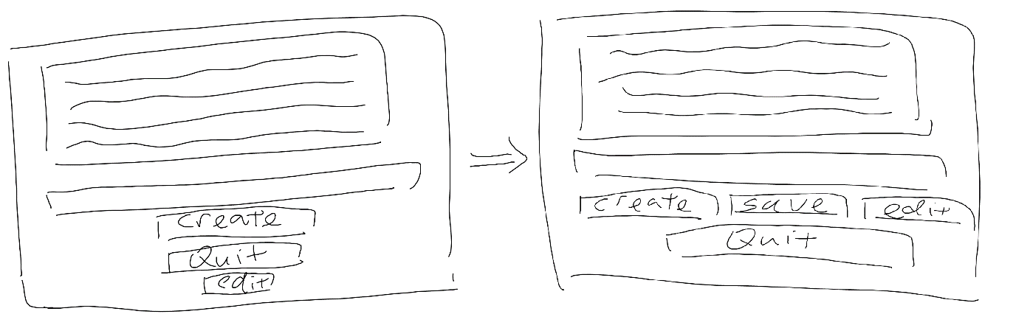

Elisa then started the criteria ‘play audio without saving’ on a new branch called “previewText”. Elisa started with creating a new class and creating a new fxml file called Preview. Elisa then added on widgets for tasks it should perform. Wong then continued on the branch and completed some functionality, specifically the back button. Wong also removed a button label ‘replay’ since it seemed redundant when there is another button called ‘play’, although it may not be possible. The GUI appearance change was like so: