Supervisor: Gerry Moloney
Institution: South East Technological University
Subject: SD3 Project
Purpose of Submission: Software Engineering 3 Project
Date of Submission: 05/02/2026

Blogger Manager - Research and Design Document
A page that helps people and newspapers to find nearby bloggers based on their location and topics they write about.

C00296913 Reanielle Broas
0. Table of Contents

1. Market Research & Comparison
1.1 Existing Similar Applications
1.2 Relevant Tech
2. Tech Stack
3. High-level Design and the System Architecture
4. Data Architecture and Data Structures
4.1 Database Design (Firestore Collections)
4.2 Data Structures
5. Major Interfaces
5.1 Search Dashboard
5.2 Multi-Step Sign-Up Wizard (depending on who u are)
5.3 Moderation Suite
6. Security and Compliance
6.1 Encryption:
6.2 GDPR Compliance:
6.3 Digital Services Act (DSA):
7.1 Geolocation Search Algorithm:
7.2 Niche Tag/Category Matching Algorithm
7.3 Moderation (Pending -> Verified/Denied/Deleted) Algorithm

1. Market Research & Comparison
To design an application that feels familiar to consumers yet innovative for it to stand out in the market, two primary industry leaders were studied for their UX patterns and also their data discovery tech.

1.1 Existing Similar Applications
Booking.com (Geolocation & Search UX):
Research: Users can easily search for rooms using filters (also including Smart Filters using AI), along with a focus on geolocation searching, being able to search based off of radius or town, which is done using the Google Maps API.
Application: bLOG.db adopts the "Smart Filters" and the radius selection feature that allows users to find bloggers within 1km, 5km, or 20km of a specific Eircode.

Medium.com (Niche Content & Credibility):
Research: We’ve analysed their interest-based tagging and their profile management. This platform seems to be the current go-to place for Bloggers to upload their work, implying that there is still a market for our product, along with a new found gap in the market for ‘location focus blogger sites’ that also cater to newspaper agencies.
Application: bLOG.db mimics the niche categorisation (e.g. Politics, Food, Cars) but will also be taking into account geolocation through its partnership with local newspapers.

1.2 Relevant Tech
Google Maps Platform:
Looking into the Google Maps API (to convert Irish postcodes/Eircodes into coordinate pairs) and the Distance Matrix API (to calculate radius distances of a blog from the reader).

Cross-Platform Portability:
Whilst assigned to use Flutter, looking into it, in comparison to similar technologies, Flutter excels on performance on low-end hardware (minimum 2GB RAM requirement) and along with having 90% UI parity across Web and Mobile. Which is perfect for having both a mobile application and a web application.

2. Tech Stack
Frontend Framework: Flutter
Programming Language: Dart
Backend / Cloud Hosting Service: Firebase

3. High-level Design and the System Architecture

Client Layer
Flutter apps (Web/App)
Search Dashboard UI
Profile Dashboard UI
Rating Dashboard UI
Category Dashboard UI
Sign Up Dashboard UI
Blogger Starting UI
User Starting UI
User Starting UI
Moderator Dashboard UI
||
\/
Logic Layer
Content C.R.U.D.
User C.R.U.D.
Content Moderation
API Communication
||
\/
Data Layer
Database for Moderation Suite
Database for Search results

4. Data Architecture and Data Structures

4.1 Database Design (Firestore Collections)
users table:
- uid: String (Unique Firebase Auth ID)
- role: String (Blogger, Reader, or Moderator)
- email: String
- username: String

bloggers table:
- userId: Reference
- location: GeoPoint
- domain_link: String
- profile_details: String (bio, social handles)
- tags: Array (e.g. ["Politics", "Food", “Cats”])
- verification_status: String (Pending, Approved, Denied)

moderation_queue table:
- content_id: String
- user_id: Reference
- content: variable
- details: Date
- selection: boolean [true / false]

content table:
- blogs, reviews, comments (associated with userID): metadata

4.2 Data Structures
Since Firestore doesn't use SQL, it may struggle with the radius searches, thus using a GeoHash allows for the system to use a specific string prefix representing a geographic “bucket" on the map. Info about GeoHashing: https://en.wikipedia.org/wiki/Geohash

5. Major Interfaces

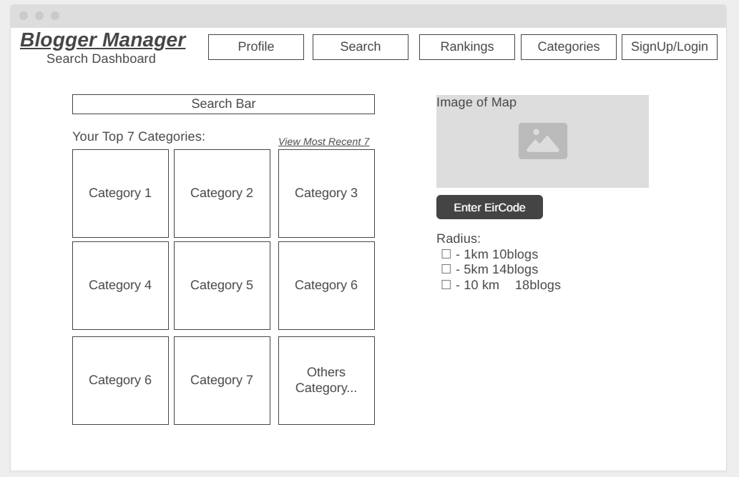
5.1 Search Dashboard

This is the main screen where readers and journalists find local content. It combines a search bar with a map to show exactly where bloggers are located.
- Smart Search Bar: Users can type their niche interest or category that is within the selected radius from the provided eircode.
- Eircode Search: Users can type in their eircode.
- Distance selector: Users can choose how far to search *may be implemented as a slider in future iterations
- Map with Pins: Uses the Google Maps API to show close blogs as icons on a map, being able to visually see how close blogs are along with just having to click and view through the map. Functionality of being able to full screen/increase map size will be implemented in future iterations.
- Categories Grid: Small boxes used as a way to showcase a user's Top 7 categories (initialised at startup first), and also its most recently viewed 7 categories. Also allowing users an option to go see other categories, redirecting them to the categories page.

5.2 Multi-Step Sign-Up Wizard (depending on who u are)
To keep things simple, the sign-up process is broken into small, easy steps instead of one long form. Initial page sign up is the same for bloggers and readers.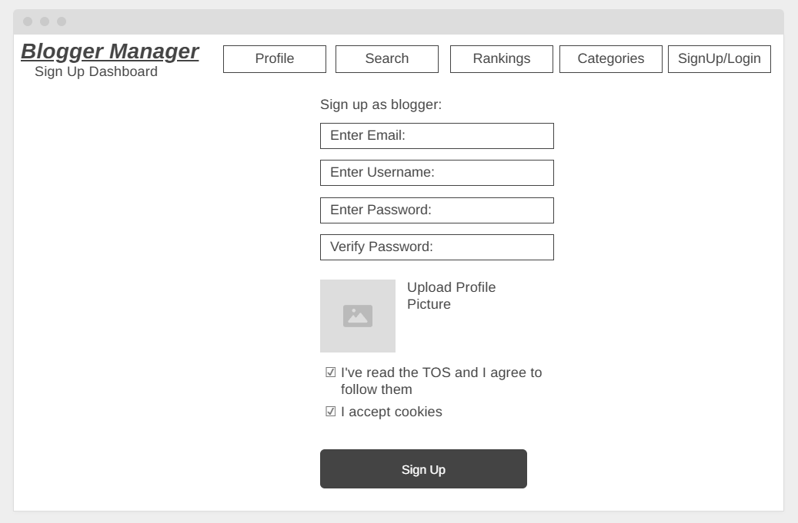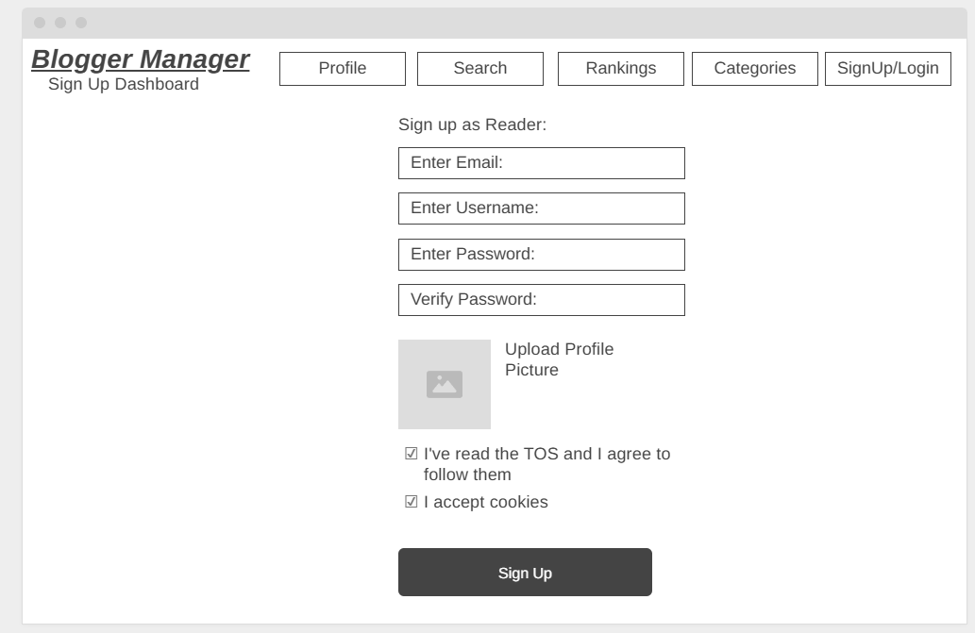

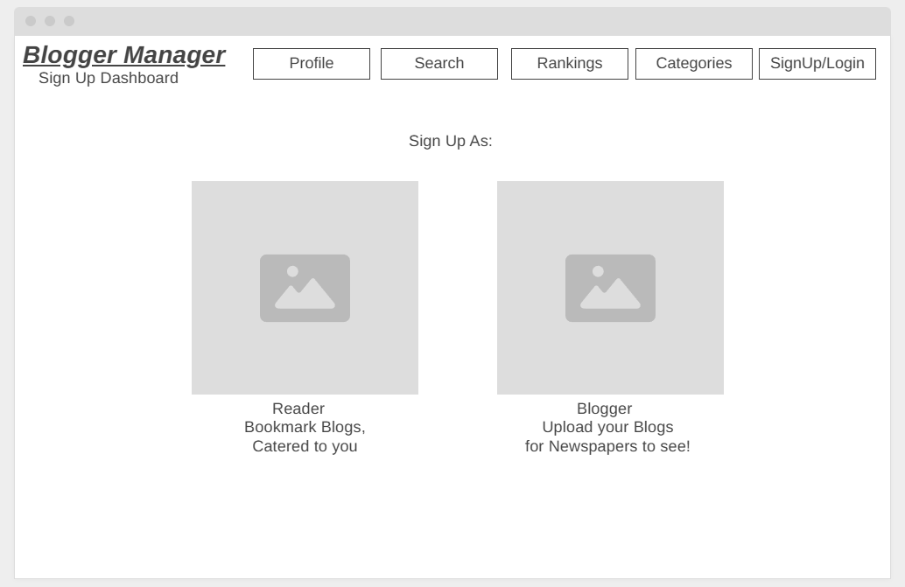
- Role Selection: Users first choose if they are a Blogger or a Reader.

- Blogger Setup:
  - Getting Started welcome Page, redirecting bloggers to uploading their first blog, editing their profile, or checking out the rankings/socials,
  - Profile Dashboard and Upload blog page where bloggers can Upload their blogs, edit, and delete them. Enabling the geolocation of the blog by simply enabling geolocation. They can also see the rating of each blog.
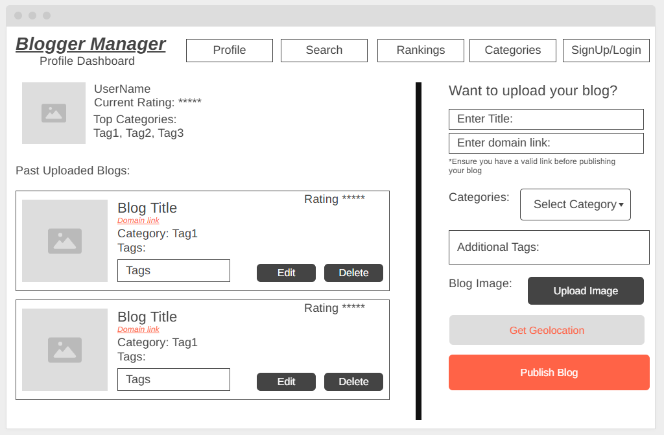
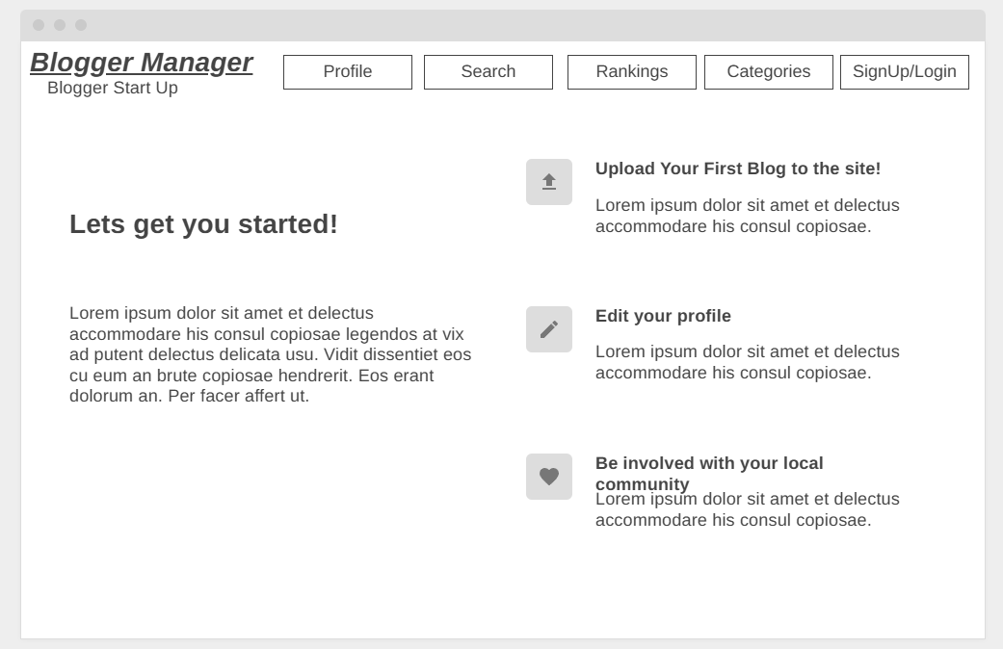
  - Categories and Topic Tags: A drop down of categories and A list of buttons to pick interests like #Food, #Sports, or #Politics.
- Reader Setup: A quicker version that only asks for their favorite topics and general location. Then showcases 4 blogs that cater to their top 4 interests.
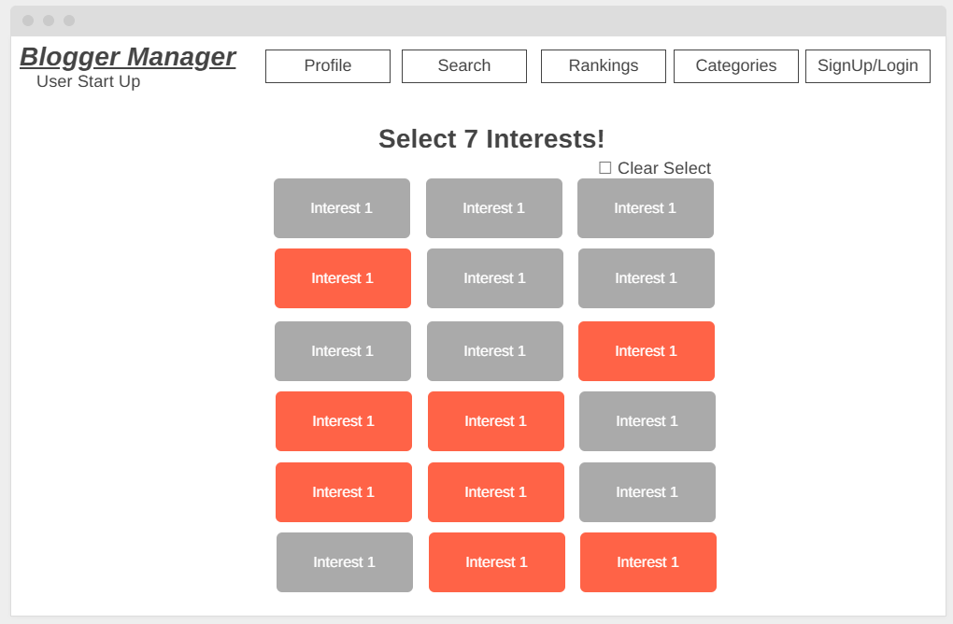
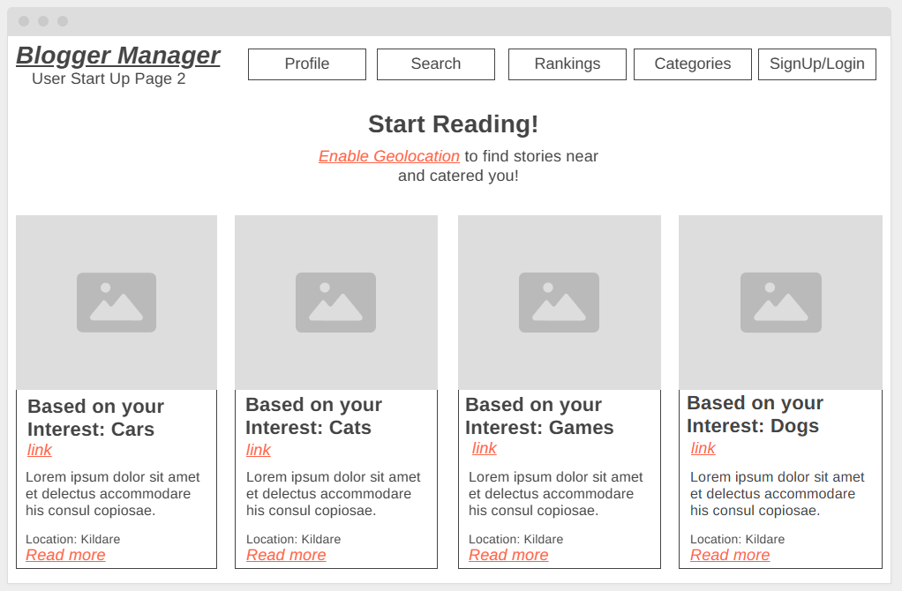

5.3 Moderation Suite
This is a private dashboard for moderators to keep the platform safe and trustworthy.
- Pending Queue: A list of new bloggers waiting to be checked, along with content flagged by users [these can be filtered (e.g. view Users only, view Comments only, or view Reviews only)].
- Review Pane: Allows the moderator to see the blogger’s details and click their link to verify their content. Along with being able to view the content reported without leaving the dashboard.
- Action Buttons: Simple Approve, Deny, or Delete buttons to manage the database in real-time.
- Mass Moderation: Using simple checkboxes, moderators can quickly mass approve/deny/edit/delete content,or sometimes users. The mass Delete function for users is capped at 3 max to prevent any mass deletion of “Pending” users either due to rogue moderators, or accident.
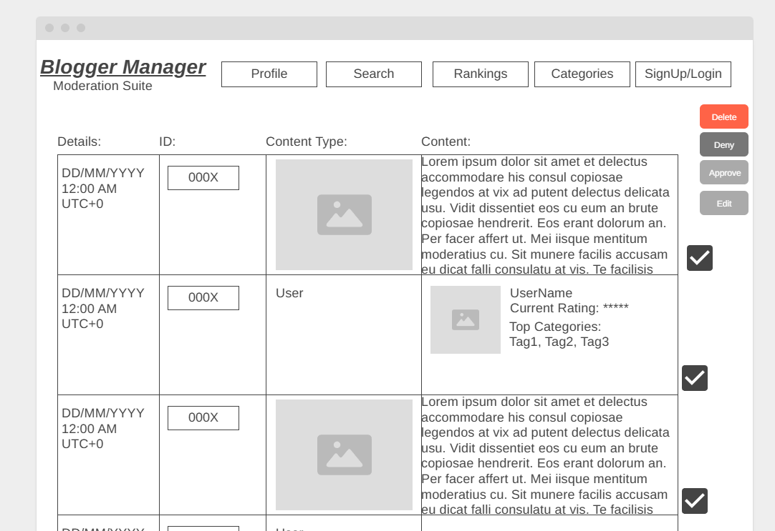

6. Security and Compliance

6.1 Encryption:
Implementation of the AES-256 for PII (Personally Identifiable Information) and in transit via TLS 1.2 or higher in Firestore.

https://www.progress.com/blogs/use-aes-256-encryption-secure-data

6.2 GDPR Compliance:
Automated logic functions to allow users to "Request Data Deletion," which triggers a Cloud Function to wipe all of said users data from the database.

https://en.wikipedia.org/wiki/General_Data_Protection_Regulation

6.3 Digital Services Act (DSA):
Inclusion of a "Notice and Action" reporting mechanism in the GUI to allow users to flag content for moderation.

https://en.wikipedia.org/wiki/Digital_Services_Act

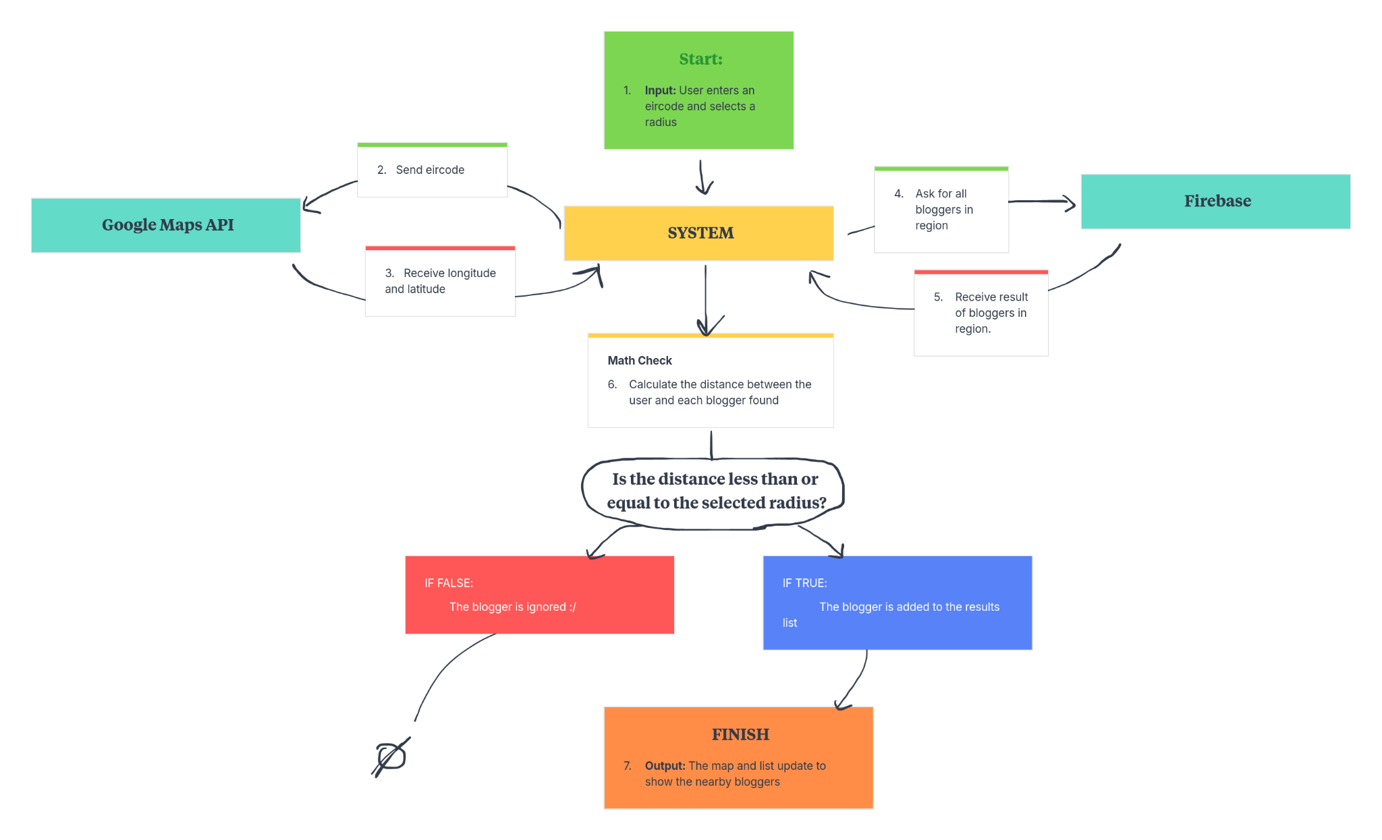
7. Key Algorithms

7.1 Geolocation Search Algorithm:
This algorithm runs whenever a reader wants
to find bloggers near their specific
Eircode or town.

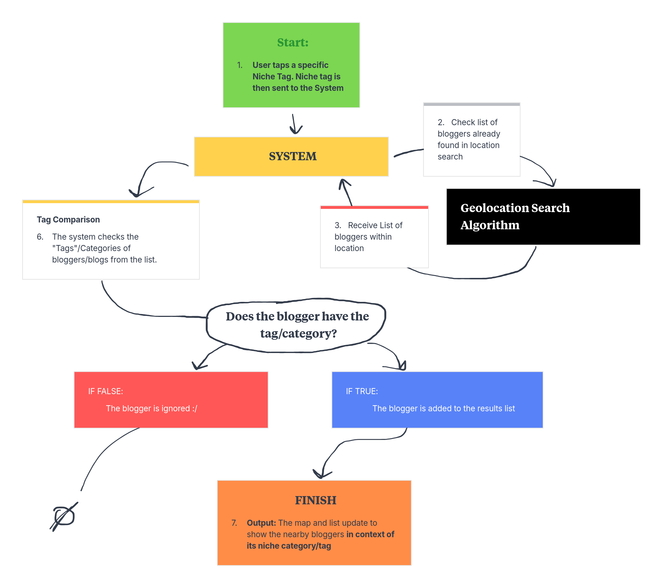
7.2 Niche Tag/Category Matching Algorithm
This flow ensures that the reader only sees
topics they are interested in
(like "Food" or "Politics").

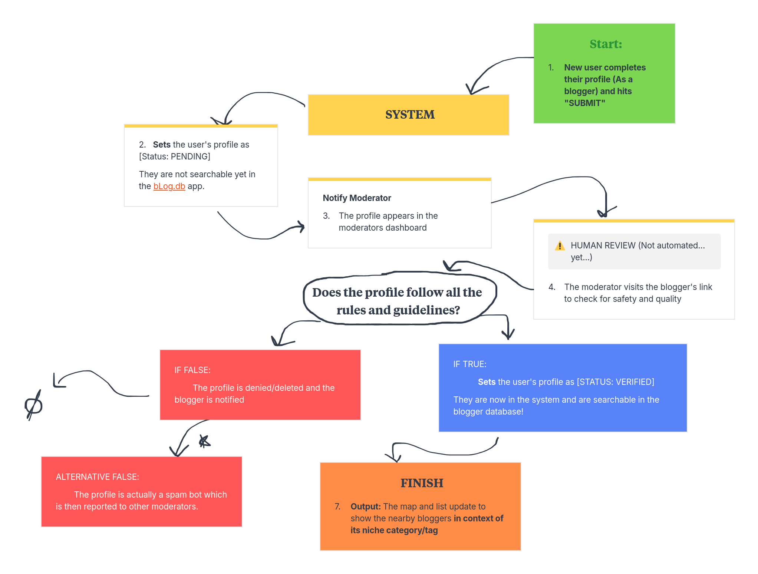
7.3 Moderation (Pending -> Verified/Denied/Deleted) Algorithm
This is the algorithm that ensures only safe,
verified bloggers are visible to the public.

