Supervisor: Gerry Moloney
Institution: South East Technological University
Subject: SD3 Project
Purpose of Submission: Software Engineering 3 Project
Date of Submission:

Blogger Manager - Vision Document
A page that helps people and newspapers to find nearby bloggers based on their location and topics they write about.

C00296913 Reanielle Broas
0. Table of Contents

1. Introduction
1.1 Introduction
1.2 Brief Overview of Project
2. Target Users and Platforms
2.1 Target Users
2.2 Target Platforms
3. Functional Requirements
3.1 Blogger registration
3.2 Searching by Geolocation
3.3 Niche tag searching/categorization
3.4 Moderation suite
4. Non-Functional Requirements
4.1 Security
4.2 Performance
4.3 Reliability
4.4 Portability
4.5 Serviceability/Maintainability
5. Risks
5.1 Data Privacy
5.2 Content Quality and Moderation
5.3 API Costs
5.4 Critical Mass & Network Effect Risk
6. Rough Iteration Plan
7. Rough System Context Diagram
8. Business Model Canvas

Introduction

1.1 Introduction
The purpose of this document is to identify the purpose and scope of the Blogger Manager platform. It provides a roadmap by detailing function/non-functional requirements, identifying potential risks, and outlining an interactive development plan. Furthermore, context diagrams and a Business Model Canvas is provided for our Flutter-based tech to stay in track with our mission: connecting niche local content creators and regional newspaper publishers to thrive together.

1.2 Brief Overview of Project
A web/mobile platform designed to connect niche local content creators and regional newspaper publishers. This would help people find local writers in the area. It’s designed to help small-town bloggers get noticed and to help local newspapers find local stories to share. By using this system, newspapers can discover new talent, and bloggers can reach more people. This is done by using a safe, moderated, searchable, geographic database.

Target Users and Platforms

2.1 Target Users
- Users: Local readers looking for niche-local content.
- Bloggers: Independent content creators looking to grow/increase their visibility.
- Newspaper Agencies: Looking for blogs to publish onto their local papers.

2.2 Target Platforms
- Mobile platform: iOS and Android (built with Flutter/Dart)
- Web platform: Web application (built with Flutter for Web)

Functional Requirements

3.1 Blogger registration
- Self-service page for bloggers to link their social profiles, pages, and the niche categories/tags they're under.

3.2 Searching by Geolocation
- Function that allows users to filter bloggers by their regions (e.g, Kildare) or that are within a specific radius of their own geolocation (e.g, 10km) using GPS or postcodes.

3.3 Niche tag searching/categorization
- A search and tagging system that will allow users to search based on their specific niche interests (e.g, Local Politics, Finances, Cars).

3.4 Moderation suite
- A dedicated admin page for the publishers to review, approve, or delete blogs.

Non-Functional Requirements

4.1 Security
- Any data used for analytics must be anonymized to protect user identity, including customer details, and payment information (involved with the Premium model).
- These personal details must be encrypted to comply with GDPR regulations in Ireland.

4.2 Performance
- The app should be reliable and responsive.
- The app must handle a large amount of concurrent users with any issues with performance, anticipating potential growth in Irish fish consumers.
- A consistent UI/UX across the Flutter app and Web interface to ensure ease of use for non-technical bloggers.

4.3 Reliability
- In the case of data loss in the event of unforeseen events, backups must be made regularly to minimise the damage caused by said unforeseen events. To ensure the reliability and stability of the Blogger Manager system, the system will be thoroughly tested to ensure reliability.

4.4 Portability
- The Blogger Manager system must be developed/designed for cross-platform compatibility, ensuring high performance on low-end hardware, such as budget mobile devices, and older desktop systems. In brief, this can simply be done through optimized rendering, resource efficiency, and adaptive asset management.

4.5 Serviceability/Maintainability
- The maintenance of the Blogger Manager system should be able to be performed by any person with knowledge of the Tech Stack used in developing this project (Flutter, DART).

Risks

5.1 Data Privacy
- By ensuring the handling of geographical data of users is done properly under the GDPR, as the platform will be responsible for the personal data published.

5.2 Content Quality and Moderation
- Maintaining a high standard of moderated content, the absence of moderation or the lack of may result in a lawsuit under the Digital Services Act or possibly under Defamation if a blogger posts a false statement that damages someone’s reputation.

5.3 API Costs
- Heavy reliance on geographical APIs like google maps for distance-based searches can be really expensive to maintain.

5.4 Critical Mass & Network Effect Risk
- The system's value depends on the number of registered bloggers (a.k.a. a “critical mass”). If the initial user base is too small, newspaper publishers will find the geographic search result empty or irrelevant, leading to low retention and a failure of the platform's ecosystem.

Rough Iteration Plan
Iteration 1  Foundation Stuff | Backend & Core Database with Firebase.  Build the Blogger Sign-up form and profile management.  Set up Google Maps to find Eircodes.  Create the database for users and tags.
Iteration 2  Launching the app!!! | Build+Evolve the Map Search screen.  Create the Moderator Dashboard to approve bloggers.  Add "Radius" and "Tag" filters.  Focus on Major Algorithms and Major Interfaces.  Deploy the Web and Mobile apps.
Iteration 3  Non-functional requirements focus.  Making the app safe and fast. | • Make search results load faster (under 2s).  • Add a "Report" button for bad content (DSA law).  • Fix any bugs found after the launch.  • Add "Featured Blogger" badges.

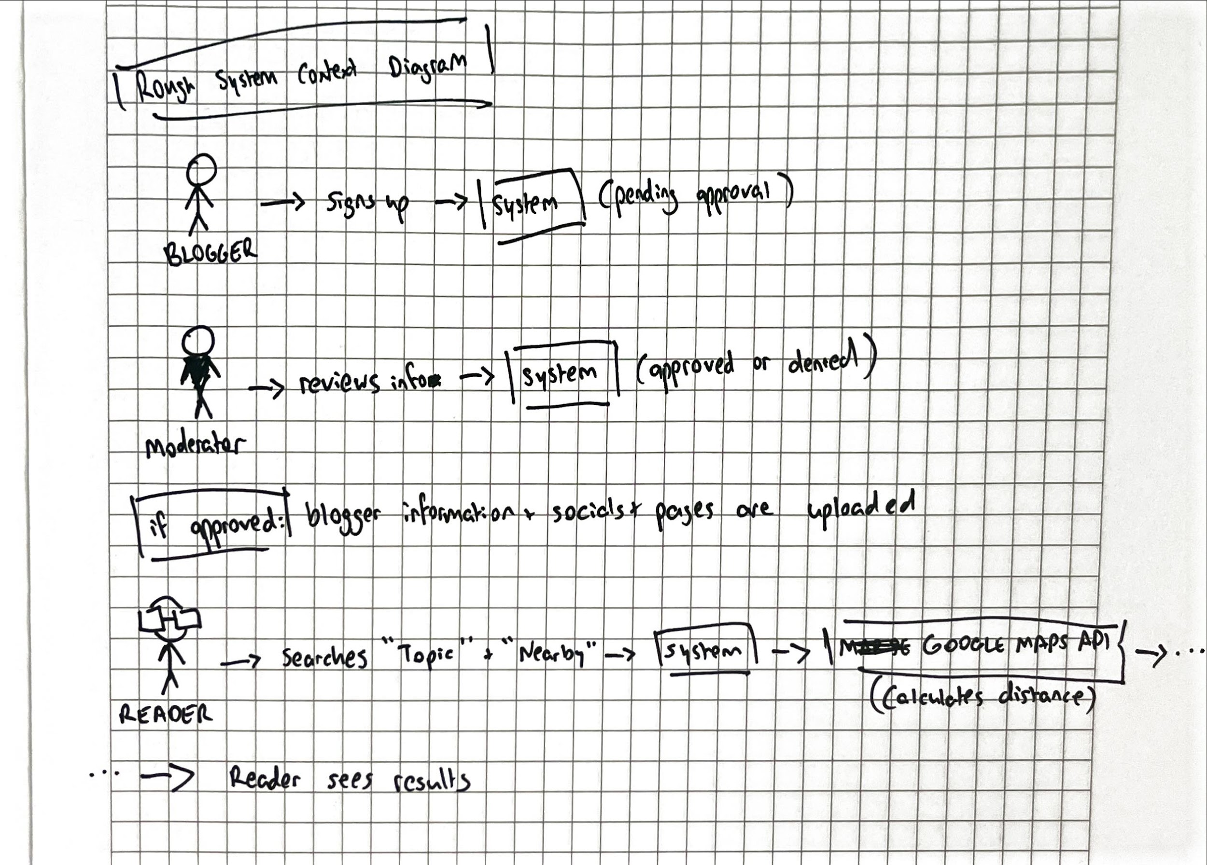
Rough System Context Diagr

Business Model Canvas
Key Partners |  | Key Activities |  | Value Proposition |  | Customer Relationships |  | Customer Segments
Local Newspaper Publishers  Indie Bloggers  Google Maps API  Cloud Host |  | Researching  Design (UX/UI)  Development  Testing  Maintenance  Launch/Marketing  Moderation  Community Management  Customer Support |  | For Creators: Increase visibility for indie bloggers and credibility via newspaper affiliation.  For Users: An application where users can discover niche blogs/content in their local area.  For Newspapers: A low-cost, searchable database to discover verified local writers and stories.  By connecting bloggers and newspapers, we are creating a “trust”. |  | In-App Customer Support  Guaranteed trust & safety through active moderation.  Community Feedback. |  | Local Indie Bloggers  Local Readers  Journalists (for Newspaper)
 |  | Key Resources |  |  |  | Channels
 |  | Backend Database and API  Development Team  Moderation Team  Database of Local Regions |  |  |  | Mobile App  Web Portal
Cost Structure |  |  |  |  | Revenue Stream
Development Costs  Server/Hosting  Maintenance  Moderation (either personnel or software) |  |  |  |  | Sponsorships  Freemium Model

GDPR is a European law that protects personal data by requiring consent, transparency, and security in how business’ collect, store, and use people’s information.
Under new EU rules, platforms must have a clear "notice and action" mechanism. Failing to provide a way for people to report illegal content (like hate speech or harassment) can result in massive fines—up to 6% of your global turnover.

