Supervisor: Gerry Moloney
Institution: South East Technological University
Subject: SD3 Project
Purpose of Submission: Software Engineering 3 Project
Date of Submission: 05/02/2026

Blogger Manager - Specification Document
A page that helps people and newspapers to find nearby bloggers based on their location and topics they write about.

C00296913 Reanielle Broas
0. Table of Contents

1. Introduction
1.1 Use Case Diagram
1.2 Use Case Description
Register Blogger Profile
C.R.U.D* Users
Moderate Content (Approve/Deny/Delete)
Search Blogs by Location & Niche
2. Non-Functional Requirements
2.1 Security
2.2 Performance
2.3 Reliability

2.4 Portability

Introduction

1.1 Use Case Diagram
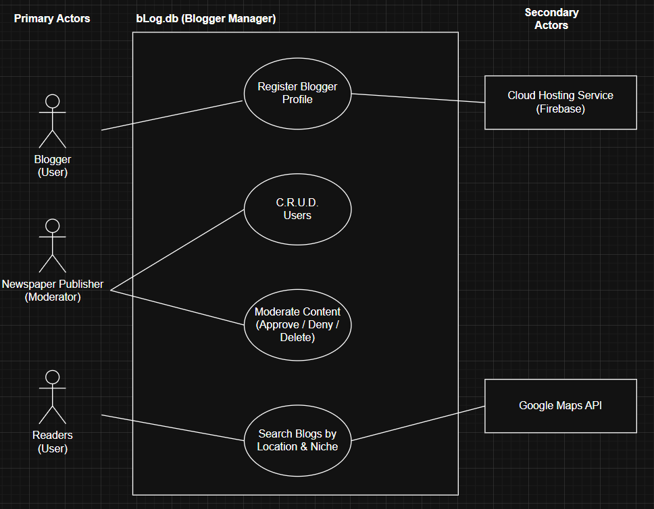
Fig 1.0 Blogger Manager Use Case Diagram, Reanielle Broas (2026)

Use-Case Description

Register Blogger Profile
Actors: Blogger (Users), Cloud Hosting Service (Firebase)
Description: This use case begins when the Blogger wishes to register for a blogger profile. The details in the registration include their email, username, password, domain link to their content, tags/filters of their content, and geolocation. The Blogger Manager application will send this new information to the cloud hosting service. The use case ends when the Blogger has submitted their registration form and it has been sent to the Cloud Hosting Service for Moderators to review.

C.R.U.D* Users
Actors: Newspaper Publisher (Moderator)
Description: This use case begins when the Moderator wishes to Create, Read, Update or Delete User account information. The details of the user include user ID, user email, user password, user geolocation. It may also include blogger domain links to their content, and blogger tags/filters. The Blogger Manager application will send this new information to the cloud hosting service. The use case ends when the user or moderator has finished their work in relation to the user/s account.

Moderate Content (Approve/Deny/Delete)
Actors: Newspaper Publisher (Moderator)
Description: This use case begins when the Moderator wishes to Approve/Deny/Delete content from the Blogger Manager. The details of content differ as it can either be Blogs (titles, domain link, tags, geolocation), Reviews (title, message), or Comments (message), content will also be associated with the User ID. The application will send this new information to the backend database. The use case ends when the Moderator has finished their work in relation to the content.

Search Blogs by Location & Niche
Actors: Readers (Users), Google Maps API
Description: This use case begins when the Reader wishes to search for a blog by its location (radius, or definite), or niche tag/category filter/s. The details of the blogs include title, domain link, tags, and geolocation. The use case ends when the blogs are returned to the Reader for viewing, filtered by the readers criteria.

* Create, Read, Update, and Delete (C.R.U.D.).

Detailed Use Case

Register Blogger Profile
Actors: Blogger (Users), Cloud Hosting Service (Firebase)
Main success Scenario:
- This use case begins when the Blogger wishes to register for a blogger profile.
- The details in the registration include their email, username, password, domain link to their content, tags/filters of their content, and geolocation.
- The Blogger Manager application will send this new information to the cloud hosting service.
- The use case ends when the Blogger has submitted their registration form and it has been sent to the Cloud Hosting Service for Moderators to review.
Alternatives:

C.R.U.D* Users
Actors: Newspaper Publisher (Moderator)
Main success Scenario:
- This use case begins when the Moderator wishes to Create, Read, Update or Delete User account information.
- The details of the user include user ID, user email, user password, user geolocation. It may also include blogger domain links to their content, and blogger tags/filters.
- The Blogger Manager application will send this new information to the cloud hosting service.
- The use case ends when the user or moderator has finished their work in relation to the user/s account.
Alternatives:

Moderate Content (Approve/Deny/Delete)
Actors: Newspaper Publisher (Moderator)
Main success Scenario:
- This use case begins when the Moderator wishes to Approve/Deny/Delete content from the Blogger Manager.
- The details of content differ as it can either be Blogs (titles, domain link, tags, geolocation), Reviews (title, message), or Comments (message), content will also be associated with the User ID.
- The application will send this new information to the backend database.
- The use case ends when the Moderator has finished their work in relation to the content.
Alternatives:

Search Blogs by Location & Niche (Brief is here)
Actors: Readers (Users), Google Maps API
Main success Scenario:
- This use case begins when the Reader wishes to search for a blog by its location (radius, or definite), or niche tag/category filter/s.
- The details of the blogs include title, domain link, tags, and geolocation.
- The use case ends when the blogs are returned to the Reader for viewing, filtered by the readers criteria.
Alternatives:

Non-Functional Requirements

2.1 Security
- Any data used for analytics must be anonymized to protect user identity, including customer details, and payment information (involved with the Premium model).
- These personal details must be encrypted to comply with GDPR regulations in Ireland.

2.2 Performance
- The app should be reliable and responsive.
- The app must handle a large amount of concurrent users with any issues with performance, anticipating potential growth in Irish fish consumers.
- A consistent UI/UX across the Flutter app and Web interface to ensure ease of use for non-technical bloggers.

2.3 Reliability
- In the case of data loss in the event of unforeseen events, backups must be made regularly to minimise the damage caused by said unforeseen events. To ensure the reliability and stability of the Blogger Manager system, the system will be thoroughly tested to ensure reliability.

2.4 Portability
- The Blogger Manager system must be developed/designed for cross-platform compatibility, ensuring high performance on low-end hardware, such as budget mobile devices, and older desktop systems. In brief, this can simply be done through optimized rendering, resource efficiency, and adaptive asset management.

GDPR is a European law that protects personal data by requiring consent, transparency, and security in how business’ collect, store, and use people’s information.

