Supervisor: Gerry Moloney
Institution: South East Technological University
Subject: SD3 Project
Purpose of Submission: Software Engineering 3 Project
Date of Submission: 22/01/2026

Blogger Manager - Vision Document (DRAFT)
A page that helps people and newspapers to find nearby bloggers based on their location and topics they write about.

C00296913 Reanielle Broas

Brief Overview:
A web/mobile platform designed to connect niche local content creators and regional newspaper publishers. This would help people find local writers in the area. It’s designed to help small-town bloggers get noticed and to help local newspapers find local stories to share. By using this system, newspapers can discover new talent, and bloggers can reach more people. This is done by using a safe, moderated, searchable, geographic database.

Target Users & Platform
Target Users:
- Users: Local readers looking for niche-local content.
- Bloggers: Independent content creators looking to grow/increase their visibility.

Platform:
- Mobile platform: iOS and Android (built with Flutter/Dart)
- Web platform: Web application (built with Flutter for Web)

Functional features
Blogger registration
- Self-service page for bloggers to link their social profiles, pages, and the niche categories/tags they're under.
Searching by Geolocation
- Function that allows users to filter bloggers by their regions (e.g, Kildare) or that are within a specific radius of their own geolocation (e.g, 10km) using GPS or postcodes.
Niche tag searching/categorization
- A search and tagging system that will allow users to search based on their specific niche interests (e.g, Local Politics, Finances, Cars).
Moderation suite
- A dedicated admin page for the publishers to review, approve, or delete blogs.

Non-Functional Characteristics

Security,
- Any data used for analytics must be anonymized to protect user identity, including customer details, and payment information (involved with the Premium model).
- These personal details must be encrypted to comply with GDPR regulations in Ireland.

Performance,
- The app should be reliable and responsive.
- The app must handle a large amount of concurrent users with any issues with performance, anticipating potential growth in Irish fish consumers.
- A consistent UI/UX across the Flutter app and Web interface to ensure ease of use for non-technical bloggers.

- The app must handle a large amount of concurrent users with any issues with performance, anticipating potential growth in Irish fish consumers.
- A consistent UI/UX across the Flutter app and Web interface to ensure ease of use for non-technical bloggers.

Main Project Risks
- Data Privacy, ensuring the handling of geographical data of users are done properly under the GDPR.
- Content Quality, maintaining a high standard of moderated content.
- API Costs, heavy reliance on geographical APIs like google maps for distance-based searches can be really expensive to maintain.
- The system's value depends on the number of registered bloggers.

Rough Iteration Plan

Iteration 1 | Backend & Core Database
Iteration 2 | Blogger forms and profile management
Iteration 3 | Search function & Geolocation stuff
Iteration 4 | Admin dashboard for blocking/approving content
Iteration 5 | UX & Launching the application

Rough System Context Diagram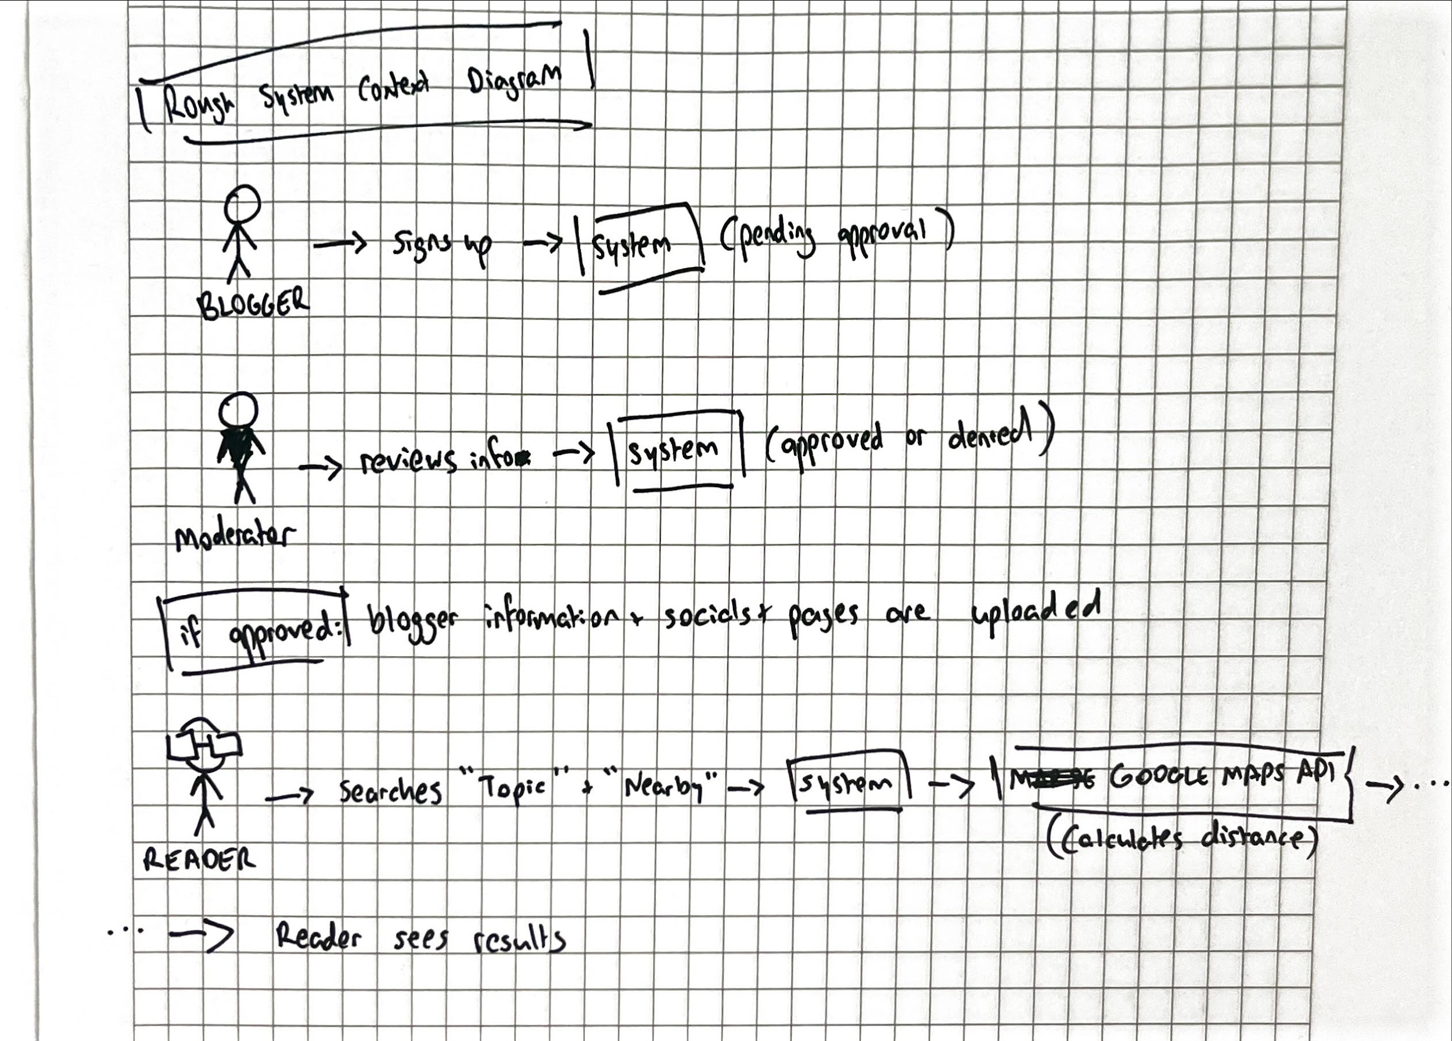

Business Model Canvas - Fish for Thoughts
Key Partners |  | Key Activities |  | Value Proposition |  | Customer Relationships |  | Customer Segments
Local Newspaper Publishers  Indie Bloggers  Google Maps API  Cloud Host |  | Researching  Design (UX/UI)  Development  Testing  Maintenance  Launch/Marketing  Moderation  Community Management  Customer Support |  | Increase visibility for indie bloggers and credibility via newspaper affiliation.  An application where users can discover niche blogs/content in their local area. |  | In-App Customer Support  Guaranteed trust & safety through active moderation. |  | Local Indie Bloggers  Local Readers  Journalists (for Newspaper)
 |  | Key Resources |  |  |  | Channels
Backend Database and API

Development Team

Moderation Team

Database of Local Regions
Cost Structure |  |  |  |  | Revenue Stream
Development Costs  Server/Hosting  Maintenance  Moderation (either personnel or software) |  |  |  |  | Sponsorships  Freemium Model

GDPR is a European law that protects personal data by requiring consent, transparency, and security in how business’ collect, store, and use people’s information.

