Y2 Project - StudentHub

SQL DOCUMENTATION

C00296913 - Reanielle Broas

Database Used: SQLite

# CREATE SQL:

CREATE USERS

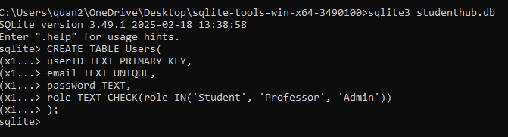

CREATE COURSES

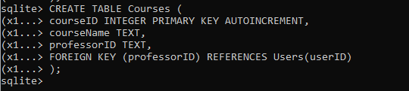

CREATE GRADES

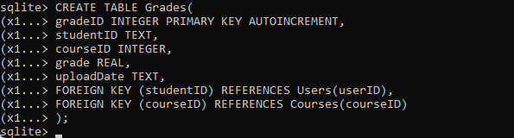

CREATE NOTES

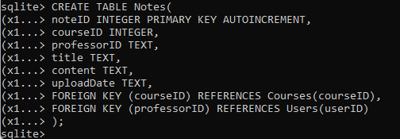

CREATE TIMETABLE

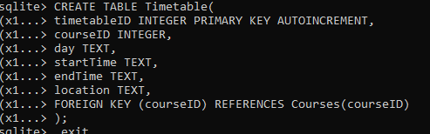

.schema

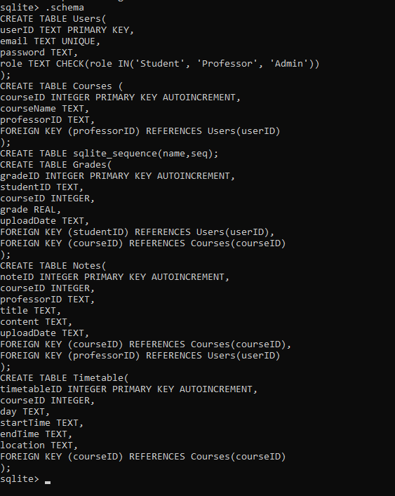

# INSERTING TEST DATA:

# DATABASE TABLES:

SELECT * FROM USERS

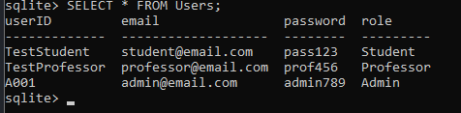

SELECT * FROM COURSES

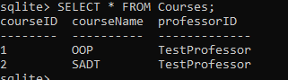

SELECT * FROM GRADES

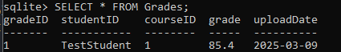

SELECT * FROM NOTES

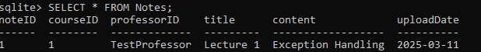

SELECT * FROM TIMETABLE

