Module 1 Revision 1
Part 1 Listening（听力部分）30%
Ⅰ. Listen and choose（听一听，选出听到的内容，将字母代号写在前面的括号内）：5%
( ) 1. | A. /ə'pɑ:tmənt | B. /'peimənt/ | C. /'peivmənt /
( ) 2. | A. / 'krɔ:s / | B. / ə'krɔ:s / | C. /'krɔs.əuvə /
( ) 3. | A. / 'pju:pl / | B. /'su:pə / | C. /'pə:pl /
( ) 4. | A. across | B. cross | C. crossing
( ) 5. | A. feet | B. foot | C. walk
Ⅱ. Listen and choose（听一听，选出听到的句子，将字母代号写在前面的括号内）：4%
( ) 1. | A. There is a sports meeting in the forest on a big mountain.
 | B. There is a sports meeting in the zoo behind a big mountain.
 | C. There is a sports meeting in the zoo in front of a small mountain.
( ) 2. | A. A fox, a baby panda and some small animals are sitting under the trees.
 | B. A fox, a baby panda and some big animals are standing.
 | C. A fox, a baby panda and some small animals are standing under the trees.
( ) 3. | A. My two sisters are students of No.1 school.
 | B. My two sisters are teachers of No.1 school.
 | C. My two brothers are students of No.1 school.
( ) 4. | A. Don’t throw any snow on that road.
 | B. Don’t throw any toys on that highway.
 | C. Don’t litter on that road.
Ⅲ. Listen and choose（听问句，选答句；听答句，选问句，将字母代号写在前面的括号内）： 4%
( ) 1. A. I like Monday. B. I like Maths. C. I like sunny.
( ) 2. A. By bus. B. At seven. C. Take a bus.
( ) 3. A. There are 20. B. 20 yuan. C. They are 20.
( ) 4. A. Miss Fang. B. Miss Fang’s. C. Yes, it’s Miss Fang’s.
Ⅳ. Listen and number（根据听到的顺序，用“1---5”给下列句子编号）：5%
( ) Today is Saturday. It’s sunny. It’s on the eleventh of February.
( ) Now he is making two invitations for his birthday party.
( ) One is for Peter and one is for Tom. Peter and Tom are his good friends.
( ) They are in the same class.
( ) Eddie is at home. Tomorrow is his birthday. He’s thirteen years old.
Ⅴ. Listen and choose（听小对话和问题，选择最佳答案，将字母代号写在前面的括号内）：4%
( ) 1. | A. I can stop. | B. I can go. | C. I can wait.
( ) 2. | A. Yes, he can. | B. Yes, she can. | C. No, she can’t.
( ) 3. | A. At 7:00. | B. At 7:30. | C. At 8:00.
( ) 4. | A. She is sad. | B. She is happy. | C. She is sick.
Ⅵ. Listen and write（听一听，填入所缺单词完成短文，每线一词）：4%
Deserts get very little rain, so they are very __________. In a desert, it is very ________ during the day and very __________at night. There are __________and insects in deserts. The largest desert in the world is the Sahara.
Ⅶ. Listen and judge（听短文，判断正误，用T或F表示）：4%
( ) 1. There are eleven different names for Chinese years.
( ) 2. The evening before the Spring Festival is the Eve in Chinese year
( ) 3. People go shopping and clean the house before the Spring Festival.
( ) 4. Dumplings are the favorite food for Chinese people on the Eve.

Part 2 Reading and writing（笔试部分）70%
Ⅰ. Copy the sentences（正确抄写下列句子，注意大小写和标点符号）：4%
wait for the green light please dont go across the road now
_____________________________________________________________________
Ⅱ. Look and write（根据图意完成句子，每线一词）：6%
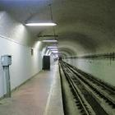 | 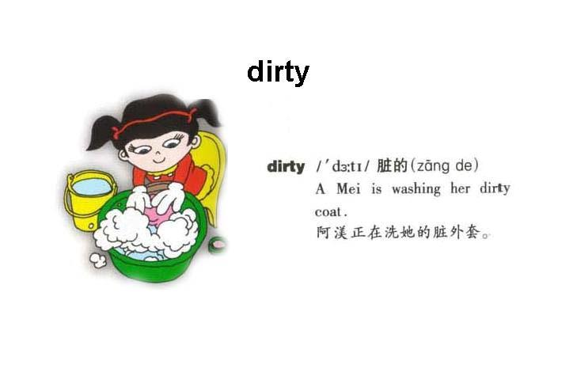 | 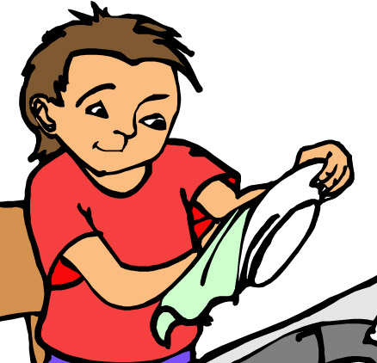 | 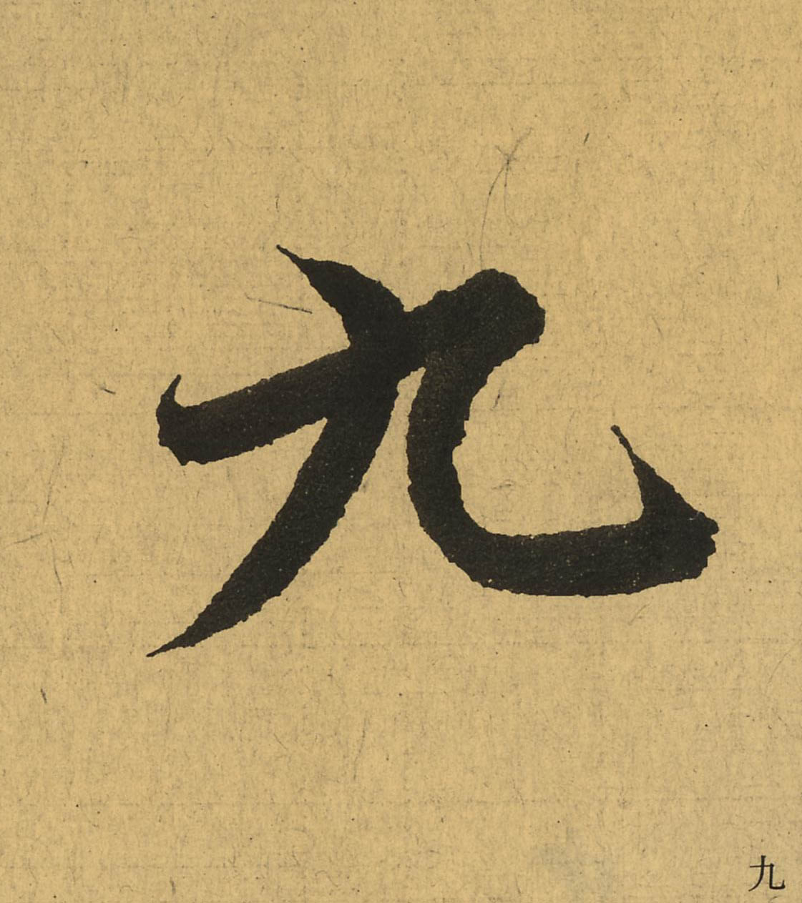  月 | 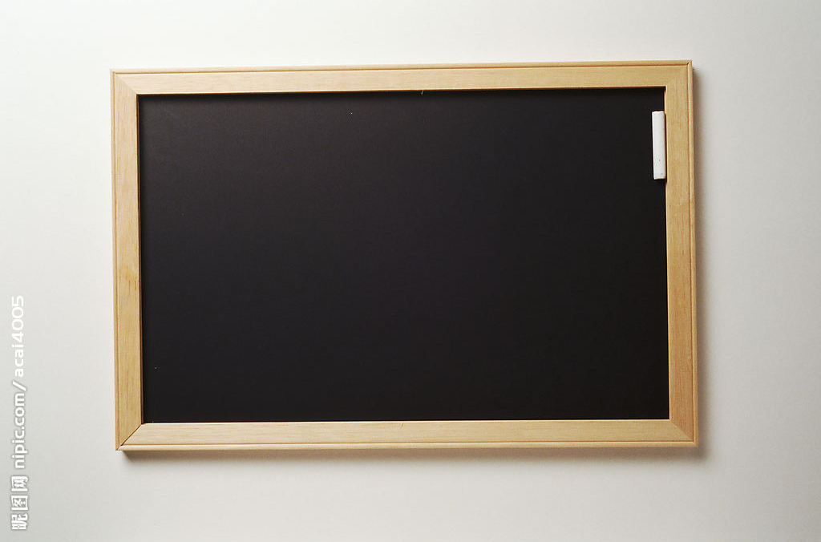 | 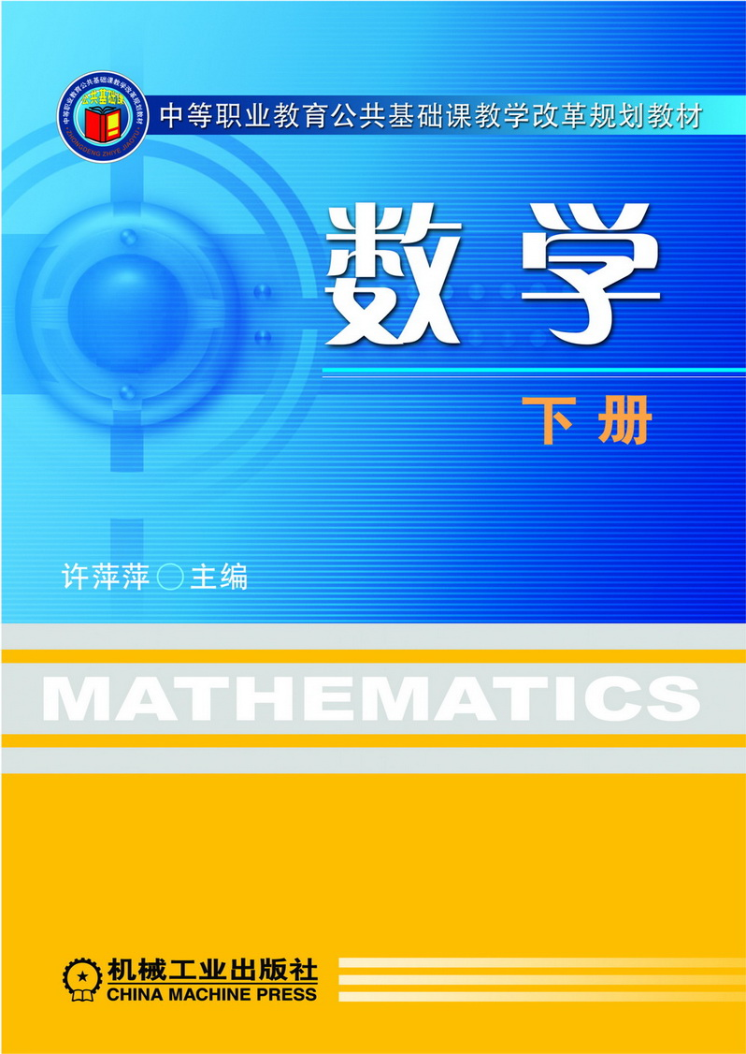
(1) | (2) | (3) | (4) | (5) | (6)
1. Mr. Wang and his friends are waiting for the train at the underground s____________.
2. This dress is very nice but it’s too d_____________. Let me wash it now.
3. John’s father w______________ the dishes after dinner every day.
4. September is the n_____________ month of a year.
5. It’s black. It’s a rectangle. We can write on it. It’s a b___________.
6. We have two lessons on Monday afternoon. They are Chinese and M_____________.
Ⅲ. Read and choose（语音判断，将不含有所给音标的单词的编号写在前面的括号内）：4%
( ) 1./ i:/ A. these B. sleep C. head ( ) 2. /sk/ A. skip B. dusk C. skateboard
( ) 3. /tʃ/ A. school B. chair C. cheap ( ) 4. / au/ A. blouse B. window C. how
Ⅳ. Choose the best answer（用to be ,to have填空，每词限用一次）：6%
1. --- Do you _____________any lessons on Saturday? --- No, I don’t.
2. I want to ___________ a pupil of Garden Middle School.
3. _____________ there any juice in the bottle?
4. ___________ the nice paints on the wall your sister’s? --- Yes, they’re hers.
5. My little brother ___________ many toy cars.
6. There ____________ going to be a football match in the playground.
Ⅴ. Read and fill in the blanks（用所给单词的适当形式填空，每线词数不限）：6%
1. I _____ (go) to school at seven every morning. Betty _____ (go) at a quarter past seven.
2. Listen, the girls __________ (read) the third lesson.
3. Tom, _________________ (not jump) into the pond. It’s dangerous.
4. --- What time __________ Ben __________ (wash) his face? --- At six o’clock.
5. --- Let’s __________ (swim and dive) in this big pool. --- O.K.
Ⅵ. Read and choose （选择最佳答案，将字母代号写在前面的括号内）：10%
( ) 1. --- How many _________ are there in your party? --- 14.
A. child B. pupil C. children
( ) 2. The cat likes __________. The dog likes _________.
A. mouse…rice B. fish…leaves C. mice…bones
( ) 3. --- What’s your pet’s name? --- _________ name is Sam.
A. My B. Its C. It’s
( ) 4. No _________. We can’t stop our cars here.
A. cars B. parking C. stop
( ) 5. Peter and Danny are _________ biscuits under the tree.
A. eat B. eating C. eats
( ) 6. --- What is the little baby doing in the basket? --- _____________
A. He’s walking. B. He’s reading. C. He’s sleeping.
( ) 7. --- Where are the boys playing football? --- _____________
A. In the classroom. B. In the playground. C. In the office.
( ) 8. --- _________ those crayons thick? --- Yes.
A. Are B. Is C. Be
( ) 9. --- _________does your sister want to _________? --- A nurse.
A. What …be B. Which …do C. What….do
( ) 10. --- _________ sketch-books are these? --- Jim’s.
A . Who B. Who’s C. Whose
Ⅶ. Read and write（读一读，填入适当的单词完成句子，首字母已给，每线一词）：6%
1. Mary gets up at six o’clock every morning. She r_________ her bicycle to school at 7:00.
2. After supper she h___________ her mother to wash some dishes.
3. We are in Grade One. B_______ he’s in Class Two. I’m in Class Three.
4. Miss Gao and Mr. Wang are our good teachers. They’re b__________ young.
5. Danny doesn’t l____________ near school.
6. It’s black. It’s a rectangle. We can write on it. It’s a b___________.
Ⅷ. Rewrite the sentences（按要求改写下列句子，每线词数不限）：10%
1. I want to be a teacher.（划线部分提问）______________________________________
2. Look at the traffic light, please.（改成否定句）_________________________________
3. I arrive at school at 7:45.（划线部分提问）____________________________________
4. Alice and I always walk to school together.（换种说法，意思不变）__________________
5. I’m going to be a writer in the future.（写出问句）________________________________
Ⅸ. Reading comprehension（阅读理解）：12%
A. Read and judge（阅读短文，判断正误，用T或F表示）：4%
Hello. I’m Jenny. This is a picture of our skiing vacation. We are having a lovely time. It’s cold, and it’s snowing.
My mom and dad are very good at skiing. They are having a race through the trees. My dad is winning.
I am learning to ski. It’s difficult, but it’s fun. I’m laughing. My new friend Liz is next to me. She isn’t very good at skiing. She is falling over.
My brother Tony is building a snowman. My sister Sally is watching. She isn’t helping. She’s drinking hot chocolate!
( ) 1. The family is at the beach.
( ) 2. It is snowing.
( ) 3. Jenny has a new friend.
( ) 4. Jenny’s mom and dad can’t ski.
B. Read and choose（阅读短文，选择最佳答案，将字母代号写在前面的括号内）：4%
Mom and Dad always have a party on New Year’s Eve. They invite all their friends to our house. There is lots of food and drink.
Tom and I love New Year’s Eve. On other nights, we go to bed at eight o’clock. But on New Year’s Eve, we can stay up until after midnight!
Just before midnight, everyone counts the seconds until twelve o’clock. We all shout, ”Ten… nine …eight… seven…six…five…four… three…two…one.” And then everyone shouts, “Happy New Year!” We all hold hands and sing a song about good friends. Soon after that, Tom and I go to bed. New Year’s Eve is the best night of the year!
( ) 1. Who comes to the New Year’s Eve party?
A. School friends B. Tom’s school friends C. Parent’s friends
( ) 2. How many seconds do the people count until twelve o’clock? A.7 B. 10 C.12
( ) 3. What time do Alice and Tom go to bed on other nights?
A. At seven o’clock. B. At eight o’clock. C. At twelve o’clock.
( ) 4. Are there much food at home on New Year’s Eve?
A. Yes. B. No. C. I don’t know.
C. Fill in the blanks about the story（阅读短文，填空，每线词数不限）：4%
Richie feels terrible. He has a sore throat（嗓子）. And he has a headache. And he feels very tired. Mum says he needs to see the doctor. The doctor says, ”Your throat looks very red, Richie. You have a bad cold. Go home and go to bed. Don’t go to school today or tomorrow. Don’t talk too much. And drink lots of water. Take the medicine every morning and every night.”
1. Richie’s throat is very ____________.
2. Richie is ill. He has ________________.
3. The doctor tells Richies to stay home from school for ____________ days.
4. The doctor tells Richies to get some ____________twice a day（每天两次）.
Ⅹ. Write（请以“My daily life”为主题加以简单描述，要求意思连贯，语句通顺。要求不少于30个单词，不少于2--3种句型）：6%
My daily life

Module 1 Revision
Part 1 Listening（听力部分）
Ⅰ. Listen and choose（听一听，选出听到的内容，将字母代号写在前面的括号内）：
1. Wait on the pavement.
2. Go across the road.
3. I’m a pupil of Garden Primary School.
4. Look left and look right before you cross the road.
5. Mr Yang goes to work on foot every day.
(1. C 2. B 3. A 4. B 5. B )
Ⅱ. Listen and choose（听一听，选出听到的句子，将字母代号写在前面的括号内）：
1. There is a sports meeting in the zoo behind a big mountain.
2. A fox, a baby panda and some small animals are standing under the trees.
3. My two sisters are students of No.1 school
4. Don’t throw any toys on that highway.
(1. B 2. C 3. A 4. B)
Ⅲ. Listen and choose（听问句，选答句；听答句，选问句，将字母代号写在前面的括号内）：
1. Which subject do you like?
2. When do you go to school in the morning?
3. How many boys are there in your class?
4. Is this bag Miss Fang’s?
(1. B 2. B 3. A 4. C)
Ⅲ. Listen and number（听一听，用“1—5”给下列句子编号）：
Today is Saturday. It’s sunny. It’s on the eleventh of February. Eddie is at home. Tomorrow is his birthday. He’s thirteen years old. Now he is making two invitations for his birthday party. One is for Peter and one is for Tom. Peter and Tom are his good friends. They are in the same class. Peter and Tom want to give Eddie a robot because Eddie likes robots very much.
（13452）
Ⅴ. Listen and choose（听小对话和问题，选择最佳答案，将字母代号写在前面的括号内）：
1. A: Look, the traffic lights become yellow.
B: Oh, yes.
Q: What can you do?
2. A: It’s dinner time. Lily and Ben want to have dinner. Lily wants to have some noodles.
B: How about Ben?
A: He likes to have some sweets.
Q: Does Lily want to have sweets?
3. A: Hi, I’m Ben. I go to school at seven in the morning.
B: When do you do your homework?
A: I always do my homework at half past seven.
Q: What time does Ben go to school?
4. A: Today is Sunday. But Judy is sad.
B: What is she sad?
A: Because she is ill. She is in bed.
B: I’m sorry to hear that.
Q: How is Judy today?
(1. C 2. C 3. A 4. C)
Ⅳ. Listen and fill in the blanks（听一听，填入所缺的单词完成短文，每线一词）：
Deserts get very little rain, so they are very dry. In a desert, it is very hot during the day and very cool at night. There are many plants and insects in deserts. The largest desert in the world is the Sahara.
(1. dry 2. hot 3. cool 4. plants)
Ⅴ. Listen and judge（听短文，判断正误，用T或F表示）：
The Spring Festival is our Chinese people’s festival. There are different names for each year. We all call it the year of monkey, the year of dog… and this year is the year of Chicken.
Before the day of the festival, people are busy shopping and cleaning. On the Eve, there is a big family dinner. After dinner, all the family stay up late to welcome the new year. In the middle of the night, we have some dumplings and watch TV. On the first day of the New Year, people wear new clothes to visit their relatives and say “Happy New Year” to each other.
(1. F 2. T 3. T 4. T)

Part 2 Reading and writing（笔试部分）
Ⅰ. Wait for the green light, please. Don't go across the road now.
Ⅱ. 1. station 2. dirty 3. washes/ dries 4. ninth 5. blackboard 6. Maths
Ⅲ. 1. C 2. B 3. A 4. B
Ⅳ. 1. have 2. be 3. Is 4. Are 5. has 6. is
Ⅴ. 1. go, goes 2. are reading 3. don’t jump 4. does , wash 5. swim and dive
Ⅵ. 1. C 2. A 3. B 4. B 5. B 6. C 7. B 8. A 9. A 10. C
Ⅶ. 1. rides 2. helps 3. But 4. both 5. live 6. blackboard
Ⅷ. 1. What do you want to be?
2. Don’t look at the traffic light, please.
3. What time do you arrive at school?
4. Alice and I always go to school on foot together.
5. What are you going to be in the future?
Ⅸ. A. 1. F 2. T 3. F 4. F
B. 1. C 2. B 3. B 4. A
C. 1. red 2. a headache/ a bad cold 3. two/ 2 4. medicine
Ⅹ. Omitted

