Module 1 Unit1
Part 1 Listening（听力部分）30%
Ⅰ. Listen and choose（听一听，选出听到的内容，将字母代号写在前面的括号内）：5%
( ) 1. | A. /fif/ | B. /'fifti/ | C. /fifθ/
( ) 2. | A. / fə:st / | B. / fəst / | C. / fɑ:st /
( ) 3. | A. / 'pɑ:ti / | B. / pɑ:t / | C. / pɔ:t /
( ) 4. | A. invitation | B. invite | C. interesting
( ) 5. | A. eight | B. eighth | C. eighteenth
Ⅱ. Listen and choose（听一听，选出听到的句子，将字母代号写在前面的括号内）：4%
( ) 1. | A. Welcome to my ‘orange’ party. B. Welcome to Peter’s ‘red’ party.
 | C. Welcome to Peter’s show.
( ) 2. | A. There are twelve months in a year. January is the first.
 | B. There are three months in winter. January is the first.
 | C. There are twelve months in a year. December is the twelfth.
( ) 3. | A. The next morning, Mum sees a card on the bed.
 | B. The next morning, I see a beautiful dress on the bed.
 | C. The next morning, Mum sees some flowers on the table.
( ) 4. | A. When does the birthday party begin? B. When does the wedding party begin?
 | C. When does the New Year party begin?
Ⅲ. Listen and choose（听问句，选答句；听答句，选问句，将字母代号写在前面的括号内）： 4%
( ) 1. | A. It’s on twenty-fifth of April. | B. No, it’s on twenty-fifth of April.
 | C. It’s on Wednesday.
( ) 2. | A. Thank you. | B. Yes, I’d love to. C. No, I can't go.
( ) 3. | A. A red hat. | B. a pair of yellow shoes. C. Some grass.
( ) 4. | A. Which month the last month of spring?
 | B. Which month is the third month in a year?
 | C. Which month comes after April?
Ⅳ. Listen and number（根据听到的顺序，用“1---5”给下列句子编号）：5%
( ) She can draw very well. She draws a picture of her family and some nice flowers on the card.
( ) Lisa wants to give her mother a birthday present.
( ) She wants to make something by herself. It’s late at night. She is still drawing a card.
( ) The next morning, Mum sees the nice card on the table.
( ) Today is the 28th of January. It’s Saturday.
Ⅴ. Listen and choose（听小对话和问题，选择最佳答案，将字母代号写在前面的括号内）：4%
( ) 1. | A.Room201,Building8,456Xinhua Road. |  | B. Room 202, Building 8, 456 Xinhua Road.
 | C. Room 202, Building 7, 456 Xinhua Road.
( ) 2. | A. eight | B. eighteenth C. eighteen
( ) 3. | A. write | B. draw C. draw and write
( ) 4. | A. on the first of April | B. Monday C. We can make some jokes with friends.
Ⅵ. Listen and write（听一听，填入所缺单词完成短文，每线一词）：4%
It’s __________ to give friends something on their birthdays. Peter and Bob like to give each other funny things. On Bob’s birthday, Peter __________ him shoes with flowers. Bob says, ”I want to give Peter something funny too.”
Peter’s birthday is __________. Bob gives him a big box. In the box there is a toy duck. The duck has a flower on its head. They both ____________.
Ⅶ. Listen and judge（听短文，判断正误，用T或F表示）：4%
( ) 1. Here's a picture of my class. There are four people in my family.
( ) 2. Father’s birthday is on the first of July.
( ) 3. Mother’s thirty-eight years old.
( ) 4. I’m twelve years old.
Part 3 Reading and writing（笔试部分）70%
Ⅰ. Copy the sentences（正确抄写下列句子，注意大小写和标点符号）：4%
when is your grandpas birthday its on the third of july
_____________________________________________________________________
Ⅱ. Look and write（根据图意完成句子，每线一词）：6%
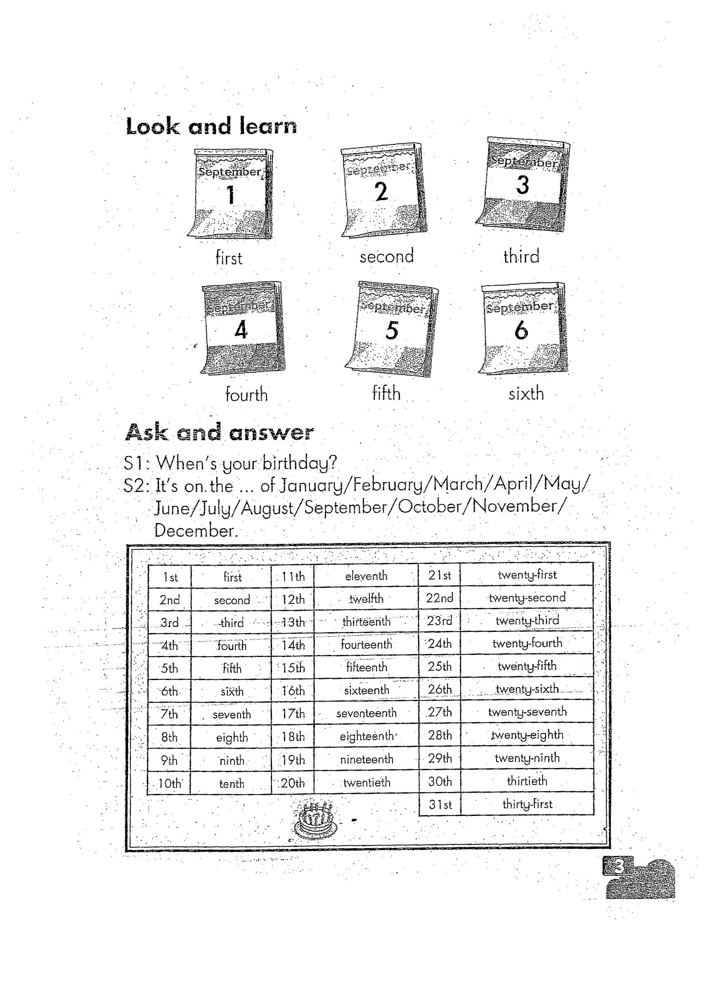  九月 |  | 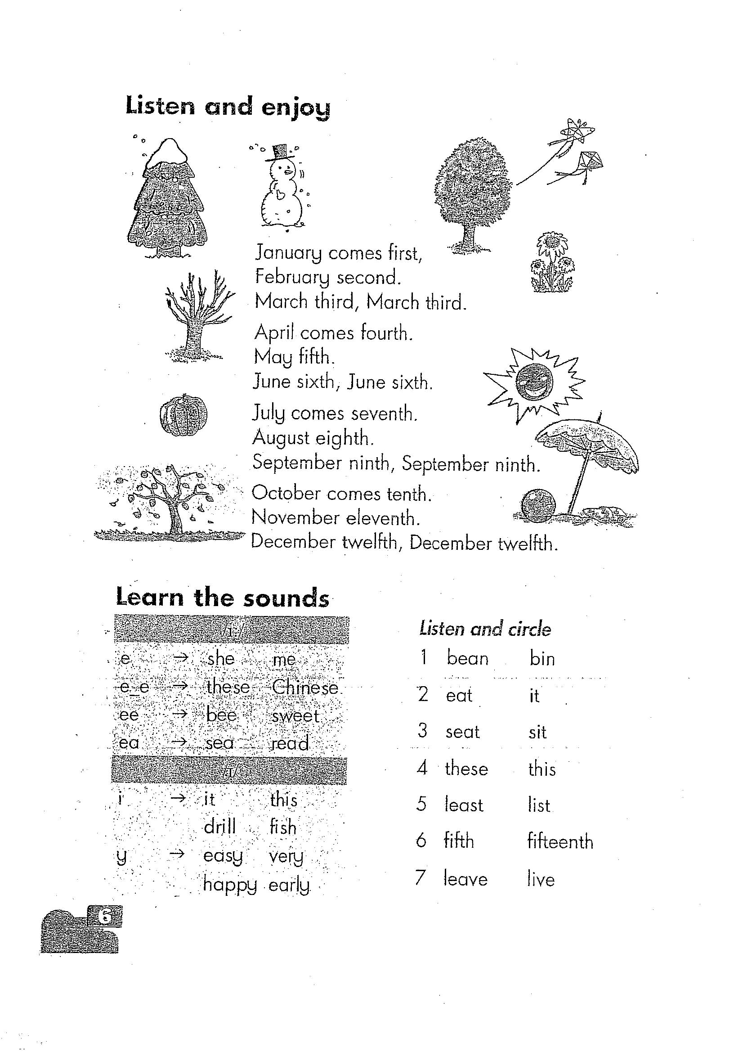 |   5.12 |  | 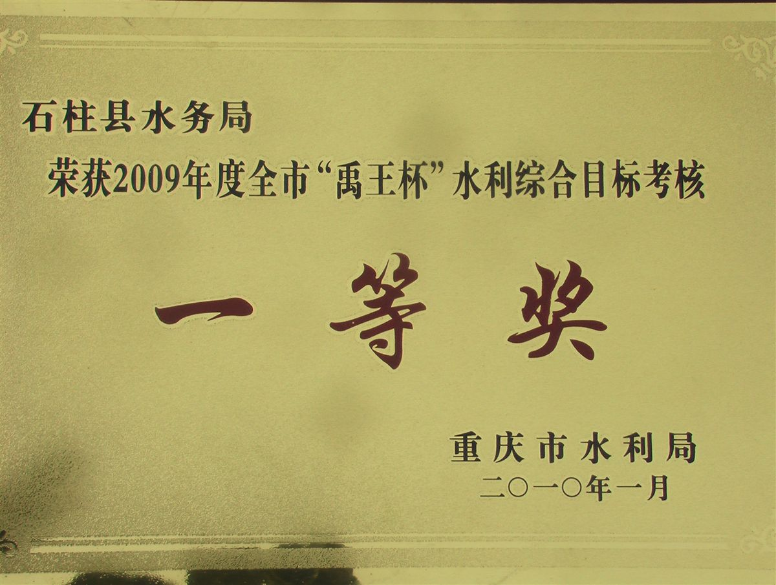
（1） | （2） | （3） | （4） | （5） | （6）
1. Today is the ___________of September.
2. Please send the ____________to your friends.
3. We can make the snowman in the ____________month of the year.
4. The Dragon Boat Festival is on the ____________ of May.
5. Take the green____________ to the ‘green’ party.
6. Mark gets the__________ prize in the Maths test.
Ⅲ. Read and choose（语音判断，将不含有所给音标的单词的编号写在前面的括号内）：4%
( ) 1./i:/ A. she B. me C. head ( ) 2. / i / A. drill B. his C. hi
( ) 3. /ei/ A. whale B. plant C. afraid ( ) 4. /ɔ/ A. those B. soft C. body
Ⅳ. Choose the best answer（用what, which, how, when, where填空，每词限用一次）：6%
1. --- _______ is Peter’s home? --- December
2. --- _______ does the cola taste? --- Sweet.
3. --- _______ do you have? --- Some nice presents.
4. --- ________ does the party begin? --- On Flower Street.
5. --- ________ is the last month of a year? --- At 1 o’clock.
Ⅴ. Read and fill in the blanks（用所给单词的适当形式填空，每线词数不限）6%
1. July comes__________ (before) June.
2. There are thirty seats in the room. I sit on the ___________ (thirty) chair.
3. It’s so much fun. We _________ (can) wait. Let’s begin.
4. --- What are you doing? --- I __________ __________ (sleep).
5. There is__________ (many) food on the table.
6. The film __________ (sound) interesting.
Ⅵ. Read and choose （选择最佳答案，将字母代号写在前面的括号内）：10%
( ) 1. January_________ first.
A. come B. comes C. is coming
( ) 2.I have many nice dresses. My brother has ________ dress.
A. some B. one C. no
( ) 3. Look at the man. He _________ always very busy.
A. is B. does C. /
( ) 4. Welcome _________ my ‘orange’ party.
A. at B. to C. for
( ) 5. --- _______ May want to bring any presents? --- Yes.
A. Do B. Does C. does
( ) 6. What _______ the Wangs do ______Tom’s birthday?
A. do, to B. does, to C. do, for
( ) 7. --- Which day is the _______ day in a week? --- Sunday.
A. first B. second C. third
( ) 8. It’s a picture of us at Peter’s party. _________ fun it is!
A. What B. How C. Let’s
( ) 9. --- How many days are there in June? --- _________.
A. Thirty B. Thirteen C. Thirtieth
( ) 10. Alice and Peter _________ sharks.
A. like both B. both like C. both likes
Ⅶ. Read and write（读一读，填入适当的单词完成句子，首字母已给，每线一词）：6%
1. --- What do you want for your birthday? --- I want a f ___________ cake.
2. I want some r______________ for my dinner.
3. I like this green dress b_______ it’s dear（昂贵的）.
4. Sam likes this pen because（因为）it’s c__________ and nice.
5. Danny has got some h____________ at MacDonald’s.
6. --- Can I have s________ salt? --- Here you are.
Ⅷ. Rewrite the sentences（按要求改写下列句子，每线词数不限）：10%
1. It begins at three o’clock in the afternoon.（改为一般疑问句）_____________________
2. His birthday is on the nineteenth of August.（根据划线提问）_____________________
3. That sounds interesting.（改为否定句）____________________________________
4. My friends have some green things for the ‘green’ party.（改成否定句）
_______________________________________________________________
5. The man is still working at night.（用the men 代替 the man，其余作相应变化）
_______________________________________________________________
Ⅸ. Reading comprehension（阅读理解）：12%
A. Read and judge（阅读短文，判断正误，用T或F表示）：4%
Betty is a lazy girl. She doesn’t study hard, and she doesn’t help her mother with the housework, either.
“What are you going to be when you grow up, Betty?” Mother asks. “You’re too lazy. No job will ever fit you.”
“But I know one,” says the girl,” I’m going to be Father Christmas.”
“You want to be Father Christmas?” Mother is surprised, “But why?”
“Because he works only one day in a whole year.”
( ) 1.Betty doesn’t like studying hard.
( ) 2. Betty wants to be Father Christmas.
( ) 3. Betty likes Father Christmas because it’s very interesting.
( ) 4. It’s very difficult for Betty to find a good job.
B. Read and choose（阅读短文，选择最佳答案，将字母代号写在前面的括号内）：4%
Jimmy is sitting on the steps in front of a house. A front of a house, a salesman comes up and asks him, “Hi, boy, is your mother at home?” “Yes,” says Jimmy.
The salesman is very happy. He begins to ring the doorbell. He rings and rings, but there is no answer. At last, he turns to Jimmy and says, ”You told me your mother is at home, didn’t you?”
“Yes, I did,” says the boy, “but did I tell you this is my house?”
( ) 1. Jimmy is ___________.
A. playing on the steps B. sitting in his house C. sitting on the steps
( ) 2. The salesman __________.
A. knows Jimmy very well B. wants to sell something C. knows Jimmy’s mother
( ) 3. Jimmy tells the salesman ____________.
A. his mother is at home B. he is playing on the steps C. this is his house
( ) 4. The salesman __________.
A. is a friend of this family B. meets Jimmy’s mother
C. thinks Jimmy is a naughty boy with a good sense of humor（幽默感）.
C. Answer the question（阅读短文，回答下列问题）：4%
It is evening. The Tangs are at home. Mrs. Tang is washing in the yard. Mr. Tang is in the living room. He is watching the TV news. Tom, their son, is playing video games in his room. Alice is helping her mother. She is a good girl. They are all very happy.
1. Where are Mr. and Mrs. Tang? __________________________________________
2. What is Mr. Tang doing? _______________________________________________
3. What is Mrs. Tang doing? ______________________________________________
4. How many people are there in Mr. Tang’s family? ___________________________
Ⅹ. Write（请以“My Birthday Party”为主题加以简单描述，要求意思连贯，语句通顺。要求不少于30个单词，不少于2--3种句型）：6%
My Birthday Party

Module 1 Unit 1
Part 1 Listening（听力部分）
Ⅰ. Listen and choose（听一听，选出听到的内容，将字母代号写在前面的括号内）：
1. fifty 2. first 3. party
4. The party is so interesting. Let’s have some fun.
5. Miss Li’s birthday is on the eighteenth of January.
(1. B 2. A 3. A 4. C 5. C)
Ⅱ. Listen and choose（听一听，选出听到的句子，将字母代号写在前面的括号内）：
1. | Welcome to Peter’s ‘red’ party.
2. | There are twelve months in a year. December is the twelfth.
3. | The next morning, Mum sees a card on the bed.
4. | When does the New Year party begin?
(1. B 2. C 3. A 4. C )
Ⅲ. Listen and choose（听问句，选答句；听答句，选问句，将字母代号写在前面的括号内）：
1. When is your birthday, Tom?
2. Would you like to come to my home?
3. What can you bring to a ‘green’ party?
4. It’s March.
(1. A 2. B 3. C 4. B)
Ⅲ. Listen and number（听一听，用“1—5”给下列句子编号）：
Today is the 28th of January. It’s Saturday. Tomorrow is Lisa’s mother’s birthday. Lisa wants to give her mother a birthday present. But she has not much money to buy a gift. She wants to make something by herself. It’s late at night. She is still drawing a card. She can draw very well. She draws a picture of her family and some nice flowers on the card. The next morning, Mum sees the nice card on the table. Lisa says ‘Happy birthday, Mum!’
(42351)
Ⅴ. Listen and choose（听小对话和问题，选择最佳答案，将字母代号写在前面的括号内）：
1. A: Hello, Alice. This Saturday is my birthday. I want to have a party.
B: Really? Happy birthday to you, Peter.
A:Thank you . Would you like to come to my party?
B: Ok. I’d love to. Where’s your home?
A: It’s Room 202, Building 8,456 Xinhua Road. The party begins at 2:00 in the afternoon.
B: I see. See you then.
Q: Where is Peter’s home?
2. A: Nice to meet you. My name is Tomas.
B: Nice to meet you, too. My name is Jill, your new deskmate.
A: What’s your student number？
B: There’re twenty girls in our class. I’m the eighteenth girl.
A: It’s Num. Eighteen?
B: You’re clever, Tomas.
A: Thanks.
Q: What’s Jill’s student number?
3. A: Dad, I want to invite my classmates to my party.
B: Then you can give them invitations.
A: What can I write on the invitation?
B: You can write the time and place of the party on it and you can also draw nice pictures.
A: Thank you, dad.
B: That’s all right, honey.
Q: What can the boy do with the invitation?
4. A: Alice, is the Fool’s Day on the first of April?
B: I don’t know. Let’s look up on the internet.
A: Oh, yes. The Fool’s Day is on the first of April
B: And on that day, we can make small jokes with friends.
A: Yes, that sounds interesting.
Q: When is the Fool’s Day?
(1. B 2. C 3. C 4. A)
Ⅳ. Listen and fill in the blanks（听一听，填入所缺的单词完成短文，每线一词）：
It’s fun to give friends something on their birthdays. Peter and Bob like to give each other funny things. On Bob’s birthday, Peter gives him shoes with flowers. Bob says, ”I want to give Peter something funny too.”
Peter’s birthday is coming. Bob gives him a big box. In the box there is a toy duck, The duck has a flower on its head. They both laugh.
- fun 2. gives 3. coming 4. laugh)
Ⅴ. Listen and judge（听短文，判断正误，用T或F表示）：
Here's a picture of my family. There are four people in it. This is my father. He is thirty-eight years old. His birthday is on the first of June. This lady is my mother. She is thirty-six years old. Her birthday is on the twentieth of October. This is my brother. He is eleven. We are twins. Our birthdays are on the same day. How interesting it is!
(1. T 2. F 3. F 4. F)

Part 2 Reading and writing（笔试部分）
Ⅰ. When is your Grandpa’s birthday? It’s on the third of July.
Ⅱ.1. fouth 2. invitation 3. twelfth 4. fifth 5. present 6. first
Ⅲ. 1. C 2. C 3. B 4. A
Ⅳ. 1. Where 2. How 3. What 4. When 5. Which
Ⅴ. 1. after 2. thirtieth 3. can’t 4. am sleeping 5. much 6. sounds
Ⅵ.1. B 2. C 3. A 4. B 5. B 6. C 7. A 8. B 9. A 10. B
Ⅶ. 1. fruit 2. rice 3. but 4. cheap 5. hamburgers 6. some
Ⅷ. 1. Does it begin at three o’clock in the afternoon?
2. When is his birthday?
3. That doesn’t sound interesting.
4. My friends don’t have any green things for the ‘green’ party.
5. The men are still working at night.
Ⅸ. A. 1. T 2. T 3. F 4. T
B. 1. C 2. B 3. A 4. C
C. 1. At homes.
2. He is watching TV news.
3. Mrs. Tang is washing in the yard.
4. Four.
Ⅹ. Omitted

