# visual results on the provided images. include at least the following scenarios:

## For the binary images (circle, square, star, shape) and the vase, segment the objects

## Circle

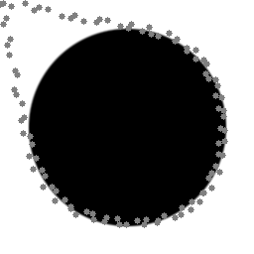

## Square

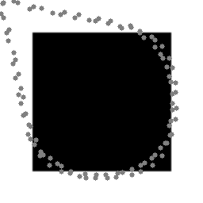

## Star



## Shape

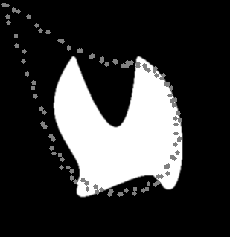

## Vase

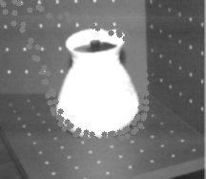

## For the dental image, segment the row of teeth

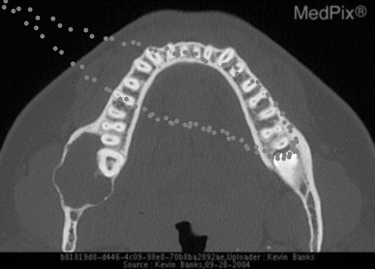

## For the brain image, segment the outer layer of the skull, the inner contour of the brain matter

## Brain outer

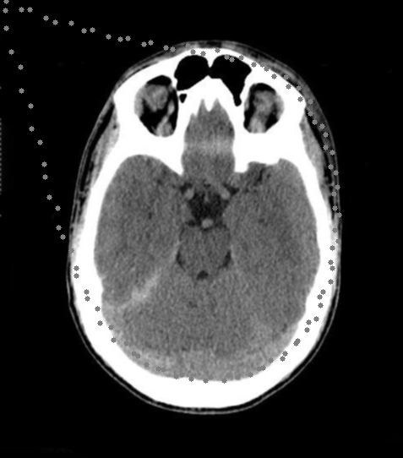

## Brain inner

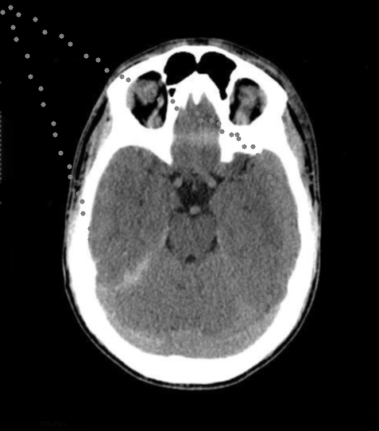

## The right eye hole

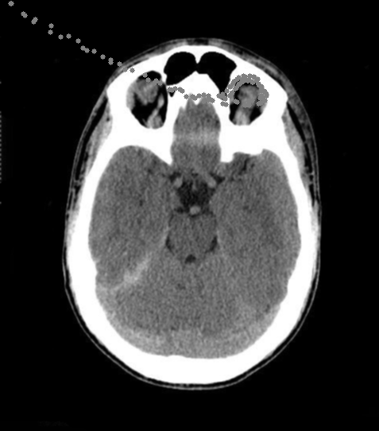

# proof of the bonus question (optional).

## The equation for Eterm essentially measures the curvature of an image.

## The numerator captures changes in intensity (or gradient direction) in the image, using second-order derivatives. These changes in intensity direction are indicative of curvature.

## The denominator normalizes the result based on the strength of the gradient. This ensures that the measure is not overly influenced by flat regions (where gradient magnitude is close to zero). In simpler terms, the equation captures how rapidly the direction of intensity changes in an image, normalized by the strength of that change. This is the essence of curvature in an image context.