# Part 1: Image reconstruction

## Target

reconstructed_image

## Least square error: 4.4142387100209355e-11

## Target1

reconstructed_image

## Least square error: 2.577319392375843e-11

## Large

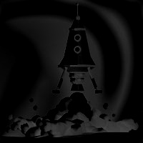

## Least square error: 4.098964272186757

## Large1

# reconstructed_large1

## Least square error: 6.178830861121975

# Part 2: Poisson blending

## source1 + target

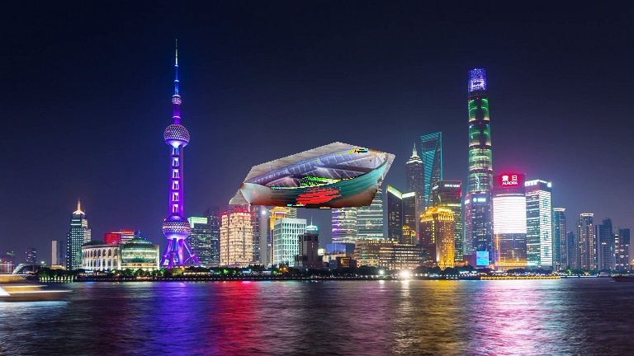

## Least square error: 7.548360620049058e-12

## Source2 + target

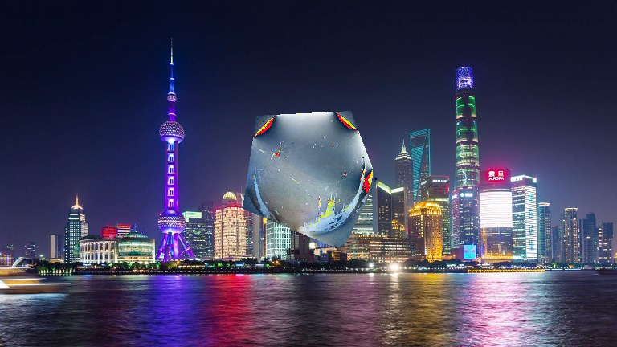

## Least square error: 1.1157592633233997e-11