#### CMPT 762 X100, Fall 2024, Computer Vision

#### Project 3: 3D Reconstruction

Name: Wenhe Wang

Student Number: 301586596

Email: wwa118@sfu.ca

##### 3.1.1 Implement the eight point algorithm

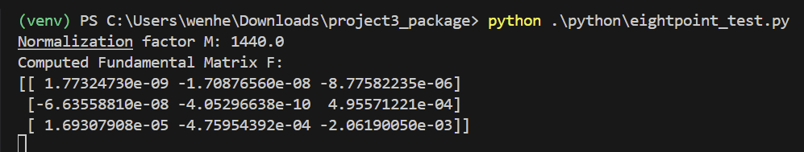

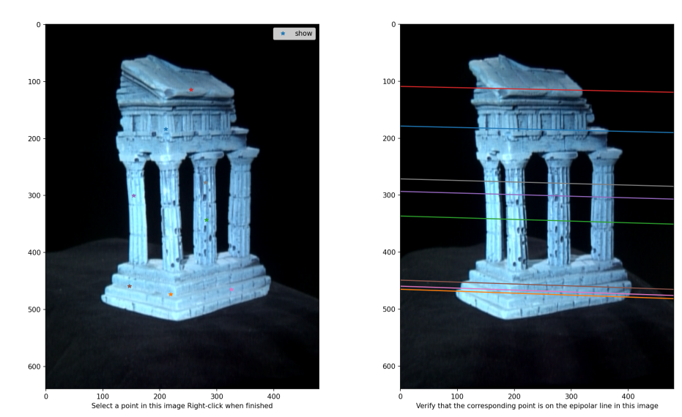

**3.1.2 Find epipolar correspondences**

The similarity metric here is using Euclidean distance on the Grey scaled pixel values of different windows. Because we are trying to do the square to the error here, so I converted my images to Grey color to prevent the loss to become too huge for RGB images. Obviously, if we pick any points such as in the poles or arbitrary background “black points”, the mismatching will happen more often, as all background point values are 0, so our algorithm can’t tell the difference and will just pick a arbitrary background black point.

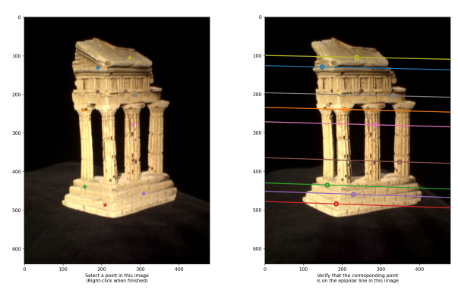

**3.1.3 Write a function to compute the essential matrix**

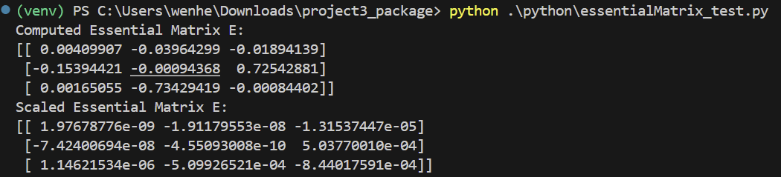

**3.1.4 Implement triangulation and 3.1.5 Write a test script that uses templeCoords**

As can be seen, there are 4 extrinsic matrix to choose after we pass the essential matrix to the camera2 function. The correct one is the fourth matrix as it has 288 correspondences. As for the projection errors, I got 0.5593 for pts1 and 0.5650 for pts2.

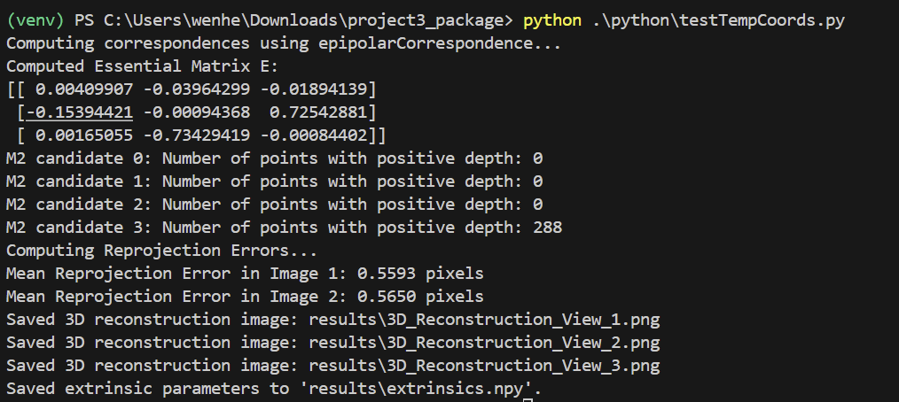

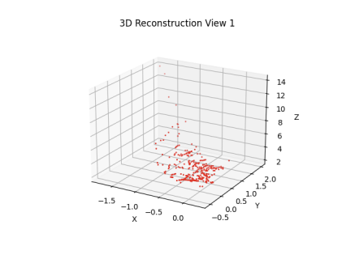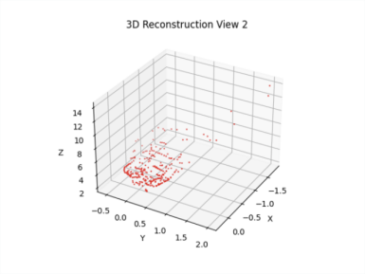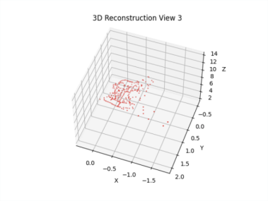

**3.2.1 Image rectification**

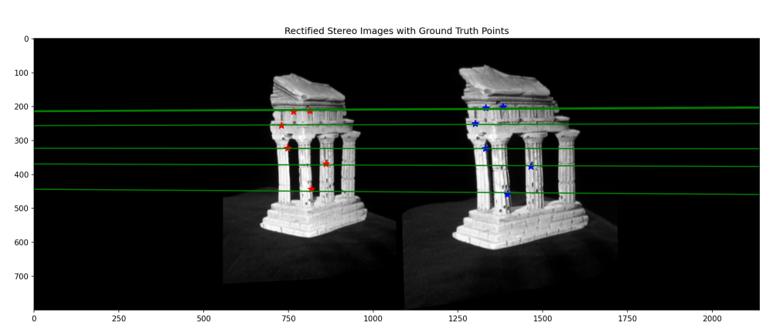

**3.2.2 Dense window matching to find per pixel density and 3.2.3 Depth map**

Disparity map(left) and depth map(right) before rectification:

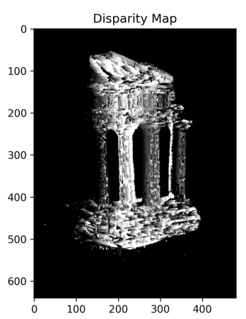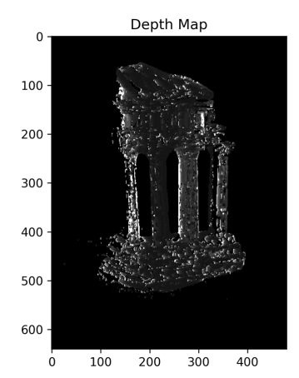

Disparity map(left) and depth map(right) after rectification:

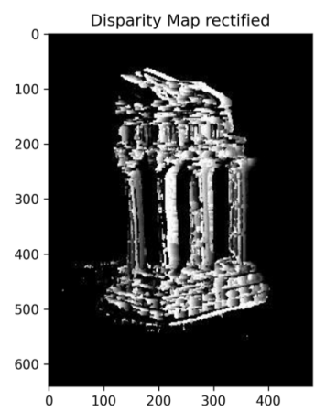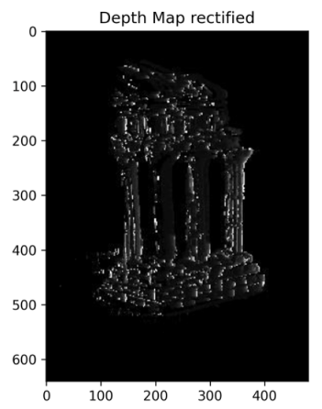

**3.3.1 Estimate camera matrix P**

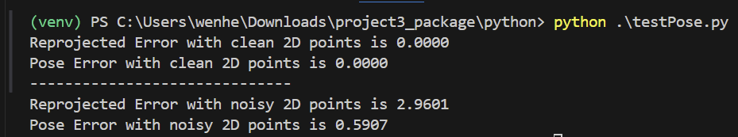

**3.3.2 Estimate intrinsic/extrinsic parameters**

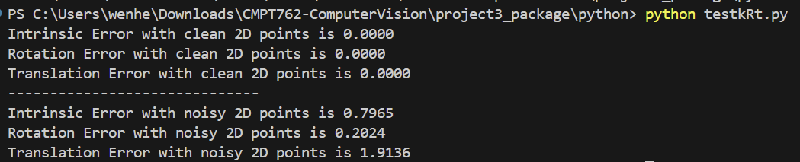

**3.4.1**

templeR0013

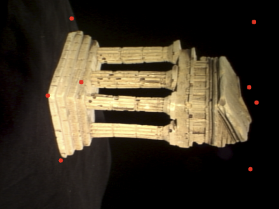

templeR0014

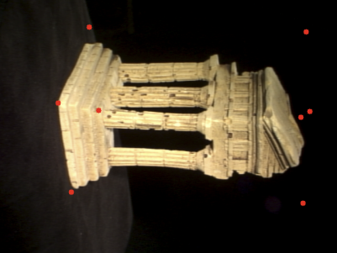

templeR0016

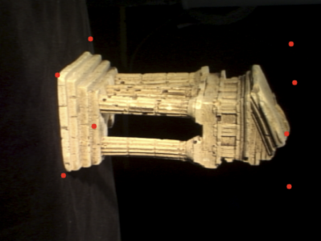

templeR0043

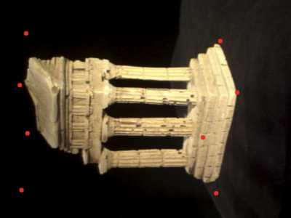

templeR0045

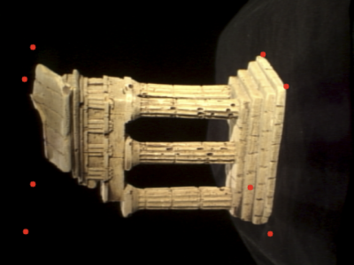

**3.4.2**

I have some issues with this visualization plot, but the depth information is preserved well

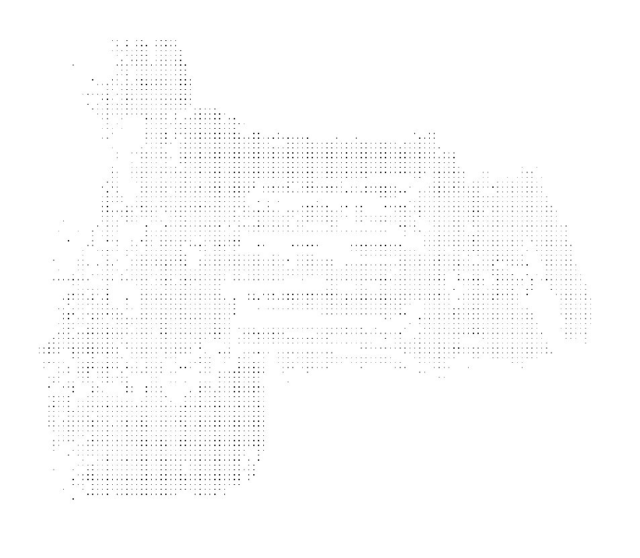

**3.4.3**

