AUTOSCALING-PROJECT:

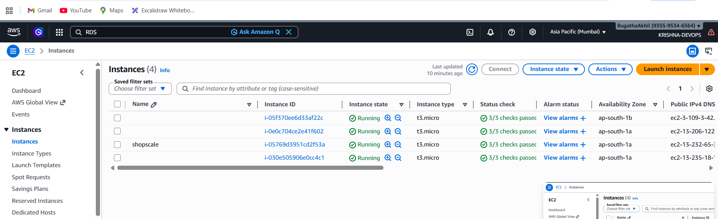

Your Browser / Locust EC2
↓
Krishnadevops.info (Route 53 / DNS)
↓
Application Load Balancer (port 80 / 443)
↓
Auto Scaling Group
┌─────────────────────────────────────────┐
│ EC2 Ubuntu 24.04 (from Custom AMI) │
│ systemd → Gunicorn → Flask app │
│ min: 1 · desired: 1 · max: 5 │
│ Scale out: CPU > 50% │
└─────────────────────────────────────────┘
↓
RDS MySQL 8.0 (shopscale DB)

shopscale/
├── app.py # Flask app (UI + REST API)
├── schema.sql # MySQL schema + 24 seed products
├── locustfile.py # Locust load test (deploy on separate EC2)
└── user-data.sh # ASG Launch Template bootstrap script

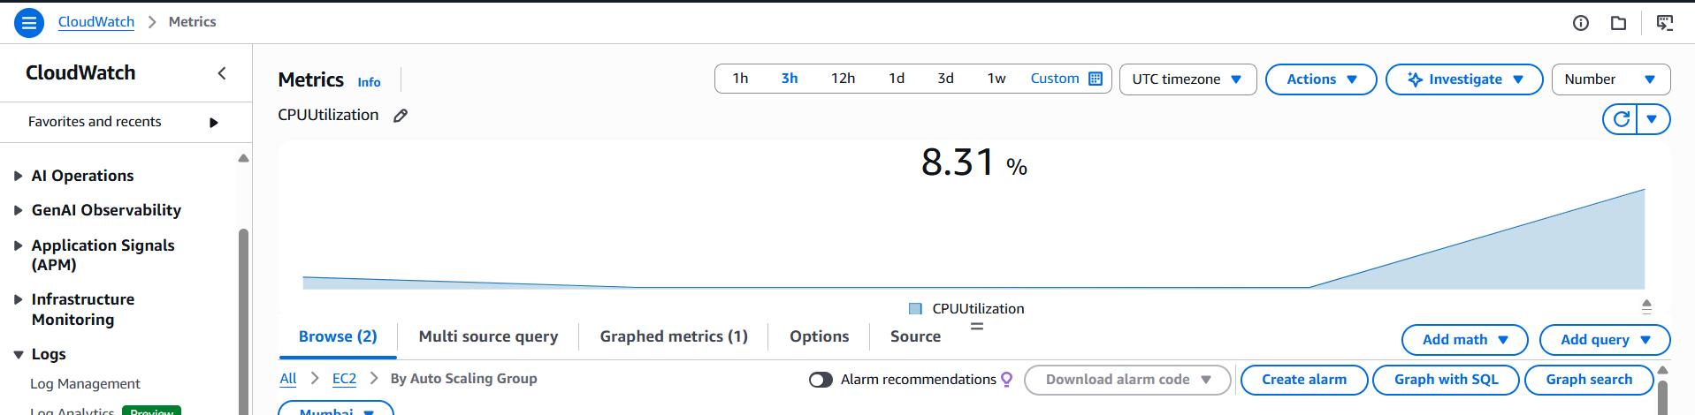

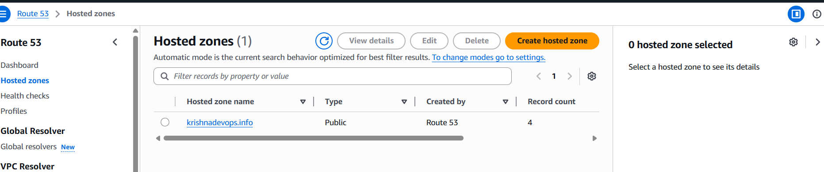

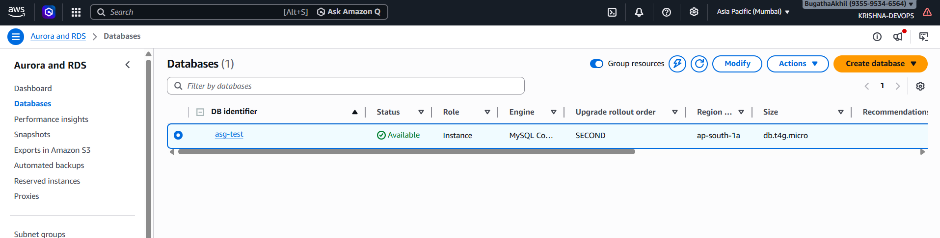
RDS → Create Database
Engine: MySQL 8.0
Template: Free tier (demo) / Production (real)
Instance: db.t3.micro
DB name: shopscale
Username: admin
Password: <your-password>
VPC: same VPC as your EC2s
Public access: No
Security group: allow port 3306 from EC2 security group only

Run this once from any EC2 in the same VPC:
sudo apt install mysql-client -y
mysql -h YOUR_RDS_ENDPOINT -u admin -p < schema.sql
Connect and install dependencies

ssh -i your-key.pem ubuntu@<ec2-public-ip>

# Update system
sudo apt update && sudo apt upgrade -y

# Install Python
sudo apt install python3 python3-pip python3-venv -y

# Create app directory
sudo mkdir /app
sudo chown ubuntu:ubuntu /app
cd /app

# Create virtual environment
python3 -m venv venv
source venv/bin/activate

# Install packages
pip install flask gunicorn mysql-connector-python
Deploy app files
# From your local machine
scp -i your-key.pem app.py ubuntu@<ec2-public-ip>:/app/

# Or create directly on EC2
vi /app/app.py # paste app.py contents

Create env file
sudo vi /etc/shopscale.env
DB_HOST=asg.c8pqywawgz1b.us-east-1.rds.amazonaws.com
DB_PORT=3306
DB_USER=admin
DB_PASS=milky19
DB_NAME=shopscale
INSTANCE_ID=placeholder
SECRET_KEY=h87hshd789ihhdshdshd7

sudo chmod 600 /etc/shopscale.env
sudo vi /etc/systemd/system/shopscale.service
[Unit]
Description=ShopScale E-commerce App
After=network.target

[Service]
User=ubuntu
WorkingDirectory=/app
EnvironmentFile=/etc/shopscale.env
ExecStartPre=+/bin/bash -c '\
TOKEN=$(curl -s -X PUT "http://169.254.169.254/latest/api/token" \
-H "X-aws-ec2-metadata-token-ttl-seconds: 21600"); \
INSTANCE_ID=$(curl -s -H "X-aws-ec2-metadata-token: $TOKEN" \
http://169.254.169.254/latest/meta-data/instance-id); \
grep -q "^INSTANCE_ID=" /etc/shopscale.env \
&& sed -i "s/^INSTANCE_ID=.*/INSTANCE_ID=$INSTANCE_ID/" /etc/shopscale.env \
|| echo "INSTANCE_ID=$INSTANCE_ID" >> /etc/shopscale.env'
ExecStart=/app/venv/bin/gunicorn --workers 4 --bind 0.0.0.0:80 app:app
Restart=always
RestartSec=5

[Install]
WantedBy=multi-user.target

# Enable and start
sudo systemctl daemon-reload
sudo systemctl enable shopscale
sudo systemctl start shopscale

# Check status
sudo systemctl status shopscale

Verify everything works
# Health check — must show db: connected
curl http://localhost/health

# Products API — must return 24 products
curl http://localhost/api/products | python3 -m json.tool | head -30

# Open in browser
http://<ec2-public-ip>

Create AMI
EC2 → Instances → select shopscale-base
→ Actions → Image and Templates → Create Image

Image name: shopscale-ubuntu-v1
Description: ShopScale, Ubuntu 24.04, Python venv, Gunicorn 4 workers
No reboot: leave unchecked

→ Create Image
Create Target Group
EC2 → Target Groups → Create Target Group
Target type: Instances
Name: shopscale-tg
Protocol: HTTP
Port: 80
Health check path: /health
Healthy threshold: 2
Unhealthy threshold: 2
Interval: 15 seconds
Create ALB
EC2 → Load Balancers → Create → Application Load Balancer
Name: shopscale-alb
Scheme: Internet-facing
VPC: your VPC
Subnets: select at least 2 AZs
Security group: allow 80 and 443
Listener: HTTP:80 → forward to shopscale-tg
→ Create
Launch Template
EC2 → Launch Templates → Create Launch Template
Name: shopscale-lt
AMI: ami-xxxxxxxxxxxxxxxxx ← your custom AMI
Instance type: t3.micro
Key pair: your-key
Security group: allow 80 from ALB SG only, 22 from your IP only
User Data (paste in Advanced Details section):
#!/bin/bash
# App is already installed in the AMI
# Just inject DB credentials and restart the service
# Uses IMDSv2 — required on Ubuntu 24.04

# Step 1: Get IMDSv2 token
TOKEN=$(curl -s -X PUT "http://169.254.169.254/latest/api/token" \
-H "X-aws-ec2-metadata-token-ttl-seconds: 21600")

# Step 2: Fetch instance ID using token
INSTANCE_ID=$(curl -s -H "X-aws-ec2-metadata-token: $TOKEN" \
http://169.254.169.254/latest/meta-data/instance-id)

# Step 3: Write env file
cat > /etc/shopscale.env << ENVEOF
DB_HOST=YOUR_RDS_ENDPOINT.us-east-1.rds.amazonaws.com
DB_PORT=3306
DB_USER=admin
DB_PASS=YOUR_DB_PASSWORD
DB_NAME=shopscale
INSTANCE_ID=$INSTANCE_ID
ENVEOF

# Step 4: Secure and restart
chmod 600 /etc/shopscale.env
systemctl restart shopscale
Auto Scaling Group
EC2 → Auto Scaling Groups → Create

Step 1 — Template
Name: shopscale-asg
Launch template: shopscale-lt

Step 2 — Network
VPC: your VPC
Subnets: select 2-3 AZs (us-east-1a, 1b, 1c)

Step 3 — Load balancing
Attach to: existing ALB target group
Target group: shopscale-tg
Health check type: ELB
Grace period: 60 seconds

Step 4 — Capacity
Minimum: 1
Desired: 1
Maximum: 5

Step 5 — Scaling policy
Policy type: Target Tracking
Metric: Average CPU utilization
Target value: 50%
Warm-up: 60 seconds

→ Create Auto Scaling Group
Locust Load Generator
Deploy on a separate EC2 — NOT inside the ASG.
Launch Locust EC2
AMI: Ubuntu 24.04 LTS
Instance type: t3.micro
Security group: allow 22 (your IP), 8089 (your IP only)
ssh -i your-key.pem ubuntu@<locust-ec2-ip>

# Install Docker
sudo apt update
sudo apt install docker.io -y
sudo systemctl start docker
sudo usermod -aG docker ubuntu

# Log out and back in, then:
mkdir locust && cd locust

cat > locustfile.py << 'LOCUST'
from locust import HttpUser, task, between
import random

class ShopUser(HttpUser):
wait_time = between(1, 3)

@task(5)
def browse_products(self):
self.client.get("/api/products")

@task(3)
def view_homepage(self):
self.client.get("/")

@task(2)
def search_products(self):
terms = ["merino", "keyboard", "yoga", "coffee"]
self.client.get(f"/api/search?q={random.choice(terms)}")

@task(1)
def add_to_cart(self):
self.client.post("/api/cart", json={
"product_id": random.randint(1, 24),
"quantity": 1,
"session_id": f"user-{random.randint(1000, 9999)}"
})
LOCUST

docker run -d \
--name locust \
--restart always \
-p 8089:8089 \
-v $(pwd):/mnt/locust \
locustio/locust \
-f /mnt/locust/locustfile.py
Open Locust UI
http://<locust-ec2-ip>:8089
